Final Exam – Economics of Income Distribution
Name/Surname/Student ID#:
- Last year, the Conservative Party in the UK had a major election victory against Labor, which proposed taxing the rich and using the extra tax revenues for services that would benefit the poor. In the class, we discussed several models that explain why the poor do not support the economic policies that favor them. If you were the leader of the Conservative Party, Boris Johnson, which model would you prefer to explain your party’s victory? Discuss the model. (Hint: Only one model is correct.)

- The figure below shows after-tax income inequality measured by the Gini coefficient and the annual average growth rates for selected OECD countries.
- How would Stiglitz respond to this data? Explain your argument.
- How would Pinker respond to Stiglitz? Explain your argument.

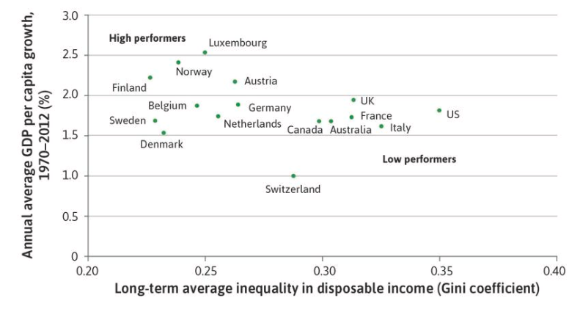

- According to an article published in Science in 2018, GDP per capita and secularity are positively correlated (see the figure below). As we discussed in the class, the link between the growth of GDP per capita and income equality are also positive.
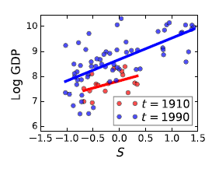
109 nations in the 20th century. Here S denotes the level of secularity. GDP is in per capita terms.
- According to these results, should the link between income equality and secularity be positive or negative?
- Is this consistent with the real world data?

- According to TUİK, the distribution of income in Turkey can be summarized as follows:
 |  | 1st quintile⁽¹⁾ |  | Second quintile |  | Third quintile |  | Fourth quintile |  | Last quintile
Mean (TL) |  | 5 880 |  | 10 174 |  | 14 288 |  | 20 194 |  | 45 173

- Compute the Gini coefficient among these five groups.
- Explain why the actual Gini in the whole economy is definitely higher than your answer.

