Quiz Questions – Mathematical Economics
IMPORTANT: If the quiz takes place during an online class hour, then your quiz questions will be slightly different regarding the numerical values, albeit essentially the same.
1) Assume that you want to buy a house in the real estate market but the offers by the sellers are uncertain. The house prices (per m²) are over [5000TL, 9000TL] according to the PDF depicted below:
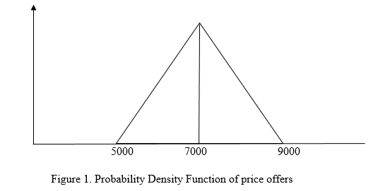
- What is the height of the triangle above? (Hint: The triangle is the graph of a PDF.)
- Suppose you will receive offers from two randomly chosen sellers. The first seller offers 7000TL per m². What is the probability that you will get a higher offer from the second seller?
- If you buy the cheapest house, what is the expected price that you will pay?

2) Suppose that $θ$ is a random variable uniformly distributed over $\left[0,1\right]$.
a) Compute $\operatorname{Pr}\left(θ<1/3|θ<1/2\right)$, the probability that $θ<1/3$ knowing that $θ<1/2$.
b) Find the expected value of $θ$ given that $θ<1/3.$ That is, $E\left[θ | θ<\frac{1}{3}\right].$

