- The Stone-Geary utility function has the form
$$u\left(x\right)=\prod_{i=1}^{n}{{\left(x_{i}-a_{i}\right)}^{b_{i}}}$$
where $b_{i}≥0$ and $\sum{b_{i}}=1$. The $a_{i}≥0$ are often interpreted as ‘subsistence’ levels of the
respective commodities.
- Derive the associated expenditure and indirect utility functions. Show that the former is linear in utility, whereas the latter is proportional to the amount of ‘discretionary income’,
$$m-\sum{p_{i}a_{i}}.$$
Solution: To find the expenditure function, let us solve:
$$\min{(px)}$$
s.t.
$$\overline{u}=\prod_{i=1}^{n}{{\left(x_{i}-a_{i}\right)}^{b_{i}}}$$
by choosing $x≥0$. We know that the solution will imply
$$MRS_{i,j}=\frac{p_{i}}{p_{j}}.$$
Let us remember where this result comes from. First form the Lagrangian:
$$L=px+λ\left(\overline{u}-u\left(x\right)\right).$$
FONC is:
$$L_{x_{i}}=p_{i}-λ\frac{du}{dx_{i}}=0$$
for each $i=1,…,n$. This directly gives us
$$\frac{p_{i}}{p_{j}}=\frac{λ\frac{du}{dx_{i}}}{λ\frac{du}{dx_{j}}}=\frac{\frac{du}{dx_{i}}}{\frac{du}{dx_{j}}}=\frac{MU_{i}}{MU_{j}}=MRS_{i,j}.$$
So we need to compute the marginal utilities:
$$\frac{du}{dx_{i}}=b_{i}{\left(x_{i}-a_{i}\right)}^{b_{i}-1}×…×{\left(x_{j}-a_{j}\right)}^{b_{j}}=b_{i}{\left(x_{i}-a_{i}\right)}^{-1}×u.$$
So the MRS rule gives us:
$$\frac{b_{i}}{b_{j}}\frac{\left(x_{j}-a_{j}\right)}{(x_{i}-a_{i})}=\frac{p_{i}}{p_{j}}.$$
From this observation deduce that
$$\frac{b_{i}}{b_{j}}\left(x_{j}-a_{j}\right)\frac{p_{j}}{p_{i}}=\left(x_{i}-a_{i}\right).$$
Now plug $x_{i}-a_{i}$ into
$$\overline{u}=\prod_{i=1}^{n}{{\left(x_{i}-a_{i}\right)}^{b_{i}}}$$
which gives
$$\overline{u}=\frac{p_{j}}{b_{j}}\left(x_{j}-a_{j}\right)\prod_{i=1}^{n}{{\left(\frac{b_{i}}{p_{i}}\right)}^{b_{i}}}.$$
So the Hicksian demand is
$$x_{j}^{h}\left(p,\overline{u}\right)=a_{j}+\overline{u}\frac{b_{j}}{p_{j}}×A$$
where $A$ is a given constant.
$$A={\left(\prod_{i=1}^{n}{{\left(\frac{b_{i}}{p_{i}}\right)}^{b_{i}}}\right)}^{-1}.$$
So the expenditure function is
$$e\left(p,\overline{u}\right)=\sum{p_{j}{(a}_{j}+\overline{u}\frac{b_{j}}{p_{j}}×A)}=\sum{p_{j}{(a}_{j})}+\sum{(\overline{u}A)}.$$
To find the indirect utility, we must solve
$$MRS_{i,j}=\frac{p_{i}}{p_{j}}$$
which is equivalent to $$\frac{b_{i}}{b_{j}}\frac{\left(x_{j}-a_{j}\right)}{(x_{i}-a_{i})}=\frac{p_{i}}{p_{j}}$$
and
$$px=m.$$
From the first equation (MRS rule), we obtain
$$\sum{\frac{b_{i}}{b_{j}}\left(x_{j}-a_{j}\right)p_{j}}=\sum{p_{i}(x_{i}-a_{i})}$$
$$\frac{\left(x_{j}-a_{j}\right)p_{j}}{b_{j}}=m-\sum{p_{i}\left(a_{i}\right)}.$$
This gives us the Marshallian (Walrasian) demand
$$x_{j}=a_{j}+\left( m-\sum{p_{i}\left(a_{i}\right)}\right)\frac{b_{j}}{p_{j}}.$$
So the indirect utility function is
$$v\left(p,m\right)=\prod_{i=1}^{n}{{\left(x_{i}-a_{i}\right)}^{b_{i}}}=\prod_{i=1}^{n}{{\left(\left( m-\sum{p_{j}\left(a_{j}\right)}\right)\frac{b_{i}}{p_{i}}\right)}^{b_{i}}}=\left( m-\sum{p_{j}\left(a_{j}\right)}\right)\prod_{i=1}^{n}{{\left(\frac{b_{i}}{p_{i}}\right)}^{b_{i}}}=\frac{\left( m-\sum{p_{j}\left(a_{j}\right)}\right)}{A}.$$
This is obviously proportional with respect to the discretionary income, $m-\sum{p_{j}\left(a_{j}\right)}$.

- Show that $b_{i}$ measures the share of this ‘discretionary income’ that will be spent on ‘discretionary’ purchases of good $x_{i}$ in excess of the subsistence level $a_{i}$.
Answer: We already showed
$$x_{j}-a_{j}=\left( m-\sum{p_{i}\left(a_{i}\right)}\right)\frac{b_{j}}{p_{j}}$$
Which implies
$$\frac{p_{j}\left(x_{j}-a_{j}\right)}{\left( m-\sum{p_{i}\left(a_{i}\right)}\right)}=b_{j}$$

- Let the production function be
$$F\left(K,L\right)={\left(δ{\left(aK\right)}^{σ}+(1-δ){\left(bL\right)}^{σ}\right)}^{\frac{1}{σ}}$$
where $δ∈\left(0,1\right).$
- Derive the 2nd order derivative matrix (i.e. the Hessian) of $F\left(K,L\right)$.
Solution.
$$F_{K}=\frac{1}{σ}{\left(δ{\left(aK\right)}^{σ}+(1-δ){\left(bL\right)}^{σ}\right)}^{\frac{1}{σ}-1}δσ{\left(aK\right)}^{σ-1}a=({Y^{σ})}^{\frac{1}{σ}-1}δ{\left(aK\right)}^{σ-1}a=aδ{\left(\frac{aK}{Y}\right)}^{σ-1}$$
where $Y=F(K,L)$. Likewise,
$$F_{L}=b\left(1-δ\right){\left(\frac{bL}{Y}\right)}^{σ-1}.$$
Therefore,
$$F_{KK}= aδ(σ-1){\left(\frac{aK}{Y}\right)}^{σ-2}(\frac{a}{Y}-\frac{aK}{Y^{2}}F_{K})$$
$$F_{KL}=- aδ\left(σ-1\right){\left(\frac{aK}{Y}\right)}^{σ-2}\frac{aK}{Y^{2}}F_{L}.$$
Therefore, the Hessian is
$H=\left[\begin{matrix}F_{KK} & F_{KL} \\ F_{LK} & F_{LL}\end{matrix}\right]=\left[\begin{matrix}aδ(σ-1){\left(\frac{aK}{Y}\right)}^{σ-2}(\frac{a}{Y}-\frac{aK}{Y^{2}}F_{K}) & - aδ\left(σ-1\right){\left(\frac{aK}{Y}\right)}^{σ-2}\frac{aK}{Y^{2}}F_{L} \\ - aδ\left(σ-1\right){\left(\frac{aK}{Y}\right)}^{σ-2}\frac{aK}{Y^{2}}F_{L} & b(1-δ)(σ-1){\left(\frac{bL}{Y}\right)}^{σ-2}(\frac{b}{Y}-\frac{bL}{Y^{2}}F_{L})\end{matrix}\right]$.
- Find a condition on $σ$ to ensure that $F\left(K,L\right)$ is a concave function.
Concavity requires the principal minors change signs, starting from negative. Therefore,
$$aδ\left(σ-1\right){\left(\frac{aK}{Y}\right)}^{σ-2}\left(\frac{a}{Y}-\frac{aK}{Y^{2}}F_{K}\right)<0.$$
This is equivalent to
$$\left(σ-1\right)\left(\frac{a}{Y}-\frac{aK}{Y^{2}}F_{K}\right)<0$$
Note that
$$\left(\frac{a}{Y}-\frac{aK}{Y^{2}}F_{K}\right)=\frac{a}{Y}\left(1-\frac{K}{Y} \frac{dY}{dK} \right)=\frac{a}{Y}\left(1-\frac{K}{Y} aδ{\left(\frac{aK}{Y}\right)}^{σ-1} \right)=\frac{a}{Y}\left(1- δ{\left(\frac{aK}{Y}\right)}^{σ} \right)>0$$
because
$$δ{\left(\frac{aK}{Y}\right)}^{σ}=\frac{δ{\left(aK\right)}^{σ}}{\left(δ{\left(aK\right)}^{σ}+(1-δ){\left(bL\right)}^{σ}\right)}<1.$$
Therefore, $σ<1$.
You can show that
$$\det\left[\begin{matrix}F_{KK} & F_{KL} \\ F_{LK} & F_{LL}\end{matrix}\right]>0$$
provided that $σ<1.$

- Assume that a competitive firm solves
$$\max{F\left(K,L\right)-rK-wL}$$
by choosing $\left(K,L\right)$. Show that the labor share of income in this economy is equal to the $L$ elasticity of $Y$.
Solution: The labor elasticity of output is defined as
$$\frac{d\ln{F\left(K,L\right)}}{d\ln{L}}=ϵ_{Y,L}.$$
However,
$$\frac{d\ln{F\left(K,L\right)}}{d\ln{L}}=\frac{dF}{dL}\left(\frac{L}{F}\right).$$
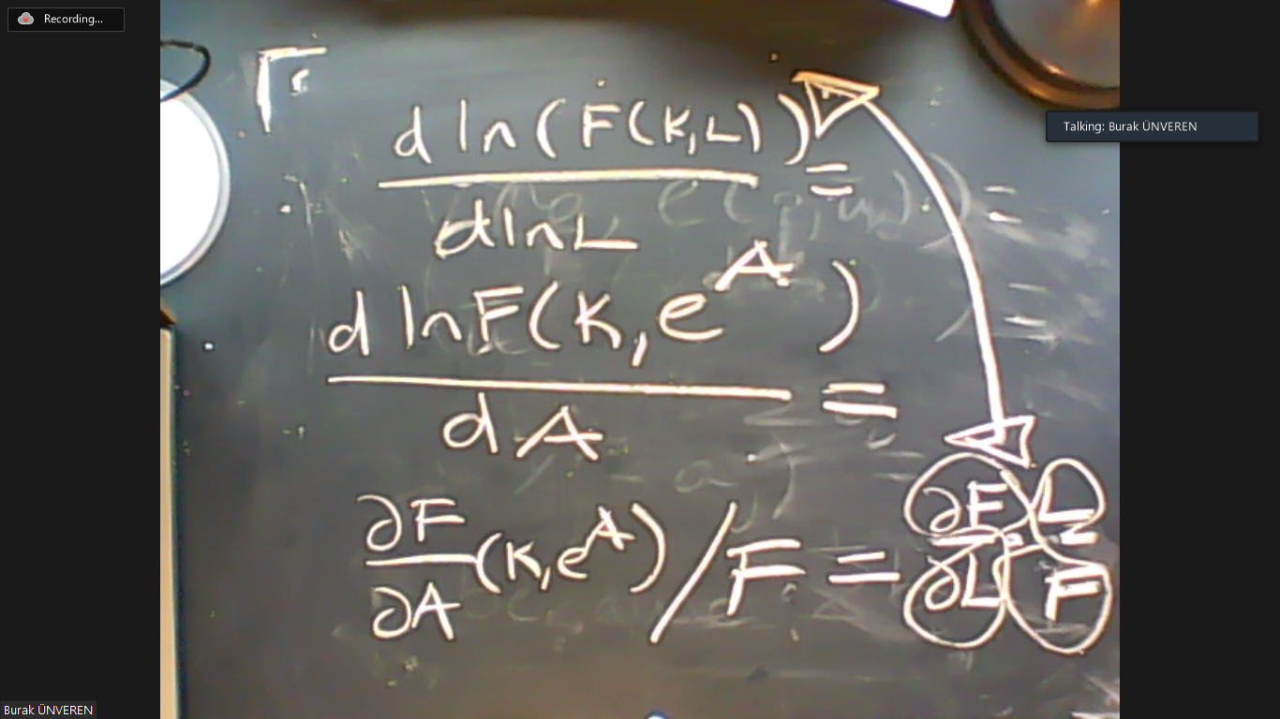
If the firm maximizes its profit, then
$$F_{L}=w.$$
Multiply both sides by $L$ then divide by $Y$ to see
$$F_{L}×\left(\frac{L}{Y}\right)=\frac{wL}{Y}$$
$$Elasticity=Labor Share.$$
In this economy, the technology is
$$F\left(K,L\right)={\left(δ{\left(aK\right)}^{σ}+(1-δ){\left(bL\right)}^{σ}\right)}^{\frac{1}{σ}}.$$
Therefore, the labor share is
$$F_{L}×\left(\frac{L}{Y}\right)=\left(1-δ\right){\left(\frac{bL}{Y}\right)}^{σ}.$$
- Average producivity of labor, $Y/L$, has an upward trend in almost all countries in the world, including Turkey. Labor share in Turkey has declined over the last decade. What does that imply in terms of $σ$ in Turkey?
The labor share, according to our question is
$$\left(1-δ\right){\left(\frac{bL}{Y}\right)}^{σ}.$$
We are told that this expression is getting smaller over time. Therefore,
$${\left(\frac{bL}{Y}\right)}^{σ}$$
should decrease over time. But we are also told that $Y/L$ is increasing. Conclude $σ>0$.
- According to econometric estimates, $σ≈-1$ in Turkey and elsewhere. What does that imply in terms of $b$?
If $σ=-1$, then the labor share (which is decreasing) would be
$${\left(\frac{bL}{Y}\right)}^{σ}={\left(\frac{bL}{Y}\right)}^{-1}=\frac{Y}{bL}.$$
This can only happen if $b$ is increasing over time. In fact, $b$ should grow faster than $Y/L$.

- Consider an individual who solves
$$\max{u(c,1-h)}$$
s.t.
$$pc=wh\left(1-τ\right)+T$$
by choosing $(c,h)$ where $(p,w$) is a given tuple. The parameters $τ$ and $T$ denote the income tax rate and the transfers, which are exogenous for the individual. Here
$$u\left(c,1-h\right)=a\ln{c}+\left(1-a\right)\frac{{\left(1-h\right)}^{1-γ}}{1-γ}.$$
- Derive the first order conditions for this problem.
$$L=u+λ\left(pc-wh\left(1-τ\right)-T\right).$$
The FONC are:
$$\frac{du}{dc}+λp=0$$
$$\frac{du}{d(1-h)}+λw(1-τ)=0.$$
In explicit terms,
$$\frac{a}{c}=-λp$$
$${(1-a)(1-h)}^{-γ}=-λw\left(1-τ\right).$$
Substituting for $λ$ gives us
$$(1-a){(1-h)}^{-γ}=\frac{a}{pc}w\left(1-τ\right).$$
In other words,
$$\left(wh\left(1-τ\right)-T\right)\left(1-a\right)=a{(1-h)}^{γ}w\left(1-τ\right).$$

- Impose $τh=T$ on the optimality conditions due to the government’s balanced budget.
In this case, the optimality condition would be
$$\left(h\right){\left(1-h\right)}^{-γ}\left(1-a\right)=a\left(1-τ\right).$$

- Now consider the graph below which plots the labor supply in Turkey from 1980 to 2017.

Find values of $(α,γ)$ consistent with the trend in labor supply given that the tax-to-GDP ratio rose from 15% to 25% over the same period in Turkey.

According to these data, we can deduce that
$$\left(0.33\right){\left(1-0.33\right)}^{-γ}\left(1-a\right)=a\left(1-0.15\right).$$
$$\left(0.315\right){\left(1-0.315\right)}^{-γ}\left(1-a\right)=a\left(1-0.25\right).$$

