Production and Firms
Today we will discuss how firms produce by employing labor and investing in capital. This discussion is analogous to how consumers choose consumption bundles, as we discussed in previous classes. The discussion on production and firms will complete the picture for a competitive market economy. Moreover, this discussion has also serious implications for technology and income distribution.
Example: During the Great Recession, labor productivity in the US rose by 3.2% in 2007. The previous saw a labor productivity increase by only 2%. Why did the labor productivity increase during a financial crisis even more than financially stable times?
Example: Would workers benefit if firms use more capital in production? On the one hand, more capital could mean higher productivity for the workers, which would be good for wages. On the other hand, workers could be substituted by capital, losing their jobs to machines.
To answer these types of questions from a microeconomics perspective, we should first analyze what a firm wants. Our assumption is that firms want to maximize their profits.
What a firm wants
The profit of a firm is defined as
$$π=R-C$$
where $R$ is revenue and $C$ is cost. Revenue is defined as
$$R=p×q$$
where $p$ is the price and $q$ is the quantity of the commodity that the firm produces. The firm produces $q$ by using inputs such as labor, capital, raw materials, natural resources, energy, etc. But we will only focus on labor denoted by $L$ and capital denoted by $K$. The technological relationship between output $q$ and inputs $\left(K,L\right)$ can be represented by a function
$$q=f\left(K,L\right).$$
This function $f(K,L$) is called “the production function” or “the technology” as it tells us “how much output would be produced if the firm uses certain amounts of capital and labor.
Example: Consider a plant which uses a technology to produce bicycle wheels. For a single wheel, the firm should use 3 workers ($L$) and 1 machine ($K$). The relation between the output and the inputs is the function $f$, technology.
Example: Suppose that the production technology for producing $q$ amounts of a commodity is
$$q=f\left(K,L\right)=\frac{K}{2}+\frac{L}{4}.$$
This means inputs can perfectly substitute each other to produce any given amount of output. The producer does not need to use labor and capital together. This relationship is the technology or the production technology. (End of example)

In the short-run, typically, firms cannot adjust their capital. So capital is fixed in the short-run. In that case, we express the production technology as
$$q=f(\overline{K},L)$$
where $\overline{K}$ is the fixed amount of capital. Let us see a typical graph of a short-run production technology.
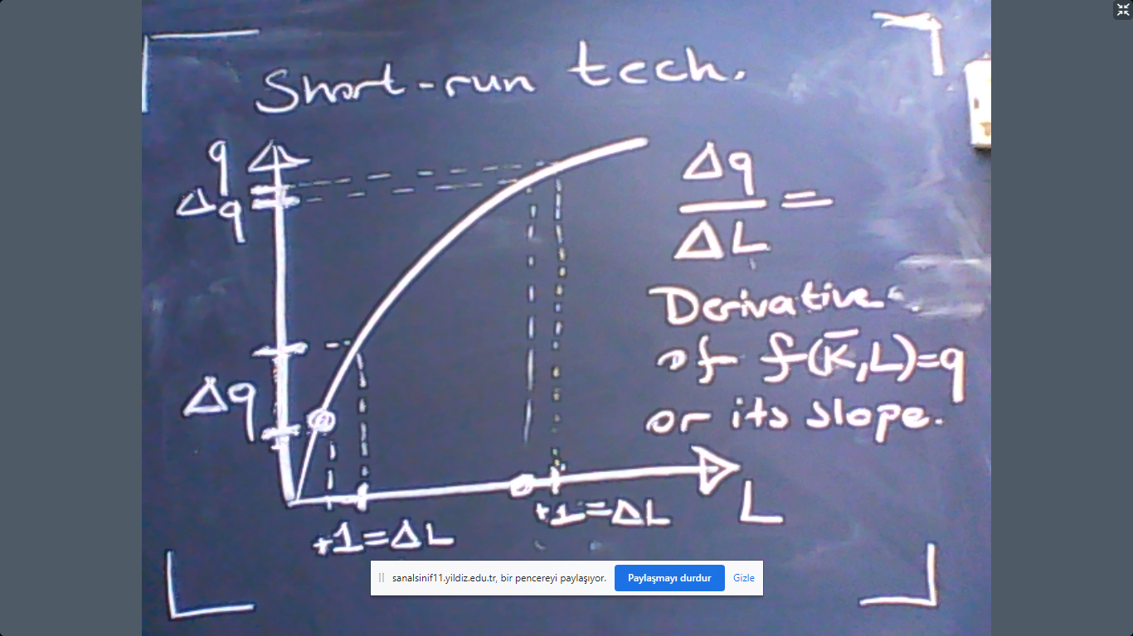

Since the level of capital is fixed, the only variable that the firm could choose is $L$. According to the graph, output $q$ increases with $L$ at a decreasing rate. This means that the derivative of the slope of $$q=f(\overline{K},L)$$
denoted by
$$\frac{Δq}{ΔL}$$
is large if $L$ is small. If $L$ is large, the derivative is small. They are negatively related. We call $$MP_{L}=\frac{Δq}{ΔL}$$
as the “Marginal Productivity of Labor” which measures the extra output due to an extra worker. But typically, productivity of labor is meant to describe average productivity:
$$AP_{L}=\frac{q}{L}.$$
Another important notion is (labor) elasticity (of output) measured by
$$ϵ_{q,L}=\frac{MP_{L}}{AP_{L}}=\frac{Δq}{ΔL}×\frac{L}{q}.$$
Note that labor elasticity of output measures % change in $q$ due to 1% change in $L$.
Example: Suppose that you are considering to hire a new worker at your firm. Which measure of productivity would be important for you? Average, marginal, or elasticity? The firm would be concerned about the extra output that the new worker would bring about, which is marginal productivity.
Example: Suppose that the production technology is
$$q={\left(K×L\right)}^{\frac{1}{2}}$$
and capital is fixed at 100. So the short-run technology is
$$q={10\left(L\right)}^{\frac{1}{2}}.$$
- What is $MP_{L}$ at $L=100$?
- What is $AP_{L}$ at $L=100$?
- What is $ϵ_{q,L}$ at $L=100?$
Answer: Recall that, by definition,
$$MP_{L}=\frac{dq}{dL}=\frac{5}{\sqrt{L}}.$$
When $L=100$, this means $MP_{L}=1/2$. In other words,
$$f\left(100,100\right)=100 and f\left(100,101\right)≈100+\frac{1}{2}.$$
In contrast, when $L=1$, this means $MP_{L}=5.$ Therefore,
$$f\left(100,1\right)=10 and f\left(100,2\right)≈10+5.$$
b) What is $AP_{L}$? The answer is
$$\frac{q}{L}=\frac{10}{\sqrt{L}}=1.$$
c) Therefore, elasticity is
$$ϵ=\frac{MP_{L}}{AP_{L}}=\frac{\frac{1}{2}}{1}=\frac{1}{2}.$$
The interpretation is “1% increase in labor causes 0.5% increase in output”.
Long-term production
In the long-term all inputs are variable and no input is fixed. This means
$$q=f\left(K,L\right).$$
In this case, the marginal and average productivities of capital are calculated similar to labor. In particular,
$$MP_{K}=\frac{dq}{dK}$$
$$AP_{K}=\frac{q}{K}.$$
Ex: Let us assume that there is a production technology $q=f\left(K,L\right)$ where
$$MP_{K}=\frac{1}{2}$$
$$MP_{L}=\frac{1}{2}$$
$$q=100$$
at $\left(K,L\right)=\left(100,100\right).$ (For example, this production technology could be $q={\left(K×L\right)}^{\frac{1}{2}}.$) Suppose that the firm fires a worker. To ensure that there is no decrease in output, how much extra capital should the firm use?
Answer: Due to 1 less worker, the drop in production is $MP_{L}=1/2$. The firm can compensate this reduction in output by 1 extra capital because $MP_{K}=1/2$. In general
$$\frac{dK}{dL}|_{q is fixed}=\frac{MP_{L}}{MP_{K}}.$$
This is called “marginal rate of technical substitution” and it measures “how much extra capital is needed (dK) if we reduce labor by a small amount (dL) given that output does not change (q is fixed)”.
This concept is very similar to the marginal rate of substitution that we discussed when we analyzed utility maximization. In a similar fashion, we can visualize the marginal rate of technical substitution as follows:
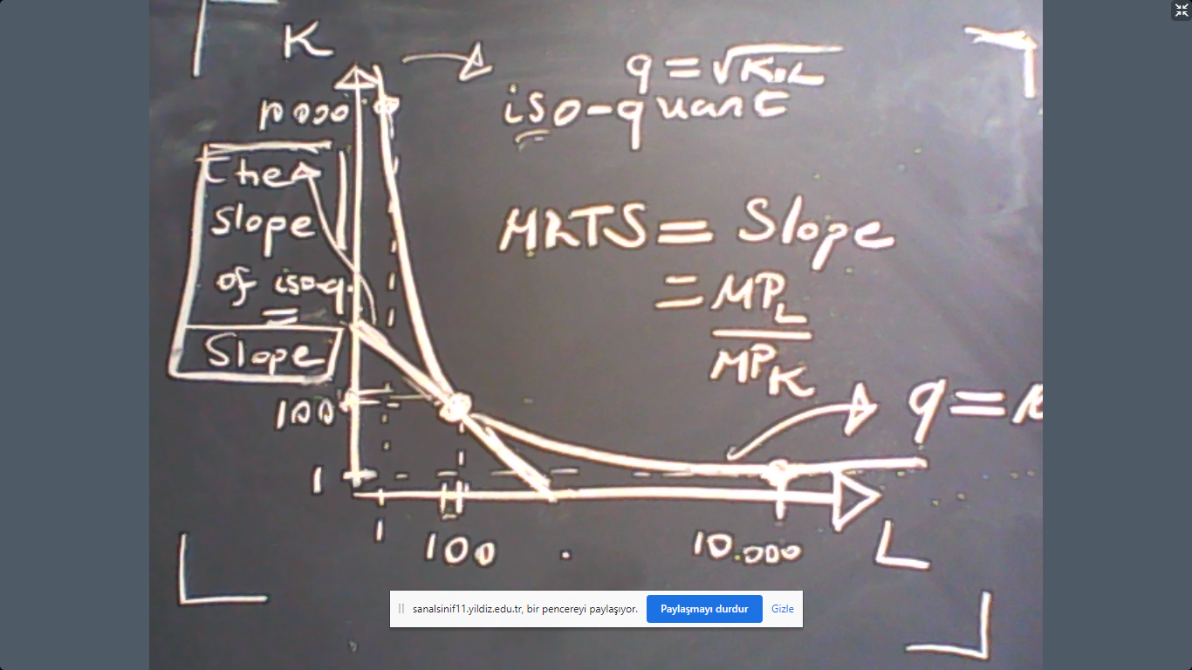
Indeed, this discussion is very similar to utility maximization. For example, let us consider different technologies.
Technology 1: 1 unit of output requires 1 unit of capital and 1 unit of labor. In this case,
$$q=f\left(K,L\right)=\min\left\{\frac{K}{a},\frac{L}{b}\right\}.$$
This is Leontief (perfect complements) technology. Example: 1 sewing machine is useful only with 1 worker. Extra unit of either the machine or the worker does not produce any extra unit of cloth.
Technology 2: 1 unit of output can be produced by either 1 unit of capital or 1 unit of labor. In this case,
$$q=f\left(K,L\right)=a×K+b×L.$$
This is linear (perfect substitutes) technology. Example: Agricultural production can be undertaken using mechanization or labor intensive techniques. Manual labor in agriculture can be substituted by machines. Robots vs. Humans is another example.
Technology 3: These are two polar cases. The exact average would be the Cobb-Douglas technology where
$$q=K^{a}L^{b}.$$
The Cobb-Douglas technology is a very good representation of a large economy where there are many firms with Leontief technology and many other firms with linear technology.

To visually analyze these technologies, we should draw their iso-quants. An iso-quant is the graph of all capital and labor couples that produce a particular fixed amount of output. This is the same as the indifference curve. So let us skip the iso-quant graphs because they would be repetitive.
Returns to scale
Consider the following question? A firm uses inputs to produce a certain amount of output, say $q=10$. How much the output change if the firm doubled its inputs? Also doubled, less than doubled or more than doubled?
If the resulting output is less than 20, then we say that the technology exhibits “decreasing returns to scale”. If the resulting output is more than 20, then we say that the technology exhibits “increasing returns to scale”. Finally, if the resulting output is exactly 20, then we say that the technology exhibits “constant returns to scale”.
In mathematical terms, let $λ>1$. Then
$$DRS means f\left(λ×K,λ×L\right)<λf\left(K,L\right)$$
$$IRS means f\left(λ×K,λ×L\right)>λf\left(K,L\right)$$
$$CRS means f\left(λ×K,λ×L\right)=λf\left(K,L\right).$$

Example: The Cobb-Douglas production technology is
$$q=f\left(K,L\right)=K^{a}L^{b}.$$
To find out the returns scale in Cobb-Douglas, let us double (or increase by $λ)$all inputs. In that case
$$f\left(2K,2L\right)=({2K)}^{a}(2{L)}^{b}={\left(2\right)}^{a+b}({K)}^{a}({L)}^{b}={\left(2\right)}^{a+b}f\left(K,L\right).$$
Now observe that
$$f\left(2K,2L\right)=2 f\left(K,L\right)$$
if $a+b=1$. In this case, we have constant returns to scale. Therefore, there is increasing returns to scale if $a+b>1$ which gives
$$f\left(2K,2L\right)>2 f\left(K,L\right).$$
Finally, there is decreasing returns to scale if $a+b<1$ which gives
$$f\left(2K,2L\right)<2 f\left(K,L\right).$$
This discussion shows that if the Cobb-Douglas technology exhibits constant returns to scale, then
$$q=K^{a}L^{1-a}$$
because $a+b=1$.

