Review of calculus
Consider a function $y=f(x)$. The derivative of $f$ with respect to $x$ is
$$f^{'}\left(x\right)=\lim_{Δx→0}{\frac{f\left(x+Δx\right)-f(x)}{Δx}}.$$
Although this expression looks quite “ugly”, it is indeed very natural and elegant. Let us see some examples.
Example: Consider a car which travels $y$ km in $x$ hours.
$$y=f\left(x\right)$$ | $$x$$
0 | 0
150 | 1
300 | 2

Suppose that $Δx=1.$ Then
$$\frac{f\left(x+Δx\right)-f(x)}{Δx}=\frac{f\left(x+1\right)-f(x)}{1}=f\left(x+1\right)-f\left(x\right)=\frac{Δy}{Δx}=150.$$
By computing the derivative, we basically calculate the speed the car. The only difference is that $Δx→0$ for the derivative. The limit means we take the smallest possible value for $Δx$. In this example, it is $Δx=1$. (End of example)
In fact there are several interpretations of derivatives:
- Speed.
- Rate of change.
- Slope.
The limit in the definition allows us to calculate speed or slope or rate of change in a very specific point.
Example: Suppose that the total number of COVID19 cases in Turkey at time $x$ is $y=f\left(x\right).$

$$y=f\left(x\right)$$ | $$x$$
15K | March-April
120K | April-May
164K | May-June
200K | June-July

Suppose that $Δx=1.$ Then
$$\frac{f\left(x+Δx\right)-f(x)}{Δx}=\frac{f\left(x+1\right)-f(x)}{1}=f\left(x+1\right)-f\left(x\right)=\frac{Δy}{Δx}=105 then 44 then 36.$$
We see that the rate of change is declining. (End of example)
As these examples demonstrate, derivative is a very natural concept. That is the reason why, we can easily visualize these concepts.
Example: So the rate of change in COVID19 cases is actually “the new cases”. Let us plot its graphic: 15, 105, 44, 36
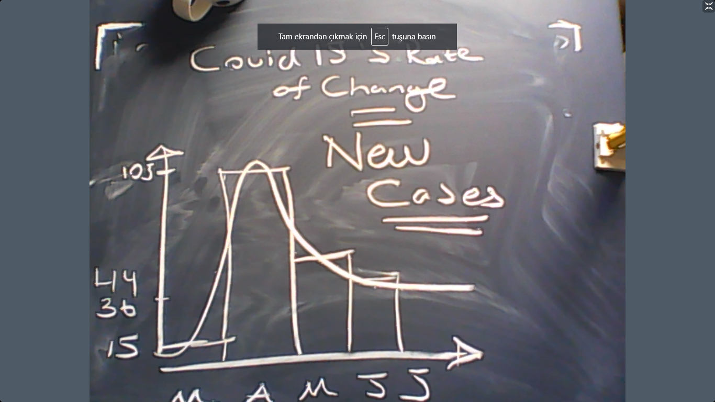

Example: Suppose that $y=x^{2}$. What is $y^{'}\left(x\right)$?
Solution:
$$\lim_{Δx→0}{\frac{f\left(x+Δx\right)-f(x)}{Δx}}=\lim_{Δx→0}{\frac{{\left(x+Δx\right)}^{2}-{\left(x\right)}^{2}}{Δx}}=\lim_{Δx→0}{\frac{{x^{2}+2xΔx+\left(Δx\right)}^{2}-{\left(x\right)}^{2}}{Δx}}==\lim_{Δx→0}{\frac{{2xΔx+\left(Δx\right)}^{2}}{Δx}}=\lim_{Δx→0}{\frac{2xΔx}{Δx}}+\lim_{Δx→0}{\frac{{\left(Δx\right)}^{2}}{Δx}}=2x+0=2x.$$
Example: Suppose that $y=x^{1/2}$. What is $y^{'}\left(x\right)$?
$$\lim_{Δx→0}{\frac{f\left(x+Δx\right)-f\left(x\right)}{Δx}}=\lim_{Δx→0}{\frac{{\left(x+Δx\right)}^{\frac{1}{2}}-{\left(x\right)}^{\frac{1}{2}}}{Δx}}=\lim_{Δx→0}{\frac{{\left(x+Δx\right)}^{\frac{1}{2}}-{\left(x\right)}^{\frac{1}{2}}}{Δx}}\frac{{\left(x+Δx\right)}^{\frac{1}{2}}+{\left(x\right)}^{\frac{1}{2}}}{{\left(x+Δx\right)}^{\frac{1}{2}}+{\left(x\right)}^{\frac{1}{2}}}=\lim_{Δx→0}{\frac{{\left(x+Δx\right)}^{1}-{\left(x\right)}^{1}}{Δx}}\frac{1}{{\left(x+Δx\right)}^{\frac{1}{2}}+{\left(x\right)}^{\frac{1}{2}}}=$$
$$\lim_{Δx→0}{\frac{1}{{\left(x+Δx\right)}^{1/2}+{\left(x\right)}^{1/2}}}=\frac{1}{2{\left(x\right)}^{1/2}}.$$

Some derivative rules: Suppose that $f\left(x\right)$ and $h\left(x\right)$ are two functions.

- Chain rule: $(f{\left(h\left(x\right)\right))}^{'}=f^{'}×h'$
- Multiplication rule: $(f{\left(x\right)×h\left(x\right))}^{'}=f^{'}×h+f×h^{'}.$
- Division rule: $(f{\left(x\right)/h\left(x\right))}^{'}=\frac{f^{'}}{h}-\frac{fh^{'}}{h^{2}}=\frac{f^{'}h-fh^{'}}{h^{2}}$
- Addition rule: $(f{\left(x\right)+h\left(x\right))}^{'}=f^{'}+h'$.
- Power rule: ${\left(x^{a}\right)}^{'}=ax^{a-1}.$
- Exponential rule: ${\left(e^{x}\right)}^{'}=e^{x}$
- Exponential rule (generalized): ${\left(e^{f(x)}\right)}^{'}=f'e^{f(x)}$
- Logarithmic rule: ${\left(lnx\right)}^{'}=\frac{1}{x}.$
- Logarithmic rule (generalized): ${\left(lnf(x)\right)}^{'}=\frac{f'}{f}.$
Now let us see the slope interpretation of the derivative:
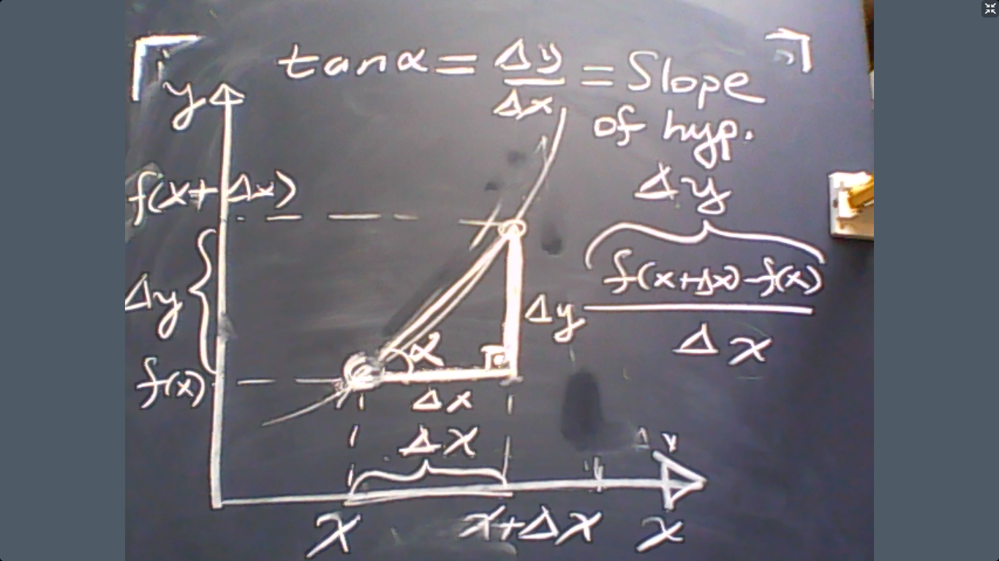
In this graphical example, we see that the slope of the hypothomes is approximately equal to the derivative of $y$ at the point $x$. If we take the limit as $Δx→0$, then they would be identical in the limit.
Now let us see a more economically interesting example:
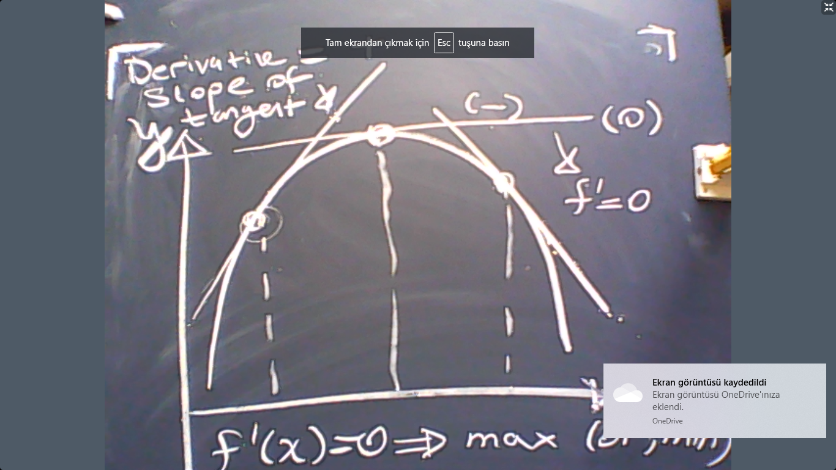

This gives us a very helpful tool to analyze optimization problems. In particular, if we want to solve a maximization problem:
$$\max{f\left(x\right)}$$
then we should solve $f^{'}\left(x\right)=0.$ In the multivariate case, the problem becomes:
$$\max{f\left(x_{1},x_{2}\right)}$$
then we should solve
$$\frac{df\left(x_{1},x_{2}\right)}{dx_{1}}=0$$
$$\frac{df\left(x_{1},x_{2}\right)}{dx_{2}}=0.$$
This is called “unconstrained optimization”.
Example: Suppose that a firm uses $L$ (labor) to produce $Q(L)=L^{1/2}.$ The hourly wage of $L$ is$w$, and the product is sold at price $p=1$. The firm takes wages as given but chooses $L$ freely. So the profit of the firm is
$$π=Q\left(L\right)-wL=Revenue-Cost.$$
Let us maximize $π$ with respect to $L$ by solving
$$\frac{dπ}{dL}=Q^{'}-w=0.$$
(Why? Because maximizing any function requires taking the derivative and equating it to zero).
The result would be
$$Q^{'}=w.$$
Note that $Q^{'}=\frac{1}{2L^{\frac{1}{2}}}$. This means
$$\frac{1}{2L^{\frac{1}{2}}}=w.$$
Therefore,
$$L^{*}=\frac{1}{4w^{2}}.$$
This is called “labor demand” which means the level of employment that would maximize profits as a function of wages. Hence,
$$\frac{dL^{*}}{dw}=-0.5 w^{-3}<0.$$
This means “wages decrease labor demand”. This result has serious political implications. For example, governments typically refrain from legislating higher minimum wage laws, fearing that high wages would decrease employment.
Constrained Optimization
In most of the economic problems, the optimization problem involves a constrained. Let us see the standard utility maximization example.
Consider an individual whose utility from consuming $(x,y)$ consumption bundles is given by
$$u\left(x,y\right).$$
The price of $x$ is $p_{x}$ and the price of $y$ is $p_{y}$. Therefore, the expenditure for consuming the bundle $\left(x,y\right)$ is equal to
$$Expenditure=p_{x}x+p_{y}y.$$
Let us suppose that the income of the individual is $I>0$. So the individual solves
$$\max{u\left(x,y\right)}$$
s.t
$$p_{x}x+p_{y}y=I.$$
The constraint tells us that “Income=Expenditure”. Now how can we solve this problem?
Method 1 (Substitution): Note that, due to the budget constraint,
$$x(y)=\frac{I-p_{y}y}{p_{x}}.$$
Plug this into the utility function to obtain:
$$f\left(y\right)=u\left(x(y),y\right)=u\left(\frac{I-p_{y}y}{p_{x}},y\right).$$
Therefore, we can solve the utility maximization problem by simply maximizing $f(y)$ with respect to $y$. To do so, we should solve
$$f'\left(y\right)=0.$$

But how can we calculate $f'$?
$$f^{'}=-\frac{p_{y}}{p_{x}}×\frac{du}{dx}+\frac{du}{dy}=0$$
Re-arrange the terms on the right-hand side:
$$\frac{du}{dy}=\frac{p_{y}}{p_{x}}×\frac{du}{dx}$$
$$MU_{y}=\frac{p_{y}}{p_{x}}×MU_{x}$$
$$\frac{MU_{y}}{MU_{x}}=\frac{p_{y}}{p_{x}}$$
$$MRS_{y,x}=\frac{p_{y}}{p_{x}}.$$
If we combine this equation with the budget constraint, we get
$$p_{x}x+p_{y}y=I$$
$$MRS_{y,x}=\frac{p_{y}}{p_{x}}.$$

This box gives us 2 equations to solve for two variables $\left(x,y\right).$ The result would be utility maximizing level of consumption.

$$L=u\left(x,y\right)+λ\left(I-p_{x}x-p_{y}y\right).$$

$$\frac{dL}{dx}=\frac{du}{dx}-λp_{x}=0$$
$$\frac{dL}{dy}=\frac{du}{dy}-λp_{y}=0$$
$$\frac{dL}{dλ}=I-p_{x}x-p_{y}y=0$$
We solve this system by choosing $\left(x,y,λ\right).$ Now we can observe

$$MU_{x}-λp_{x}=0$$
$$MU_{y}-λp_{y}=0$$
$$I-p_{x}x-p_{y}y=0$$
Consider the first two equations, we yield (after substituting for $λ$)
$$\frac{MU_{y}}{MU_{x}}=\frac{p_{y}}{p_{x}}.$$
So these three equations boil down to two equations:
$$I-p_{x}x-p_{y}y=0$$
$$\frac{MU_{y}}{MU_{x}}=\frac{p_{y}}{p_{x}}.$$
But these two equations are identical to the box above because
$$MRS_{y,x}=\frac{MU_{y}}{MU_{x}}.$$
Example: Suppose that $u=x×y$ and $p_{x}=2$ and $p_{y}=4$ and $I=16.$ Under these conditions “the box” simplifies to

$$2x+4y=16$$
$$\frac{x}{y}=\frac{4}{2}.$$

The solution is $\left(x^{*},y^{*}\right)=\left(4,2\right).$
That is the end of the lesson.

