Cost
Consider a firm which has the production technology
$$Y=F\left(K,L\right).$$
If the price of $\left(K,L\right)$ are $(r,w)$, then the cost of using $\left(K,L\right)$ as inputs would be
$$rK+wL.$$
The firm, we assume, behave optimally which means it minimizes the cost of production:
$$\min\left(rK+wL\right)$$
s.t.
$$Y=F\left(K,L\right).$$
where $(Y,w,r)$ and technology is given. The firm only chooses $\left(K,L\right).$ If the solution is
$$K^{*}\left(Y,w,r\right) and L^{*}(Y,w,r)$$
then the total cost, or cost of production, or (simply) cost is
$$C\left(Y\right)= rK^{*}\left(Y\right)+wL^{*}\left(Y\right).$$
In that case,
$$MC=\frac{dC}{dY}.$$
Example: Suppose that the production technology is Cobb-Douglas:
$$Y={\left(KL\right)}^{1/2}.$$
Let us solve the cost minimization:$$\min\left(rK+wL\right)$$
s.t.
$$Y={\left(KL\right)}^{1/2}.$$
An easy way to solve this problem is to observe that
$$\frac{Y^{2}}{K}=L.$$
Therefore, the cost is
$$\left(rK+w\frac{Y^{2}}{K}\right).$$
To minimize this expression with respect to $K$, differentiate with respect to $K$ to see
$$r-w\frac{Y^{2}}{K^{2}}=0.$$
Conclude
$$K^{*}=Y×{\left(\frac{w}{r}\right)}^{1/2}.$$
So the cost is
$$C\left(Y\right)=2Y$$
assuming $r=w=1$. The marginal cost is the derivative of $C$:
$$\frac{dC}{dY}=2.$$
In general, the geometry of the cost function and the technology are related as follows:
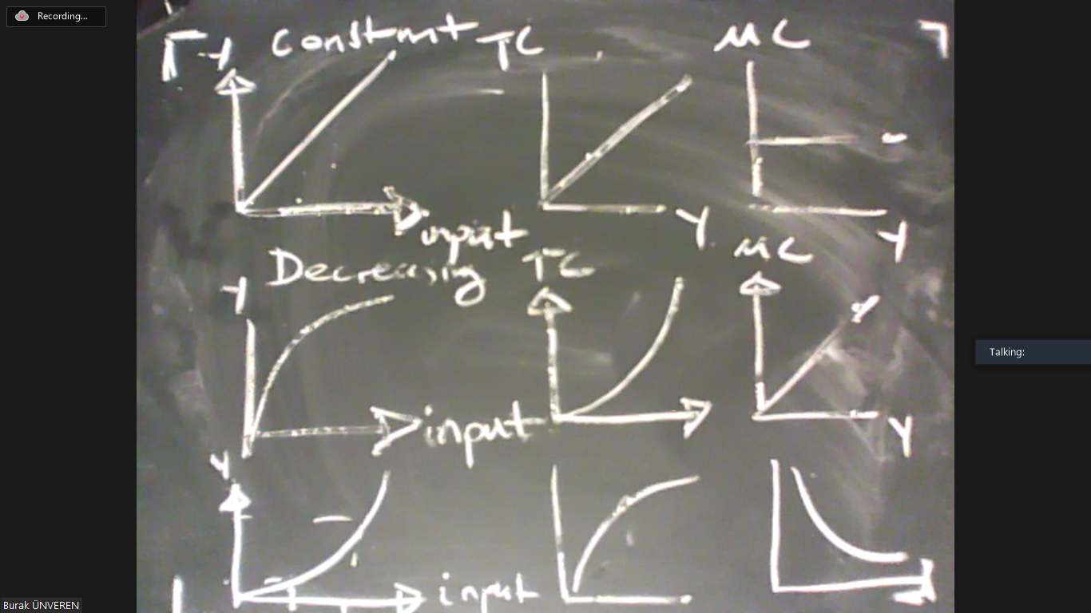

Theorem: MC is increasing/constant/decreasing if and only if the technology exhibits decreasing/constant/increasing returns to scale.
This is relevant as the marginal cost is actually the supply curve in competitive markets. In particular, the profit maximization problem can be stated as
$$Π=P×Y-C(Y)$$
where $C\left(Y\right)$ is the total cost. This is equivalent to
$$Π=P×Y-R×K-W×L$$
where $Y=F\left(K,L\right).$ To maximize the first expression, we solve
$$\frac{dΠ}{dY}=P-\frac{dC}{dY}=0.$$
In other words, if the competitive firm maximizes its profit, then
$$P=MC.$$
However, the supply curve is “how much the firm would produce to maximize its profit at any given price”. Therefore, $P=MC$ is the supply curve.
Example: Suppose that $C\left(Y\right)=Y^{2}.$ Then the profit maximization rule tells us
$$P=MC=2Y.$$
So the relation $P=2Y$ tells us how much output would maximize profit at any given price.

So we have seen thus far that technology is pivotal to income distribution and the determination of value. Next week we will see that technology also determines the economic growth.

