Production
Technology is the relationship between output and input. In particular, technology tells us how much output can be produced by a certain amount of inputs. In economics, this relationship is represented by a production function
$$Y=F(X_{1},…X_{n})$$
where $(X_{1},…X_{n})$ is a vector of inputs (e.g. labor, capital, energy, etc.) and $Y$ is the level of output. Here we interpret $F$ as the technology and call it the “production function”.
Example: The Leontief production function is
$$Y=\min{\{a_{1}X_{1},…,a_{n}X_{n}\}}.$$
In this formulation, all inputs are complementary.
Example: The linear production function is
$$Y=a_{1}X_{1}+…+a_{n}X_{n}.$$
In this formulation, all inputs are substitutes.
If we consider substitutes and complements as two polar cases, then Cobb-Douglas technology is the exact intermediate case.
Example: The Cobb-Douglas production function is
$$Y=X_{1}^{a_{1}}….X_{n}^{a_{n}}.$$
where $a_{1}+…+a_{n}=1$
In this formulation, all inputs are neither substitutes nor complements.
All these well-known production technologies are actually special cases of a more general production technology:
Definition: If the production function is “constant elasticity of substitution” (CES) type, then
$$Y={\left({\left(a_{1}X_{1}\right)}^{ρ}+…+{\left(a_{n}X_{n}\right)}^{ρ}\right)}^{1/ρ}$$
where $ρ≤1$ is a constant parameter. We interpret
$$σ=\frac{1}{1-ρ}$$
as the “elasticity of substitution”.
Moreover, $a_{i}$ is the factor-augmenting technology term for the input $X_{i}$.
Theorem: If the production technology is of the CES type then the technology satisfies the following properties:
- As $ρ→1$, the technology converges to the linear technology.
- As $ρ→-∞$, the technology converges to the Leontief technology.
- As $ρ→0$, the technology converges to the Cobb-Douglas technology.

The CES formulation is typically used in the context of labor vs. capital or high vs. low skilled labor. For example,
$$Y={\left({\left(a_{1}K\right)}^{ρ}+{\left(a_{2}L\right)}^{ρ}\right)}^{1/ρ}.$$
Another example is
$$Y={\left({\left(a_{1}H\right)}^{ρ}+{\left(a_{2}L\right)}^{ρ}\right)}^{1/ρ}.$$
where $H$ is the high-skilled labor and $L$ is the low-skilled labor.
Now consider a firm which has the production technology above:
$$Y={\left({\left(a_{1}H\right)}^{ρ}+{\left(a_{2}L\right)}^{ρ}\right)}^{1/ρ}$$
and its profit is given by
$$Π=Y-w_{H}H-w_{L}L.$$
To maximize the profit, the firm solves
$$\frac{dΠ}{dH}=\frac{1}{ρ}{\left({\left(a_{1}H\right)}^{ρ}+{\left(a_{2}L\right)}^{ρ}\right)}^{\frac{1}{ρ}-1}ρ{\left(a_{1}H\right)}^{ρ-1}a_{1}-w_{H}=0$$
$$\frac{dΠ}{dL}=\frac{1}{ρ}{\left({\left(a_{1}H\right)}^{ρ}+{\left(a_{2}L\right)}^{ρ}\right)}^{\frac{1}{ρ}-1}ρ{\left(a_{2}L\right)}^{ρ-1}a_{2}-w_{L}=0.$$
Let us take the ratios of wages to obtain
$$\frac{w_{H}}{w_{L}}=\frac{\frac{1}{ρ}{\left({\left(a_{1}H\right)}^{ρ}+{\left(a_{2}L\right)}^{ρ}\right)}^{\frac{1}{ρ}-1}ρ{\left(a_{1}H\right)}^{ρ-1}a_{1}}{\frac{1}{ρ}{\left({\left(a_{1}H\right)}^{ρ}+{\left(a_{2}L\right)}^{ρ}\right)}^{\frac{1}{ρ}-1}ρ{\left(a_{2}L\right)}^{ρ-1}a_{2}}=\frac{{\left(a_{1}H\right)}^{ρ-1}a_{1}}{{\left(a_{2}L\right)}^{ρ-1}a_{2}}=\frac{{\left(a_{1}\right)}^{ρ}{\left(H\right)}^{ρ-1}}{{{\left(a_{2}\right)}^{ρ}\left(L\right)}^{ρ-1}}.$$
In general, elasticity of substitution is
$$\frac{d\ln{(H/L)}}{d\ln{(w_{H}/w_{L})}}.$$
To calculate the elasticity of substitution, note that
$$\ln{(w_{H}/w_{L})}=ρ\ln{(a_{1}/a_{2}})-\left(1-ρ\right)\ln\left(\frac{H}{L}\right).$$
Therefore,
$$\frac{d\ln{(w_{H}/w_{L})}}{d \ln{(H/L)}}=-\left(1-ρ\right)=-\frac{1}{σ}$$
which means the elasticity of substitution is
$$\frac{d\ln{(H/L)}}{d\ln{(w_{H}/w_{L})}}=-σ.$$
Note that $-1/σ$ is the percentage change in relative wages when there is a 1% change in relative labor supply. Interestingly this value is equal to
$$-\left(1-ρ\right)≤0$$
because $ρ≤1.$ The impact of technology on relative wages is given by
$$\frac{d\ln{(w_{H}/w_{L})}}{d \ln{(a_{1}/a_{2})}}=ρ.$$
However, $ρ=1$ at perfect substitutes and $ρ=0$ at Cobb-Douglas and $ρ→-∞$ at Leontief technologies. This means that the sign of the impact of technology on relative wages depend on substitubility between $H$ and $L$.
Moreover, the income share of $H$ workers can be calculated as
$$Σ_{H}=\frac{w_{H}H}{Y}=\frac{\frac{1}{ρ}{\left({\left(a_{1}H\right)}^{ρ}+{\left(a_{2}L\right)}^{ρ}\right)}^{\frac{1}{ρ}-1}ρ{\left(a_{1}H\right)}^{ρ-1}a_{1}H}{{\left({\left(a_{1}H\right)}^{ρ}+{\left(a_{2}L\right)}^{ρ}\right)}^{\frac{1}{ρ}}}=Y^{-ρ}{\left(a_{1}\right)}^{ρ}H^{ρ}={\left(\frac{a_{1}H}{Y}\right)}^{ρ}$$
By the same token,
$$Σ_{L}=\frac{w_{L}L}{Y}={\left(\frac{a_{2}L}{Y}\right)}^{ρ}.$$
Let us define $Y/H$ as the “average productivity of $H$”.
If the average productivity of $H$ increases, does $Σ_{H}$ also increase? It depends on $ρ.$ Finally note that
$$Σ_{H}+Σ_{L}={\left(\frac{a_{1}H}{Y}\right)}^{ρ}+{\left(\frac{a_{2}L}{Y}\right)}^{ρ}=\frac{{\left(a_{1}H\right)}^{ρ}+{\left(a_{2}L\right)}^{ρ}}{Y^{ρ}}=\frac{Y^{ρ}}{Y^{ρ}}=1.$$

So the profit is zero. The reason behind result is constant returns to scale:
$$λY=F(λX_{1},…,{λX}_{n})$$
if $Y=F(X_{1},…,X_{n})$. The CES technology satisfies this property: scaling up all inputs by a constant factor increases the output by the same factor.
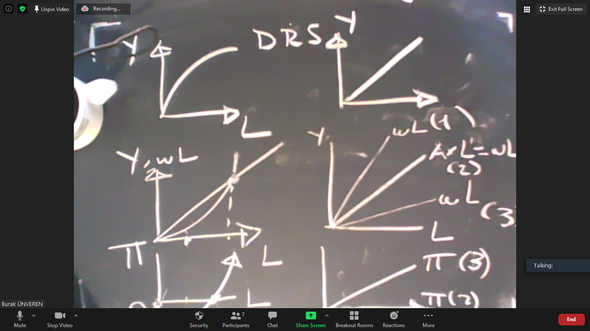

Going back to the discussion on wage inequality (i.e. college premium) and technological change, Acemoğlu estimates
$$\ln\left(\frac{w_{H}}{w_{L}}\right)=ρ\ln{(a_{1}/a_{2}})-\left(1-ρ\right)\ln\left(\frac{H}{L}\right)$$
this linear model by using the following econometric model:
$$\ln\left(\frac{w_{H}}{w_{L}}\right)=γ_{0}+γ_{1}t+γ_{2}\ln\left(\frac{H}{L}\right) +ϵ.$$
after assuming that $a_{i}$ grows at a constant rate. According to this formulation
$$a_{i}=e^{tg_{i}}.$$
Therefore, $g_{1}-g_{2}=γ_{1}$. This means
$$\ln{(a_{1}/a_{2}})=\ln{\frac{e^{tg_{1}}}{e^{tg_{2}}}=}\ln{\frac{e^{t(g_{1}-g_{2)}}}{1}=}t×\left(g_{1}-g_{2}\right).$$
The estimation results show that
$$γ_{2}=-0.71$$
which means $ρ=0.29$ so $H$ and $L$ are substitutes. Moreover, $γ_{1}=0.033$ which means the growth rate of the $H-$augmenting technological change is 3.3% per annum.

