Worker vs. Boss Game
Consider a production unit where a worker produces $a$ amounts of output if she works hard. In that case, the cost of hard-work is normalized to 1. However, she can avoid the cost of hard-work by shirking. In that case, the output is $0$ but so is the disutility of working.
The boss can audit the worker with a cost of $c>0$. If the worker is caught while shirking, she would be fired, in which case the wage is $0$. In all other cases, the wage is $w>1.$Now let us represent this interaction using a game matrix: Worker has two strategies (Shirk, Work) and Boss has two strategies (Audit, No audit).
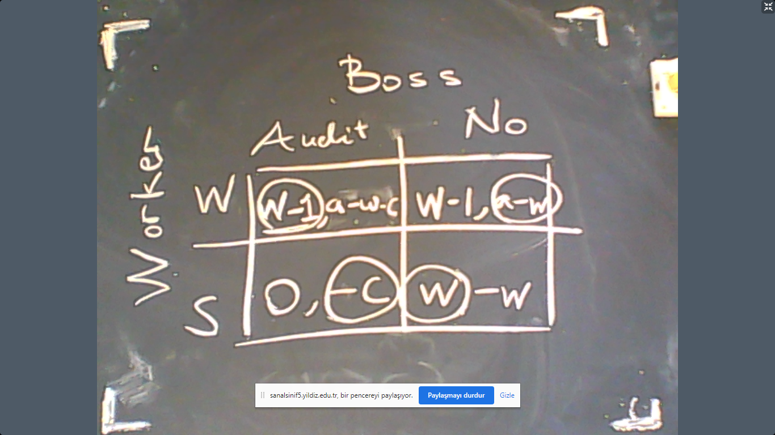

As we can see above, there is no Nash equilibrium. So let us analyze the interaction using mixed-strategies. Let the probability of working hard for Worker is $p$ and the probability of auditing for Boss is $q$. In this case, the expected utility of the worker is
$$EU_{w}=pq\left(w-1\right)+p\left(1-q\right)\left(w-1\right)+\left(1-p\right)q0+\left(1-q\right)\left(1-p\right)w.$$
As for Boss, we have
$$EU_{B}=pq\left(a-w-c\right)+p\left(1-q\right)\left(a-w\right)+\left(1-p\right)q\left(-c\right)+\left(1-q\right)\left(1-p\right)\left(-w\right).$$
Now we should calculate
$$\frac{dEU_{w}}{dp}=0 and \frac{dEU_{B}}{dp}=0.$$
The results are
$$\frac{dEU_{w}}{dp}=q\left(w-1\right)+\left(1-q\right)\left(w-1\right)-\left(1-q\right)w=0.$$
This implies
$$\left(w-1\right)=\left(1-q\right)w.$$
Therefore,
$$q^{*}=\frac{1}{w}.$$
This means, the audit probability decreases with wage.
$$\frac{dEU_{B}}{dq}=p\left(a-w-c\right)-p\left(a-w\right)+\left(1-p\right)\left(-c\right)+\left(1-p\right)w=0.$$
This implies that
$$-c+\left(1-p\right)w=0.$$
The equilibrium probability of hard-work is therefore
$$p^{*}=\frac{w-c}{w}.$$
(It is interesting to see that $w>1$ and $w>c$ are necessary and sufficient for equilibrium probabilities to be between 0 and 1.)
This means that the probability of shirking is
$$1-p^{*}=1-\frac{w-c}{w}=\frac{c}{w}.$$
As a consequence, the probability of getting laid-off (being fired) is
$$q^{*}×\left(1-p^{*}\right)=\frac{c}{w^{2}}.$$
This is also the frequency of unemployment for each worker. This means that the higher wages would decrease unemployment. The intuition is that higher wages motivate hard-work as the worker is discouraged by the probability of getting laid-off. As the worker chooses not to shirk, this discourages the boss to audit the worker because audit is costly. The end result is that higher wages reduces the probability of the case in which worker shirks and the boss audits.
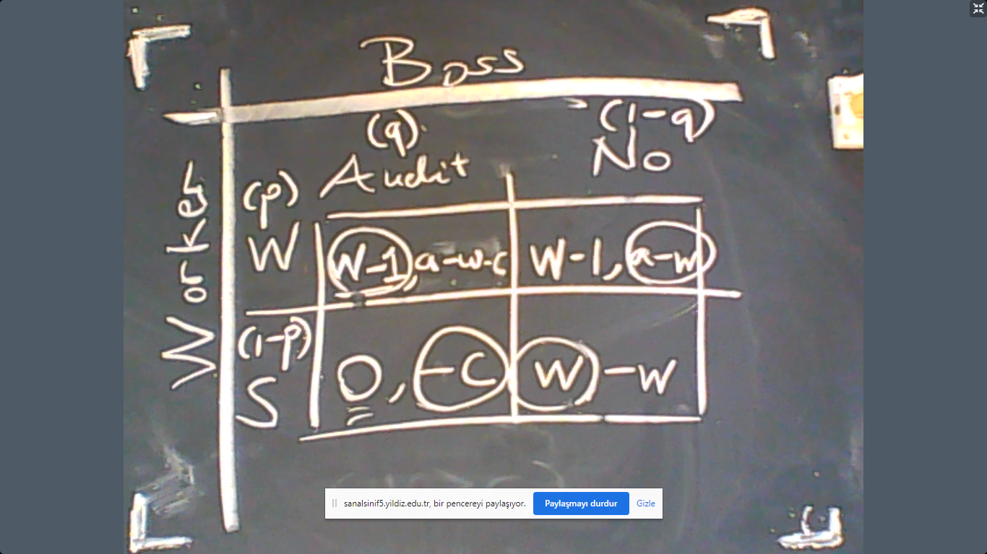
A pandemic and a test to developed to find patients
Suppose that there is a disease caught by 0.3% of the society. The medical test to detect any patient has an accuracy rate of 98%. This means if a sick person takes the test, her disease would be confirmed with a probability of 98%. And if she is not sick, the test result is negative with 98%, again.

Suppose that you take the test your result is positive which means you are sick. What is the probability that you are actually sick?

Answer: The answer is not 98%. Not even close. It is far lower.
First, who will get a positive result. First of all, 98% of all sick people. Who else? The 2% of the healthy people, 99.7%. So the total ratio of people with positive results is
$$0.003×0.98+0.997×0.02=Sick people told that they are sick+healthy people told that they re sick.$$
The actual ratio of sick people is $0.003.$ Therefore, if your test is positive, then the probability that you are sick is
$$\frac{0.003}{0.003×0.98+0.997×0.02}.$$
The numerical value is 15%.
The reason why the actual probability is so low (compared to 98%) is that 2% of the healthy people (99.7%) is very large compared to all sick people which is 0.3%. So the healthy people with wrong test results are very common. That is the reason why probably you are not sick.
But why do we tend to think that the probability is 98%? That is because we make the error of assuming
$$P\left(A | B\right)=P(B|A)$$
where $A=$You are sick and $B=$Your test result says you are sick. The correct relation is
$$P\left(A | B\right)=P\left(B | A\right)×\frac{P\left(A\right)}{P(B)}.$$
This is called the Bayes’ Rule. Recall that
$$P\left(B\right)=P\left(B | A\right)P\left(A\right)+P\left(B | not A\right)P\left(not A\right).$$
For example, in the pandemic example,
$$P\left(B\right)=0.98×0.003+0.02×0.997.$$

Adverse Selection
Our next subject is game-theoretical interaction with incomplete information. We say that there is adverse selection if the parametric features of other players are uncertain. If there is uncertainty with regards to the strategies of other players, this is called moral hazard. The most classic application of adverse selection is the private health insurance market where insurance companies cannot perfectly observe the health status of their potential customers.
To analyze these types of information problems, let us first recall probability density functions, their geometry, and related calculations. The simplest case would be “uniform disrtribution” over a certain range $[a,b]$. The uniform distribution means any event has equal probabilities. Let us visually see this.
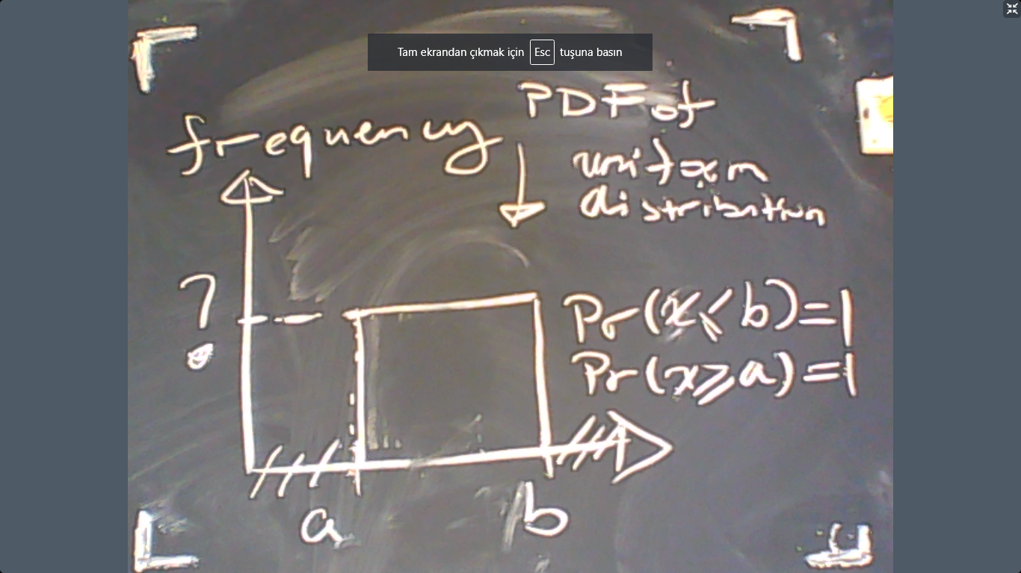

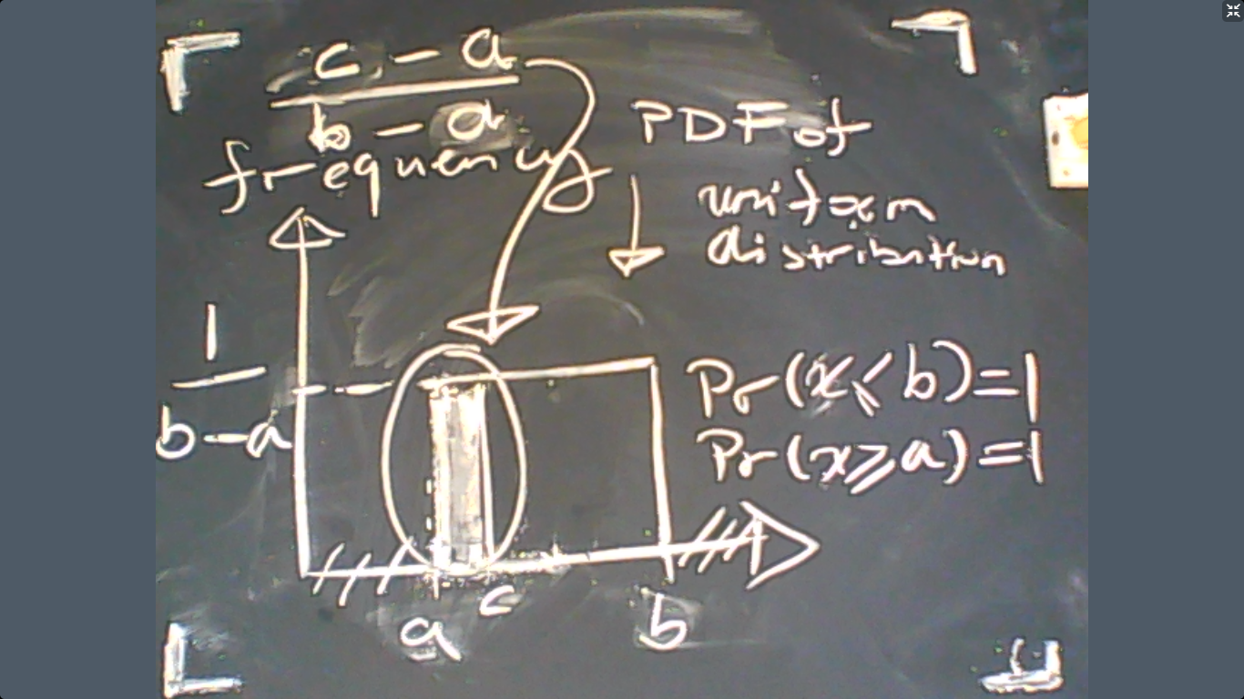

Therefore, the frequency of the uniform distribution is
$$f\left(c\right)=\frac{1}{b-a}.$$
The probability that a random uniformly distributed variable is no higher than $c$ is
$$\operatorname{Pr}\left[x≤c\right]=\int_{a}^{c}{f(x)dx}=\int_{a}^{c}{\frac{1}{b-a}dx={\left.\frac{x}{b-a}\right|}_{x=a}^{x=c}}=\frac{c-a}{b-a}.$$
For example, this means if $a=0$ and $b=1$ then
$$\operatorname{Pr}\left[x<\frac{1}{3}\right]=\frac{1}{3}.$$
What about the conditional expectation? That is, for example,
$$\operatorname{Pr}\left[x<\frac{1}{3}|x<\frac{1}{2}\right].$$
In general, how can we calculate the following expression?
$$\operatorname{Pr}\left[x<c|x<d\right].$$

