Budget Constraint
An individual, of course, would choose $(x,y)$ to satisfy her preferences $u\left(x,y\right).$ But the consumer could only choose a bundle $(x,y)$ that she could afford. This means
$$Income=Expenditure.$$
Let us denote the level of income with $I>0$. We assume that the individual earns a positive fixed amount of income. If the price of $x$ is $p_{x}$ and yhe price of $y$ is $p_{y}$, then the expenditure would be
$$p_{x}x+p_{y}y.$$
Therefore, bundles that the individual could afford are given by
$$I=p_{x}x+p_{y}y.$$
This is called the budget constraint. Now let us graphically analyze the budget constraint:
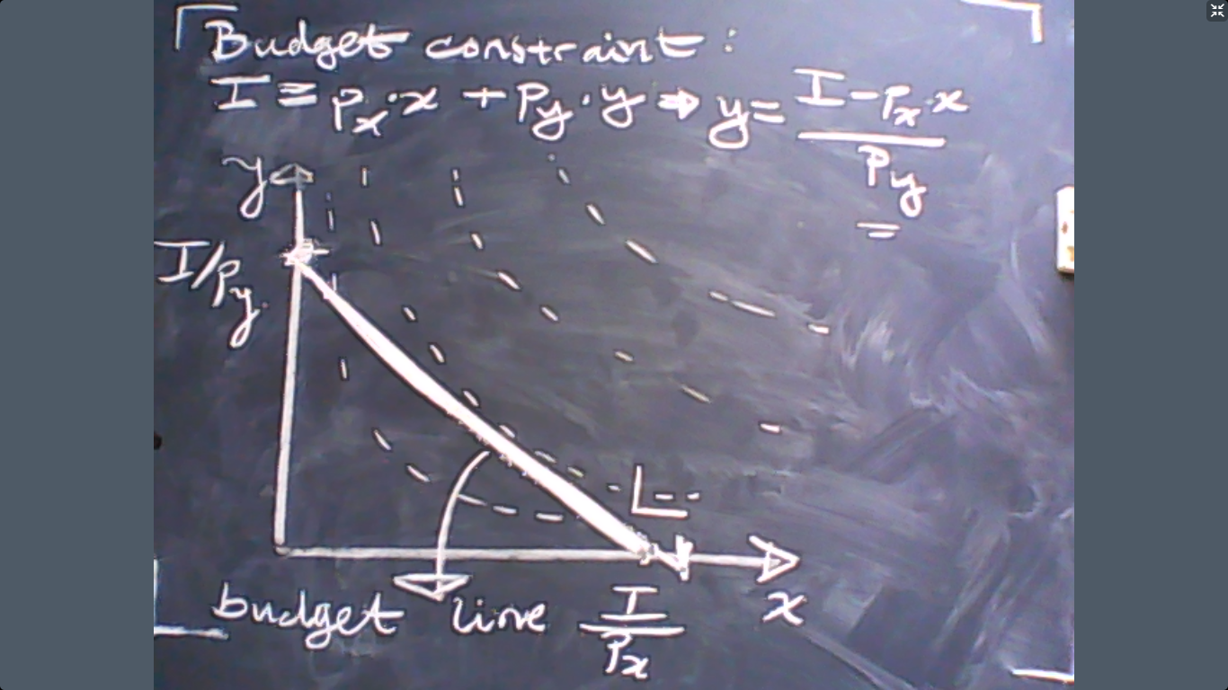
Now we can also analyze how the budget line would respond to changes in prices and income. So let us do that now:
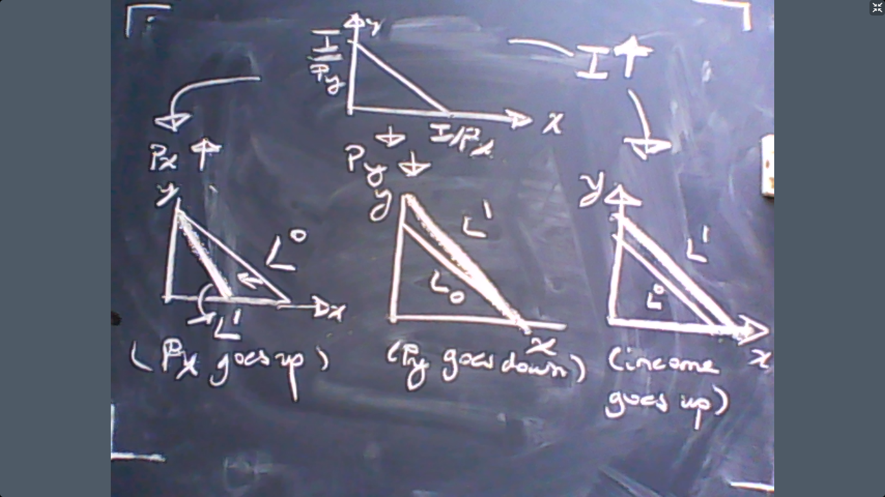

Now we know what the consumer likes, $u(x,y)$. We also know what the consumer can afford, the budget line. Now we assume that the consumer would choose $\left(x,y\right)$ that she can afford to achieve the highest utility. This assumption can be stated as:

$$\max{u\left(x,y\right)}$$
Subject to
$$I=p_{x}x+p_{y}y.$$

This is our assumption of individual behavior: maximizing utility subject to the budget constraint. This assumption is central to microeconomic analysis so we will spend some time on how to solve this problem and what the implications are.
Let us now see how to solve the utility maximization problem. The first solution method is the graphical solution.
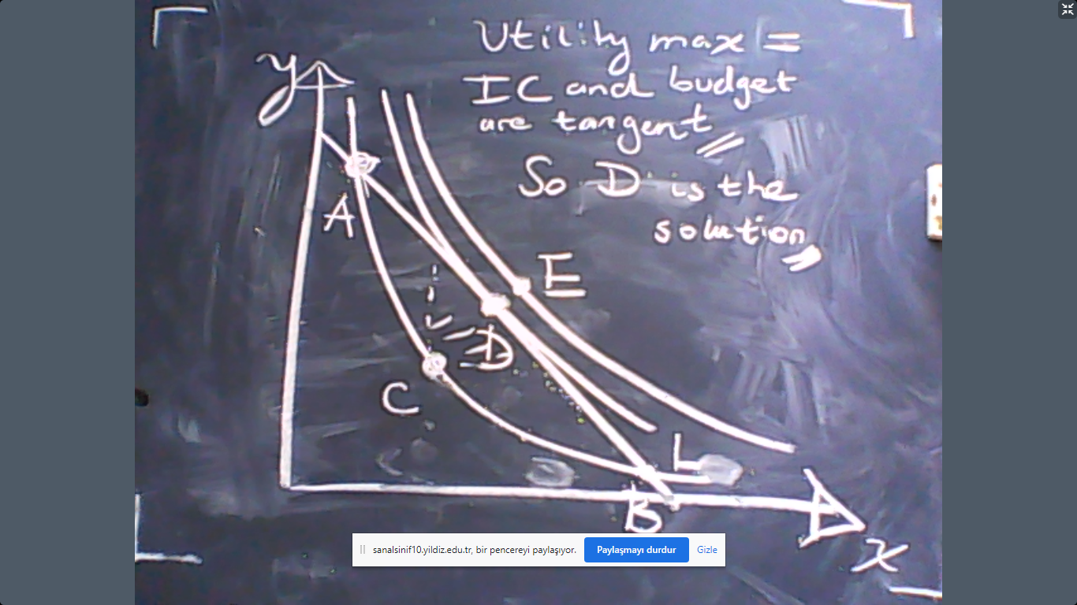

The graphical approach shows that the utility maximization means the slope of the indifference curve is equal to the slope of the budget constraint.
Now let us see how we can solve the utility maximization problem using mathematics. First, let us recall our problem:
$$\max{u\left(x,y\right)}$$
Subject to
$$I=p_{x}x+p_{y}y.$$
Now observe that the budget constraint implies
$$\frac{I-p_{x}x}{p_{y}}=y.$$
This means that we can substitute for $y$ in the utility:
$$u\left(x,\frac{I-p_{x}x}{p_{y}}\right).$$
So all is represented in a single function: there is a single variable $x$ and there is no separate budget constraint. How do we maximize a function of a single variable without any constraint?
We should take the derivative and equate it to zero to solve for the maximum of the function. The derivative of
$$u\left(x,\frac{I-p_{x}x}{p_{y}}\right)$$
is, by the total derivative rule, is
$$\frac{du}{dx}+\frac{du}{dy}×\left(\frac{dy}{dx}\right)=0.$$
But
$$\frac{dy}{dx}=-\frac{p_{x}}{p_{y}}.$$
This means that our equation is now
$$\frac{du}{dx}-\frac{du}{dy}×\frac{p_{x}}{p_{y}}=0.$$
But this equation can be stated as
$$MU_{x}-MU_{y}\frac{p_{x}}{p_{y}}=0.$$
Re-arrange the terms to obtain
$$\frac{MU_{x}}{MU_{y}}=\frac{p_{x}}{p_{y}}.$$
In other words,
$$MRS_{x,y}=\frac{p_{x}}{p_{y}}.$$
This means, “if you want to maximize utility, then the value you attribute to $x$ in terms of $y$ should be equalt to the market value of $x$ in terms of $y$.”
This means the solution to the box is given by two equations:
$$MRS_{x,y}=\frac{p_{x}}{p_{y}}$$
$$I=p_{x}x+p_{y}y.$$

This is known as the MRS rule. Now let us try to understand why $MRS=\frac{p_{x}}{p_{y}}$ should hold. Suppose not. Suppose that you pick a bundle where Income=Expenditure but
$$MRS>\frac{p_{x}}{p_{y}}.$$
Example: Let us make it more concrete. Assume $p_{x}=p_{y}=1$ but $MRS=\frac{MU_{x}}{MU_{y}}=\frac{20}{10}.$ In this case, there is an alternative bundle that the individual can afford and this alternative could make the individual better off.
To see this, first observe that $MRS>\frac{p_{x}}{p_{y}}$ implies that the consumer picked too much of $y$ and too little of $x$. Why? If she consumes an extra unit of $x$ her utility would rise by $MU_{x}=20.$ But this would cost her more than her income. So she should reduce $y$ by 1 unit because $x and y$ have the same prices. This would reduce her utility by $MU_{y}=10.$ The total net effect would
$$Extra x+Losty=MU_{x}-MU_{y}=20-10=10>0.$$
This shows that the individual can improve her utility if she does not choose $\left(x,y\right)$ to ensure that
$$MRS=\frac{p_{x}}{p_{y}}.$$
We can see this mechanism in visual terms as well:
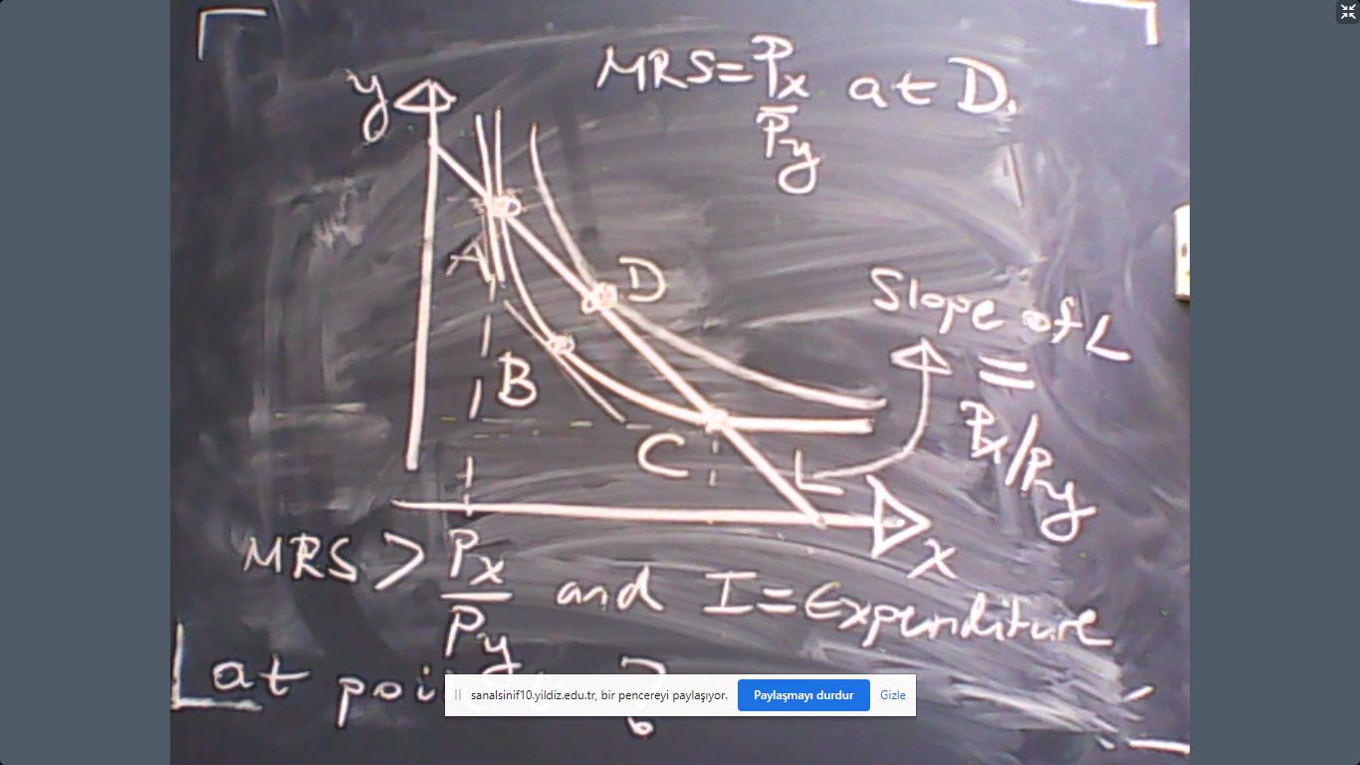
As we can see above, the marginal rate of substitution between x and y is higher than the relative prices at point A, which implies that point A cannot maximize utility. Indeed, any utility maximization would require more consumption of good x relative to point A. For example, simply consider point D where utility is maximized.
Example: Suppose that
$$u=x×y$$
and prices are $p_{x}=p_{y}=1$ and income is $I=100$. Solve the utility maximization problem.
Answer: We need to use the MRS rule to solve the problem. The marginal utilities are
$$MU_{x}=\frac{du}{dx}=y$$
$$MU_{y}=\frac{du}{dy}=x.$$
The marginal rate of substitution is
$$\frac{MU_{x}}{MU_{y}}=\frac{y}{x}.$$
In order to maximize utility, MRS=px/py must hold. This means
$$\frac{y}{x}=1.$$
In other words, $y=x$. Put this into the budget constraint
$$y+x=100$$
to obtain
$$2y=2x=100.$$
So the consumption bundle that would maximize utility would be
$$\left(x,y\right)=\left(50,50\right).$$
Example: In this example, we will see how to use the graphical method to solve the utility maximization problem. Suppose that you are an employee of Google in Seattle. Your major expenditures are housing and food. Google offers you another position in London, where food is cheaper but housing is more expensive. To convince you to go to London, Google would offer you a a higher wage which would allow you to buy what you are already consuming in Seattle. Is Google offering you too much or too little or exactly right?
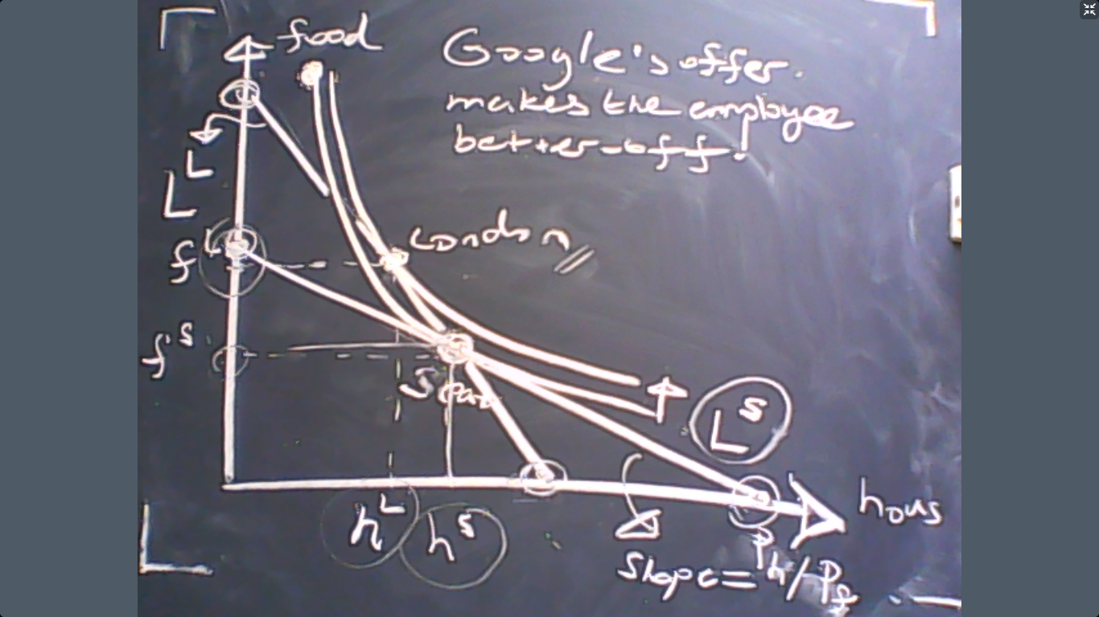
The graph above shows that Google offers more than necessary to convince you to go to London.

Ex: In this example, we will see how to use the mathematical solution techniques. Suppose that
$$u=x×y$$
and prices are $p_{x}$ and $p_{y}$ and income $I$. Solve the utility maximization problem.
Answer: We need to use the MRS rule to solve the problem. The marginal utilities are
$$MU_{x}=\frac{du}{dx}=y$$
$$MU_{y}=\frac{du}{dy}=x.$$
The marginal rate of substitution is
$$\frac{MU_{x}}{MU_{y}}=\frac{y}{x}.$$
In oder to maximize utility, MRS=px/py. This means
$$\frac{y}{x}=\frac{p_{x}}{p_{y}}.$$
In other words, $p_{y}y=p_{x}x$. Put this into the budget constraint
$$p_{y}y+p_{x}x=I$$
to obtain
$$2p_{y}y=2p_{x}x=I.$$
So the consumption bundle that would maximize utility would be
$$\left(x,y\right)=\left(\frac{I}{{2p}_{x}},\frac{I}{{2p}_{y}}\right).$$
End of the example.

VERY IMPORTANT! The solution in the previous example shows that the utility maximizing bundles depend on prices and income. This choice is called “demand” or “consumer demand”. The method we learnt today is actually the derivation of the demand curve or the demand function. In other words, demand simply means the utility maximizing consumption level.
There are several properties that demand curves should satisfy in general. So these are not restricted to our previous example.
- Law of demand:
$$\frac{dx}{dp_{x}}<0.$$
If the price of commodity rises, then its demand falls.
- If the law of demand is violated, which means
$$\frac{dx}{dp_{x}}>0$$
then good $x$ is called “Giffen good”. Example: During the Irish famine in the 19th century, rising potato prices caused higher potato demand. Why? Because poor Irish had to buy potato but more expensive potato reduced the financial power to buy extra ingredients for cooking. So they substituted other ingredients with mode potato.
- Good $y$ and $x$ are substitutes if
$$\frac{dx}{dp_{y}}>0.$$
Example: Coffee vs. tea.

- Good $y$ and $x$ are complements if
$$\frac{dx}{dp_{y}}<0.$$
Example: Car vs. oil.

- We say that good $x$ is a normal good if
$$\frac{dx}{dI}>0.$$
Ex: Housing.

- We say that good $x$ is an inferior good if
$$\frac{dx}{dI}<0.$$
Ex: Public transportation.
Now let us see other examples where we derive the demand curve:
Ex: Suppose that
$$u=\sqrt{x}+\sqrt{y}$$
and prices are $p_{x}$ and $p_{y}$ and income $I$. Solve the utility maximization problem and derive the demand functions.
Answer: We need to use the MRS rule to solve the problem. The marginal utilities are
$$MU_{x}=\frac{du}{dx}=\frac{1}{2\sqrt{x}}$$
$$MU_{y}=\frac{du}{dy}=\frac{1}{2\sqrt{y}}.$$
The marginal rate of substitution is
$$\frac{MU_{x}}{MU_{y}}=\sqrt{\frac{y}{x}}.$$
In oder to maximize utility, MRS=px/py. This means
$$\sqrt{\frac{y}{x}}=\frac{p_{x}}{p_{y}}.$$
In other words, $p_{y}^{2}y=p_{x}^{2}x$. Put this into the budget constraint
$$\frac{p_{x}^{2}x}{p_{y}}+p_{x}x=I$$
to obtain
$$x=\frac{I}{\frac{p_{x}^{2}}{p_{y}}+p_{x}}=\frac{Ip_{y}}{p_{x}^{2}+p_{x}p_{y}}.$$
So the consumption bundle that would maximize utility would be
$$\left(x,y\right)=\left(\frac{Ip_{y}}{p_{x}^{2}+p_{x}p_{y}},\frac{Ip_{x}}{p_{y}^{2}+p_{x}p_{y}}\right).$$
What we calculate above are the demand functions. How can we determine whether x and y are substitutes or complements? How can we know whether good y is a normal or an inferior good?
$$\frac{dx}{dp_{y}}>0$$
they are substitutes. Since
$$\frac{dx}{dI}>0$$
so x is a normal good. Moreover, x also satisfies the law of demand. (Why?)
End of the example.
Example: Note that the MRS rule requires the utility function to be differentiable. But the famous Leontief utility
$$u\left(x,y\right)=min⁡\{x,y\}$$
cannot be differentiated. Then how can we solve the utility maximization problem under Leontief utility?
The answer is very simple. First observe that neither $x>y$ nor $y>x$ could solve the utility maximization problem due to the Leontief utility. Utility maximization requires
$$x=y.$$
Put this into the budget constraint
$$p_{y}y+p_{x}x=I$$
to see
$$p_{y}x+p_{x}x=I.$$
The result is
$$x=\frac{I}{p_{y}+p_{x} }.$$
So the consumption bundle that would maximize utility would be
$$\left(x,y\right)=\left(\frac{I}{p_{x}+p_{y}},\frac{I}{p_{x}+p_{y}}\right).$$
These are again demand functions.
End of example.
Solution to Quiz question: Assume that the preferences of an individual is
$$u\left(x,y\right)=16x^{\frac{1}{2}}+y.$$
If the individual has 0 units of $y$ and 16 units of $x$, how many units of $x$ she would forgo in exchange for an extra unit of $y$.
Solution 1: The rate of change between $y$ and $x$ is given by the MRS:
$$MRS_{y,x}=\frac{MU_{y}}{MU_{x}}=\frac{1×\sqrt{x}}{16×\frac{1}{2}}=\frac{1×\sqrt{16}}{16×\frac{1}{2}}=\frac{1}{2}=\frac{dx}{dy}.$$
So the individual would give up $1/2$ units of x for a 1 unit of $y$.

