Now let us derive the labor supply. To do so, we need to specify the preferences of the worker and her utility maximization problem. The resulting choice of leisure will determine the optimal level of labor supply.
For example, suppose that the worker’s utility is
$$u\left(c,l\right)=c^{3}l$$
while the budget constraint is
$$c=\left(1-l\right)×w.$$
Thus, the MRS rule says that
$$MRS_{l,c}=\frac{c^{3}}{3c^{2}l}=\frac{c}{3l}=w=\frac{Price of l}{Price of c}.$$
Note that the price of $c$ is simply $1$. This means that all other prices are relative to consumption. For example, $w$ measures labor income relative to consumption’s price. This is called “real wage”. In other words, $w$ is the real wage due to the fact that the price of $c$ is the numeraire.
This discussion shows that we should mathematically solve
$$\frac{c}{3l}=w$$
$$c=\left(1-l\right)×w$$
in $(c,l)$ to find the labor supply. That is to say,
$$w3l=\left(1-l\right)×w$$
$$3l=\left(1-l\right)$$
$$l=1/4.$$

The result is
$$\left(c^{*},l^{*}\right)=\left(\frac{3w}{4},\frac{1}{4}\right).$$
Hence, the labor supply is
$$1-l^{*}=1-\frac{1}{4}=\frac{3}{4}.$$
Let us plot the labor supply and analyze its interaction with the labor demand graphically:
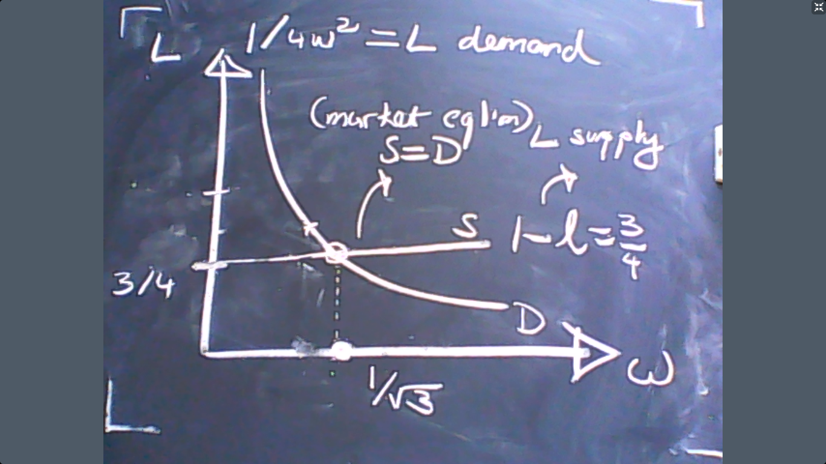

The graph above shows that the market equilibrium where labor demand and labor supply are equal. We assume that the actual observed wage in the market would be this equilibrium point. The reason is graphically explained below:
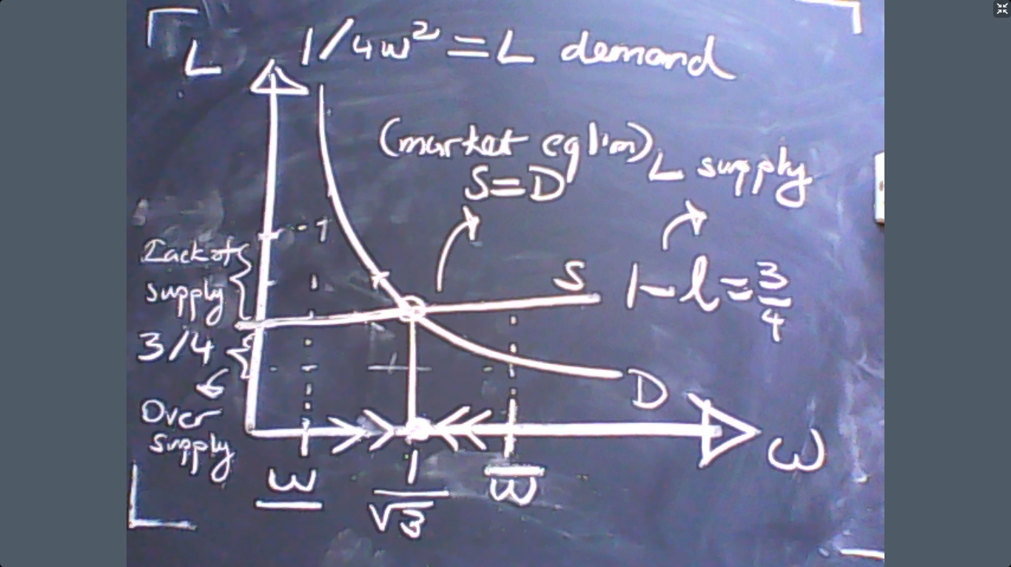
High wage creates lack of demand for labor and low wage causes over-demand in the labor market as can be observed above. In these instances, the wage would adjust and approach towards the equilibrium level, $1/\sqrt{3}$.
To be precise, what we calculated above is the general equilibrium. In other words, we can calculate how much the worker consumes, what the wage rate is, how much the firm produces, what the level of profit is and so on. Relative prices, income distribution, and all economic activities are fully solved. For instance, the profit level is
$$π=f\left(L\right)-wL=L^{\frac{1}{2}}-wL={\left(\frac{3}{4}\right)}^{\frac{1}{2}}-\frac{1}{3^{\frac{1}{2}}}×\frac{3}{4}=≈0.433.$$
In formal terms, this is called the general equilibrium defined as follows
Definition: $(p^{*},w^{*})$ is a general equilibrium if
$$L^{*}+l^{*}=1$$
where $L^{*}$ solves the profit maximization and $l^{*}$ solves the utility maximization problems at the price levels $\left(p^{*},w^{*}\right).$
Voting
Consider 3 individuals who will decide the level of income taxes, $H \left(high\right),L (low)$. Their preferences over these tax proposals are given below:
1 | 2 | 3
H | L | H
L | H | L

The majority rule says that we should pick the choice which would have the most votes. Therefore, $H$ would win the voting when the majority rule is applied. Now let us assume that there are three options for the level of income taxes: $H,M,L$.
1 | 2 | 3
H | L | M
M | M | L
L | H | H
In this case, majority rule would be inapplicable. A French politician, Condercet, proposed the following voting method:
Condercet Voting: Run a majority voting for all possible pairs of options (H vs. M, for instance). The option – or the choice – that wins against all options is the winner, called the Condercet winner.
H vs. M | H vs. L | M vs. L
1 vs. 2 | 1 vs. 2 | 2 vs. 1
So in this example, the Condercet winner is $M$because $M$ does not lose any majority voting against any alternative. The preferences of the individuals can also be visually described.
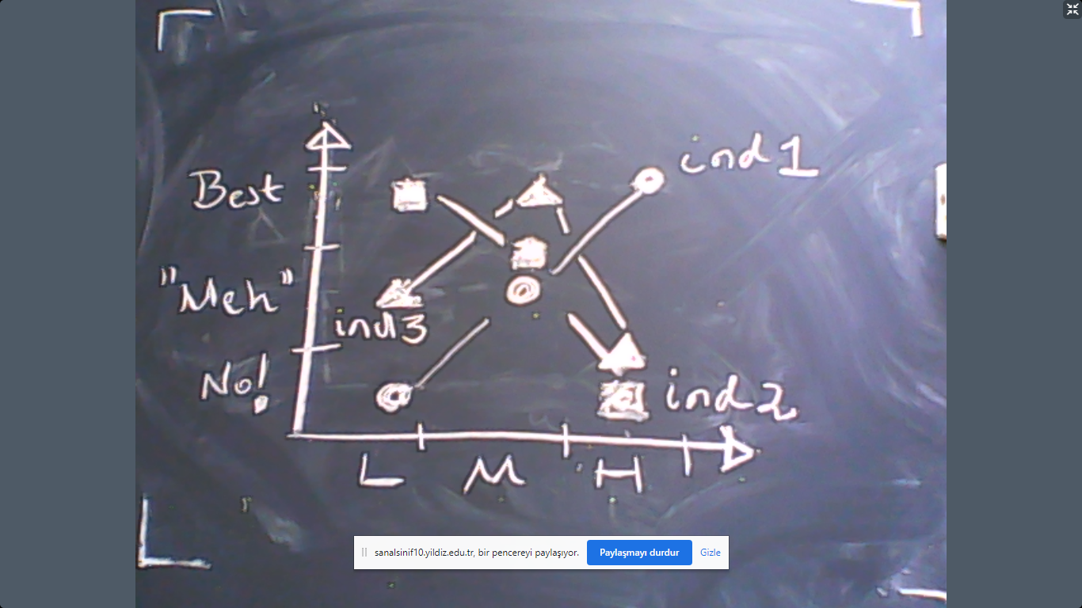

Now consider the following famous example:
There are three options, again. These are denoted by $a,b, and c$. The preferences of the individuals are given by the table below:
1 | 2 | 3
a | c | b
b | a | c
c | b | a

a vs. b | a vs. c | b vs. c
2 vs. 1 | 1 vs. 2 | 2 vs. 1

There is no option that wins against all possible alternatives in 1-1 majority voting. So there is no “Condercet winner”. We know the reason why there is no winner in this voting mechanism. Let us see that visually:

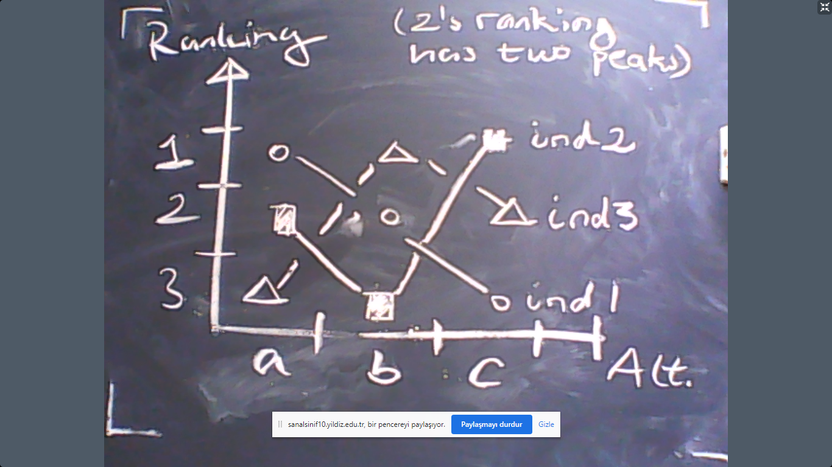

Theorem: If an odd number of voters have single peaked preferences, then the median voter is the Condercet Winner. The median voter is the person whose most preferred option divides the society into two groups.
This is called the Median Voter Theorem. It is the political science equivalent to market equilibrium in economics. The benchmark technique of analyzing how equilibrium is achieved in political science is the median voter theorem.
Example: Consider $2n+1$ number of houses located over a straight street. A bus stop will be built in front of one of these houses. Each house prefers the closest point as the bus stop location. Where will the bus stop be built?
Observation 1: If the MVT applies, then no voter has an incentive to misrepresent her preferences.
Observation 2: If two political parties compete to get most of the votes by choosing their position over all possible points, they will both choose the median point.
Observation 3: The previous observation is applicable to the location choices of firms/shops. This location can be the spatial position as well as the spectrum of product quality or variety.

