Example: In Turkey, post-tax Gini is around 0.40. Suppose that the income distribution in Turkey can be represented by 3 individuals: Low income, Medium income, High income. This is
$$Y=\left\{Y_{1},Y_{2},Y_{3}\right\}.$$
The GDP per capita is
$$63K=\frac{Y_{1}+Y_{2}+Y_{3}}{3}.$$
If we take the minimum wage income as the low income, $Y_{1}$, then we can calculate all variables. Therefore,
$$Y_{1}=3K\left(Turkish Liras\right)*12\left(monts\right)*(Ratio of working people).$$
Let us take the ratio to be ½. Then the
$$Y_{1}=3*12*\frac{1}{2}=18$$

Note that
$$Gini=0.4=2*\frac{1*18+2*Y_{2}+3*Y_{3}}{3*\left(63*3\right)}-\frac{4}{3}$$
$$Mean Income=18+Y_{2}+Y_{3}=63*3.$$
The result is
$$\left\{Y_{1},Y_{2},Y_{3}\right\}=\left\{18,39.6,131\right\}=\{1\min{wage,2.2\min{wage, 7.27\min{wage\}}}}.$$
To see more easily, how income distribution looks like in an economy where the Gini coefficient is 0.4, consider the following example:
$$Y=\left\{1,2,R\right\}.$$
where $R$ denotes the income level of the rich. In that case, the Gini would be
$$2*\frac{1*1+2*2+3*R}{3*\left(1+2+R\right)}-\frac{4}{3}=0.4.$$
$$2*\frac{1+4+3R}{9+3R}-\frac{4}{3}=0.4.$$
$$\frac{10+6R}{9+3R}=\frac{52}{30}.$$
The solution is $R=7$. So the income distribution would be
$$Y=\left\{1 min.wage,2\min{wage},7\min{wage}\right\}.$$
The Lorentz curve would look lie as follows:
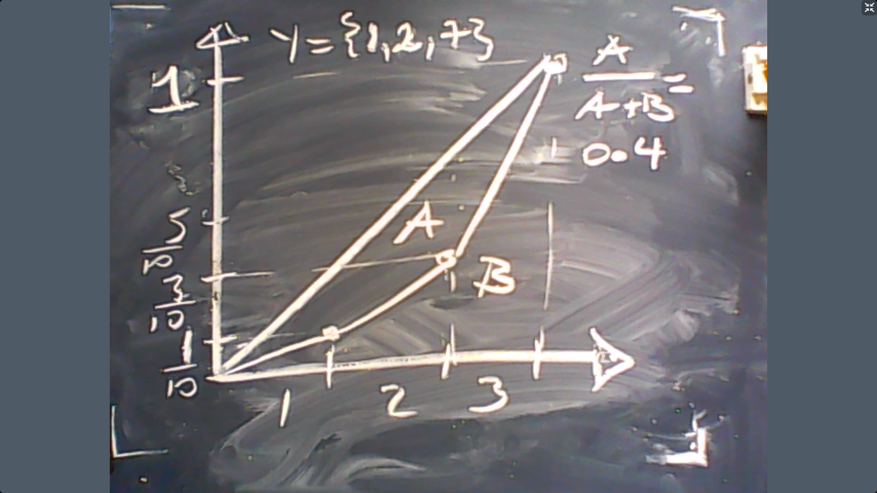

This is the end of income distribution and voting.

Game Theory
The theory of games analyzes interactions between multiple decision makers whose decisions influence everyone’s well-being. Each decision maker is called a “player”. The choice of a player is called a “strategy”. We assume that the objective of each player is to maximize her objective by choosing the appropriate strategy. The objective is called the “pay-off”.
Example: Consider two firms producing a homogenous commodity. Each firm will decide whether to invest in an ad campaign, or not. If both firms invest in ads, then everyone loses, $\left(-1,-1\right)=(Firm 1^{'}s pay-off,Firm 2^{'}s pay-off)$. Why? Due to competition, there would be no profit anyway. But no firm has an advantage if both of them invest in ads. If no one invests in ads, then their pay-offs are $(0,0)$. If one firm invests but the other does not then their pay-offs are $(3,-2)$. This interaction can be represented by a pay-off matrix as follows:
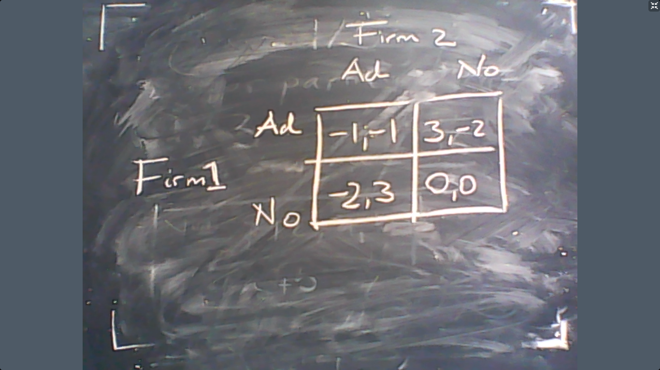

This matrix completely describes the interaction between these two firms. Now let us try to predict how each firm would behave. There are several different methods to obtain the prediction. Let us see two of them, which all yield the same result.
Method: Find the box where no firm has any incentive to change its decision.
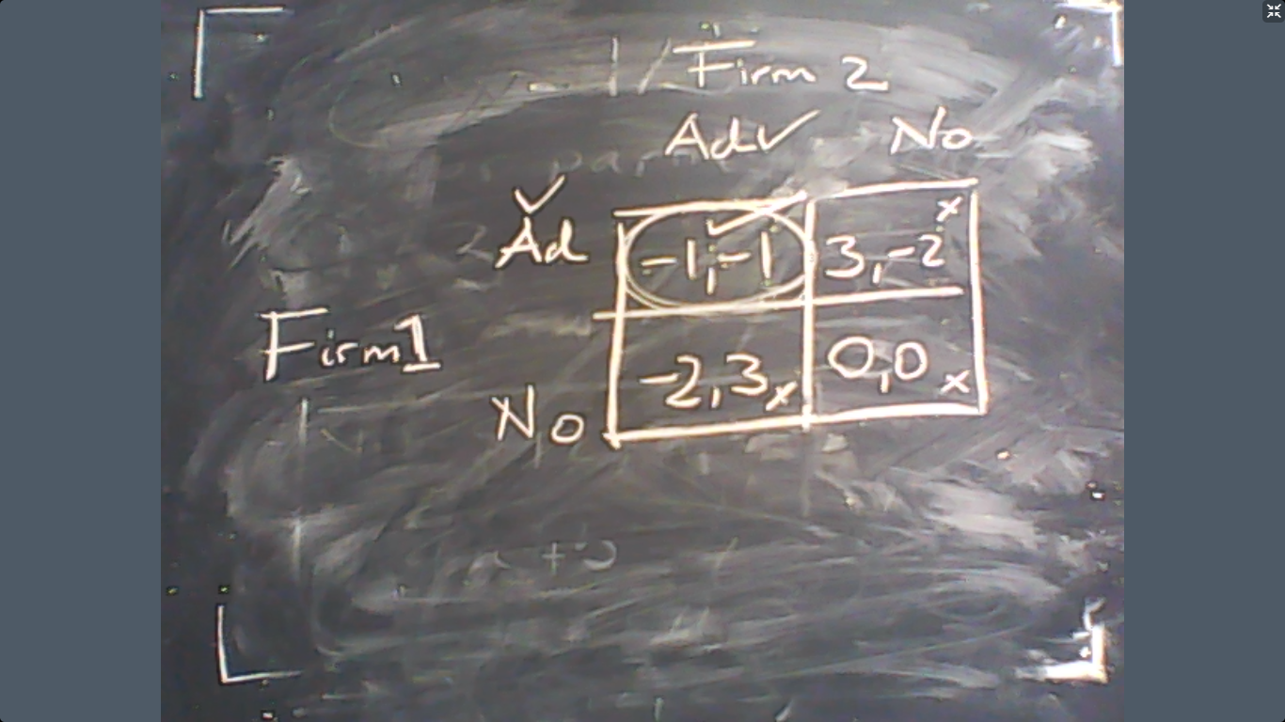
So our prediction is (Ad, Ad) strategy where both firms lose money.
The second method to make a prediction about how these firms invest in ads, we can use the “best-response” strategy.
Method 2: Suppose that Fim i chooses a strategy. Then find the best response of the other firm, Firm j. If best-responses agree, then this is our prediction.
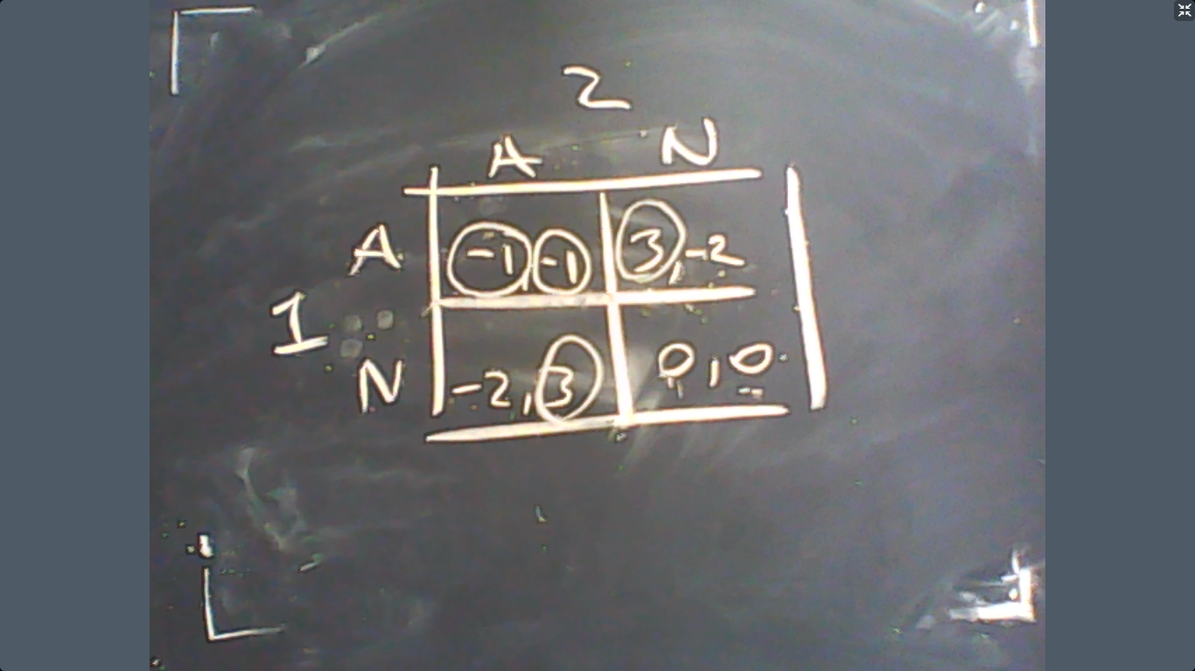
The prediction is again the same, (Ad, Ad).

These predictions are called the Nash equilibrium, which means “any profile of strategies by the players where no player wants to deviate (no player can benefit from changing its strategy)”
So, in a sense, Firms in the previous example choose their strategies to the best that they can but at the end they just lose money. However, there is an alternative set of strategies (No,No) where no one loses money. Then why do not the firms make such a choice?
The reason is that if both firms choose not to put any money in ads, then deviation from this strategy would be beneficial for any firm. This ensures that $(N,N)$ strategy cannot be observed.
However, the Nash equilibrium may not exist in some instances. This means the method of predicting the outcome of certain interactions cannot be the methods that we discussed above.
Example (Matching Pennies): Consider two individuals who choose between A and B. If both individuals choose the same letter, then Player 1 wins. If they choose different letters, then Player 2 wins. This game is known as “matching pennies”. The matrix representation of this game is below:
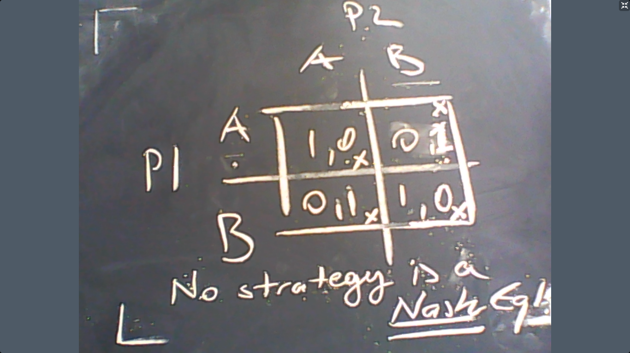

So we cannot predict what the players would do in this game based on the notion of Nash equilibrium. An alternative method could be using the mixed-strategy approach. The idea is to assign a probability of playing a strategy for each player, and the players choose these probabilities to maximize their expected pay-offs. See the graph below:
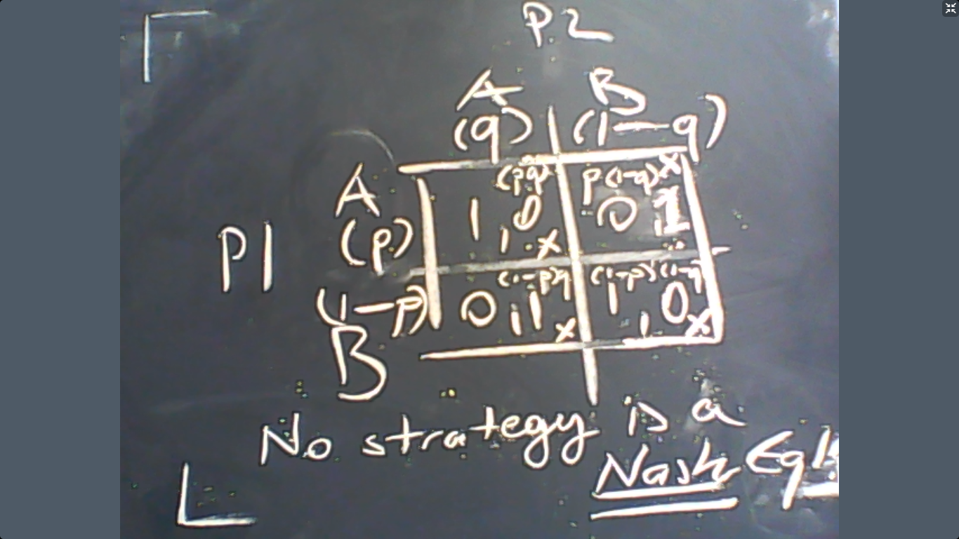
Now let us calculate the expected pay-off of player 1:
$$EU_{1}=1×p×q+0×p×\left(1-q\right)+0×\left(1-p\right)×q+\left(1-p\right)×\left(1-q\right)×1=pq+\left(1-p\right)\left(1-q\right).$$

In order to maximize $EU_{1}$ with respect to $p$, we should solve:
$$\frac{dEU_{1}}{dp}=0=q-\left(1-q\right).$$
The result is, $q^{*}=1/2$. The same logic applies to Player 2, so that the equilibrium in mixed strategies is
$$\left(p^{*},q^{*}\right)=\left(\frac{1}{2},\frac{1}{2}\right).$$

