Final Exam – Economics of Income Distribution
Name/Surname/Student ID#:
- Last year, the Conservative Party in the UK had a major election victory against Labor, which proposed taxing the rich and using the extra tax revenues for services that would benefit the poor. In the class, we discussed several models that explain why the poor do not support the economic policies that favor them. If you were the leader of the Conservative Party, Boris Johnson, which model would you prefer to explain your party’s victory? Discuss the model. (Hint: Only one model is correct.)

Answer: A particular explanation that Boris Johnson could make is “leaking bucket”. It is the idea that taxation for redistribution reduces the total income. Why? Taxation is a bureaucratic activity that is costly for the tax authority. Taxation also reduces net income which also reduces the motivation to work.
To see how this mechanism works suppose that the income profile in UK can be represented by
$$Y=\left\{1,3,11\right\}$$
Mean of $Y$ is 5, total income is 15 and $Y^{med}=3.$ This means the median voter is poorer than the average. Assume that the utility from tax $t$ is
$$U_{i}=\left(1-t\right)Y_{i}+t×α×\overline{Y}$$
where $\overline{Y}$ is the average income and $α∈[0,1]$ is the efficacy of taxation. The derivative of $U_{i}$ with respect to $t$ is
$$U_{i}^{'}=-Y_{i}+α\overline{Y}.$$
For the median voter, this means
$$-3+α5.$$
If this expression is negative than the median voter would support the Conservative Party:
$$α<0,6.$$

- The figure below shows after-tax income inequality measured by the Gini coefficient and the annual average growth rates for selected OECD countries.
- How would Stiglitz respond to this data? Explain your argument.
- How would Pinker respond to Stiglitz? Explain your argument.

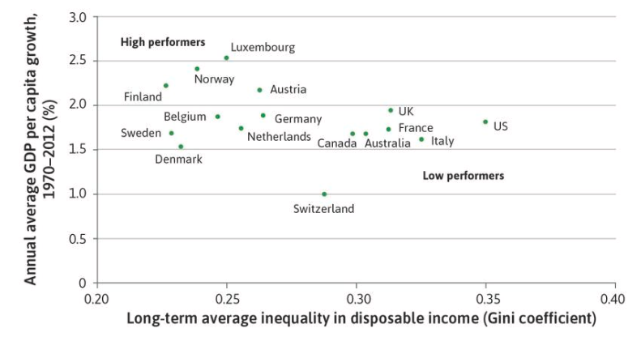

- The figure shows a negative relationship between inequality and economic growth. Stiglitz would argue that this relationship supports his claim: There is a price of inequality. The price of inequality can be caused by several different factors. For example, inequality among parents perpetuate unequal opportunities among children in education. This would waste the most important economic input – human intellect. Another reason could be monopolization, which causes inequality and reduces economic activity.

- Pinker could argue that the data in figure does not tell us the direction of causality. It is highly likely that countries with efficient institutions would grow faster and have better income distribution. So, maybe, this data simply reflects us which countries possess better institutions. Pinker could also add if there is any problem of inequality of opportunity or monopolization, then these issues should be solved by direct relevant policies, not income redistribution. So inequality of opportunity among children in education requires better schooling. Monopolization should be solved by regulation. Not redistribution.

- According to an article published in Science in 2018, GDP per capita and secularity are positively correlated (see the figure below). As we discussed in the class, the link between the growth of GDP per capita and income equality are also positive.
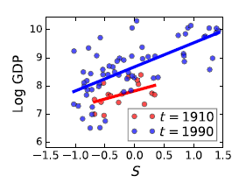
109 nations in the 20th century. Here S denotes the level of secularity. GDP is in per capita terms.
- According to these results, should the link between income equality and secularity be positive or negative?
Answer: Suppose that secularity rises. Then income would be higher. If income is higher, then economic equality would be enhanced. So our expectation should be a positive link between secularity and equality.

- Is this consistent with the real world data?

Answer: Yes it is. As we discussed in the class, income equality and secularity are positively correlated.

- According to TUİK, the distribution of income in Turkey can be summarized as follows:
 |  | 1st quintile⁽¹⁾ |  | Second quintile |  | Third quintile |  | Fourth quintile |  | Last quintile
Mean (TL) |  | 5 880 |  | 10 174 |  | 14 288 |  | 20 194 |  | 45 173

- Compute the Gini coefficient among these five groups.
- Explain why the actual Gini in the whole economy is definitely higher than your answer.
Answer:
$$2×\frac{1*5,8+2*10,17+3*14,3+4*20,2+5*45,2}{5*\left(5,8+10,17+14,3+20,2+45,2\right)}-\frac{6}{5}=0,37.$$
In reality, the Gini coeeficient is 0,4 (post-tax) and 0,47 (pre-tax).
Answer: The reason why we found a smaller number is that the income inequality in each quantile is ignored when we calculate the Gini coefficient based on 5 quantiles. Therefore, if we use representative income groups, income distribution will necessarily look smaller.

