**Learning by Doing**

In this lesson we will see discuss a very fundamental idea in economics of technology: learning by doing. This idea can explain how firms can succeed to dominate the market. And we will also see that learning by doing can explain why the university education is not very practical but very abstract, theoretical, and academic.

Let us start with a specific example. one of the most promising vaccines against SARS-CoV-2 has been developed by a company named Biontech, founded by Dr. Şahin and Dr. Türeci. Commenting on the development process for Financial Times, Dr. Türeci states:

“If the pandemic were to have happened three years ago, it would have been much more difficult.”

As Dr. Türeci explains, the reason is that they gained crucial experience with RNA manufacturing – a key component of their vaccine - during their previous work on cancer:

“We had a lot of experience with RNA in the context of manufacturing it for individualized cancer vaccines,”

The innovation process of the vaccine against COVID-19 as explained by one of the founders of Biontech, Dr. Türeci, clearly indicates that productivity in medical innovation increases with previous experiences. This idea can be formalized by the production technology:

where is the new technologies or products, and is labor, and is a fixed parameter. In order to obtain the effect of “the higher the experience the greater the productivity” effect, we must assume In this case, we would have “increasing returns to scale”.

To see this, note that

if .

The reason why there is increasing returns to scale in innovation (of vaccines) is called “learning by doing”, which means perfection in production is obtained by experience and experimentation.

Now let us see the implications of a production process with increasing returns to scale and learning by doing.

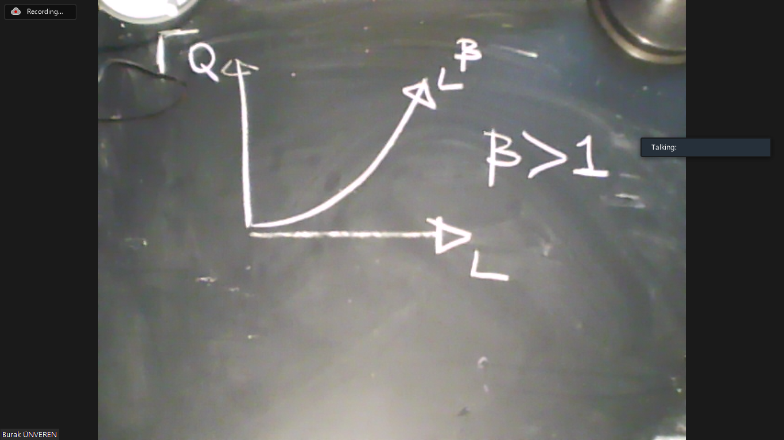

Now we can calculate the total cost and marginal cost and average cost based on this production technology. First of all, if

then

This equation says: “if you want to produce , then you should use amount of labor”. If the unit cost of is , then the cost function is

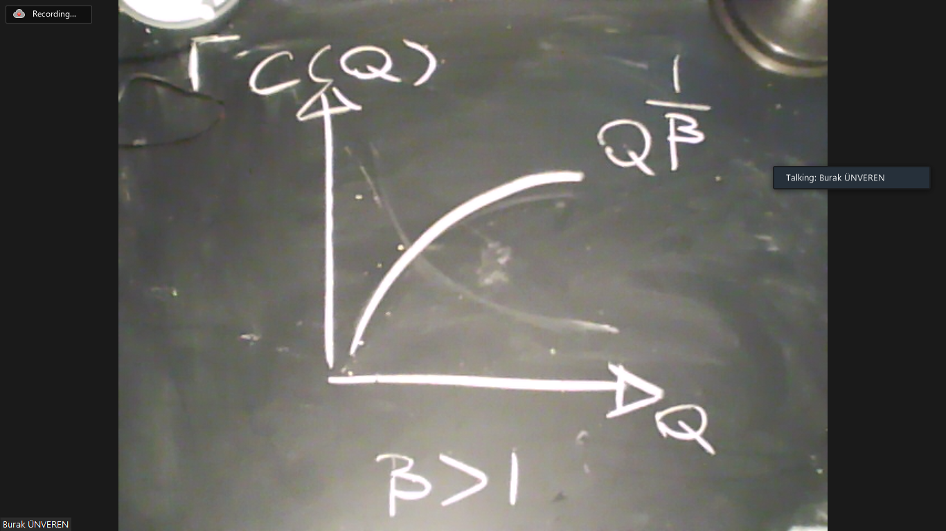

In the graph above, we take because is not very important for our discussion. But the marginal cost and average cost curves are

and

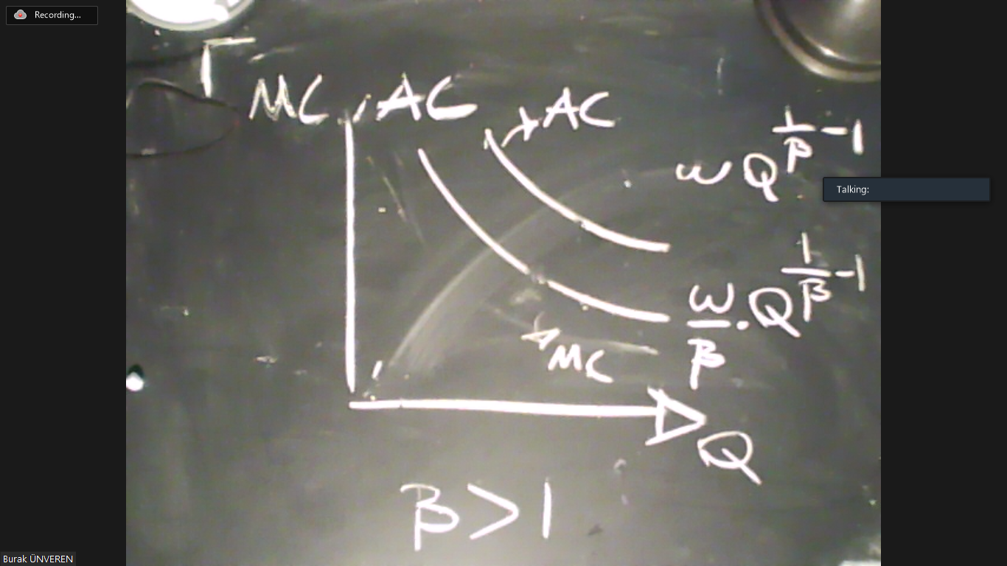

The implications of learning by doing - increasing returns to scale due to obtaining more experience with producing more - was first understood during 1960s. For example, according to an article entitled “The Experience Curve” published by the CEO of Boston Consulting Group in 1968,

“The implications for corporate strategy development are so sweeping that it is difficult to overstate them.”

The type of increasing returns to scale that motivated our discussion is known as “learning by doing”. More experience implies more productivity. Now we will answer two questions about this.

* Is learning by doing widespread?
* Why does it exist?

Let us start with the first question. The figure below is from an article published at the Science in 1990, entitled “Learning Curves in Manufacturing”.



A learning curve shows how much extra labor is needed to produce 1 more unit if there is already an output level of produced. In mathematical terms, this is

Given our technological specification, , this gives

So the learning curve and marginal cost curve are proportional. So the graph above shows “ MC is decreasing with more production” which is simply increasing returns to scale.

So let us move to the second question. Why is there learning by doing? There can be, of course, different explanations. However, an important issue is that production requires fine tuning in many different parameters. For example, during the early periods of Industrial Revolution, most of the increases in productivity came from experience obtained from using the new machines of automation. In case of yarn production; humidity, type of cotton, speed of the machines, and countless many other parameters affect the productivity. According to some estimates, it almosy took 50 years to figure out the best conditions for yarn production during the Industrial Revolution.

The idea that actual production involves many unknown parameters that should be adjusted, calibrated, and fine tuned for maximum efficiency can also explain why the college education is mostly academic. When university students graduate and enter in real professional life, they will need to figure out countless different job-specific parameters that they should master. This is impossible to be thaught in the classroom by reading books. This means learning by doing is impossible to circumvent in real life. You can only learn by actually doing something!