Microeconomics Final Exam 2020 Fake Exam
Name/Surname/Student ID#:
1) The long-run cost for production of hard-disk drivers is given by
$$C\left(Q\right)=\sqrt{wr}\left(120Q-20Q^{2}+Q^{3}\right),$$
where $Q$ is the annual output of aw firm, $w$ is the wage rate for skilled assemply labor, and $r$ is the price of capital services. The price of capital services is fixed at $r=1$. Note that your answer will be expressed as a function of $w$.
a) In a long-run competitive equilibrium, how much output each firm would produce?
b) In a long-run competitive equilibrium, what will be the market price?
c) Suppose that market demand curve is given by $D\left(P\right)=10000/P$. What is the market equilibrium number of firms as a function of $w$?
Answer:
In a long-run equilibrium, we solve the following equations:
$$MC=AC (free-entry)$$
$$P=MC (competitive profit maximization)$$
$$nQ=Demand (Supply=Demand).$$
Let us start wit the first equation. Since the cost function is
$$C\left(Q\right)=\sqrt{wr}\left(120Q-20Q^{2}+Q^{3}\right)$$
It follows that
$$MC=\frac{dC}{dQ}=\sqrt{wr}(120-40Q+3Q^{2}).$$
$$AC=\frac{C}{Q}=\sqrt{wr}\left(120-20Q+Q^{2}\right).$$
Due to $MC=AC$ equation,
$$\sqrt{wr}\left(120-40Q+3Q^{2}\right)=\sqrt{wr}\left(120-20Q+Q^{2}\right)$$
$$\left(-40Q+3Q^{2}\right)=\left(-20Q+Q^{2}\right)$$
$$\left(2Q^{2}\right)=\left(20Q\right)$$
$$Q=10.$$
b) In a competitive market,
$$P=MC.$$
Since
$$MC=\sqrt{wr}\left(120-40Q+3Q^{2}\right)=\sqrt{wr}\left(120-40×10+3×100\right)=20\sqrt{w}.$$
c) Due to supply=demand
$$10×n=\frac{10000}{P}=\frac{10000}{20\sqrt{w}}.$$
Therefore,
$$n=\frac{50}{\sqrt{w}}.$$

2) Suppose that you own a firm that produces high quality A4 papers. The marginal cost of producing a package of A4 is 15TL. The demand for your product is
$$Q=P^{-3}.$$
Moreover, A4 papers with the exact same quality can be shipped from Portugal with prices starting from 20TL. Assuming everyone buys from the cheapest seller, what would be your price to maximize your profit?
Answer:
The profit of the firm (if $P<20$) is given by
$$π=P×Q-15Q.$$
But the demand function $Q=P^{-3}$ implies that
$$π=Q^{-\frac{1}{3}}×Q-15Q$$
$$=Q^{-\frac{1}{3}}×Q-15Q$$
$$=Q^{\frac{2}{3}}-15Q.$$
Now we should maximize $π$ by
$$\frac{dπ}{dQ}=\frac{2}{3}Q^{-\frac{1}{3}}-15=0$$
$$Q^{-\frac{1}{3}}=\frac{45}{2}=22.5=P.$$
But the firm cannot charge this price because it would be out-bidden by the Portuguese competitors. So the price should be $P<20$ but as high as possible, $P=19.99.$

3) Senem is a 17 year old student from İstanbul. Her parents give her 50 TL pre-day as pocket-money. Senem spends her income on cinema tickets and drinking coffee with her friends at their favorite coffee shop. Yesterday, Senem found out that she got into ODTÜ. Senem is very happy because cinema tickets are the same but coffee shops are more expensive in İstanbul. So her parents told her “We will reduce your allowance to 40 TL because this money is exactly the amount that would afford your expensive İstanbul habits in Ankara.” Senem is still happy. Explain why using graphical techniques that we developed in the class.
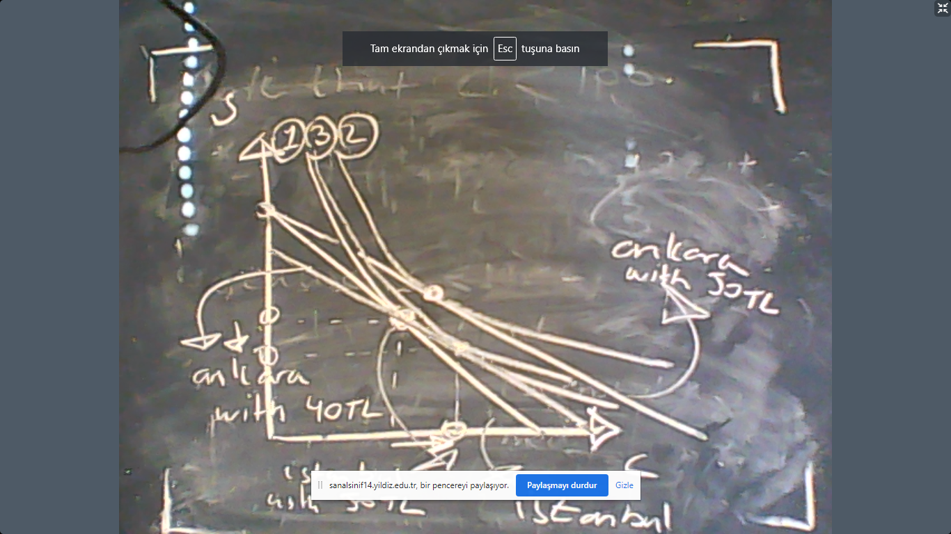

4) The academic members of Yıldız Technical University have free access to certain software, such as Matlab, a popular mathematical software developed by MathWorks. YTU pays a fixed fee, denoted by $F>0$, for an unlimited license. Let the demand for Matlab in YTU be
$$P=300-2Q$$
where $P$ is the price that each user would pay.
a) Note that access is free for all. Then what is the marginal cost of one license?
Answer: Marginal cost is the derivative of total cost with respect to quantity. Since the total cost is simply $F$, the answer is
$$MC=0.$$
b) Find the optimal $F$ that would maximize MathWorks profit?
If YTU buys the software, the number of users would be
$$P=MC=300-2Q=0.$$
Therefore, $Q=150.$ As the consumer, the value attributed to Matlab by YTU is given by the consumer surplus:
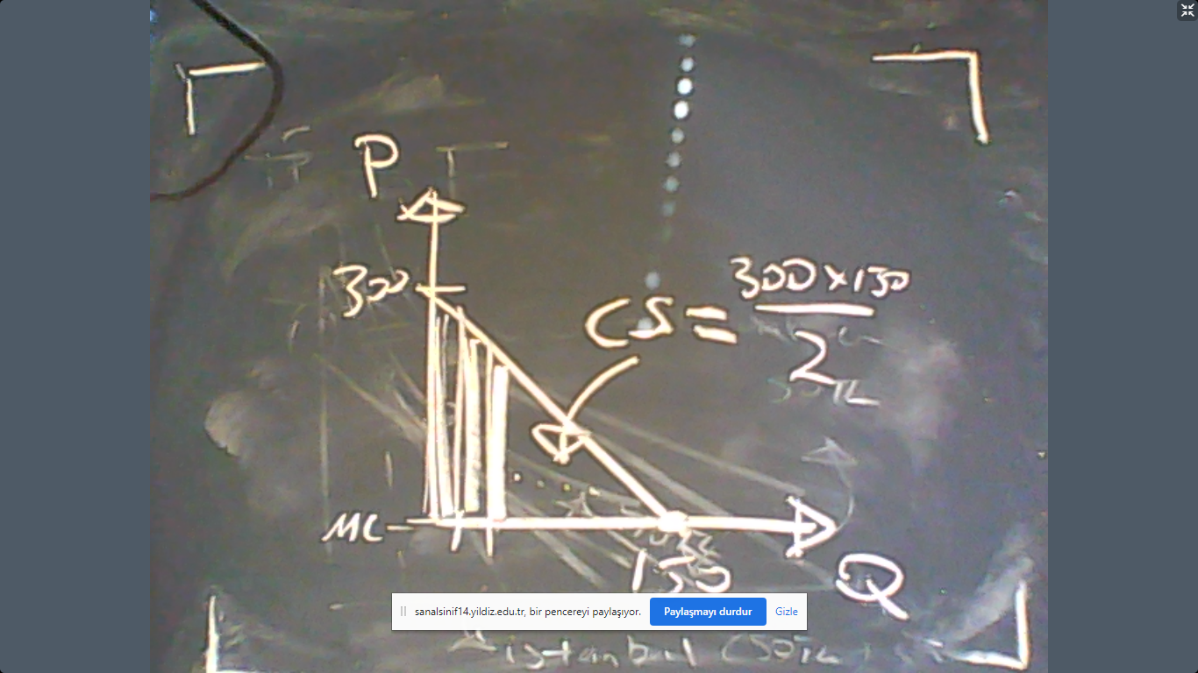
The MathWorks should choose $F=CS=22500.$ This is a price discrimination of the first type.

c) Instead of an unlimited license, MathWorks also considers to sell its product for a fee-per-user basis where $P$ is the fee that each user would pay. Explain to the management of MathWorks that this is a bad idea.
This is a very bad idea because YTU already pays all its consumer surplus to MathWorks with 1st degree price discrimination. Any other pricing policy would simply reduce the profit level. YTU would and could never pay anything more than its consumer surplus.
For example, if MathWorks charges $P$ per user, then its profit would be
$$π=P×Q$$
because there is no cost. Since demand is $P=300-2Q$, we obtain
$$π=\left(300-2Q\right)×Q.$$
To maximize this expression, solve
$$\frac{dπ}{dQ}=300-4Q=0.$$
$$Q^{M}=75.$$
$$P^{M}=300-2×75=150.$$
Therefore,
$$π^{M}=150×\frac{150}{2}=\frac{Profit with 1st degree price discimination}{2}.$$

c) Assume there are 100 universities that would buy Matlab. They all have the same demand function. What is the maximum amount of money that MathWorks would had spent on developing Matlab?
Since the producer surplus per university is 22500TL, the total amount is
2.250.000TL.
Therefore, the cost of developing Matlab should not exceed this level of producer surplus.

