Fake Final Exam – Economics of Income Distribution
Name/Surname/Student ID#:
- In 2019 the Conservative Party in the UK had a major election victory against Labor, which proposed taxing the rich and using the extra tax revenues for services that would benefit the poor. In the class, we discussed several models that explain why the poor do not support the economic policies that favor them. If you were the leader of the Conservative Party, Boris Johnson, which model would you prefer to explain your party’s victory?
Answer: A particular explanation that Boris Johnson could make is the “leaking bucket” idea. It is the idea that taxation for redistribution reduces the total income. Why? There are at least two major reasons. First of all, taxation is a bureaucratic activity that is costly for the tax authority. The organization to collect taxes costs money. The second reason, which is arguably more important, is that taxation reduces motivation to work and to invest via decreasing net disposable income. So the Conservative Party’s leader Boris Johnson could had said “The voters in the UK does very-well understand that taxing the rich is an economically bad idea that would harm everyone.”

- The figure below shows after-tax income inequality measured by the Gini coefficient and the annual average growth rates for selected OECD countries.
- How would Stiglitz respond to this data? Explain your argument.
- How would Pinker respond to Stiglitz? Explain your argument.

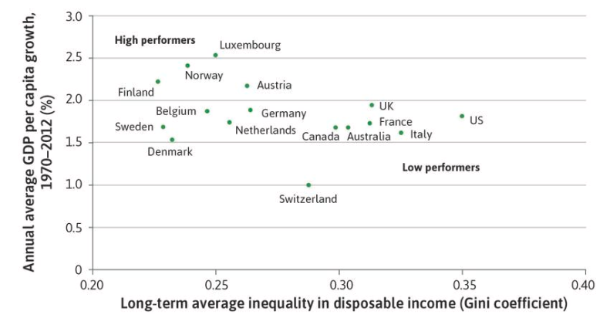

- The figure shows a negative relationship between inequality and economic growth. Stiglitz would argue that this relationship supports his claim: There is a price of inequality which reduces economic activity. This price of inequality can be caused by several different factors. For example, inequality among parents may perpetuate unequal opportunities among children in education. This would waste the most important economic input – human intellect. Another reason could be monopolization, which causes inequality and reduces overall economic activity.

- Pinker could argue that the data in figure does not tell us the direction of causality. It is highly likely that countries with efficient institutions would grow faster and have better income distribution. So, maybe, this data simply reflects us which countries possess better institutions. Pinker could also add if there is any problem of inequality of opportunity or monopolization, then these issues should be solved by direct relevant policies, not income redistribution. So inequality of opportunity among children in education requires better schooling. Monopolization should be solved by regulation. Not redistribution.

- According to an article published in Science in 2018, GDP per capita and secularity are positively correlated (see the figure below). As we discussed in the class, the link between the growth of GDP per capita and income equality are also positive.
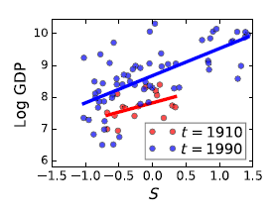
109 nations in the 20th century. Here S denotes the level of secularity. GDP is in per capita terms.
- According to these results, should the link between income equality and secularity be positive or negative?
Answer: Let us first focus on the graph. According to the graph above, a more secular economy means more income which means economic growth. That is all the graph above tells us. But (as the question reminds us) we also discussed in the class that higher economic growth is positively correlated with higher economic equality. So our expectation should be a positive link between secularity and equality (through the channel of economic growth).
- Is this consistent with the real world data?

Answer: Yes it is. As we discussed in the class, income equality and secularity are positively correlated. Our theoretical prediction regarding the link between equality and secularity is supported by the data.

- According to TUİK, the distribution of income in Turkey can be summarized as follows:
 |  | 1st quintile⁽¹⁾ |  | Second quintile |  | Third quintile |  | Fourth quintile |  | Last quintile
Mean (TL) |  | 5 880 |  | 10 174 |  | 14 288 |  | 20 194 |  | 45 173

- Compute the Gini coefficient among these five groups.
- Explain why the actual Gini in the whole economy is definitely higher than your answer.
Answer:
$$2×\frac{1*5,8+2*10,17+3*14,3+4*20,2+5*45,2}{5*\left(5,8+10,17+14,3+20,2+45,2\right)}-\frac{6}{5}=0,37.$$
In reality, the Gini coefficient is 0,4 (post-tax) and 0,47 (pre-tax) in Turkey.
Answer: The reason why we found a smaller number is that the income inequality in each quantile is ignored when we calculate the Gini coefficient based on 5 quantiles. Therefore, if we use representative income groups, income distribution will necessarily look smaller.

