Cost
As we discussed earlier, the objective of the firm is profit which is defined as
$$π=R-C.$$
Today we will focus on $C$, the cost. In economics, cost is the “alternative cost”, which means the value of the best alternative use of a resource. For example, the cost of capital for a firm is the value that could earned by using the capital in the second best alternative.
This concept of cost is different than the “explicit cost” or the “accounting cost”. Typically, alternative cost and the explicit cost do not agree.
Example: Suppose that you inherited a shop. The market value for renting the shop, let us say, 10.000TL. But you want to run your own business. At the end of the month, you look at how much money you have after subtracting all your expenses. The amount that you earned by running your own business is 7.000TL.
An accountant would say your profit is 7K. But an economist would argue that the profit is
7K-10K= -3K.
That is because, “the alternative cost” of the shop is not taken into account if you think that your profit is 7K. (End of example)

This observation has important implications.
Observation 1) When you consider the profit of a firm, it does not matter who owns the capital that the firm uses for its production. That is to say, even if you own the firm and the capital (note these can be owned by different people) the capital is costly for the firm.
Observation 2) It is very easy to calculate the cost of capital. You should simply consider how much you could earn if you rented your capital to someone else. This directly gives you the cost of capital.
Observation 3) If you cannot re-sell or rent the investment that you make, then its cost is zero for the current decision making. That is because, its alternative cost is zero. These types of costs are called “sunk-cost”. Examples include a machine that is specific to your business or the decoration of your office that cannot be used anywhere else.
Types of cost
We can categorize costs into different types. In particular,
$$TC=VC+FC$$
where $TC=$total cost, $VC=$variable cost, $FC=$fixed cost. Variable cost changes as the firm decreases or increases its output. It depends on the level of production. Fixed cost is paid regardless of the level of production.
The increase in total cost due to a small increase in output is called the marginal cost, and it is calculated by taking the derivative with respect to quantity:
$$MC=\frac{dTC}{dq}.$$
A related concept is the average cost:
$$AC=\frac{TC}{q}.$$
Ex: $TC\left(q\right)=100q-4q^{2}+0.2q^{3}+450.$
Therefore,
$$FC=TC\left(0\right)=450.$$
$$VC\left(q\right)=100q-4q^{2}+0.2q^{3}.$$
$$MC=TC^{'}\left(q\right)=100-8q+0.6q^{2}.$$
$$AC\left(q\right)=\frac{TC}{q}=100-4q+0.2q^{2}+\frac{450}{q}.$$
The average variable cost is
$$\frac{VC}{q}=100-4q+0.2q^{2}.$$
Now let us draw the graphs:
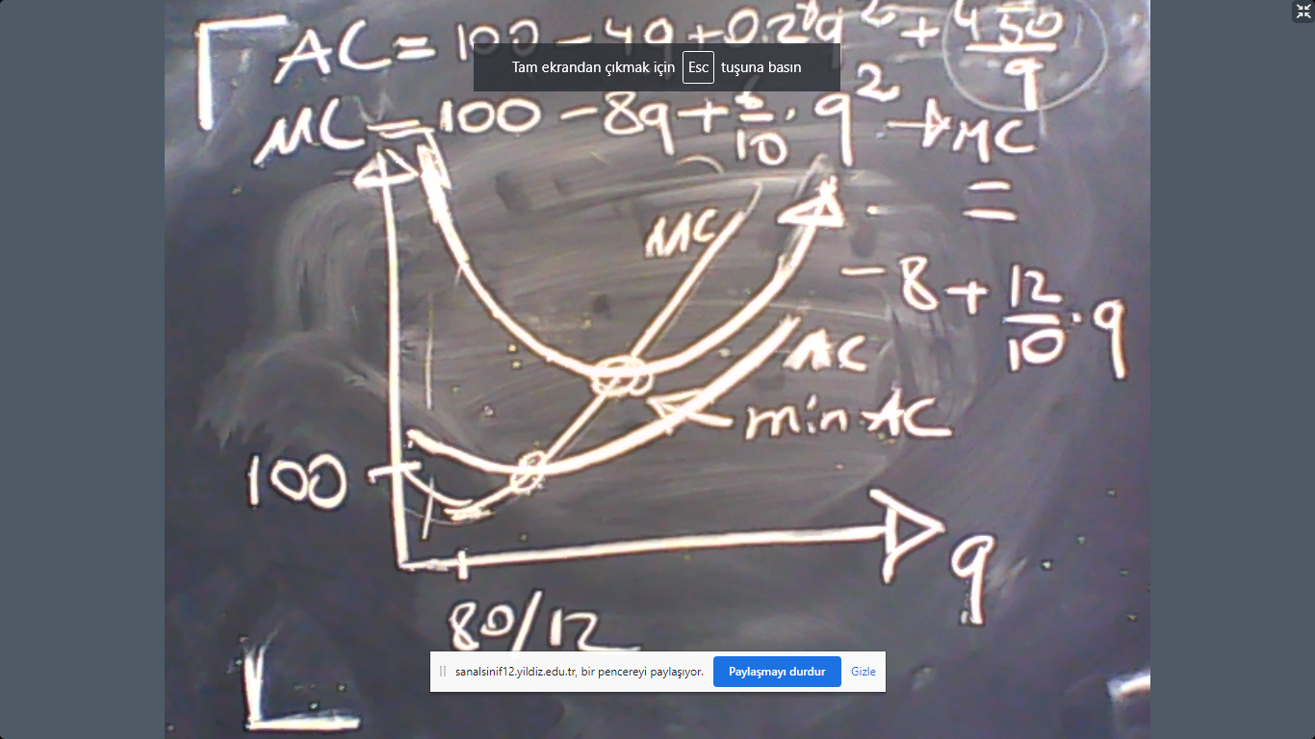

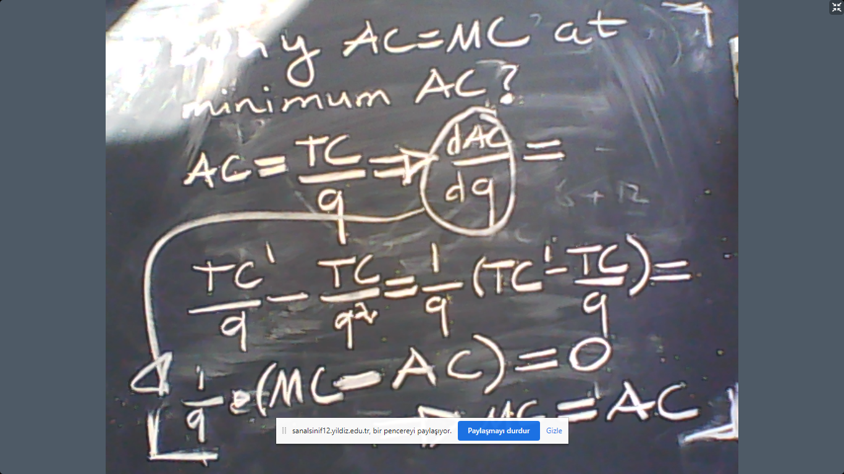

Cost is actually a function of the production technology. This is intuitively very clear. If, for example, the productivity is high, then the cost would be low? Likewise, if the productivity is low, then the cost would be high. Let us see the connection between cost and technology in the next example.
Example: Let the production function be
$$q=K^{1/2}L^{1/2}.$$
And we are in the short-run so that capital is fixed. Assume that $K=100.$ In this case, the short-run technology would be
$$q=10L^{1/2}.$$
The price of capital is $r$ and the wage for labor is $w$. Then $\left(K,L\right)$ would cost
$$TC=rK+wL.$$
However, we know that $K=100$. So first observe we can rephrase TC as
$$TC=r100+wL.$$
Moreover, using the technology, we can also express $L$ as a function of $q$. That is because,
$$q=10L^{1/2}$$
$$\frac{q}{10}=L^{1/2}$$
$$\frac{q^{2}}{100}=L.$$
Now let us put this term back to TC to see
$$TC(q)=r100+w\frac{q^{2}}{100}.$$
To make the example more numeric, assume $w=100$ and $r=1$. The result is
$$TC\left(q\right)=100+q^{2}.$$
As a consequence,
$$MC=\frac{dTC}{dq}=2q.$$
$$AC=\frac{100}{q}+q.$$
From this information we can deduce that the minimum of AC is achieved at $q=10$ because this is the solution to
$$AC=MC.$$
The graph would therefore look like the following:
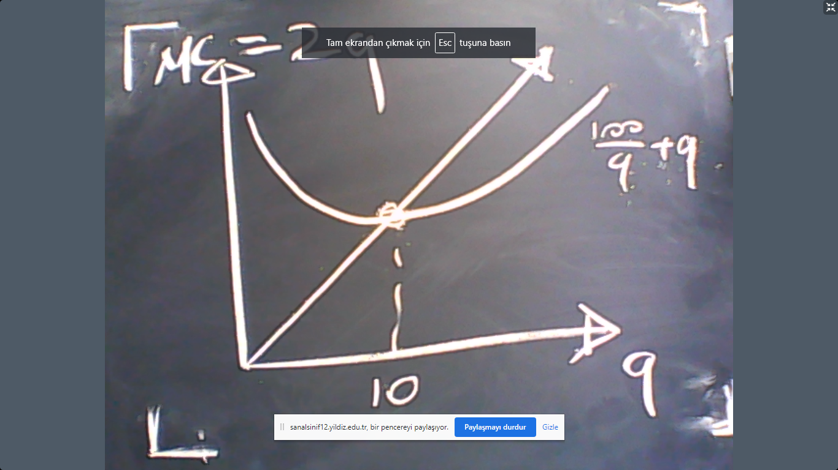

Until now, we have seen the short-run cost and the shot run technology. This means the level of capital is fixed and not variable. (See the example above). If all inputs are variable (including capital), then we would have the long-run cost curve.
In the long-run, the cost of $q$ is the minimum level of cost to produce $q.$ So we solve the following problem in the long-run:
$$\min{rK+wL}$$
s.t.
$$q=f(K,L)$$
by choosing $\left(K,L\right)$ and taking $q$ as fixed.
The idea here is that if the prices of inputs motivate the producer, then the firm would and could replace one of the inputs with the other. This would take time but in the long-run, by definition, this replacement can be achieved. So the firm faces the optimization problem above.
Ex: Let us re-analyze the previous example but this time in the long-run. So we solve
$$\min{K+100L}$$
s.t.
$$q=K^{1/2}L^{1/2}.$$
A straightforward method to solve this problem is to first consider the fact that
$$q=K^{1/2}L^{1/2}$$
implies
$$\frac{q^{2}}{L}=K.$$
Plug this into the cost to see
$$K+100L=\frac{q^{2}}{L}+100L.$$
To minimize this function, first take the derivative of
$$\frac{q^{2}}{L}+100L$$
To see that it is equal to:
$$-\frac{q^{2}}{L^{2}}+100.$$
Equate this expression to zero and solve $L$ to obtain
$$L^{*}=\frac{q}{10}.$$
Therefore,
$$K^{*}=10q.$$
Put these into the cost to obtain:
$$TC\left(q\right)=K+100L=20q.$$
In that case,
$$MC=20$$
and
$$AC=20.$$
(End of example)

There is a very close relationship between “returns to scale” and the shape of the long-run cost curve. See the graph below:
