Microeconomics
Introduction: Let us first ask ourselves what microeconomics is. Microeconomics is the study of how individuals and firms make decisions of consumption and production. Occasionally, the discussion will focus on the government.
Example: Suppose that Koç Holding decides to invest in artificial intelligence: $10 million. But before the investment takes place, a sudden fall in wages takes place in Turkey. How would this affect the investment of Koç Holding?
One possible argument would be investment in AI would go up as wages go down because cost of production would decrease which increases rate of return. But this view ignores why firms invest in AI. The primary reason for AI is “replacing labor with software and machines to cut labor costs” but if labor cost is already low why would you invest in AI?
This is a very simple, basic, but important example for microeconomic analysis. (End of example)
It is reasonable to argue that microeconomics is the study of “trade-offs” or “alternative cost”. Trade-off is the fact that any choice involves not choosing something else.
Example: A summer-term student chooses to enroll in Microeconomics course. This means she cannot enroll Public Economics, which is at the same on Monday.
Trade-offs:
- What do we produce? If we produce more cars, then we have to produce some other items less (Why? Because there would be less raw material, labor, and capital for the production of other goods)
- Who produces and who consumes? If you consume more, then I will consume less.
- Who earns? If you have more, then I would have less.
The reason why trade-offs exist is because resources are scarce. So another definition of microeconomics is the study of allocating scarce resources.
Microeconomics is based on theoretical models. We make simplifying assumptions about the subject that we want to analyze so that the issue can be mathematically formulized.
Q1: Do we have to make assumptions? Yes we have to make assumptions. A perfectly realistic model would be perfectly useless. The perfect model is the real world itself which is freely available. But it is so complicated that we hardly understand what is happening and why.
Q2: Then how do we choose the assumptions? Which assumptions should we not make? The criterion for making assumptions is not “realistic assumptions” but “realistic predictions”. Our assumptions should give us predictions that are consistent with reality.
There are two types of models a) Positive models b) Normative models.
In a positive model, we want to replicate reality. The reality can be good, bad, ugly. We are totally antagonistic with respect to how bad or how good the outcome would be. Example: A model where we analyze the labor supply decision of a worker as tax rates increase.
In a normative, we want to address what is good, bad, and ugly. For example, we ask ourselves whether it is a good idea or a bad idea to increase taxes. In certain cases, it would be good but in some others, it would be bad.

Supply and Demand
In any given market, there are two sides: demand and supply. Demand is how much consumers are willing to buy at the prevailing (current) conditions. If quantity demanded is denoted by $Q$, then it is a function
$$Q=D\left(Price,Prices of other goods, Taste\left(preferences\right),Income\right).$$
$$D\left(p,p_{s}, T,I\right).$$
Example: Suppose that the demand for coffee is given by
$$Q=8.56-p-0.3 p_{s}+0.1 Y$$
where $p_{s}$ is the price of sugar and $Y$ is income.
The price of coffee, $p$, has a negative effect on $Q$. There are two reasons for that
- Substitution effect. If the price of a commodity increases, cheaper goods would be easier to substitute the commodity. In other words, when a commodity becomes more expensive, other alternatives become more attractive.
- Income effect. When the price of a good increases, the consumers with given income become “poorer” in terms of the good’s price. Of course, we consume less when we are poorer. This is the income effect.
- Total (Price) effect = SE+IE. But both of them are negative which means PE<0. That is the reason why, the price of coffee, $p$, has a negative effect on $Q$. This is called “the law of demand”: quantity demanded decreases as its own price increases
What about the price of sugar, $p_{s}$? Why does it have a negative impact on demand? That is because, “sugar and coffee are complements”. Consumers often consume them together. If they were substitute, then the impact would be positive.
- $Y$ affects demand positively as we consume more if we are richer. But sometimes this is not true. If you consume less of a commodity when you are richer, then this good is “inferior”. Example: Public transportation, bread, poultry.
Suppose that the price of sugar is $p_{s}=\$0.2$ per lbs and $Y=\$35K$ per annum. Then the demand becomes
$$Q=8.56-p-0.3×0.2+0.1×35=12-p.$$
To be clear,
$$Q=12-p.$$
Let us plot this relation.
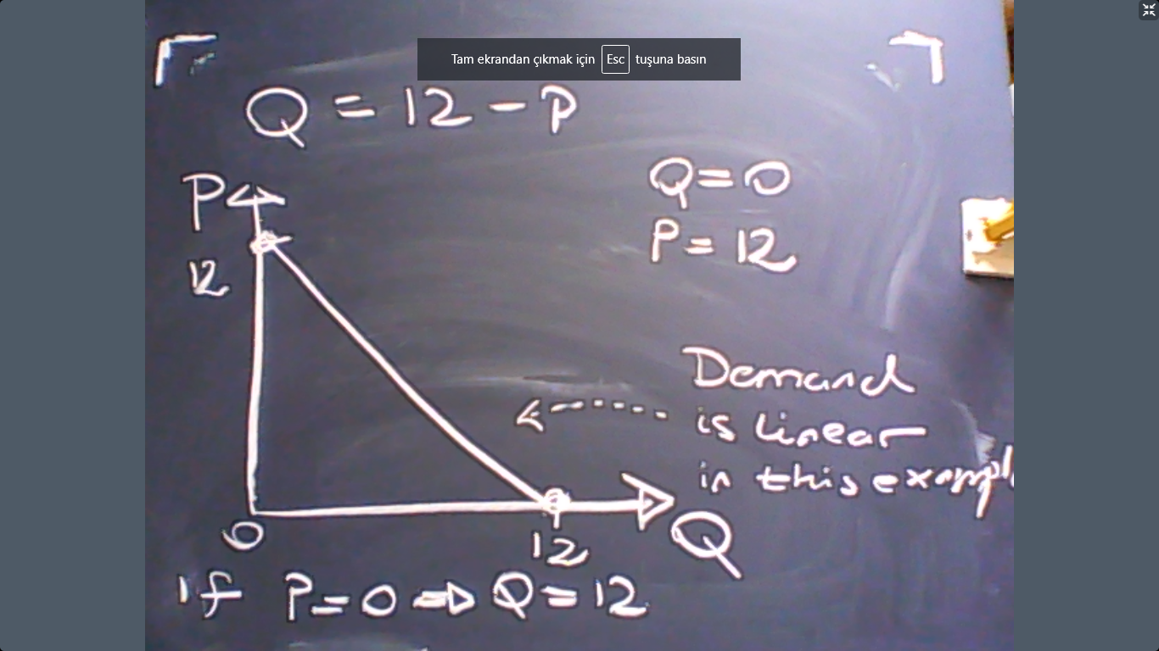

Remark: If $p$ changes, then we move along the demand curve.
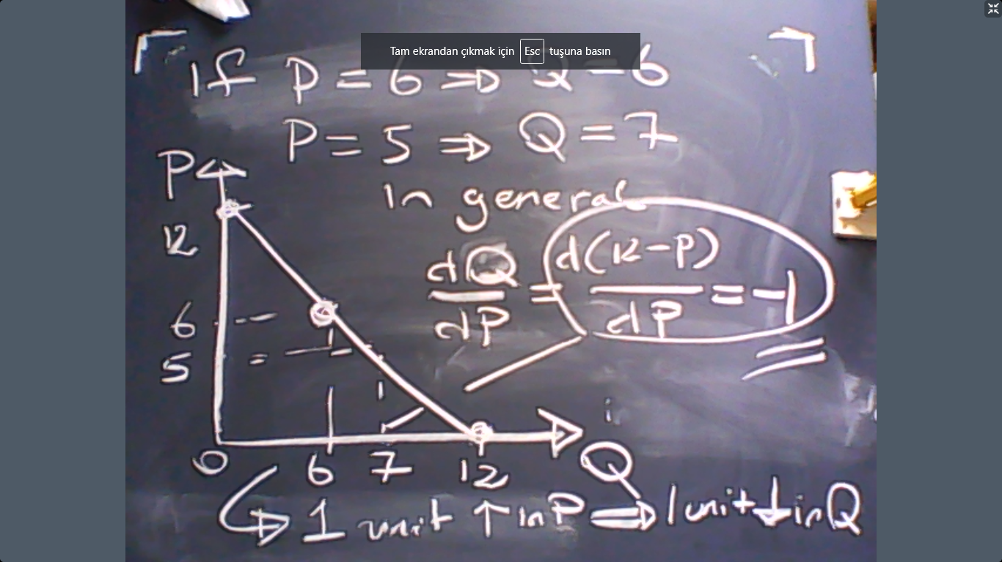

Remark: If other variables change, then the curve shifts.
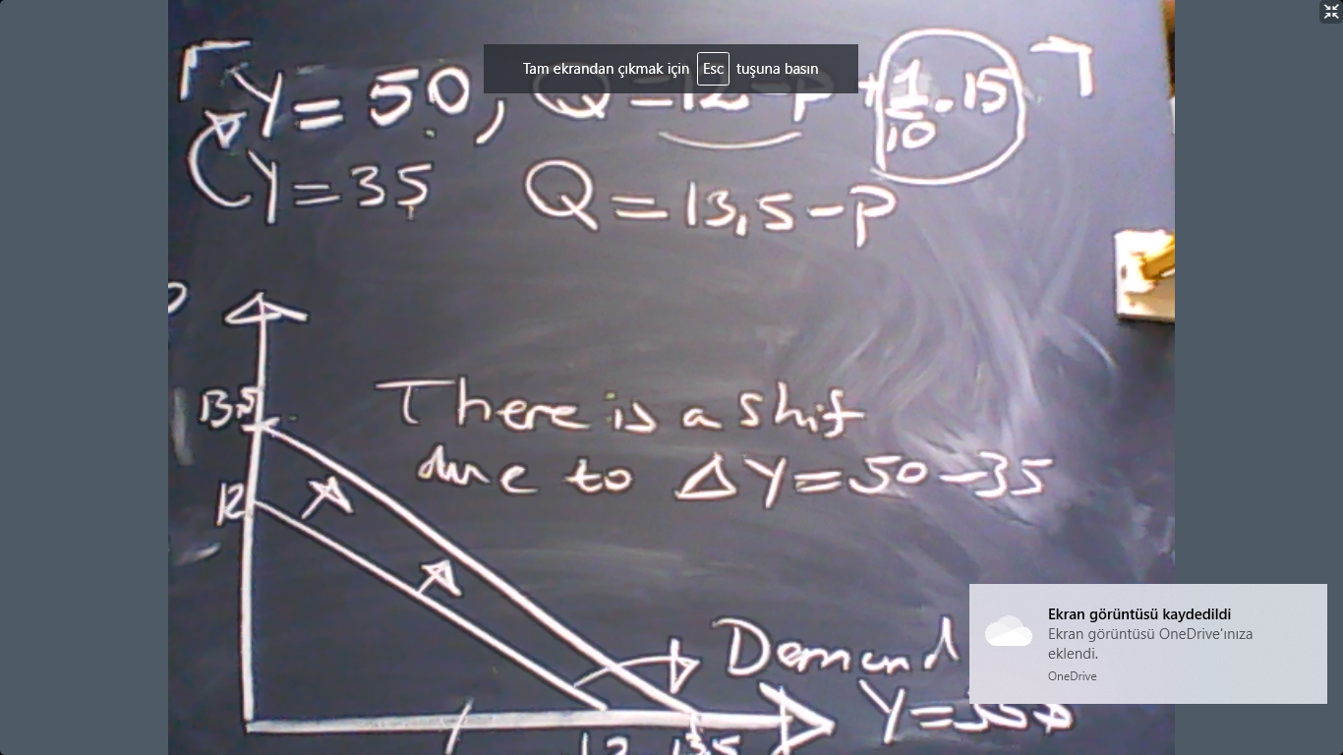

Now we can discuss supply. Again consider the coffee market. If we write $Q$ for the supply of coffee, then it a function:
$$Q=S(p,p_{c})$$
where $p_{c}$ is the price of cocoa, an important ingredient for the production of coffee. In general, the prices of inputs affect supply.
The price of coffee would have a positive effect on $S$ because coffee producers were not cultivating some land before the price increase (because land rent was too high). But not coffee is sufficiently expensive to cultivate even in expensive lands. This is a demonstration of trade-off and alternative-cost. If the price coffee goes even higher, then they would take land from other producers such as wheat, maze, or corn. This means cost of production increases with the price of the commodity because the producer would use even extra expensive methods of production to produce more when prices are high. This is called the law of supply.
Remark: The prices of other commodities such as tea or soda would not effect the supply decision of coffee producers. What we consider here is a competitive economy where there are many producers and many consumers. Therefore, no one has a concern about whether he/she would be able to find a customer. Demand is not something a single producer can control. Therefore, all producers think that “if this is the market price, then there is a consumer for it”. So the idea that “high tea prices would encourage coffee demand” is not an issue for the coffee producer.
Remark: In general, the suppliers of a good in a competitive economy would only take the price of their supply and the prices of relevant inputs into account. Other products’ prices are irrelevant in a competitive world.
Suppose that the supply of coffee is given by
$$Q=9.6+0.5p-0.2p_{c}.$$
As we can see, the law of supply is satisfied. And the price of inputs have a negative impact on supply, as well. Assume that the price of cocoa is $p_{c}=3$. Then the supply relation would be:
$$Q=9+p/2.$$
Let us draw that:
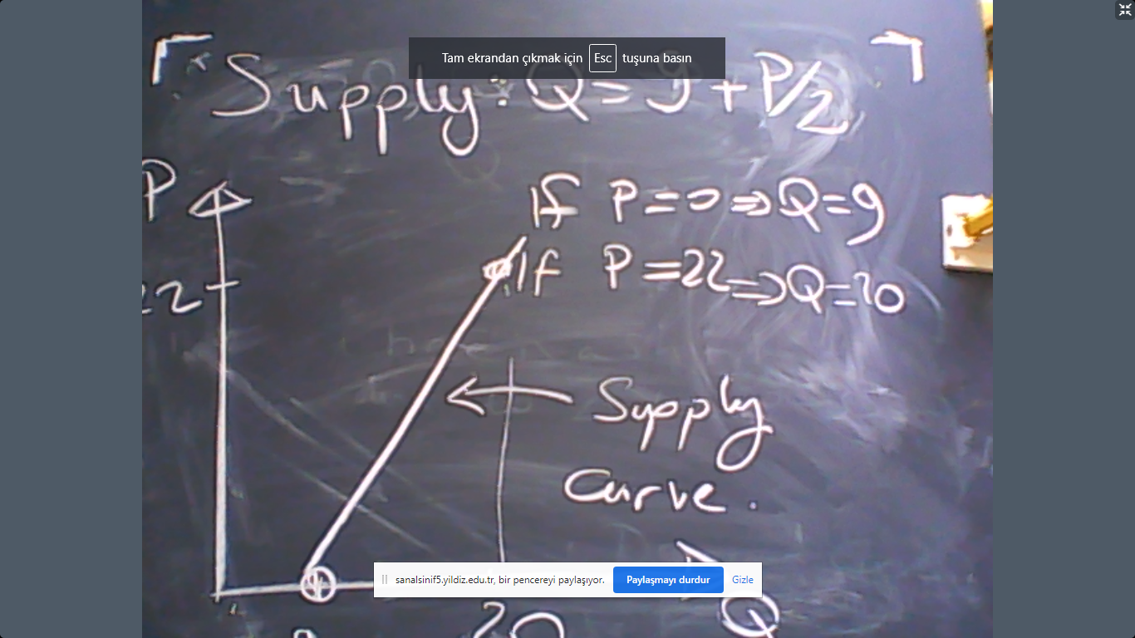
As it is the case with the demand curve, the change in $p$ means moving along the curve while change in other variables would cause the curve to shift. For example, an increase in the price of cocoa, $p_{c}$, would curve the shift leftward. You can easily draw its graph.
Market equilibrium:
The market economy achieves its equilibrium when demand and supply are equal. This is not a legal or mechanical consequence. The market forces oblige the equality of supply and demand. This would mean in our example
$$Supply=Demand$$
$$9+\frac{p}{2}=12-p.$$
The solution would be $p^{*}=2.$ Let us see this equilibrium point on the graph:
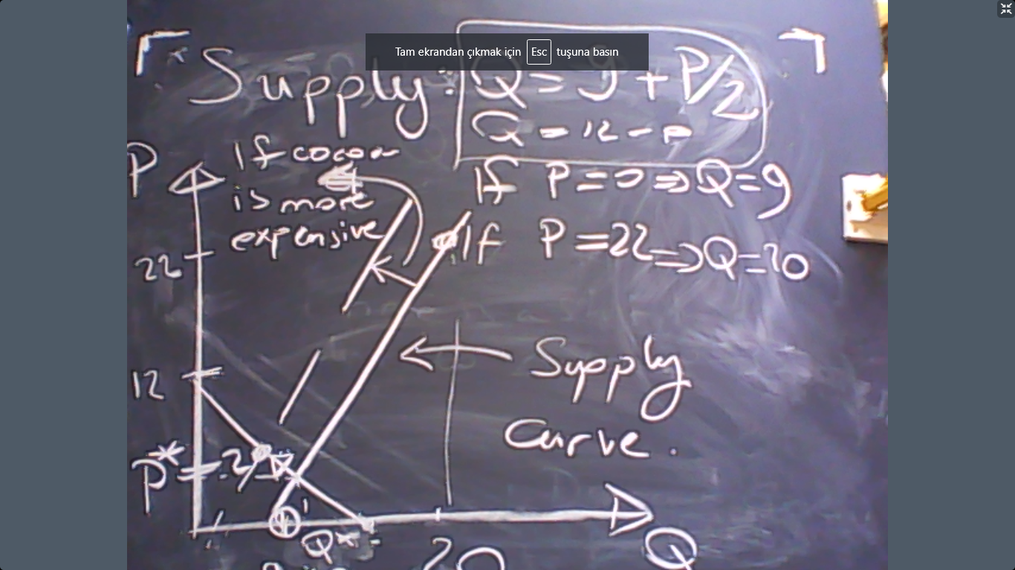

But why do we calculate the equilibrium price? That is because, other prices where $S≠D$ would immediately disappear from the market until $S=D$ is achieved. If $S>D$, then prices would go down. And if $D>S$ then prices would go up. Excess supply means underbidding by the producers and excess demand means overbidding by the consumers. So the competitive market equilibrium is a self-organizing system which achieves its equilibrium without any intervention or planning. This is called the invisible hand, a term famously coined by Adam Smith.

Now let us ask ourselves, how the market equilibrium would be affected by a change in another variable. Suppose that cocoa is more expensive. Then?
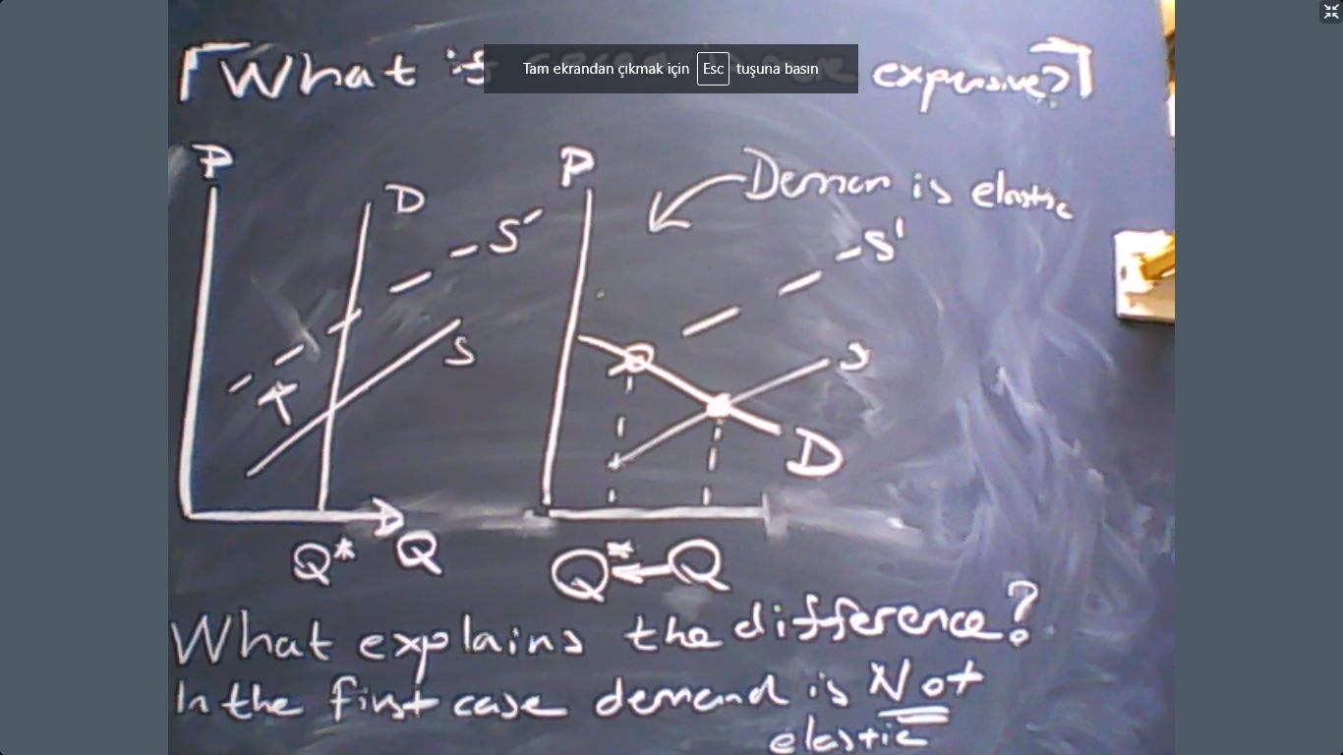
The answer obviously depends on the shape of the demand curve, in particular its elasticity.
Elasticity is a measure of sensitivity. If we calculate the price elasticity of demand, then we measure %change in $D$ due to 1% increase in $P$. First of all, note that
$$\% change in P=\frac{Change in P}{P}=\frac{dP}{P}.$$
Likewise,
$$\% change in D=\frac{Change in D}{D}=\frac{dD}{D}.$$
Therefore, by definition of elasticity
$$\frac{\%Change in D}{\%Change in P}=ϵ_{D,P}=\frac{\frac{dD}{D}}{\frac{dP}{P}}=\frac{dD}{dP}\frac{P}{Q}.$$
The final result is
$$ϵ_{D,P}=\frac{dD}{dP}\frac{P}{Q}.$$
Example: Linear demand. Suppose that $P=a-b×Q$ where a and b are constants. In this case, assuming $Q=D,$
$$\frac{dD}{dP}=-\frac{1}{b}.$$
Therefore, the elasticity is
$$ϵ_{D,P}=-\frac{1}{b}\frac{P}{Q}=-\frac{1}{b}\frac{a-b×Q}{Q}=-\frac{1}{b}\left(\frac{a}{Q}-b\right)=-\frac{a}{bQ}+1$$
So the answer depends on what the value of $Q$ is. Let us see that graphically:
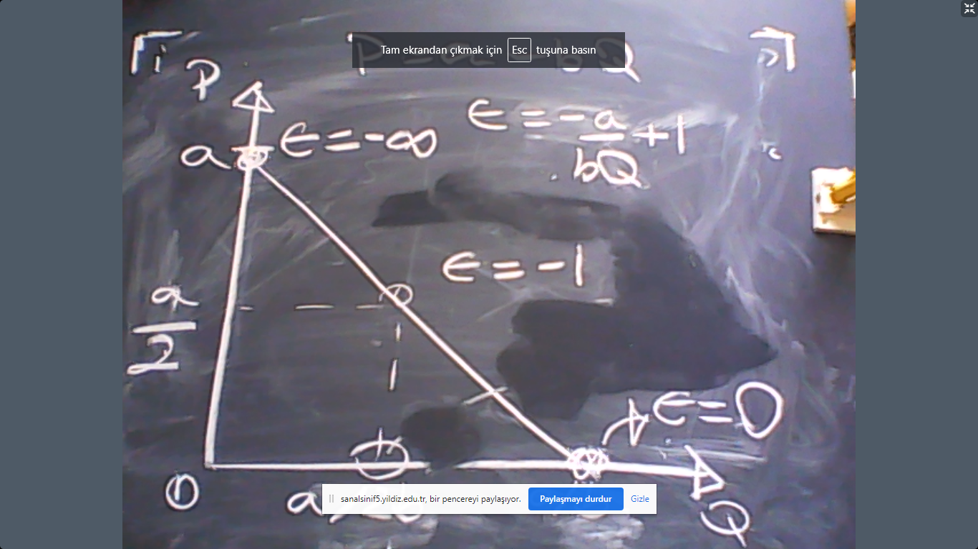

$ϵ=-1$ is unit elasticity. 1 percent increase in price causes 1 percent decrease in demand.
If $ϵ>-1$, then the demand is inelastic.
If $ϵ<-1$, then the demand is elastic.

Q1: Suppose that $ϵ=-2$. Then is demand elastic or not? (Answer: elasic)
Q2: Note that $ϵ≤0$. Why? Why cannot we see a positive price elasticity of demand?
Answer: Suppose that $ϵ>0.$ Then
$$ϵ=\frac{dD}{dP}\frac{P}{Q}>0.$$
But $P$ and $Q$ are already positive. Then this would mean
$$\frac{dD}{dP}>0.$$
However, this violates “the law of demand” which says “the slope of demand with respect to its price is negative”. Therefore, the law of demand ensures that the elasticity is negative.

