Distribution and Efficiency
Consider two individuals who are cake enthusiasts. There is a cake to be share between them but the size of the cake is fixed.
Definition: The share of individual $i=1,2$ is denoted by $s_{i}∈\left[0,1\right]$. We say that $(s_{1},s_{2})$ is feasible if and only if $s_{1}+s_{2}≤1$.
Suppose that the utility from having a share from the cake is $u_{i}(s_{i}$) for each $i=1,2$. The fact that these two individuals love cake means
$$\frac{du_{i}}{ds_{i}}>0.$$
The interpretation is that the more you get the happier you are.
Example: For instance $u_{1}=100s_{1}$ and $u_{2}=e^{s_{2}}.$
Consider any feasible allocation, $(s_{1},s_{2})$. How can we decide whether $(s_{1},s_{2})$ is an efficient allocation? The standard way to do this in economics is to use Pareto-efficiency criterion.
Definition: A feasible allocation $(s_{1}^{*},s_{2}^{*})$ is Pareto-efficient if for any other feasible sharing $(s_{1},s_{2})$ the following condition holds:
$$u_{1}\left(s_{1}^{*}\right)<u_{1}\left(s_{1}\right) implies u_{2}\left(s_{2}^{*}\right)>u_{2}\left(s_{2}\right).$$
Interpretation: If a sharing is efficient, then both individuals cannot be better-off at some other alternative allocation.
Question: Is $\left(s_{1}^{*},s_{2}^{*}\right)=(1/2,1/2)$ efficient?
Answer: This is efficient. That is because, there is no alternative sharing where both individuals are better-off. For example, if individual 1 is better-off then she would get more than ½. This would however imply that individual two gets less ½ so individual 2 is not better-off. Conclusion: it is not possible to make everyone better-off if they equally share the cake.
Question: Is $\left(s_{1}^{*},s_{2}^{*}\right)=(1/3,1/3)$ efficient?
Answer: There is some cake left on the table. So we can make both individuals better-off without hurting any of them. Conclude that $\left(s_{1}^{*},s_{2}^{*}\right)=(1/3,1/3)$ is inefficient.
Remark: Any sharing that satisfies $s_{1}+s_{2}=1$ is Pareto-efficient (optimal) in this example.
Now consider a where 2 individuals share cake and coffee. Let $\left(x_{i},y_{i}\right)$ denote the (coffee, cake) consumption by individual $i=1,2$. Suppose that the total amount of available coffee and cake is given by $(\overline{x},\overline{y})$. The utility of individual $i$ is $u_{i}\left(x_{i},y_{i}\right).$
Definition: $\left(x_{i},y_{i}\right), i=1,2$ is feasible if and only if $x_{1}+x_{2}≤\overline{x}$ and $y_{1}+y_{2}≤\overline{y}$.
Now we can generalize our Pareto-efficiency definition to cases in which there are multiple good:
Definition: A feasible allocation $\left(x_{i}^{*},y_{i}^{*}\right), i=1,2$ is Pareto-efficient if for any other feasible allocation $\left(x_{i},y_{i}\right), i=1,2$ the following condition holds:
$$u_{1}\left(x_{1}^{*},y_{1}^{*}\right)<u_{1}\left(x_{i},y_{i}\right) implies u_{2}\left(x_{2}^{*},y_{2}^{*}\right)<u_{2}\left(x_{2},y_{2}\right).$$
Interpretation: The same. If an allocation is efficient, then no other alternative can make both individuals better-off.
Remark: Suppose that individual 1 own all the coffee and individual 2 owns all the cake. Although a similar distribution in the first example was efficient, in this case this is clearly not efficient. That is because, both individuals would be better-off if they traded their coffee and cake. This is the foundation of the market economy and international trade.
Theorem: An allocation $\left(x_{i}^{*},y_{i}^{*}\right), i=1,2$ is Pareto-efficient if
$$MRS_{x,y}^{1}=MRS_{x,y}^{2}$$
and $x_{1}+x_{2}=\overline{x}$ and $y_{1}+y_{2}=\overline{y}.$

Example: Now let us consider an example where MRSs are not equal and see that this cannot be Pareto-efficient. Our strategy is to demonstrate that there is an alternative allocation where everyone is better-off when MRSs are unequal.
So assume that
$$MRS_{x,y}^{1}=2$$
(MUx/MUy=2. If individual 1 gets 1 small extra unit of x then she could give in return 2 units of y)
$$MRS_{x,y}^{2}=1/3.$$
(MUx/MUy=1/3. If individual 1 gets 1 small extra unit of y then she could give in return ? units of x)
Now let us suppose that individual 1 offers the following trade deal “give me 1 unit of x and I will give you 1 unit of y”. If individual 2 agrees, then she would get
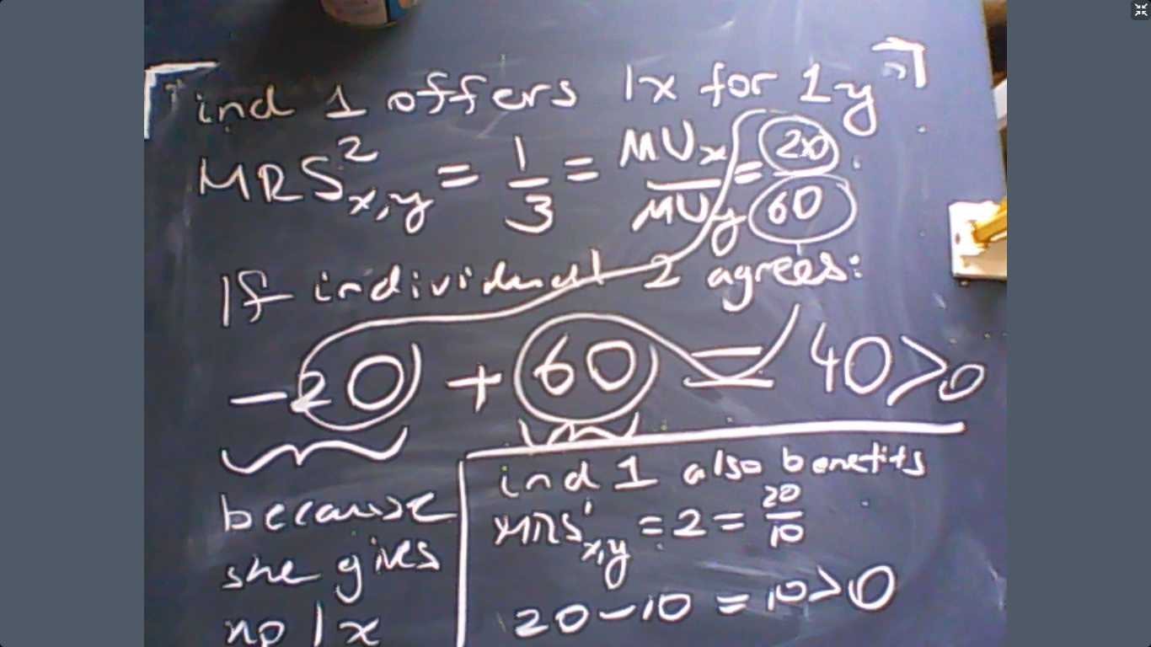
So this discussion shows us that whenever MRSs are unequal, one of the individuals have the motivation to offer a trade deal to the other individual which would make everyone better-off. This means that the original allocation is not efficient.
Now let us analyze a specific example. Assume that the utility functions of each individual is given by:
$$u_{1}=x_{1}y_{1}$$
$$u_{2}=\ln{x_{2}}+3\ln{y_{2}}$$
Moreover, assume that $\overline{x}=1$ and $\overline{y}=1$. Is equal sharing efficient?
Answer: The MRS for individual 1 is
$$MRS_{x,y}^{1}=\frac{y_{1}}{x_{1}}$$
$$MRS_{x,y}^{2}=\frac{y_{2}}{3x_{2}}.$$
We ask whether equal sharing is efficient. This means everyone gets ½ from all goods because there is 1 unit available from each good. Therefore,
$$MRS_{x,y}^{1}=1$$
$$MRS_{x,y}^{2}=\frac{1}{3}.$$
So MRS are not equal and equal sharing is not efficient. A possible trade deal that would be better for everyone is “2 x for 1 y”.

Of course, this trade deal would improve both individual’s well-being. But as they engage in trade more and more there would be less room left for trade. Eventually, there would be no motivation for further trade. This point is called the market equilibrium. The rate of change (i.e. price) between good x and good y at this point is also the market equilibrium price.
In the next section we will discuss how to compute the market equilibrium.
Equilibrium
Until now we did not specify how much income each individual has. This income level depends on what the individual can supply in the market. So we will assume that each individual has some coffee and some cake from the beginning and then let the individuals trade in the market. We will try to calculate the equilibrium prices where demand and supply for coffee and cake are equal.
Consider the following example: There are two individuals with the following utility functions.
$$u_{1}={\left(x_{1}y_{1}\right)}^{1/2}$$
$$u_{2}={\left(x_{2}\right)}^{1/2}+{\left(y_{2}\right)}^{1/2}.$$
Suppose that individual 1 owns 1 unit of $x$ and individual $2$ owns 1 unit of $y$. These are called “initial endowments”.
Initial endowments are denoted by $e_{1}=(1,0)$ and $e_{2}=(0,1)$. Let us write $p_{x}$ for the price of good $x$ and $p_{y}$ for the price of good $y$. So the income of individual 1 is
$$e_{1}.\left(p_{x},p_{y}\right)=p_{x}.$$
The income of individual 2 is:
$$e_{2}.\left(p_{x},p_{y}\right)=p_{y}.$$
So the budget constraint of individual 1 is
$$p_{x}x_{1}+p_{y}y_{1}=p_{x}$$
$$Expenditure=Income.$$
So individual 1 solves
$$\max{{\left(x_{1}y_{1}\right)}^{1/2}}$$
s.t.
$$p_{x}x_{1}+p_{y}y_{1}=p_{x}.$$
If we apply the utility maximization solution technique that we discussed in the previous class, then we should solve these two equations:
$$MRS_{x,y}^{1}=\frac{p_{x}}{p_{y}}$$
$$p_{x}x_{1}+p_{y}y_{1}=p_{x}.$$
But note that
$$MRS_{x,y}^{1}=\frac{MU_{x}}{MU_{y}}=\frac{\frac{1}{2}×{\left(\frac{y_{1}}{x_{1}}\right)}^{\frac{1}{2}}}{\frac{1}{2}×{\left(\frac{x_{1}}{y_{1}}\right)}^{\frac{1}{2}}}=\frac{{\left(\frac{y_{1}}{x_{1}}\right)}^{\frac{1}{2}}}{{\left(\frac{x_{1}}{y_{1}}\right)}^{\frac{1}{2}}}=\frac{y_{1}}{x_{1}}.$$
So we want to solve the following two equations:
$$p_{x}x_{1}+p_{y}y_{1}=p_{x}$$
$$\frac{y_{1}}{x_{1}}=\frac{p_{x}}{p_{y}}.$$
The MRS=px/py equation (the second equation) tells us that $p_{x}x_{1}=p_{y}y_{1}.$ Therefore, the budget constraint implies that
$$2p_{x}x_{1}=p_{x}$$
$$x_{1}=1/2.$$
This completes the optimization problem for individual 1: she would consume $x_{1}=1/2$.
Now individual 2 solves
$$\max{{\left(x_{2}\right)}^{1/2}+{\left(y_{2}\right)}^{1/2}}$$
s.t.
$$p_{x}x_{1}+p_{y}y_{1}=p_{y}.$$
If we again apply the utility maximization solution technique that we discussed in the previous class, then we should solve these two equations:
$$MRS_{x,y}^{2}=\frac{p_{x}}{p_{y}}$$
$$p_{x}x_{1}+p_{y}y_{1}=p_{y}.$$
Note that
$$MRS_{x,y}^{2}=\frac{MU_{x}}{MU_{y}}=\frac{\frac{1}{2}×{\left(x_{2}\right)}^{-\frac{1}{2}}}{\frac{1}{2}×{\left(y_{2}\right)}^{-\frac{1}{2}}}=\frac{{\left(\frac{y_{2}}{x_{2}}\right)}^{\frac{1}{2}}}{{\left(\frac{x_{2}}{y_{2}}\right)}^{\frac{1}{2}}}={\left(\frac{y_{2}}{x_{2}}\right)}^{\frac{1}{2}}.$$
So we want to solve the following two equations:
$$p_{x}x_{2}+p_{y}y_{2}=p_{y}$$
$${\left(\frac{y_{2}}{x_{2}}\right)}^{\frac{1}{2}}=\frac{p_{x}}{p_{y}}.$$
The second MRS=px/py equation tells us that $p_{x}^{2}x_{2}=p_{y}^{2}y_{2}.$ Therefore, the budget constraint implies that
$$p_{x}x_{2}+p_{x}^{2}x_{2}=p_{y}.$$
So the final result (x demand by individual 2) is
$$x_{2}=\frac{p_{y}}{p_{x}+p_{x}^{2}}.$$
In equilibrium, we must have $x_{1}+x_{2}=1$. Therefore,
$$\frac{p_{y}}{p_{x}+p_{x}^{2}}=\frac{1}{2}.$$
If we calculate the price of $x$ in terms of good $y$ then $p_{y}=1$. In technical terms, we take good $y$ as the numeriare. This makes sense because only relative prices do matter. In this case, our equation becomes
$$\frac{1}{p_{x}+p_{x}^{2}}=\frac{1}{2}$$
whose solution is $p_{x}=1$. The interpretation is that “1x costs 1y” is an equilibrium price.
Equilibrium means “all individuals consume and supply goods to maximize their utilities and the prices guarantee that supply and demand are equal, (so utility maximization is feasible.)”
Remark: Note that the market equilibrium is Pareto-efficient! That is because, MRSs are equal to the relative prices for both individuals.

The computational discussion thus far can also be visualized by the standard demand-supply curves. The idea is that the point at which $S=D$ constitutes the market equilibrium. This can be seen below:
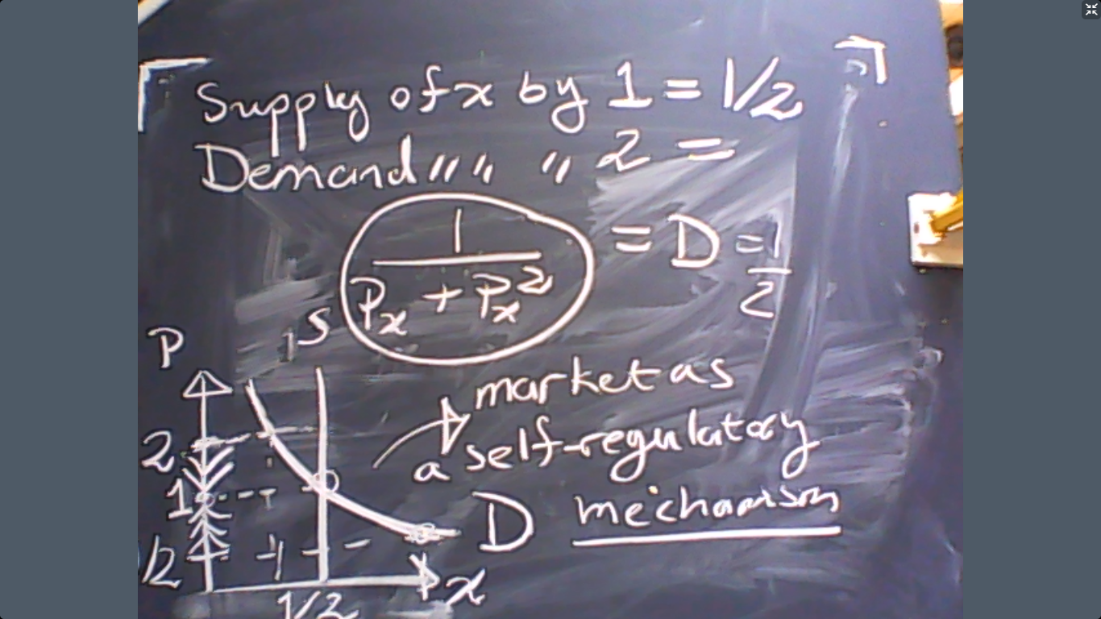

As the diagram shows, the equilibrium point is self-correcting or self-regulatory. If prices are too high, then excess supply would reduce the prices and correct the equilibrium. Likewise, too low prices would also correct the equilibrium by raising the prices due to excess demand. (These processes can be seen above).
Edgeworth Diagram (Box)
Consider an economy with 2 individuals. The initial endowments of individual 1 and 2 are given by
$$e_{1}=(2,0)$$
$$e_{2}=\left(1,3\right).$$
So the total available amounts of good 1 and good 1 are (3,3). We can plot all possible feasible allocations and the initial endowments in this economy using the classic Edgeworth box.
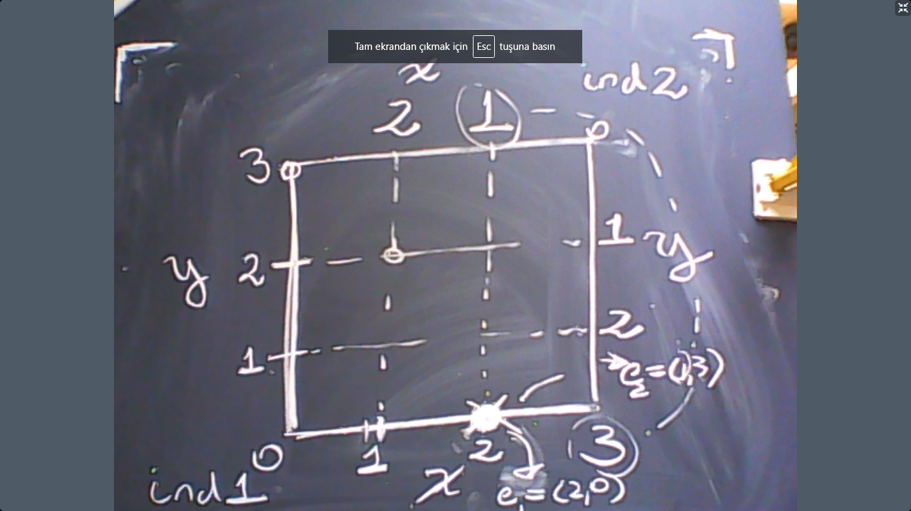

The advantage of the Edgeworth Box is how practical it is to plot all feasible allocations. These feasible allocations include the initial endowment and also the market equilibrium. The equilibrium is not shown above because we have not calculated the equilibrium yet. Nevertheless, we will. And then we can put it there.
Another advantage is that we can also depict the indifference curves of the individuals over the Edgeworth box. Why is this useful? Because this would show us how much utility each individual gets or loses by a trade deal, and how beneficial the market allocation is.
To plot the indifference curves, recall that the mathematical concept is solving
$$u_{1}\left(x_{1},y_{1}\right)=Constant_{1}$$
$$u_{2}\left(x_{2},y_{2}\right)=Constant_{2}$$
where the constants are arbitrary.
For example, assume that
$$u_{1}=\ln{x_{1}}+y_{1}.$$
Her utility at the autarky is
$$u_{1}=\ln{2}+0=\ln{2}.$$
So what are other consumption bundles that would give the same utility with the autarky? This is the indifference curve passing through the autarky. By definition, we must solve:
$$\ln{2}=\ln{x_{1}}+y_{1.}$$
Rearranging gives
$$\ln{\frac{2}{x_{1}}}=y_{1.}$$
The graph of this function (indifference curve) on Edgeworth Box is below:
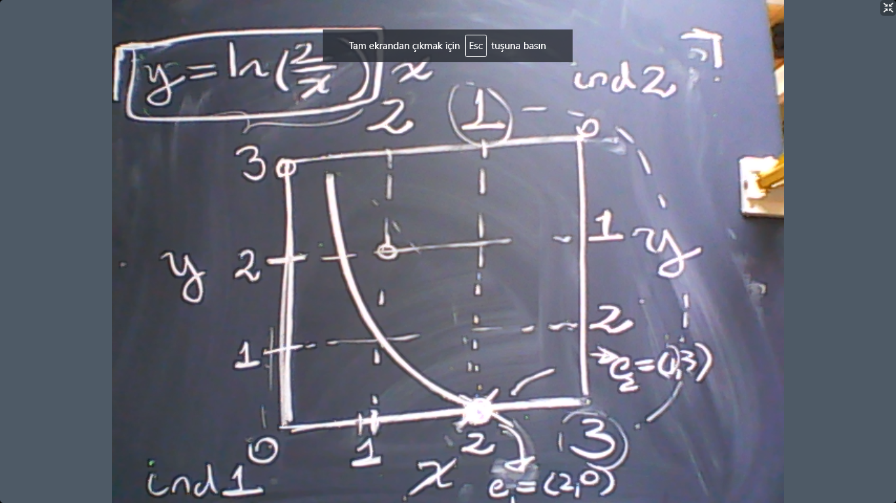
Assume that the utility function of individual 2 is given by
$$u_{2}=x_{2}y_{2}.$$
Recall that the initial endowments for individual 2 is$$e_{2}=\left(1,3\right).$$
Now we can plot the indifference curve of individual 2 passing through the autarky as well.

