**MATERIALS USED IN MAIN PARTS and BODY OF AN AUTOMOBİLE**

Before studying the materials employed in BIW (Body in White) construction, it is first useful to examine the contribution of each component to overall vehicle weight (see Fig. 2.1). Flat strip products comprise a major part of the vehicle structure and body comprises the largest segment (Fig.2.1)



**Figure 2.1** Contribution of body-in-white to overall vehicle weight



**Figure 2.2** Sheet steel content / form within the overall vehicle construction of a typical family car.

**Body in white** or **BIW** refers to the stage in automotive design or [automobile manufacturing](http://en.wikipedia.org/wiki/Automotive_industry) in which a car body's sheet metal components have been welded together — but before moving parts (doors, hoods, and deck lids as well as fenders) the motor, chassis sub-assemblies, or trim (glass, seats, upholstery, electronics, etc.) have been added and before painting.

**There are two kinds of BIW Structures :**

1. **Monocoque :** In this type of structure, all the members of the body carries load and they are integrated with each other. Here chassis is inbuilt with the BIW itself and there is no separate chassis. Wheels are directly mounted to the BIW with the help of suspension system. Used in all the passenger cars and to some extent in utility vehicles.
2. **Body on frame :** In this type of body construction, the body is placed on frame which is the major load carrying member. Body is mounted on a separate chassis/frame and the wheels are mounted on the chassis and not to the body. Used in utility vehicles, trucks, buses.

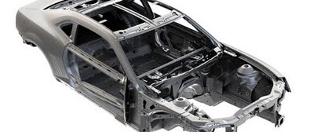

**Fig.2.3** Automakers like Ford Motor Company and General Motors offer for sale Body In White (BIW) kits like the 2010 Camaro pictured above

The increased utilization of high strength steels through various generations of vehicles is shownin Figure 2.4. The most evident recent trends are the increased proportion of dualphase (DP) steels (over 30%) plus the rise in the use of press-hardened or ultra-highstrength steels (UHSSs), averaging 8%.

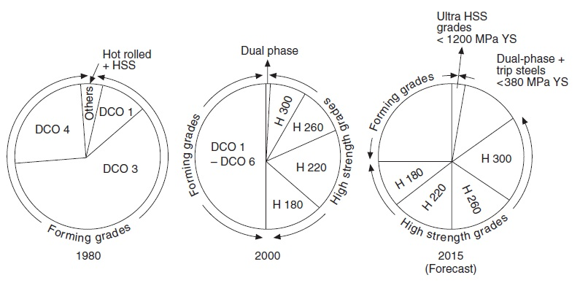

**Figure 2.4** Increasing utilization of high-strength steel grades

Environmental concerns were emerging through the 1980s and 1990s relating to

issues such as emissions control. However, efforts by carmakers intensified as

governmental pressures appeared, requiring progressively lower levels of CO2

output (in terms of grams per kilometer) and giving tax incentives for lower rated

cars. With this came a greater need for weight reduction, prompting the development

of even lighter structures; it has strengthened the case for aluminum and plastics.

However, further environmental pressures, legislation and governmental targets

represents a step change in material utilization and examples are given of this type of

technology being applied to existing models.

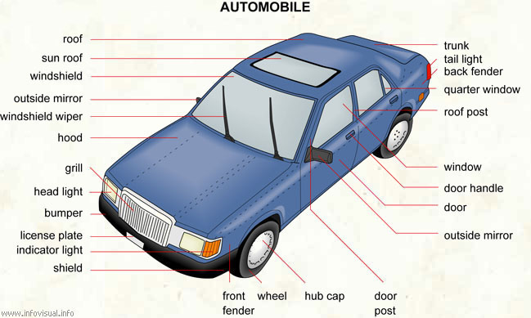

|  |
| --- |
| **Automobile**: road vehicle that is motor-driven and is used for transporting people. **Trunk**: place for stowing baggage. **Tail light**: rear light. **Back fender**: side rear part of the body that covers the wheel. **Quarter window**: window pane situated approximately above the rear wheel. **Roof post**: vertical structure that supports the top of the car. **Window**: mounted pane of glass. **Door handle**: part of the door used to open it. **Door**: opening used to enter the passenger compartment. **Outside mirror**: external mirror used for looking backwards. **Door post**: vertical structures that encase the windows. **Hub cap**: piece of metal covering the hubs. **Wheel**: round object that turns around a central axel and allows the car to advance. **Front fender**: side fore part of the body that covers the wheel. **Shield**: movable apparatus that protects against bumps. **Indicator light**: amber light that is used to signal changes in the car's direction. **License plate**: piece of metal that carries a number used to identify the automobile. **Bumper**: apparatus at the front and rear of a vehicle that protects the body from minor bumps. **Head light**: front light of a car. **Grill**: plastic or metal decoration over the radiator. **Hood**: cover of the engine compartment at the front of a car. **Windshield wiper**: movable device made partly of rubber that wipes the windshield and rear window of a car. **Outside mirror**: external mirror used for looking backwards. **Windshield**: the front window of a car. **Sun roof**: movable part that allows the roof of a car to be partially opened. **Roof**: upper part of a car, covering the passenger compartment. |

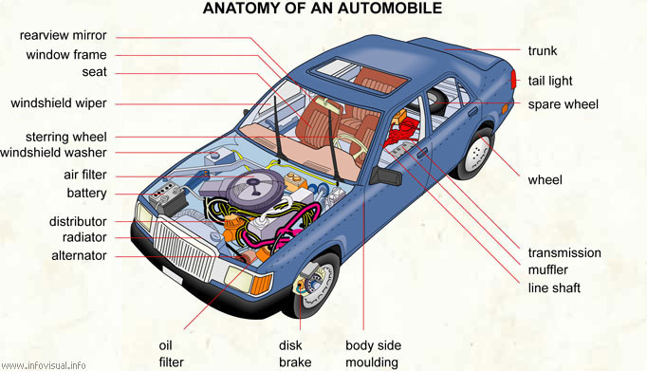

|  |  |
| --- | --- |
| **Anatomy of an automobile**: road vehicle that is motor-driven and is used for transporting people. **Trunk**: place for stowing baggage. **Tail light**: rear light. **Spare wheel**: wheel of a car used to replace a damaged wheel. **Wheel**: round object that turns around a central axel and allows the car to advance. **Transmission**: automobile apparatus that transmits mechanical power to the wheels. **Muffler**: device used to reduce engine noise. **Line shaft**: axle on which mechanical power is transmitted to the wheels. **Body side moulding**: decorative moulding on the side of a car. **Disk brake**: mechanism that slows and stops a car by friction, by pressing a disk against the axel of a wheel. **Oil filter**: device that removes impurities from oil passing through it. **Alternator**: generator that produces an alternating current. **Radiator**: apparatus that cools the motor. **Distributor**: case that is used to fire the cylinders. **Battery**: device that generates electric current. **Air filter**: device that remove impurities from air passing trough it. **Windshield washer**: liquid used to clean the windows. **Steering wheel**: device used to handle a car in conjunction with steering and gear systems. **Windshield wiper**: movable device made partly of rubber that wipes the windshield and rear window of a car. **Seat**: type of armchair in the passenger compartment of a car. **Window frame**: border around a window. **Rearview mirror**: inside mirror used for looking backward.  Automobile (view from below)   |  | | --- | | **Automobile (view from below)**: road vehicle that is motor-driven and is used for transporting people. **Radiator**: apparatus that cools the motor. **Power steering**: mechanism that automatically amplifies the movements of the steering wheel. **Line shaft**: axle on which mechanical power is transmitted to the wheels. **Exhaust system**: network of pipes through which spent gas is expelled. **Differential**: gear system connecting the two axles of a car. **Gas tank**: container used for storing extra gas. **Rear axle**: bar that crosses the bottom rear part of a vehicle. The rear wheels are attached to its ends. **Shock absorber**: device for reducing shocks. **Tire**: band of rubber composed of a casing of textile and iron, covered with rubber and containing a air tube. **Hydraulic converter**: device using static energy to modify the electric current. **Transmission**: device carrying engine power to axles. **Crankcase**: metal envelope protecting the clutch. **Oil pan**: liquid tight metal envelope containing oil. **Master cylinder**: type of container in which the piston is moving. | |

**Body zones, Terminology and Materials**

First, it is necessary to clarify the terminology used to differentiate the various areas

comprising the body. The body-in-white (BIW) splits down into the

main structure, ‘body-less-doors’, and the ‘bolt-on’ or skin assemblies. Each of these

in turn break down into the inner panel, usually deep drawn to provide bulk shape

and rigidity, plus the shallow skin panels, which provide the outer contour of the

body shape and require more aesthetic properties such as smooth blemish-free

surface and scuff or dent resistance. The key elements of the main structure are the

floor and main cage containing ‘A’, ‘B/C’ and ‘D’ posts or corner pillars and roof/

cantrail surround, plus closed sections such as cross members, and front and rear

longitudinal sections, which provide essential impact resistance. The requirements

of each zone are summarized in Table 2.1, together with recommendations for

appropriate steels and possible alternatives.

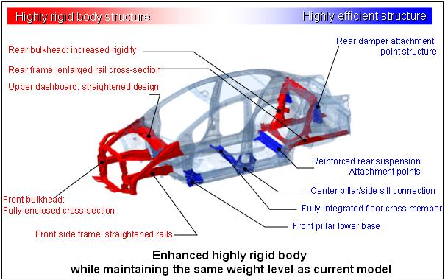

**Figure 2.5** shows main structure of body and the state-of-the-art deployment of steels within the body structure of a typical family sedan.

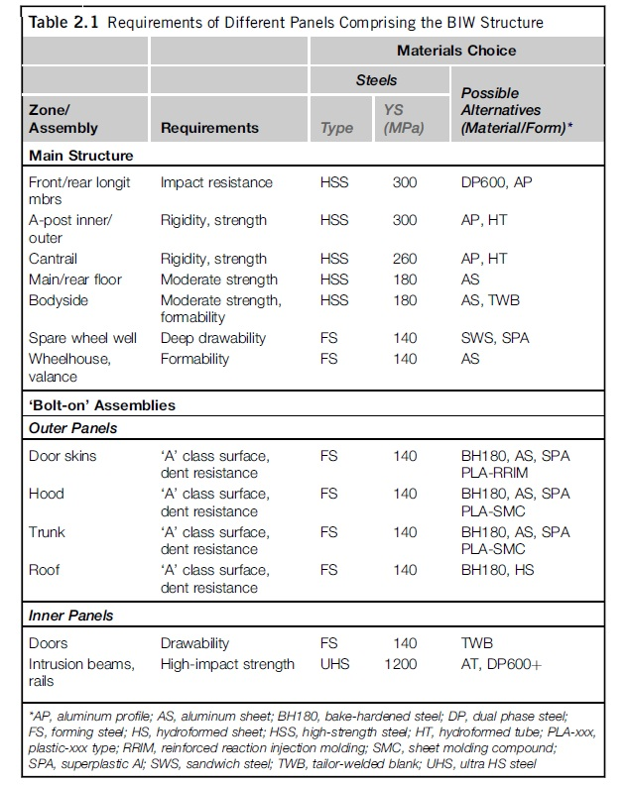

Front / rear longitudinal members connect the rear and front part of vehicle

A post inner / outer = Frame = Çerçeve

The cant rail of a vehicle is the structural member which runs over the top of the doors. The cant rail of vehicle is supported at the front by the A pillar, depending on the number of the doors, B, or C pillar at the rear. The cant rail can also act as a hausing for curtain airbags if a vehicle equipped with the feature.

Wheelhouse = Tekerleğin yerleştiği bölge

Dent resistance = Pitting / collapse resistance = Çöküntü, girinti, oyuk direnci

Instrusion beams = Kapı direği



**Fig. 2.9** Utilization of higher strength steels and tailor welded blanks in body

**Chemical Compositions and Mechanical Properties of Some Body Materials**

**BH (Bake hardening) Series**

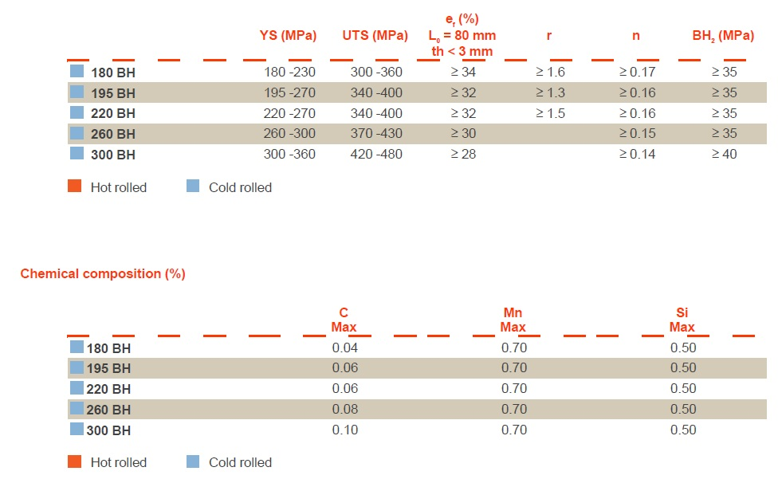

In literature BH series can also be called as H series and they are classified in the following forms;

**H Series (Solid Solution Steels –High Yield and tensile strength steels)**

Chemical Composition (%) and Mechanical Properties

**C max Mn max Si max YS (MPa) UTS (MPa) Elongation**

H180 0.040 0.70 0.50 180-240 300-360 > 35

H220 0.060 0.70 0.50 220-280 340-400 > 32

H260 0.080 0.70 0.50 260-320 380-440 > 29

H300 0.10 0.70 0.50 300-360 400-480 >26

Solid solution steels are designed to provide high strength while maintaining good drawability. These steels are hardened by phosphorous in solid solution in ferrite. These steels are used to produce parts such as longitudinal beam and cross members.

Figure 2.13 shows various forms of steel that could be used in body making in the future. At the present in addition to tailor welded blank and flexible roll forming, the major parts of body are produced by hot stamping. Techniques such as laser welding have also seen recent application, allowing stiffening of sections during assembly, enhancing the properties and even allowing localized heat treatment

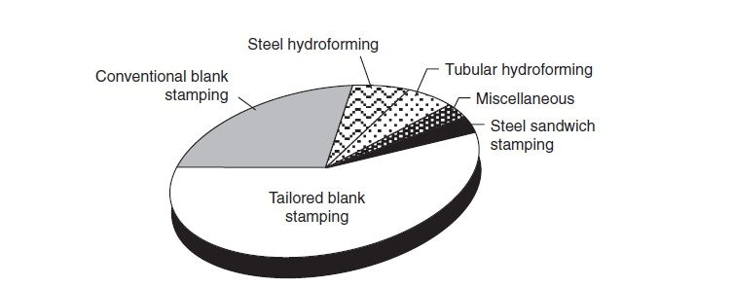

**Fig. 2.13** Utilization of different material forms in the future body structures

(Courtesy of ULSAB Consortium)

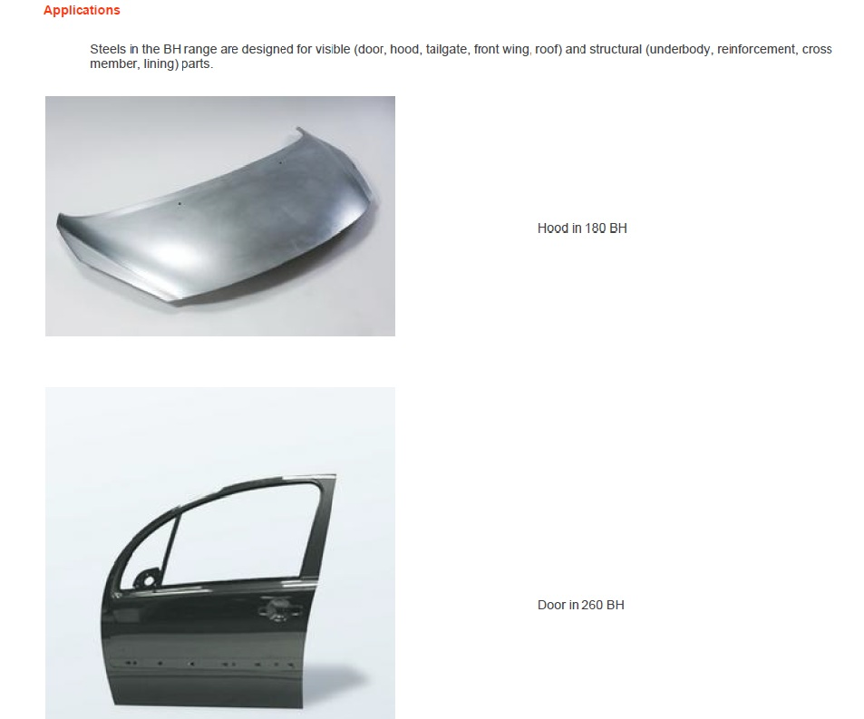

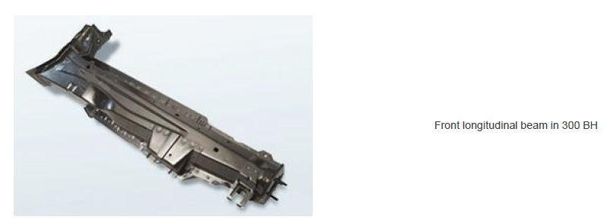

**DP 600 Steel**

Chemical Composition and mechanical properties of DP 600 steel are shown in the following tables.

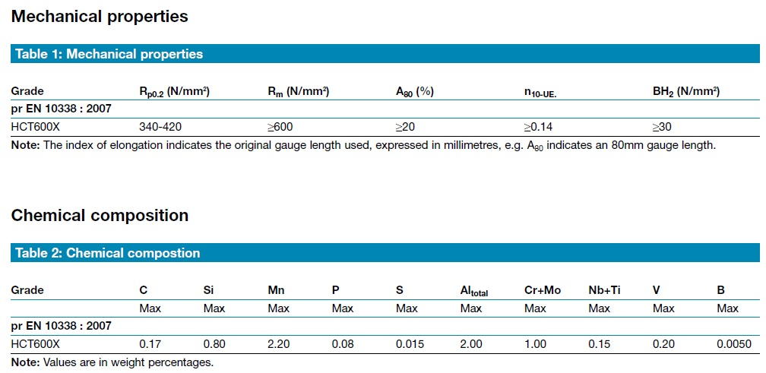

**DCO Series (Low carbon)**

