Group No | Students Info (ID Number, Name and Surname
Title: your topic from the list
Introduction
- Introduction about your material
- Properties, applications, Industrial importance, etc.
- this part must be max. 1 page.
-You can find how to add figures, tables, and citations below.
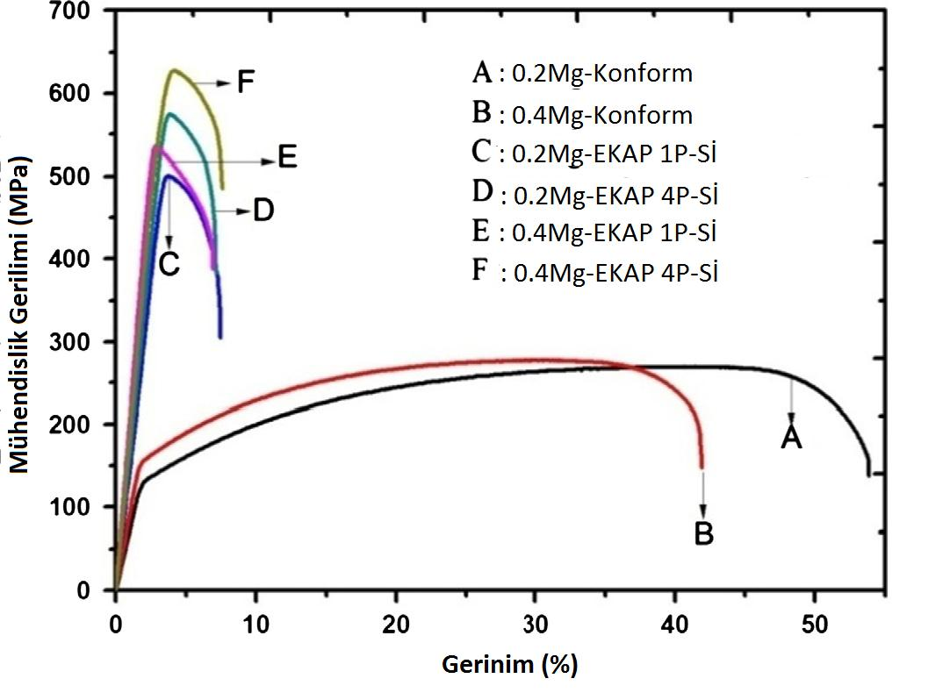
Figure. 1. Stress-Strain diagrams of EKAPed and cold worked Cu-Mg alloys (Gökduman vd. 2018)

Table 1. Parameters of EKAP conform process (Akduman vd. 2018)
Ekstrüzyon Çarkının Nominal Çapı (mm) | 400
Ekstrüzyon Çarkının Anma Hızı (rpm) | 12,5
Max. Ürün Genişliği (mm) | 170
Ürünün Kesit Alanı (mm²) | 100-2000
Ortalama Üretim (kg/h) | 1300
Hurda (%) | 5-8

Microstructure
- Explain the microstructure of your material starting with atomic bonds.
- Microstructure: crystal structure, phases, grain information (size, morphology etc. ), imperfections (defects) (slip bands, twins, stacking faults, grain boundaries, macro defects)

- This part must be max. 2 pages.
-You can find how to add figures, tables, and citations below.
Figure. 1. Stress-Strain diagrams of EKAPed and cold worked Cu-Mg alloys (Gökduman vd. 2018)

Table 1. Parameters of EKAP conform process (Akduman vd. 2018)
Ekstrüzyon Çarkının Nominal Çapı (mm) | 400
Ekstrüzyon Çarkının Anma Hızı (rpm) | 12,5
Max. Ürün Genişliği (mm) | 170
Ürünün Kesit Alanı (mm²) | 100-2000
Ortalama Üretim (kg/h) | 1300
Hurda (%) | 5-8

Strengthening Mechanisms-Microstructure Relation
- Explain the strengthening mechanisms that occur in your material.
- Define the strengthening mechanism. Give examples from similar materials that exhibit this mechanism, giving the values of the mechanical properties obtained with the mechanism.
-Explain the strengthening mechanism-microstructure (explained in the previous section) relation – this part must be max. 2 pages.
-You can find how to add figures, tables, and citations below.
Figure. 1. Stress-Strain diagrams of EKAPed and cold worked Cu-Mg alloys (Gökduman vd. 2018)

Table 1. Parameters of EKAP conform process (Akduman vd. 2018)
Ekstrüzyon Çarkının Nominal Çapı (mm) | 400
Ekstrüzyon Çarkının Anma Hızı (rpm) | 12,5
Max. Ürün Genişliği (mm) | 170
Ürünün Kesit Alanı (mm²) | 100-2000
Ortalama Üretim (kg/h) | 1300
Hurda (%) | 5-8

References
Gökduman, Aslıhan, (2018) Bakır alaşımlarının mı̇kroyapı, mekanı̇k ve elektrı̇ksel özellı̇klerı̇ üzerı̇nde eş kanallı açısal presleme-konform prosesı̇nı̇n etkı̇lerı̇nı̇n ı̇ncelenmesı̇, Yıldız Technical Üniversity, Thesis (Master of Science).
Yilmazer, H., Niinomi, M., Cho, K., Nakai, M., Hieda, J., Sato, S., Todaka, Y., Microstructural evolution of precipitation-hardened beta-type titanium alloy through high-pressure torsion, Acta Materialia. 80 (2014) 172-182.
– this part must be max. 1 page.

Instructions for the report preparation
- Title: Calibri, 12 pt., bold, align left,
- Text: Calibri, 11 pt., regular, align both side, Line spacing: 1,15.
- Captions of the figures and tables: bold numbering head like in the examples, Explanations: Calibri, 10 pt.,regular, align centered.
- Explanations of tables and figures should be given above the table and below the figure, paying attention to the ordinal numbers (Table 1., Table 2., Figure 1., Figure 2.).
- Tables and figures should also be used and explained in the text.
- All text, figures, tables and equations that do not belong to you should be given by citing the source.
  - The sources used will be written according to Harvard style. There are explanations for each source type in the link, please examine it carefully. You can also use the Mendeley program directly.
  - The sources used should be given next to the information in the text or at the end of the caption texts of the figure and tables like (Yilmazer et al., 2014, Kaya et al. 2014).
  - The cited sources should be listed alphabetically according to the surname of the first author in the References section.
- Citation should be based on ethical rules. You cannot directly copy and pasted. All reports must be checked by Turnitin, an Internet-based plagiarism detection service. The Turnitin report of the hmws must have a similarity less than 20% for overall and less than 2% for a reference.
- Do not prepare an extra cover page.
- The whole hmw report must be max. 6 pages.

