https://www.khanacademy.org/science/physics/one-dimensional-motion/acceleration-tutorial/a/acceleration-article

What does acceleration mean?
Compared to displacement and velocity, acceleration is like the angry, fire-breathing dragon of motion variables. It can be violent; some people are scared of it; and if it's big, it forces you to ttake notice. That feeling you get when you're sitting in a plane during take-off, or slamming on the brakes in a car, or turning a corner at a high speed in a go kart are all situations where you are accelerating.
Acceleration is the name we give to any process where the velocity changes. Since velocity is a speed and a direction, there are only two ways for you to accelerate: change your speed or change your direction—or change both.
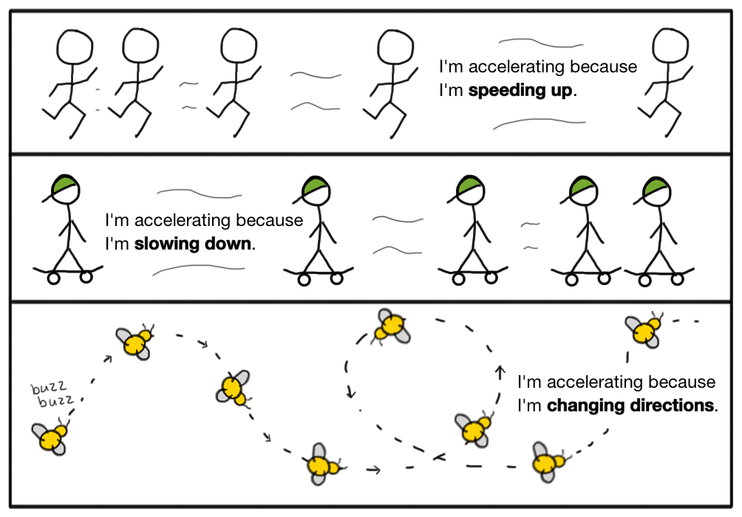
If you’re not changing your speed and you’re not changing your direction, then you simply cannot be accelerating—no matter how fast you’re going. So, a jet moving with a constant velocity at 800 miles per hour along a straight line has zero acceleration, even though the jet is moving really fast, since the velocity isn’t changing. When the jet lands and quickly comes to a stop, it will have acceleration since it’s slowing down.
In everyday language people use the word deceleration to describe slowing down. But in physics, we use the single term acceleration to mean any change in velocity, whether it be speeding up, slowing down, or changing direction.
Or, you can think about it this way. In a car you could accelerate by hitting the gas or the brakes, either of which would cause a change in speed. But you could also use the steering wheel to turn, which would change your direction of motion. Any of these would be considered an acceleration since they change velocity.
Some people erroneously think that changing directions isn't real acceleration, it is more of a technical acceleration. But changing directions is just as real of an acceleration as changing speed, as evidenced by the experience of someone sitting in between two other people on a bus taking a turn too quickly.

What's the formula for acceleration?
To be specific, acceleration is defined to be the rate of change of the velocity.
a=Δv/Δt = (vf−vi)/Δt
The above equation says that the acceleration, a, is equal to the difference between the initial and final velocities, vf−vi divided by the time, Δt, it took for the velocity to change from vi_ to vf Technically this is the formula for average acceleration since it is defined over a finite interval of time. For instantaneous acceleration, you would need to find the rate of change at a particular moment in time, which often requires calculus. Luckily for us, most introductory, algebra-based physics examples consider cases where acceleration is constant, in which case the rate of change over any interval is the same as the rate of change at any moment.
Note that the units for acceleration are m/s/s, which can also be written as m/s^2 . That's because acceleration is telling you the number of meters per second by which the velocity is changing, during every second. Keep in mind that if you solve a = (vf−vi)/Δt for vf you get a rearranged version of this formula that’s really useful. vf = vi+aΔt
This rearranged version of the formula lets you find the final velocity, vf, after a time, Δt of constant acceleration, a

What's confusing about acceleration?
I have to warn you that acceleration is one of the first really tricky ideas in physics. The problem isn’t that people lack an intuition about acceleration. Many people do have an intuition about acceleration, which unfortunately happens to be wrong much of the time. As Mark Twain said, “It ain’t what you don’t know that gets you into trouble. It’s what you know for sure that just ain’t so.”
The incorrect intuition usually goes a little something like this: “Acceleration and velocity are basically the same thing, right?” Wrong. People often erroneously think that if the velocity of an object is large, then the acceleration must also be large. Or they think that if the velocity of an object is small, it means that acceleration must be small. But that “just ain’t so”. The value of the velocity at a given moment does not determine the acceleration. In other words, I can be changing my velocity at a high rate regardless of whether I'm currently moving slow or fast.
To help convince yourself that the magnitude of the velocity does not determine the acceleration, try figuring out the one category in the following chart that would describe each scenario.
 | high speed, low acceleration | high speed, high acceleration | low speed, low acceleration | low speed, high acceleration
I wish I could say that there was only one misconception when it comes to acceleration, but there is another even more pernicious misconception lurking here—it has to do with whether the acceleration is negative or positive.
People think, “If the acceleration is negative, then the object is slowing down, and if the acceleration is positive, then the object is speeding up, right?” Wrong. An object with negative acceleration could be speeding up, and an object with positive acceleration could be slowing down. How is this so? Consider the fact that acceleration is a vector that points in the same direction as the change in velocity. That means that the direction of the acceleration determines whether you will be adding to or subtracting from the velocity. Mathematically, a negative acceleration means you will subtract from the current value of the velocity, and a positive acceleration means you will add to the current value of the velocity. Subtracting from the value of the velocity could increase the speed of an object if the velocity was already negative to begin with since it would cause the magnitude to increase. For example, if an armadillo started going left with a negative velocity of −3m/s and we subtract 1m/s from the velocity, the armadillo would speed up. Even though the velocity would become more negative, the magnitude of the velocity would increase and the armadillo would be covering more meters per second. −3m/s−1ms=−4m/ s
This shows that subtracting from the velocity (i.e., having a negative acceleration) can cause something to speed up.
If acceleration points in the same direction as the velocity, the object will be speeding up. And if the acceleration points in the opposite direction of the velocity, the object will be slowing down. Check out the accelerations in the diagram below, where a car accidentally drives into the mud—which slows it down—or chases down a donut—which speeds it up. Assuming rightward is positive, the velocity is positive whenever the car is moving to the right, and the velocity is negative whenever the car is moving to the left. The acceleration points in the same direction as the velocity if the car is speeding up, and in the opposite direction if the car is slowing down.
In the diagram below, and in most cases, the convention we will choose is to call right—or up—the positive direction for vectors and left—or down—the negative direction. If we adopt this convention, car velocities directed to the left are negative, and velocities directed to the right are positive.
There is, of course, nothing stopping us from calling leftward positive and rightward negative as long as we are consistent with that choice. If we choose left as positive, all the signs in the following diagram would be swapped, but the overall conclusion would remain. Namely, that when the velocity and acceleration point in the same direction (i.e., have the same sign) the car will be speeding up, and when the velocity and acceleration point in opposite directions (i.e., have opposite signs) the car will be slowing down.

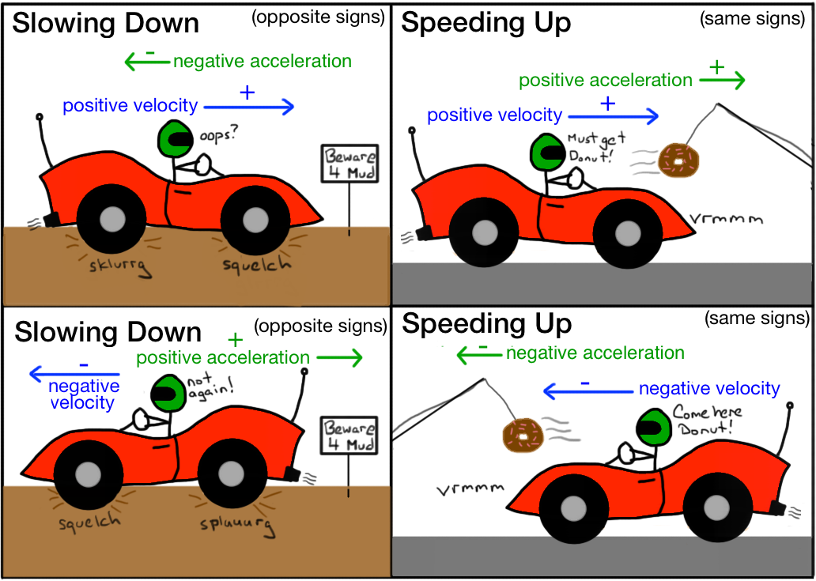
Another way to say this is that if the acceleration has the same sign as the velocity, the object will be speeding up. And if the acceleration has the opposite sign as the velocity, the object will be slowing down.

What do solved examples involving acceleration look like?

Example 1:
A neurotic tiger shark starts from rest and speeds up uniformly to 12 meters per second in a time of 3 seconds.
What was the magnitude of the average acceleration of the tiger shark?
Start with the definition of acceleration.
a=vf−viΔta= \dfrac {v_f-v_i}{\Delta t} \qquad a=Δtvf​−vi​​a, equals, start fraction, v, start subscript, f, end subscript, minus, v, start subscript, i, end subscript, divided by, delta, t, end fraction, space
Plug in the final velocity, initial velocity, and time interval.
a = (12m/s−0m/s)/3s
Calculate and celebrate!
a = 4m/s^2

Example 2:
A bald eagle is flying to the left with a speed of 34 meters per second when a gust of wind blows back against the eagle causing it to slow down with a constant acceleration of a magnitude 8 meters per second squared.
What will the speed of the bald eagle be after the wind has blown for 3 seconds?
Start with the definition of acceleration.
a = (vf−vi)/Δt
Symbolically solve to isolate the final velocity on one side of the equation.
vf = vi + aΔt
Plug in the initial velocity as negative since it points left.
vf=−34m/s+aΔt
We are choosing a convention where we treat rightward as the positive direction. But, you could have called leftward the positive direction if you wanted to, in which case the initial velocity would be positive, and the acceleration would be negative.
Plug in acceleration with opposite sign as velocity since the eagle is slowing.
vf=−34ms+8m/s^2Δt
If an object is slowing down, acceleration and velocity must have opposite signs. The initial velocity was negative since it was directed leftward and we chose to call rightward the positive direction. That means in order to have the opposite sign as the velocity, the acceleration should be positive.
You could, of course, choose to call leftward the positive direction, in which case the initial velocity would then be positive, and the acceleration would be negative. You would get the same answer for final velocity, except it would come out with the opposite sign compared to the final velocity you would get if you chose rightward as the positive direction.
Plug in the time interval during which the acceleration acted.
vf=−34ms+8m/s^2(3s)
Solve for the final velocity.
vf=−10ms
The question asked for speed; since speed is always a positive number, the answer must be positive.
final speed=+10ms
Note: Alternatively we could have taken the initial direction of the eagle's motion to the left as positive, in which case the initial velocity would have been +34m/s, the acceleration would have been −8m/s^2, and the final velocity would have come out to equal +10m/s. If you always choose the current direction of motion as positive, then an object that is slowing down will always have a negative acceleration. However, if you always choose rightward as positive, then an object that is slowing down could have a positive acceleration—specifically, if it is moving to the left and slowing down.
VOCABULARY
compared to: karşılaştırıldığında
acceleration: ivme, hızlanma
violent:şiddetli,sert, berbat
to be scared of (something): bir şeyden korkmak
to force: zorlamak
to take notice: bir şeye dikkat etmek, fark etmek
take-off: uçağın kalkması
to take off: (uçak) kalkmak
to slam çarpmak,basmak
brake: fren
situation:hal, durum, vaziyet
no matter: ne olursa olsun
to land: inmek
deceleration: yavaşlama
steer:sürmek, dümenle idare etmek,
steering wheel:direksiyon
erroneously: hatalı olarak
evidence: delil
rate: hız, oran
instantaneous: ani
particular:belli, belirli,
to require:gerektirmek
calculus:yüksek matematik, riyaziyat
introductory:başlangıç seviyesinde
algebra-based: cebir tabanlı
case: hal
case: kılıf
suit case: valiz, bavul
rearrange: yeniden düzenlemek
to warn:ikaz etmek
trick:hile
to trıck: hile yapmak, aldatmak
tricky:hileli,aldatıcı,
to lack:eksik olmak,yoksun olmak,
lackŞ eksiklik, yokluk
intuition:sezgi
misconception: yanlış fikir
pernicious zararlı, muzır
to lurk:pusuya yatmak, gizlenmek
lurking: pusuya yatan, gizlenen, gizlenmiş
it has to do with: birşeyle alakası olmak, ilişkisi olmak
to determine: tayin etmek, belirlemek,
to begin with: başlangıç olarak, başta
to cause:sebep olmak, sebep vermek
armadillo:armadillo
to point işaret etmek, yönünde olmak
to check out:kontrol etmek, otelden ayrılmak, çıkış yapmak
mud: çamur
to chase: kovalamak, takip etmek
rightward: sağa
leftward:sola
forward: ileriye
backward: geriye
upward yukarıya
downward: aşağıya
directed: yönelmiş
to swap:takas etmek, değiş tokuğ etmek,
swap takas, değiş tokuş
speed up:süratlenmek, hızlanmak
slow down: yavaşlamak
to look like:benzemek
neurotic:sinir hastası
plug in: denklemde yerine koymak, prize takmak
calculate:hesaplamak
calculator: hesap makinası
compute:hesaplamak
computer: komputer, bilgisayar
celebrate:kutlamak
bald: dazlak, kel, kabak
eagle: kartal
İsolate: yalitmak,tecrit etmek
gust: fırtına, bora

