**2017-2018 FALL**

**STRENGTH OF MATERIALS I**

**HW I**

**YILDIZ TECHNICAL UNIVERSITY**

**CIVIL ENGINEERING**

**DIVISION OF MECHANICS**



**ID:**

**GROUP #:**

**NAME:**

**NOTE:**

**HWs submitted after due date will not be accepted.**

**DUE DATE: 08.11.2017 - 09.11.2017**

**Hours are indicated at the end of this document.**



1. Fort he stress state given in the figure, by using Mohr’s circle find:
   1. Stresses on the KLPN material element,
   2. Principal stresses and their directions, show directions on a rotated material element.
   3. Max and min shear stresses and their directions, show directions on a rotated material element.



**2)** For the element given find a direction such that normal and shear stresses on the section are eaual in magnitude . Show the stresses for that section on Mohr’s circle.

**3)** For the rectangular prismatic member shown, G(2,0,0), E(0,6,0), B(0,0,4)

1. Find the normal and shear stresses on the BGE section,
2. Find the principal stresses and their directions,
3. Find maximum shear stress.



**4)** Stress state is shown on a material element. It is known that one of the principal stresses is zero.

1. Find  .
2. Find normal vector for the section with zero stress.



**5)**Rotate and superimpose plane stress states on (x-y) system (α=36°), for the superimposed state find

1. Principal stresses and their directions.
2. Extensional strain along the direction with an orientation of 700 with respect to x axis. (E=200 GPa, ν=0.3)





**6)**In the figure before and after deformation states of a **unit** square material element (OABC) are shown. (α=0.5°) By utilizing Mohr’s circle,

1. Principal strains and their directions.
2. Deformed length of the AC (i.e. A’C’) .

**7)**  In a plate under plane stress conditions principal strains at a location are measured as ε1 = 3.2×10-4 and ε2 = -5.4 × 10-4. If E=80 GPa, ν = 0,3 then find

1. Third principal strain**. b)** Principal stresses. **c)** σx , σy and τxy stress components. **d)** volumetric strain of the plate.

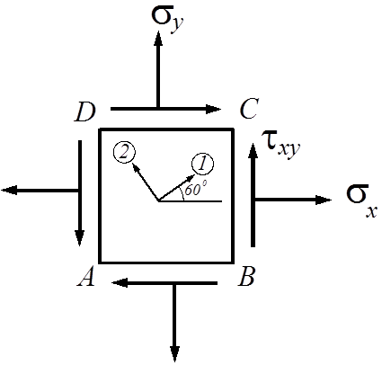

**8)** Before deformation slope of the AB line is 4/10. Find the slope of the line after the application of a normal force of 180 kN. E=200 GPa, ν = 0,3

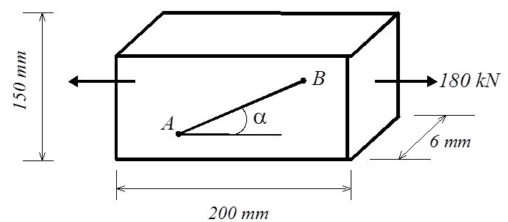

**HW SUBMISSION HOURS:**

**08.11.2017 Time: 10:00 - 13:00**

**09.11.2017 Time:10:00 - 17:00**

**NOTE: HWs are to be submitted EXACTLY on time as indicated above!!**

**For all groups oral examination will be done by Res. Ass. Dr. Esra Eylem Karataş.**

**(Civ. Eng. Dept. Block B Room#1-039)**

**Answers.**

**1)** a) 

b) 

c) 

**2)**



**3)** a) σ=42.214,τ=1.235 (MPa)

b) σ1=51.68, σ2=42.24, σ3=5.08 (MPa)

n1={-0.57384,-0.55587,0.601429}

n2={0.31022,0.532105,0.787796}

n3={0.757935,-0.55587,0.601429}

c) τmax=(σ1- σ13)/2=23.3 (MPa)

**4)** a) 

b) 

**5)** a) σ1=19.66, σ 2=4.34,θ1=-25.6°, θ2=64.4° (yatay ile)

b) ≈430x10-6

**6)** a) ϵ1=6.522x10-3, ϵ2=-7.522x10-4,θ1=109.22°, θ2=19.22° (yatay ile)

b) AC≈1.4197

**7)** a)ϵ3=0.943x10-4

b) σ1=13.89, σ2=-39.03, σ3=0

c) σx=10.35, σy=-35.49, τxy=13.23 (MPa)

d) ΔV/V=(ϵ1+ ϵ2+ ϵ3)=-1.2575x10-4

**8)** tanα≈0.3994