Deadline: Final Exam
Question 1.
In Figure 1, a bolted unstiffened end-plate connection specimen is given. Column of the specimen is formed by HEA profile with 3m height, cantilever beam of that by IPE profile with L_{beam} length. End-plate with t_{ep} thick is connected to the column flange by 8 pretensioned bolts; connected to the beam by fillet welds. S355 steel grade and E80XX weld material are used. Determine maximum P_{D} load which the fillet welds of the connecion can bear safely.
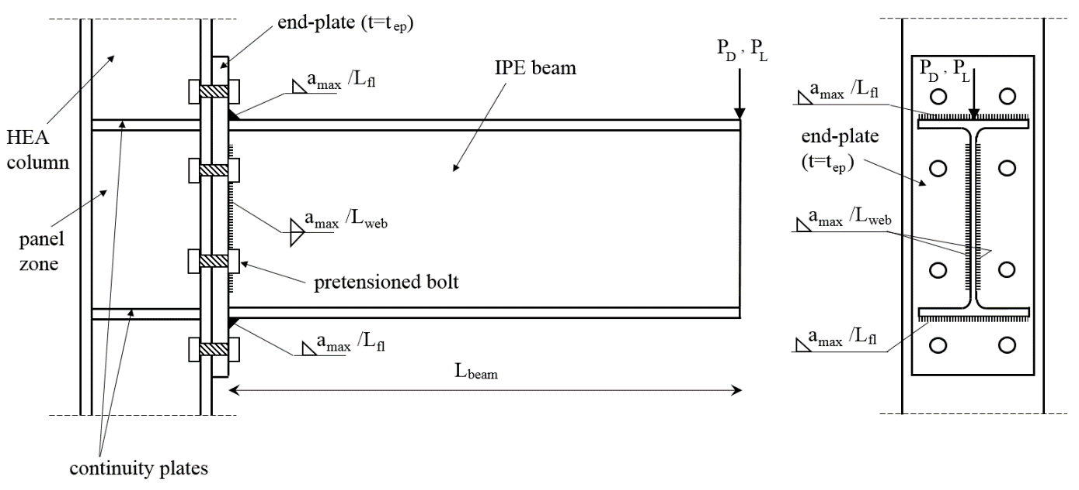
Figure 1. A bolted unstiffened end-plate connection specimen
Parameters:
L_{fl}=b_{beam} L_{web}=h_{beam}
G (Stu.No. Par.) | 0,1 | 2,3 | 4,5 | 6,7 | 8,9
Column | HE160A | HE180A | HE200A | HE220A | HE240A
Beam | IPE240 | IPE270 | IPE300 | IPE330 | IPE360
t_{ep} (mm) | 20 | 25 | 30 | 35 | 40

P_{L}=(1+0.01F+0.02H)P_{D} L_{beam}=1.2+0.1F+0.2G+0.1H (m)

Question 2.
A tension member spliced using welded connection is shown in figure 2. Same splice connection is formed using a bolt group in figure 3. Please determine the strength ratio for both connection for 1.2P_{D} + 1.6P_{L} design combination, considering the weld material is E80XX and structural steel is S355. Use maximum available weld thickness for welded connection and 8.8 bolt quality for bolted connection..
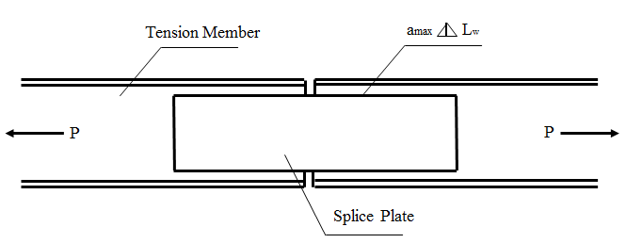
Figure 2 Welded Splice
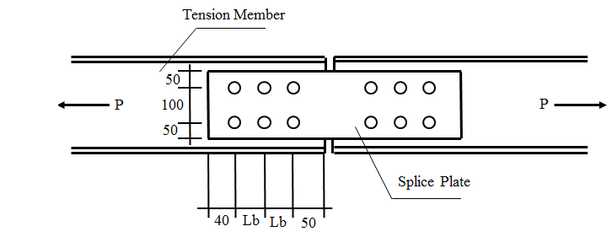
Figure 3 Bolted Splice

Parameters:
H | Tension Member | Splice Plate | Bolt Size
0-2 | IPE200 | 2□150.10 | M16
3-6 | IPE220 | 2□170.12 | M16
7-9 | IPE240 | 2□170.14 | M20

P_{D} (kN) : 100 + 20 G + 10 B
P_{L} (kN) : 150 + 10 ( E + B )
L_{w} (mm) : 100 + 100A + 10B
L_{b} (mm): 40 + 5B

