Submission Date: 09.11.2018
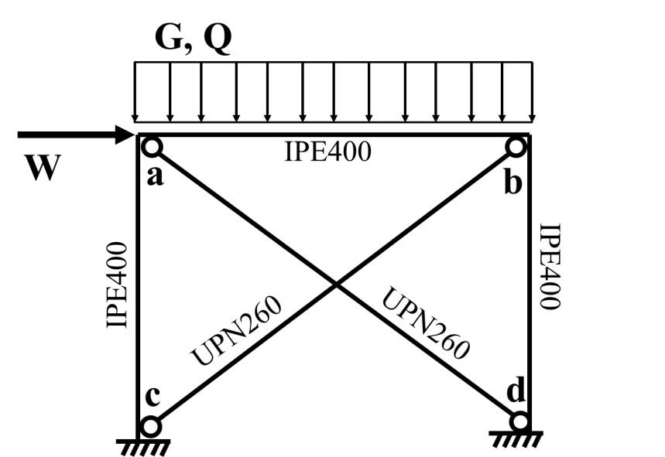
400 cm
300 cm

Figure 1
The braced frame shown in the figure 1, is subjected to dead (G), live (Q) and wind (W) forces. Beams and columns are IPE400 and brace elements are UPN260. Connection details of braces at a, b, c and d are given in the figure 2. Figure 3 shows the axial normal force produced in braces under vertical unit distributed line load and lateral unit point load respectively. Structural steel material is S355.
Considering the parameters given in the Table 1, please answer following questions.
- Determine the tensile design strength of braces considering the details presented in Figure 2.
- Determine the compressive design strength of braces.
- Calculate the ratio between produced axial normal force and the design strengths under the combinations of 1.2G + 1.6Q and 1.2G + Q + 1.6W.
Table 1. Student Parameters
G (kN/m): | (G+1)*5 + H
Q (kN/m): | B*10 + F
W (kN): | E*10
lw (mm): | 100 + A*100 + B*10
lb (mm): | 40 + B*5

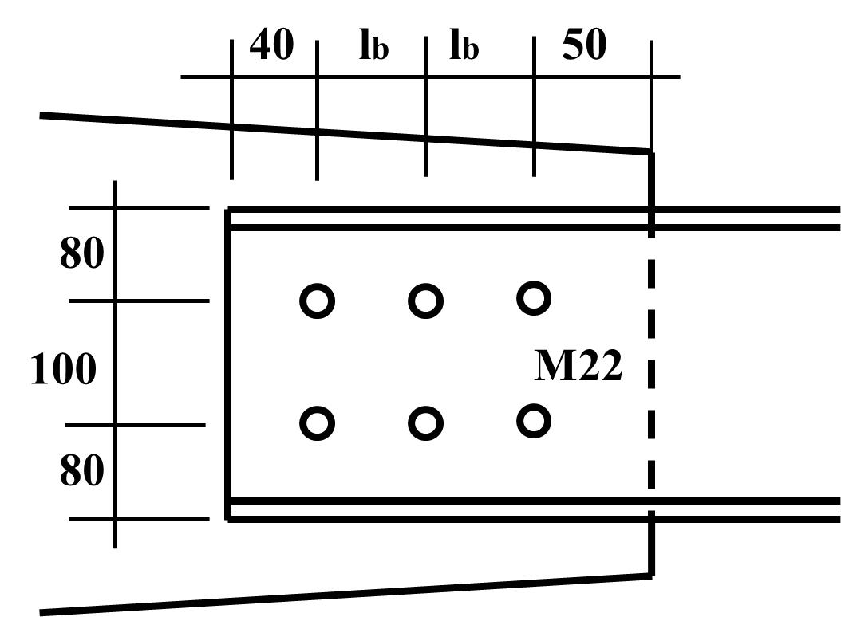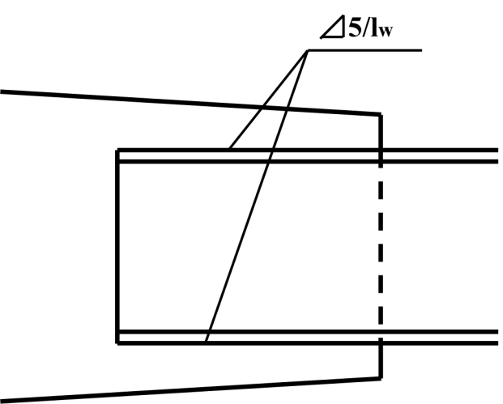
- Connection detail at joint a and b b) Connection detail at joint c and d
Figure 2

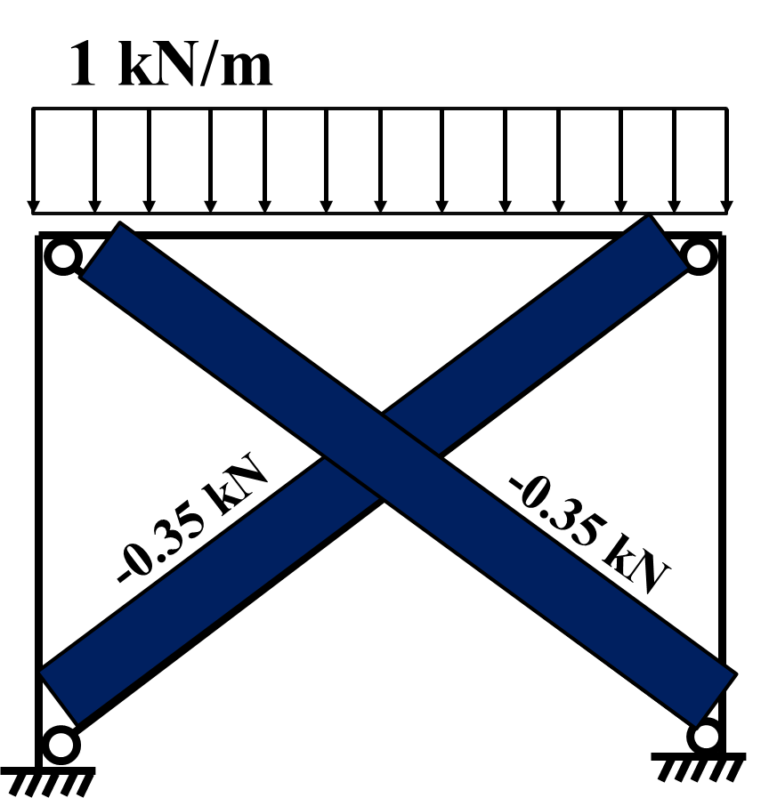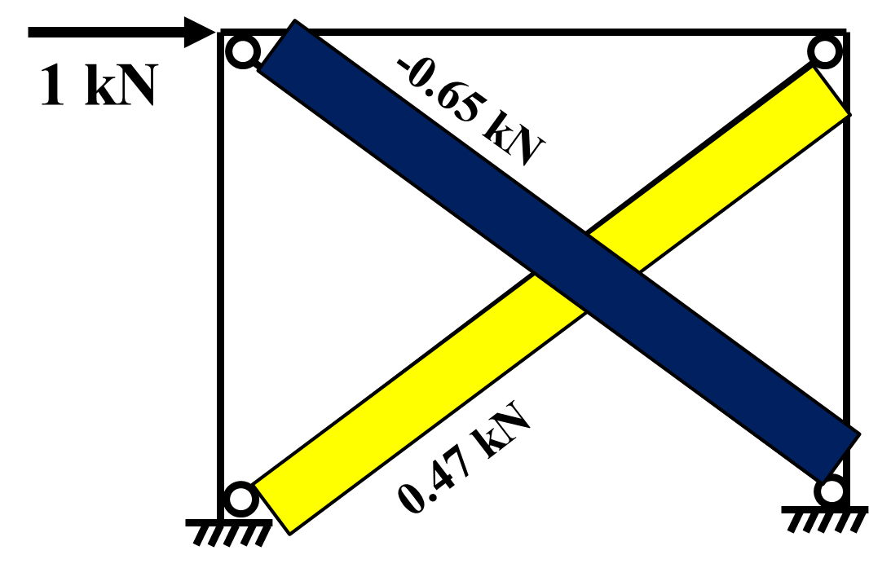
- Axial force under unit line load b) Axial foruce under unit point load
Figure 3

