Submission Date: **17.11.2018**

A frame system seen in Figure 1 is subjected to dead load, live load and earthquake load. Load cases are presented in Figure 2. If the system is analysed under 1 kN/m uniform distributed load as seen in Figure 3, internal force diagrams are obtained as in Figure 4, 5, 6 and 7, respectively. If the system is analysed under 1 kN and 1.5 kN horizontal joint load as seen in Figure 8, internal force diagrams are obtained as in Figure 9, 10, 11 and 12, respectively. Furthermore, horizontal translations of the joints under the horizontal joint loads are given in Figure 13. The system is laterally supported against out-of-displacement at all the joints using pinned connections. S355 steel is used for all the members. Check the members DE, BE, EH and HI in terms of given internal forces.

These combinations should be considered:



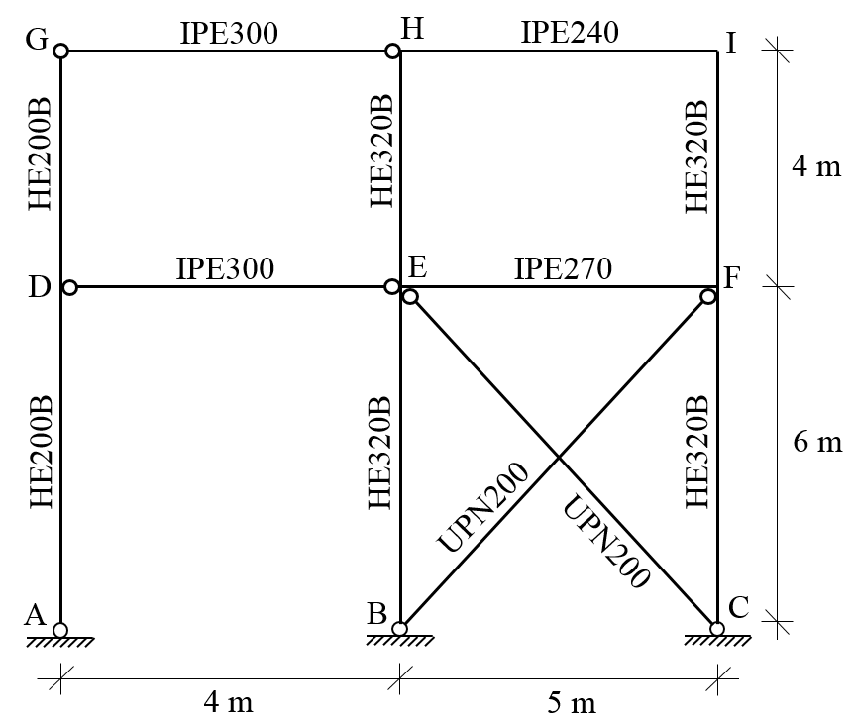

Figure 1. Plane steel frame



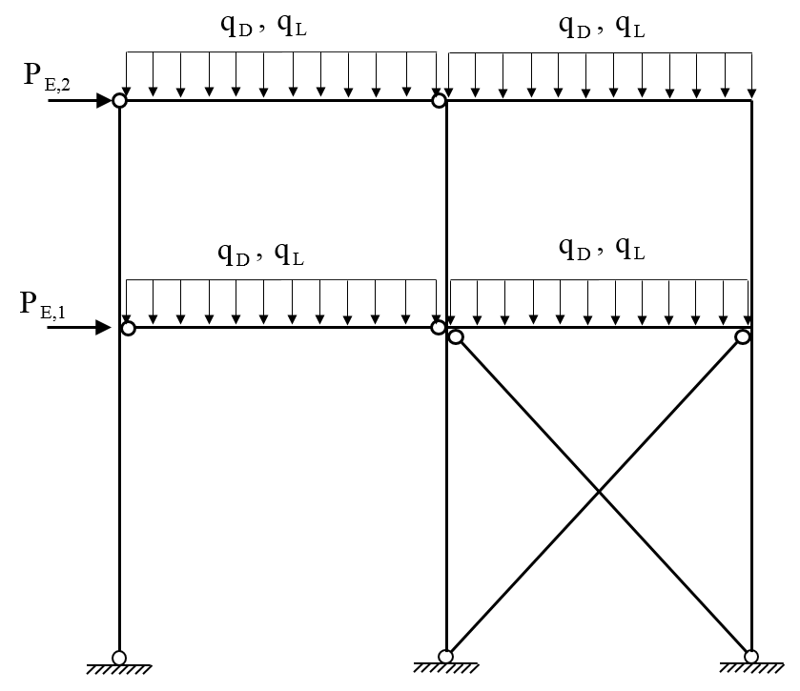

Figure 2. External loads of the system

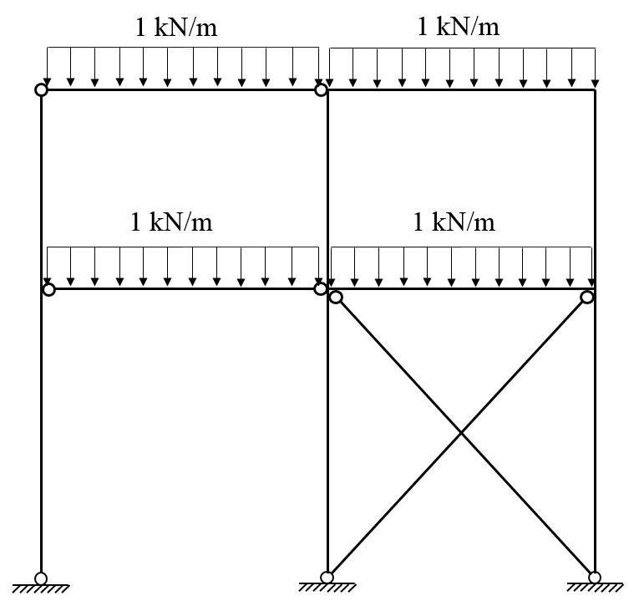

Figure 3. 1 unit uniform distributed load

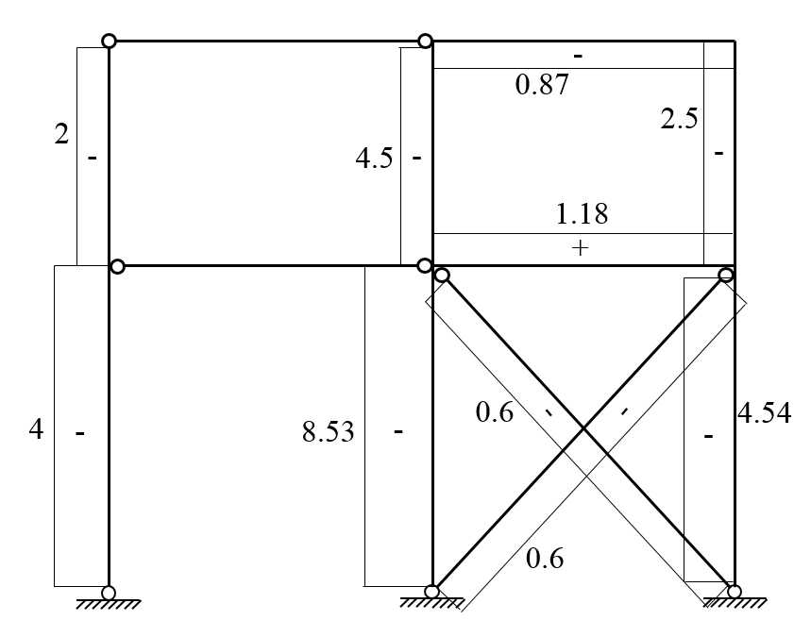

Figure 4. Axial force diagram of the system due to external load given in Figure 3

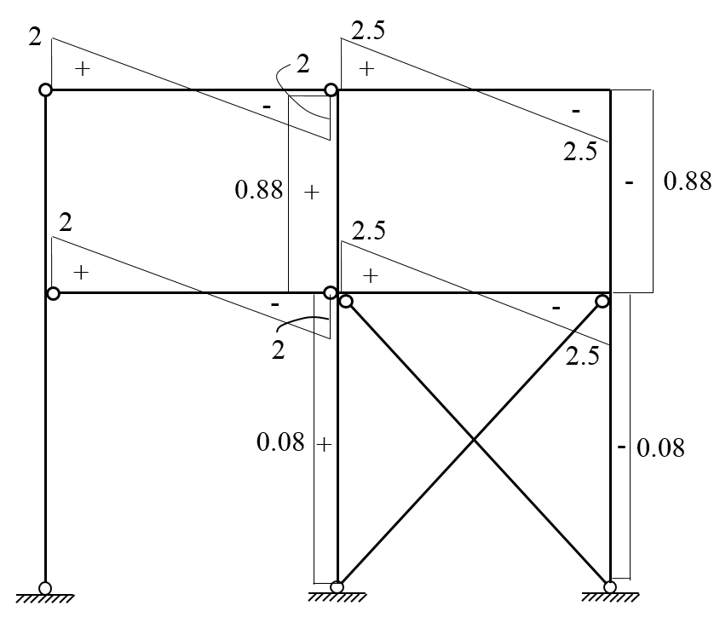

Figure 5. Shear force diagram of the system due to external load given in Figure 3

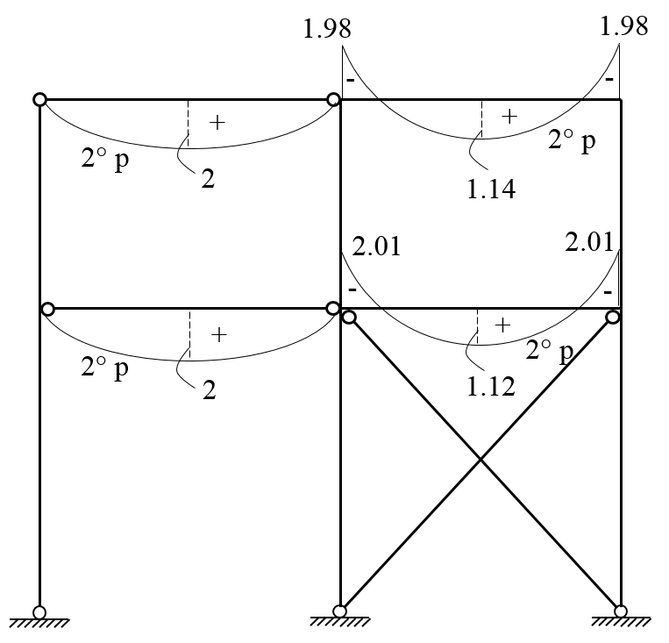

Figure 6. Moment diagram of the system due to external load given in Figure 3 (for beams)

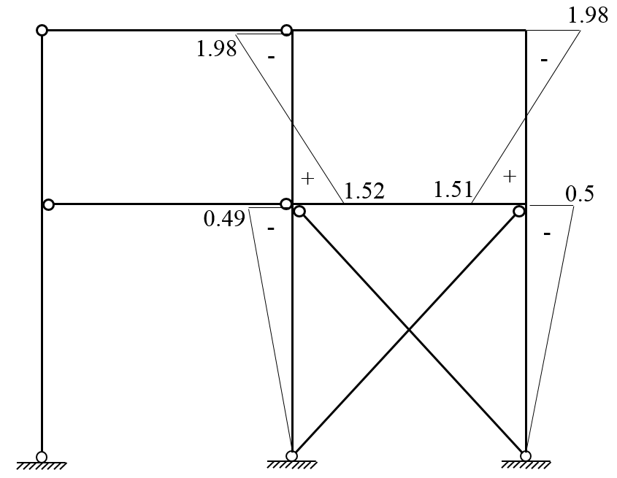

Figure 7. Moment diagram of the system due to external load given in Figure 3 (for columns)

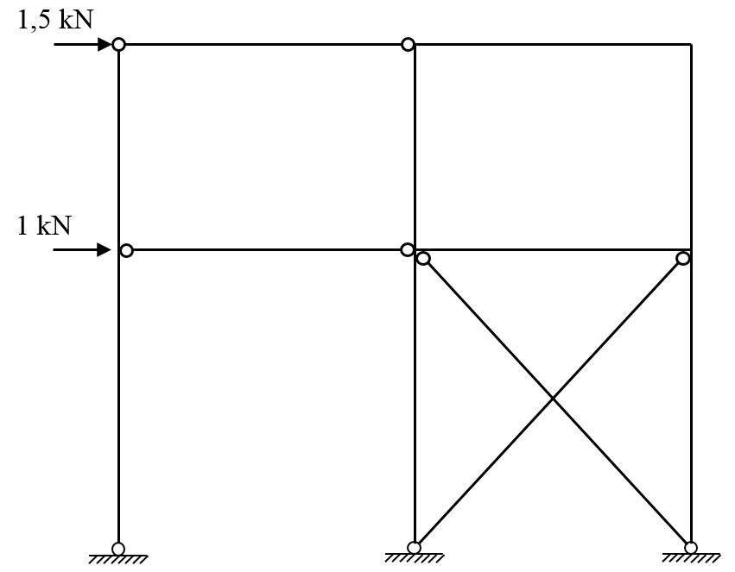

Figure 8. 1 and 1.5 unit horizontal joint loads

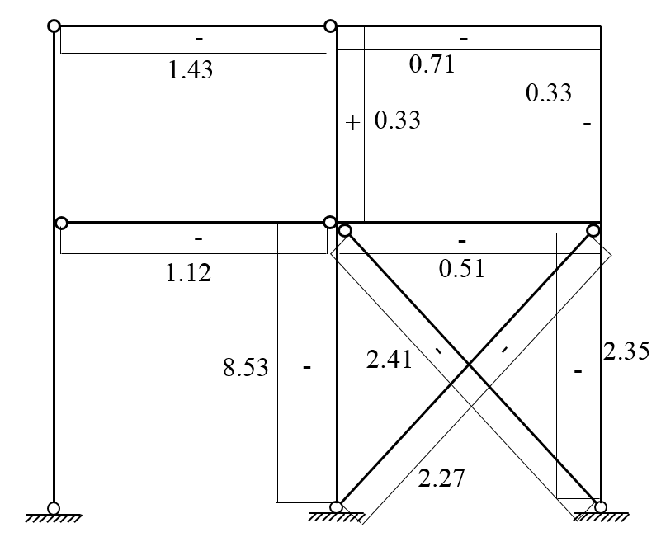

Figure 9. Axial force diagram of the system due to external load given in Figure 8

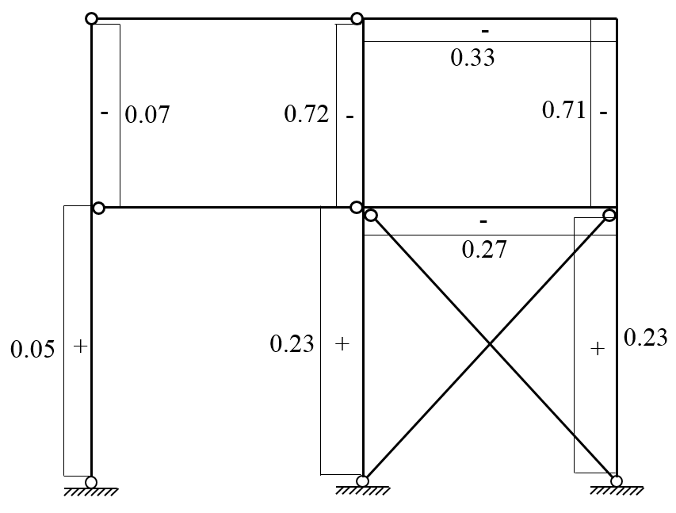

Figure 10. Shear force diagram of the system due to external load given in Figure 8

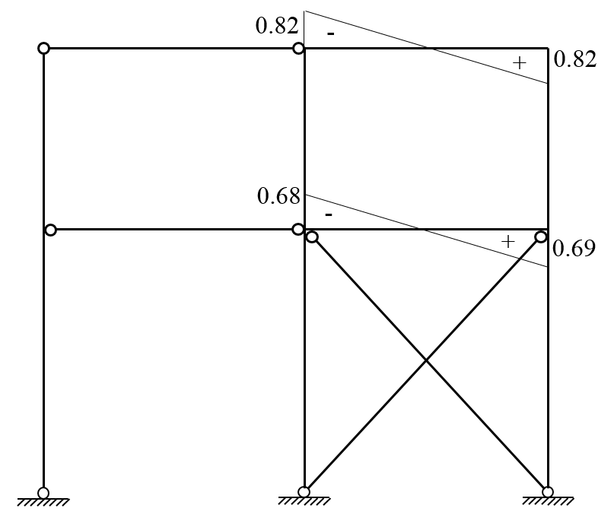

Figure 11. Moment diagram of the system due to external load given in Figure 8 (for beams)

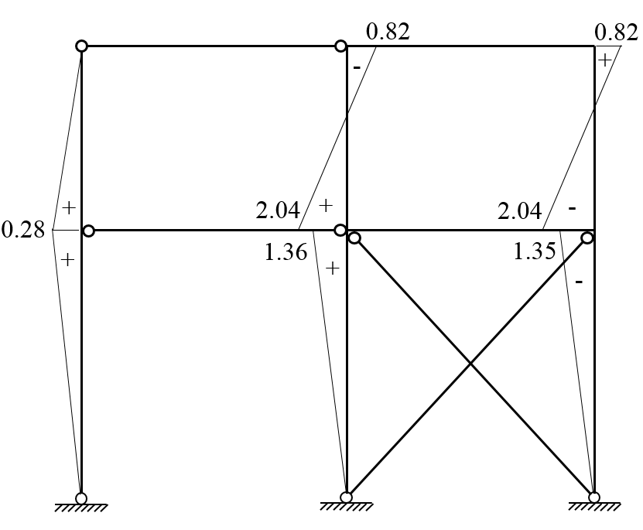

Figure 12. Moment diagram of the system due to external load given in Figure 8 (for columns)

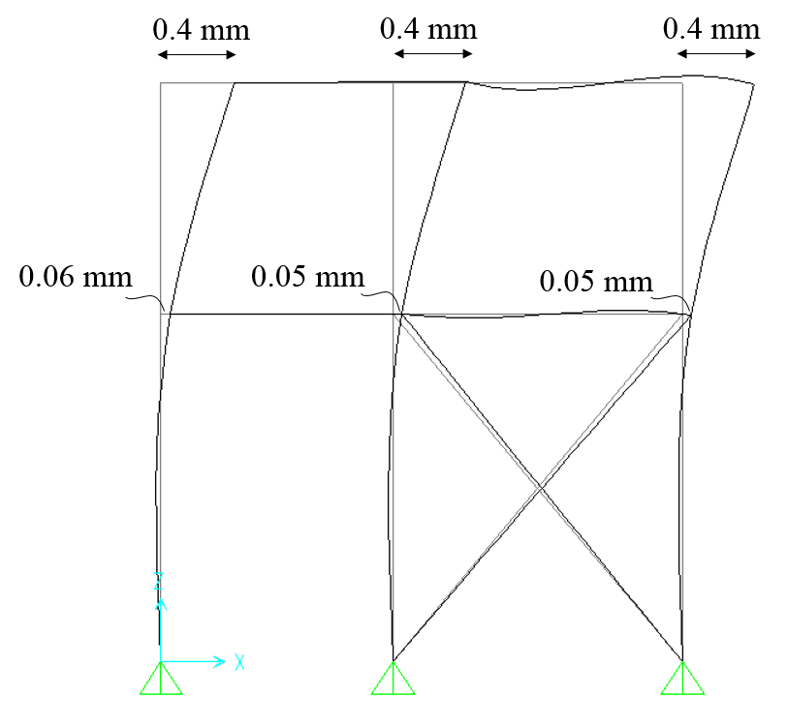

Figure 13. Horizontal translations of the system due to external load given in Figure 8