SUCCESSFUL PEOPLE

1. In what fields have these people been successful?

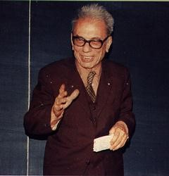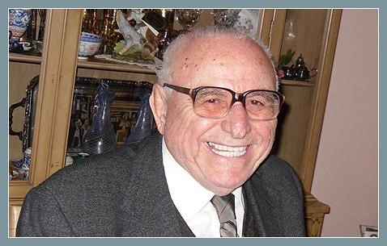
a. Cahit Arf b. Kemal Kurdaş

c. Türkan Saylan d. Margaret Chan

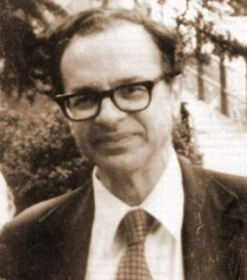 e. Feza Gürsey

2. Match the following short biographies with the above.

- Kemal Kurdaş was Turkish Minister of Finance, the IMF’s adviser to Latin American governments and deputy head of the Turkish Treasury; went on to develop Middle East Technical University (METU), built a distinctive campus for it and created a forest in what was arid, eroding land; helped found and expand a number of businesses; at the same time initiated archeological excavations, led the effort to salvage historical artifacts and monuments from flooding by the Keban dam and supported the publication of findings that throw light on the Neolithic revolution; wrote articles and books on economic policy (Wikipedia, 2011).
- Margaret Chan obtained a medical degree from the University of Western Ontario in Canada; launched new services to prevent the spread of disease and promote better health; introduced new initiatives to improve communicable disease surveillance and response, enhance training for public health professionals, and establish better local and international collaboration; effectively managed outbreaks of avian influenza and of severe acute respiratory syndrome (SARS); in 2003, joined WHO (World Health Organization) as Director of the Department for Protection of the Human Environment; in June 2005, was appointed Director, Communicable Diseases Surveillance and Response as well as Representative of the Director-General for Pandemic Influenza; in September 2005, was named Assistant Director-General for Communicable Diseases; and finally, was elected to the post of Director-General on 9 November 2006 (WHO, 2012).
- Türkan Saylan was a famous dermatologist; became active in the fight against leprosy in the 1970s founding the Turkish Leprosy Relief Association; became consultant to WHO on leprosy and a founding member of the International Leprosy Union; worked for years in rural Turkey with limited resources; worked to provide education for poor children; in 1989 helped found the Association to Support Contemporary Life, which focused primarily on the education of young girls (Arsu, 2009).
- Feza Gürsey was a highly respected mathematician and physicist; best known contribution to theoretical physics is his/her work on the Nonlinear Chiral Lagrangian; is renowned for many seminal and deep contributions to theoretical physics as well as for kindness, civility and scholarship; never hesitated to pick problems that were not fashionable; tackled the most difficult problems planting new seeds in unknown soil (Wikipedia, 2011).
- Cahit Arf was a famous mathematician; worked at various institutions: Galatasaray High School, Istanbul University, Scientific and Technological Research Council (TÜBİTAK), Robert College, Princeton, New Jersey, University of California, Berkeley, and finally METU. Is internationally known for an invariant of a quadratic form in characteristic 2 named after him/her (applied in knot theory and surgery theory in topology), and for many other theorems by his/her name (Wikipedia, 2011).

- What might be the key factors leading these people to success?

- Do you possess any of the traits/factors mentioned above?

HOW DO YOU DEFINE SUCCESS? SIX FACTORS TO CONSIDER
By Ron Haynes
You have heard the cliché; success is a journey, not a destination. In many cases I agree. There is more fun in the chasing than in the catching. I went fishing with a friend of mine and caught a very large striped bass. He was thrilled and scrambled around to find a camera to take a picture. When I bent over to let the fish go, he said, “What are you doing? We can clean it and fry it up back at the cabin!” My reply was, “Man, I don’t want to clean this fish.” Then I let him go.
That story illustrates that the fun is in the pursuit, the chase. Success is like that. We love the thrill of the chase, the excitement of what is going to happen, the what ifs, and the hopes that come with them. Once you have “arrived,” you have to set different goals to get those thrills again.
Too many people think that success is wrapped up in things, but the truth is, success is wrapped up in how you see yourself and how you’re able to enjoy your life. To have a completely successful life along these lines, you will need to consider these six components:
- Peace of Mind
Can anyone truly consider themselves successful if they lack this ingredient? People around the world are constantly searching for peace of mind. I define peace of mind as freedom from fear, worry, anger, and guilt. I think we seek peace of mind through many channels, some of them are destructive and some are worthwhile. Some seek peace of mind through faith, some through money, others in relationships, others in work, and still others seek to fill this void through participation in vices such as gambling or drugs. Very few ever truly find peace of mind outside of their faith, however. Success, no matter how you define it, must have peace of mind in the mix; otherwise your success will be bland and watered down.
- Health and Energy
“Success” without good health and the energy to enjoy life is not success at all; it is just a shell of what it can be. Many people that are financially successful in the world’s eyes spend their fortunes in desperate attempts to regain their health or to stay youthful and vibrant. Any success without health and energy is like a high performance car with no gasoline in the tank.
- Loving Relationships
No matter how much financial success someone enjoys, again, it is a hollow feeling if you have no one to share it with. It does not have to be a spouse; it can be parents, children, friends or other family members.
- Financial Freedom
That is, freedom from thinking about money all the time. Not necessarily being “rich,” but having enough money to pay your bills, feed your family, and take care of basic necessities. For some, $50,000 in the bank would be plenty, for others, $5 million would not be enough. To be sure, many people think of finances when they visualize success and it is a major component in our culture, but for the purposes of defining success, I am talking about the feeling of freedom, that deep sigh that you do not depend on anyone else but yourself.
- Worthy Goals
Most people have financial freedom as their top goal, but once you have that big pile of cash, then what? That’s why you constantly see millionaires and billionaires getting involved in some type of other business venture or philanthropy. In fact, it is the chase that they love. Money is just the means. Humans need to be chasing something. We desperately want to improve ourselves, or others. It is just human nature.
- Personal Fulfillment
This is also called Self Actualization, which is the concept of “being all you can be,” of feeling like you matter and that you are making a difference. This is the feeling that you are not just going through the motions for no reason, what you do and who you are is of vital importance. If you have the first five components, but feel unfulfilled and useless, you do not enjoy the full measure of success.
____________________________________________________________________________
Taken from: Haynes, R. (n.d.). How do you define success? Six factors to consider. Retrieved November, 09, 2011 from http://www.thewisdomjournal.com/Blog/how-do-you-define-success-six-factors-to-consider/

Getting It Across
Talk about a person whom you find successful in his/her field (whether well-known or not). Focus on the following aspects of this person:

      - Short background
      - Area of success
      - Relevance to Ron Haynes’s six factors for success

