Chapter 19 Oxidative Phosphorylation

- All oxidative steps in the degradation of carbohydrates, fats, and amino acids converge at this final stage of cellular respiration, in which the energy of oxidation drives the synthesis of ATP.

19.1 Electron-Transfer Reactions in Mitochondria

- In eukaryotes, oxidative phosphorylation occurs in mitochondria.
- Oxidative phosphorylation involves the reduction of O₂ to H₂O with electrons donated by NADH and FADH₂.
- Mitochondria have two membranes (outer and inner).
- The inner membrane bears the components of the respiratory chain and the ATP synthase.

Electrons Pass through a Series of Membrane-Bound Carriers
- Oxidative phosphorylation begins with the entry of electrons into the chain of electron carriers called the respiratory chain (Fig. 19-1).

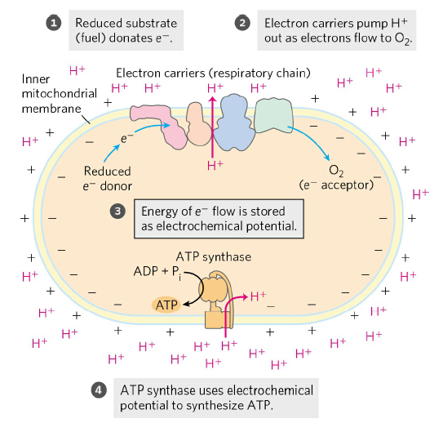
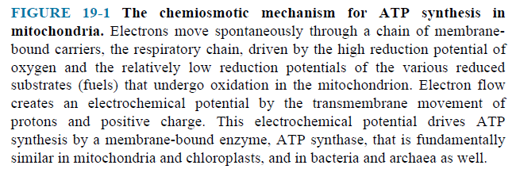

- In addition to NAD-linked dehydrogenases and FMN or FAD-linked flavoproteins, three other types of electron-carrying molecules function in the respiratory chain.
- A hydrophobic quinone (ubiquinone) is also called coenzyme Q (simply Q) (Fig. 19-3) and two different types of iron-containing proteins (cytochromes) (Fig. 19-4) and iron-sulfur proteins (Fig. 19-5).
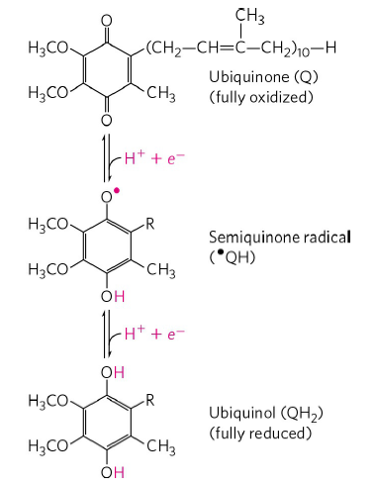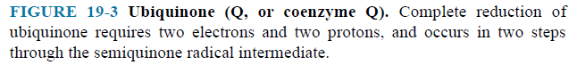

- Cytochromes have iron-containing heme prosthetic groups (Fig. 19-4a).

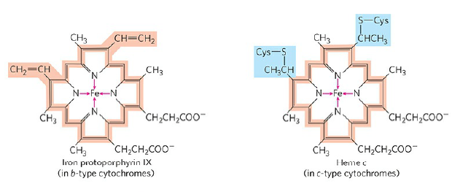
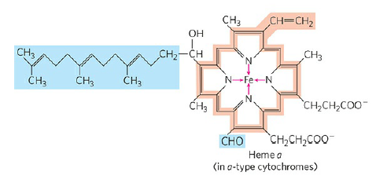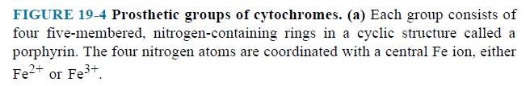

- In iron-sulfur proteins, the iron is present not in heme but in association with inorganic sulfur atoms or with the sulfur atoms of Cys residues in the protein, or both (Fig. 19-5).

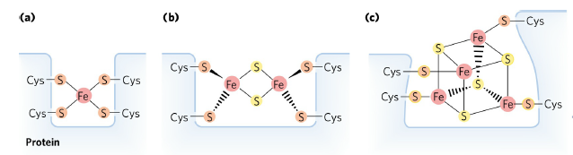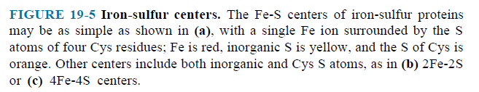

Electron Carriers Function in Multienzyme Complexes
- The electron carriers of the respiratory chain are organized into membrane-embedded supramolecular complexes.
- The inner mitochondrial membrane has four electron carrier complexes (Table 19-3).

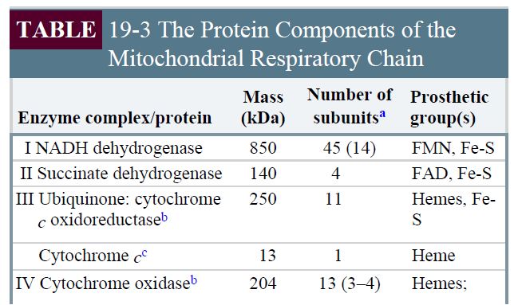

- Complex I catalyzes electron transfer to ubiquinone from NADH. (Fig. 19-8).
- It is also called NADH:ubiquinone oxidoreductase or NADH dehydrogenase.
- It contains an FMN and at least six iron-sulfur centers.
- It moves protons from the matrix to the intermembrane space.

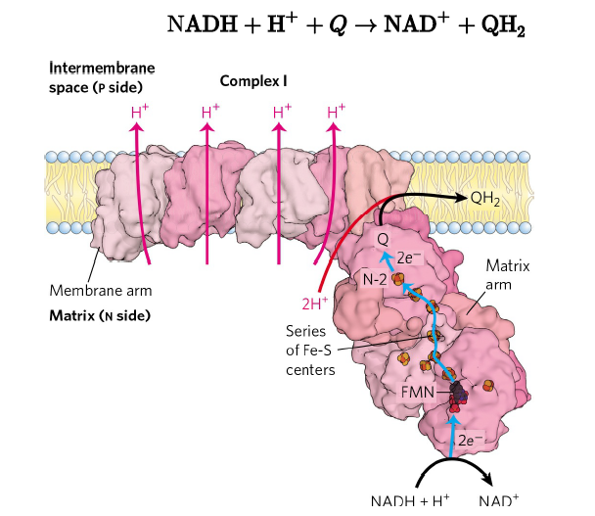

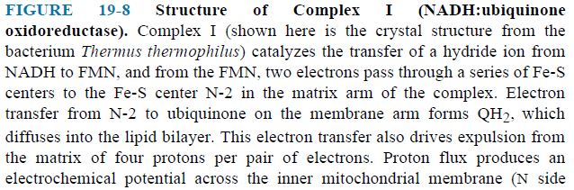

- Complex II catalyzes electron transfer to ubiquinone from succinate (FADH₂) (Fig. 19-9).
- It is also called succinate dehydrogenase, the only membrane-bound enzyme in the citric acid cycle.
- It contains an FAD and three iron-sulfur centers.

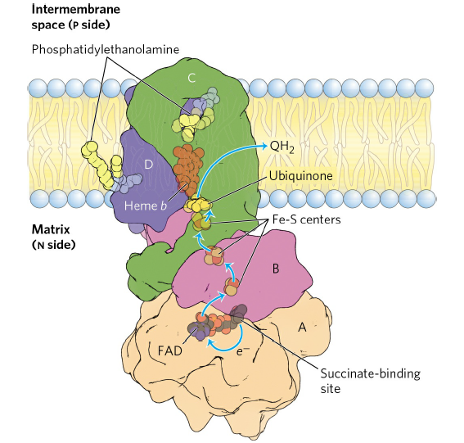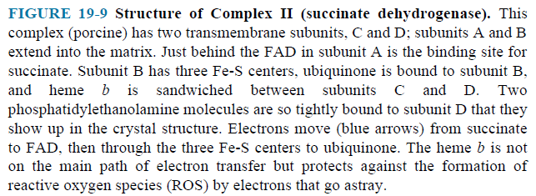
- Other substrates pass electrons into the respiratory chain at the level of ubiquinone (Fig. 19-15).

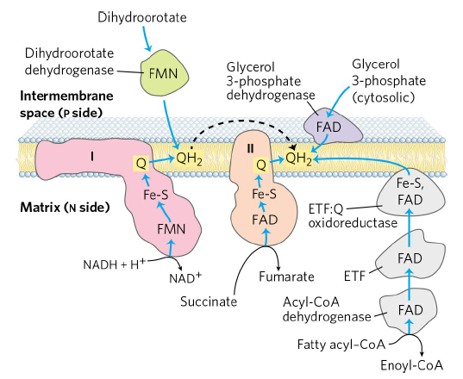

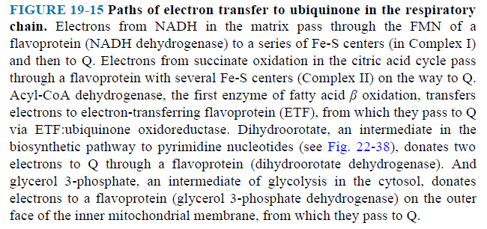

- The first step in the β oxidation of fatty acyl–CoA, catalyzed by the acyl-CoA dehydrogenase, involves transfer of electrons from the substrate to the FAD of the dehydrogenase, then to electron-transferring flavoprotein (ETF), which in turn passes its electrons to ETF:ubiquinone oxidoreductase. This enzyme transfers electrons into the respiratory chain by reducing ubiquinone.
- Glycerol 3-phosphate, formed either from glycerol released by triacylglycerol breakdown or by the reduction of dihydroxyacetone phosphate from glycolysis, donates electrons to a glycerol 3-phosphate dehydrogenase on the outer face of the inner mitochondrial membrane, from which they pass to Q.

- Complex III carries electrons from reduced ubiquinone to cytochrome c. (Fig. 19-10).
- It is also called cytochrome bc₁ complex or ubiquinone:cytochrome c oxidoreductase.
- It contains six hemes and two iron-sulfur centers.
- It moves protons from the matrix to the intermembrane space.

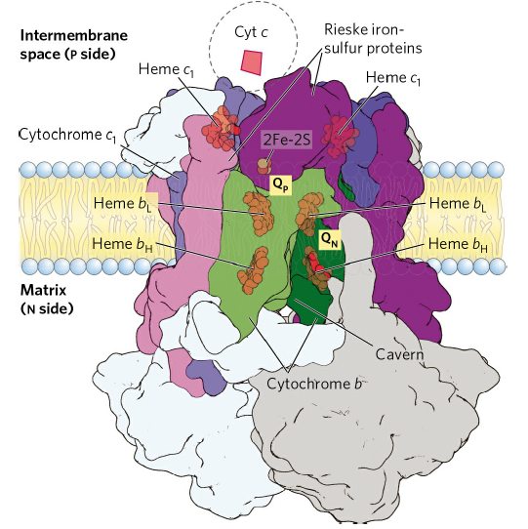

- Cytochrome c is a soluble protein of the intermembrane space.
- After its single heme accepts an electron from Complex III, cytochrome c moves to Complex IV to donate the electron to a copper center.

- Complex IV, also called cytochrome oxidase, carries electrons from cytochrome c to molecular oxygen, reducing it to H₂O. (Fig. 19-13).
- It contains two hemes and three Cu ions.
- It moves protons from the matrix to the intermembrane space.
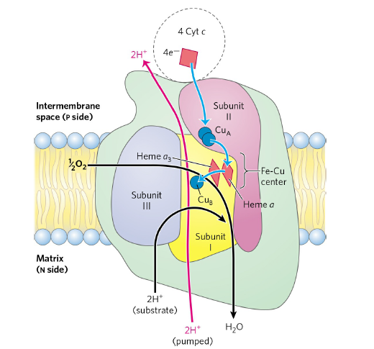

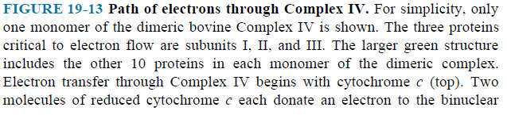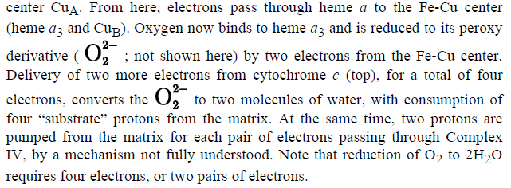

The Energy of Electron Transfer Is Efficiently Conserved in a Proton Gradient
- The transfer of two electrons from NADH through the respiratory chain to molecular oxygen can be written as
NADH + H⁺ + ½ O₂ NAD⁺ + H₂O
- This net reaction is highly exergonic. ΔGº = - 220 kJ/mol
- Much of this energy is used to pump protons out of the matrix (Fig. 19-16).

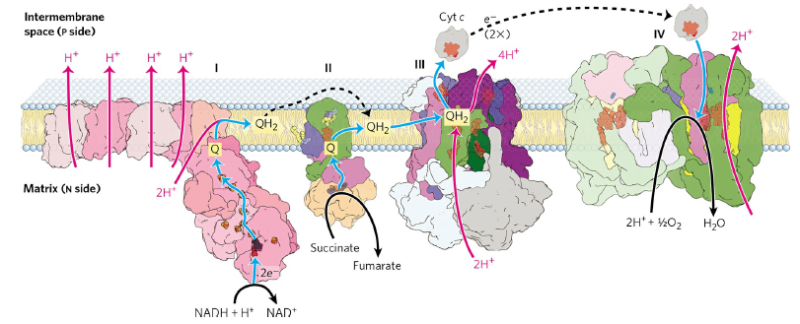

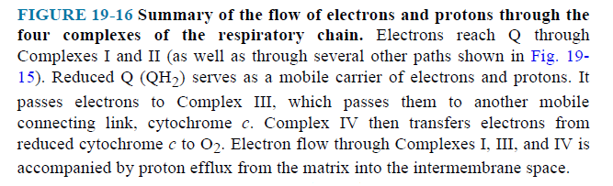
- The energy of electron transfer is efficiently conserved in a proton gradient.
- The energy stored in such a gradient, called the proton-motive force.
- In mitochondria, the electrochemical energy in the proton gradient drives the synthesis of ATP from ADP and Pi.

Reactive Oxygen Species Are Generated during Oxidative Phosphorylation
- Several steps in the path of oxygen reduction in mitochondria have the potential to produce highly reactive free radicals that can damage cells.

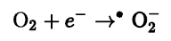

- The superoxide free radical thus generated is highly reactive; its formation also leads to production of the even more reactive hydroxyl free radical.
- To prevent oxidative damage by superoxide free radical, cells have superoxide dismutase, which catalyzes the reaction (Fig. 19-18).

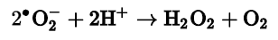

- The hydrogen peroxide is rendered harmless by the action of glutathione peroxidase (Fig. 19-18).
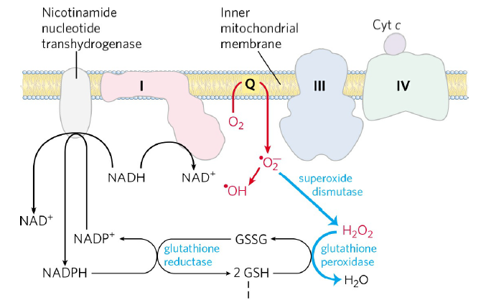
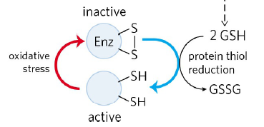

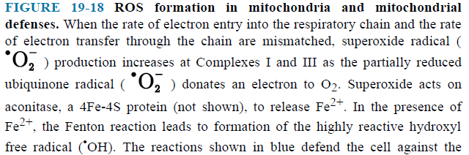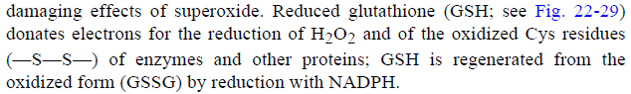

19.2 ATP Synthesis

- ATP synthesis is explained by chemiosmotic model (Fig. 19-19).

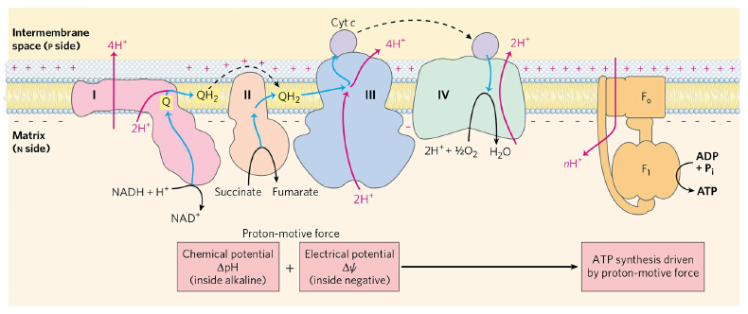

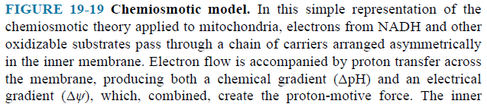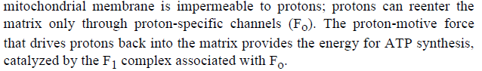

- Electron flow is accompanied by proton transfer across the membrane, producing both a chemical gradient and an electrical gradient.
- The proton-motive force drives the synthesis of ATP as protons flow back into the matrix through a proton pore associated with ATP synthase.
- ATP synthase has two functional domains, F₀ and F₁.
- If
- 10 protons are pumped out per NADH
- 6 protons are pumped out per FADH₂
- 4 protons must flow in to produce 1 ATP
- 2.5 molecules of ATP are generated by using 1 NADH in oxidative phosphorylation.
- 1.5 molecules of ATP are generated by using 1 FADH₂ in oxidative phosphorylation.

Shuttle Systems Indirectly Convey Cytosolic NADH into Mitochondria for Oxidation
- Complex I can accept electrons only from NADH in the matrix.
- The inner membrane is not permeable to NADH.
- How can the NADH generated by glycolysis in the cytosol be reoxidized to NAD⁺ by O₂ via the respiratory chain?
- Special shuttle systems carry cytosolic NADH into mitochondria by indirect route.
- One of them is malate-aspartate shuttle (Fig. 19-31).
- Complex I can accept electrons from NADH.
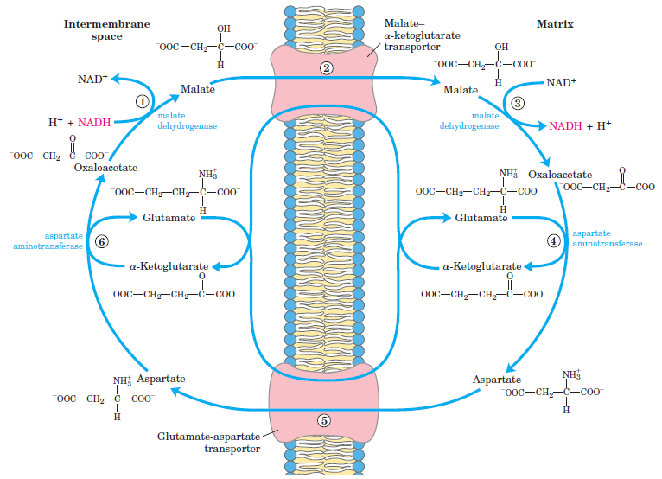

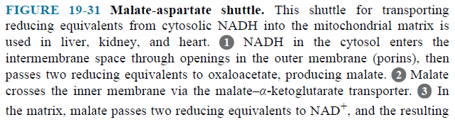
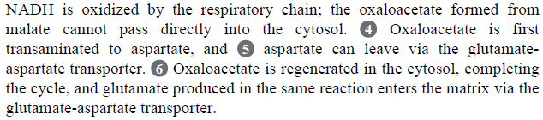

- The other is glycerol 3-phosphate shuttle (Fig. 19-32).
- Ubiquinone can accept electrons from FADH₂.

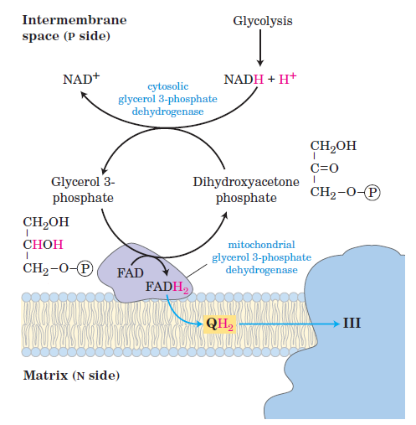

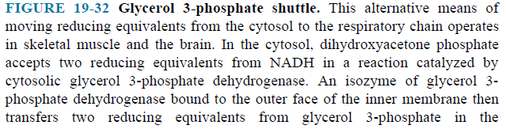

- Complete oxidation of a molecule of glucose to CO₂ yields 30 or 32 ATP (Table 19-5).

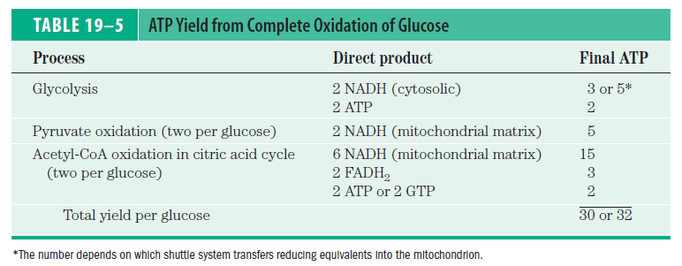

THE END

