Chapter 21 Lipid Biosynthesis

- Lipids are the principal form of stored energy in most organisms and major constituents of cellular membranes.
- Specialized lipids serve as
  - pigments (retinal, carotene),
  - cofactors (vitamin K),
  - detergents (bile salts),
  - transporters (dolichols),
  - hormones (vitamin D derivatives, sex hormones),
  - extracellular and intracellular messengers (eicosanoids, phosphatidylinositol derivatives),
  - anchors for membrane proteins (covalently attached fatty acids, prenyl groups, and phosphatidylinositol).

  - Biosynthesis of Fatty Acids
- Fatty acid biosynthesis and breakdown occur by different pathways, are catalyzed by different sets of enzymes, and take place in different parts of the cell.
- Biosynthesis requires the participation of a three-carbon intermediate, malonyl-CoA, that is not involved in fatty acid breakdown.

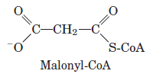

Malonyl-CoA Is Formed from Acetyl-CoA and Bicarbonate
- The formation of malonyl-CoA from acetyl-CoA is an irreversible process, catalyzed by acetyl-CoA carboxylase (Fig. 21–1).
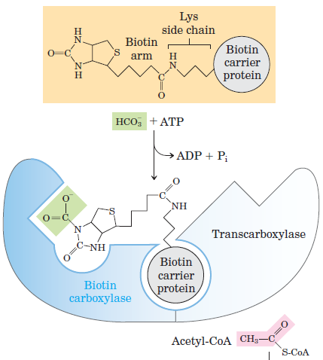
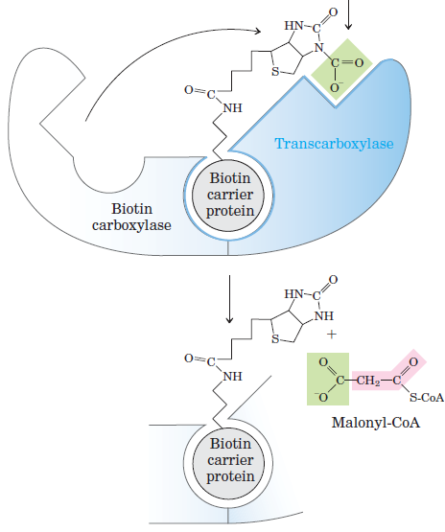
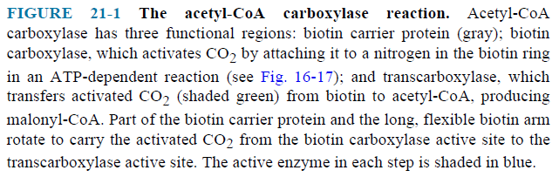

Fatty Acid Synthesis Proceeds in a Repeating Reaction Sequence
- In all organisms, the long carbon chains of fatty acids are assembled in a repeating four-step sequence, catalyzed by a system collectively referred to as fatty acid synthase (Fig. 21–2).

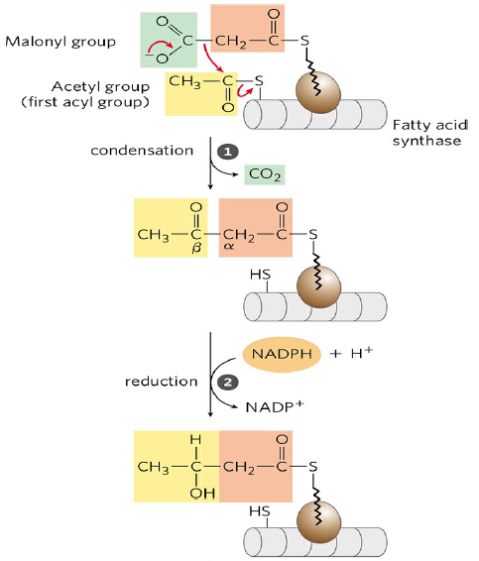
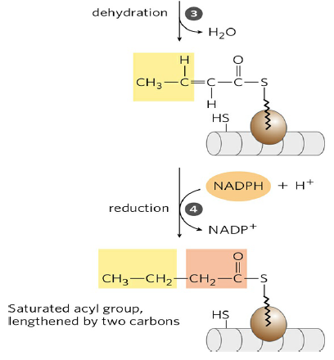
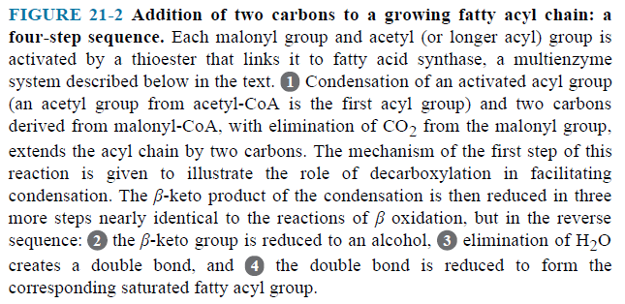
- A saturated acyl group produced by each four-step series of reactions becomes the substrate for subsequent condensation with an activated malonyl group.
- With each passage through the cycle, the fatty acyl chain is extended by two carbons.
- There are two major variants of fatty acid synthase:
- Fatty acid synthase I (FAS I), found in vertebrates and fungi,
- Fatty acid synthase II (FAS II), found in plants and bacteria.
- Seven active sites for different reactions lie in separate domains of a single polypeptide chain (Fig. 21–3a).
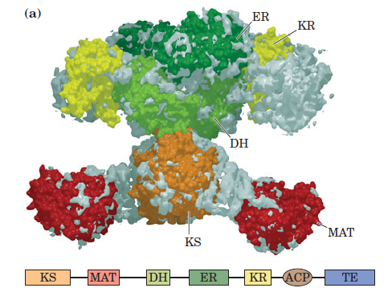

- β-ketoacyl-ACP synthase (KS),
- malonyl/acetyl-CoA–ACP transferase (MAT),
- β-hydroxyacyl-ACP dehydratase (DH),
- enoyl-ACP reductase (ER),
- β-ketoacyl-ACP reductase (KR).
- acyl carrier protein (ACP).
- thioesterase (TE)
- When the chain length reaches 16 carbons, that product (palmitate, 16:0) leaves the cycle (Fig. 21–4).
- The mammalian polypeptide functions as a homodimer.
- The subunits appear to function independently.
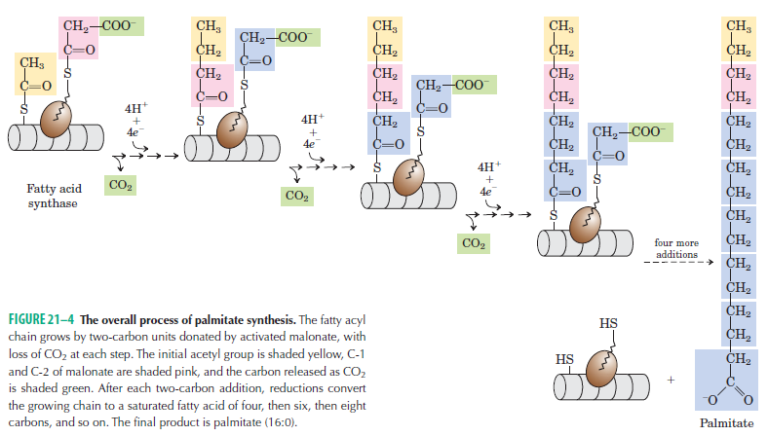

Fatty Acid Synthase Receives the Acetyl and Malonyl Groups
- The acetyl group of acetyl-CoA is transferred to ACP by the malonyl /acetyl-CoA–ACP transferase (MAT). The acetyl group is then transferred to the Cys —SH group of the β-ketoacyl-ACP synthase (KS) (Fig. 21–6).
- Transfer of the malonyl group from malonyl-CoA to the —SH group of ACP, is also catalyzed by MAT.
- Acetyl and malonyl groups are combined to form acetoacetyl-ACP by KS.
- The acetoacetyl-ACP undergoes reduction to form β-hydroxybutyryl-ACP by β-ketoacyl-ACP reductase (KR).
- Water is removed from β-hydroxybutyryl-ACP to yield trans-2-butenoyl-ACP by β-hydroxyacyl-ACP dehydratase (DH).
- Trans-2-butenoyl-ACP is reduced (saturated) to form butyryl-ACP by enoyl-ACP reductase (ER).
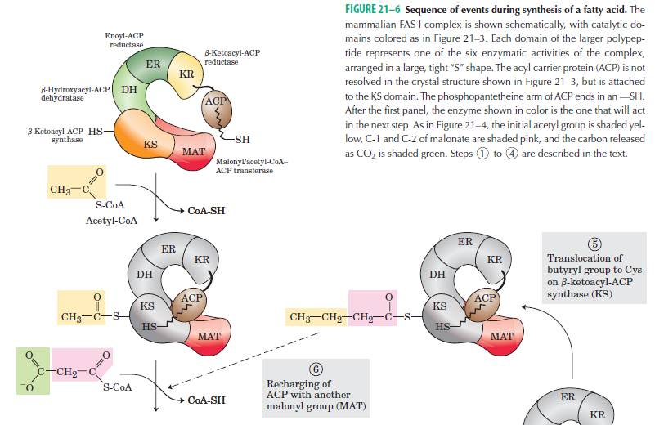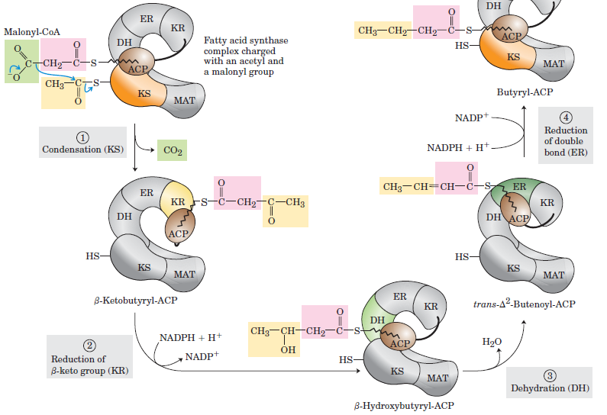

The Fatty Acid Synthase Reactions Are Repeated to Form Palmitate
- The butyryl group is transferred from the —SH group of ACP to the —SH group of β-ketoacyl-ACP synthase.
- To start the next cycle of four reactions that lengthens the chain by two more carbons, another malonyl group is linked to the —SH group of ACP by MAT (Fig. 21–7).
- After condensation, the product is a six-carbon acyl group.
- Seven cycles of condensation and reduction produce the 16-carbon saturated palmitoyl group, still bound to ACP.
- Free palmitate is released from the ACP by thioesterase (TE) in the multifunctional protein.
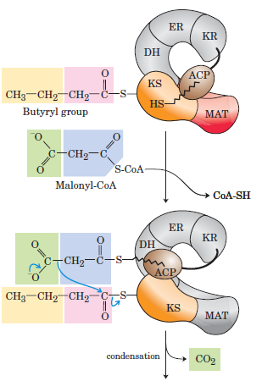
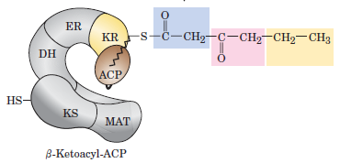
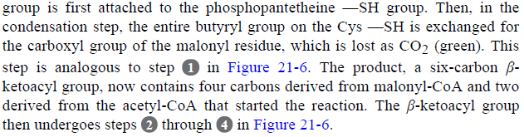

- The overall reaction for the synthesis of palmitate from acetyl-CoA is in two parts.
- The formation of seven malonyl-CoA molecules:
7 Acetyl-CoA + 7 CO₂ + 7 ATPS 7 malonyl-CoA + 7 ADP + 7 P_{i}
- The seven cycles of condensation and reduction:
Acetyl-CoA + 7 malonyl-CoA + 14 NADPH +14 H⁺

palmitate + 7 CO₂ + 8 CoA + 14 NADP⁺ + 6 H₂O
- Only six net water molecules are produced, because one is used to hydrolyze the thioester linking the palmitate product.
- The overall process is
8 Acetyl-CoA + 7 ATP + 14 NADPH + 14 H⁺

palmitate + 8 CoA + 7 ADP + 7 P_{i} + 14 NADP⁺ + 6H₂O

Acetate Is Shuttled out of Mitochondria as Citrate
- In nonphotosynthetic eukaryotes, nearly all the acetyl-CoA used in fatty acid synthesis is formed in mitochondria from pyruvate oxidation and from the catabolism of the carbon skeletons of amino acids.
- Acetyl-CoA is generated in the mitochondria and must be transported to the cytosol.
- Mitochondrial acetyl-CoA first reacts with oxaloacetate to form citrate, in the citric acid cycle reaction catalyzed by citrate synthase (Fig. 21–10).
- Citrate then passes through the inner membrane on the citrate transporter.
- In the cytosol, citrate cleavage by citrate lyase regenerates acetyl-CoA and oxaloacetate.

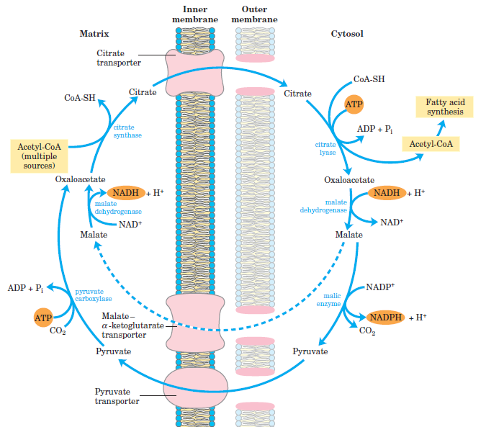

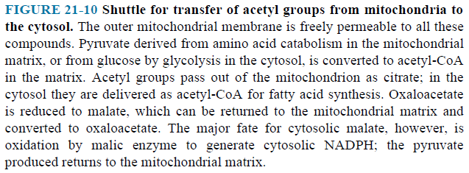

Fatty Acid Biosynthesis Is Tightly Regulated
- The reaction catalyzed by acetyl-CoA carboxylase is the rate-limiting step in the biosynthesis of fatty acids, and this enzyme is an important site of regulation.
- In vertebrates,
- Palmitoyl-CoA, glucagon and epinephrine are inhibitor
- Citrate is activator (Fig. 21–11a).
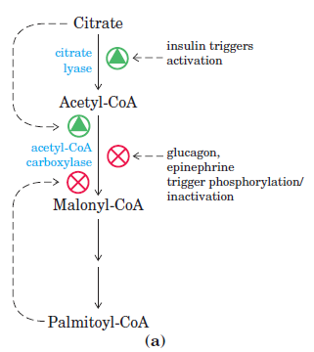

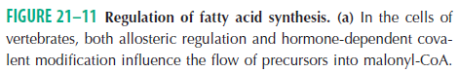

Long-Chain Saturated Fatty Acids Are Synthesized from Palmitate
- Palmitate (16:0) is the precursor of other long-chain fatty acids (Fig. 21–12).
- Palmitoleate (16:1), stearate (18:0), oleate (18:1), linoleate (18:2) are synthesized from palmitate.
- Mammals cannot make linoleate and must obtain it from plant sources.
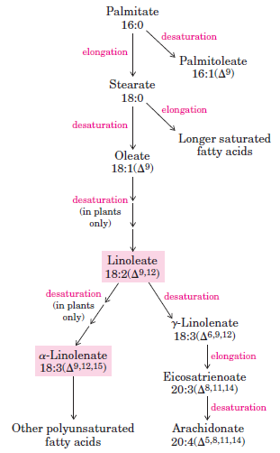
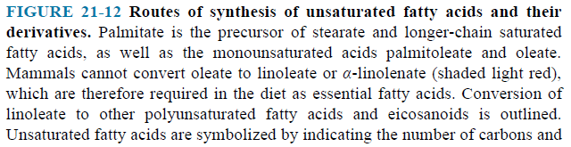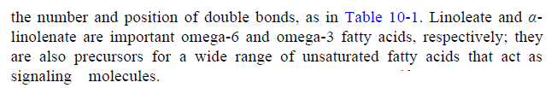

  - Biosynthesis of Triacylglycerols
- Most of the fatty acids have one of two fates:
- incorporation into triacylglycerols for the storage of metabolic energy
- incorporation into the phospholipid components of membranes.
- Both pathways begin at the same point: the formation of fatty acyl esters of glycerol.

Triacylglycerols and Glycerophospholipids Are Synthesized from the Same Precursors
- Animals can synthesize and store large quantities of triacylglycerols, to be used later as fuel.
- Humans can store only a few hundred grams of glycogen in liver and muscle (230 g), barely enough to supply the body’s energy needs for 12 hours.
- In contrast, the total amount of stored triacylglycerol in a 70-kg man of average build is about 15 kg, enough to support basal energy needs for as long as 12 weeks.
- Triacylglycerols have the highest energy content of all stored nutrients.
- The excess of carbohydrate is converted to triacylglycerols and stored in adipose tissue.
- Glycerol 3-phosphate is derived from the dihydroxyacetone phosphate by the glycerol 3-phosphate dehydrogenase; a small amount of glycerol 3-phosphate is also formed from glycerol by the glycerol kinase (Fig. 21–17).
- Fatty acyl–CoAs are formed from fatty acids by acyl-CoA synthetases.
- The first stage in the biosynthesis of triacylglycerols is the acylation of the two free hydroxyl groups of glycerol 3-phosphate by two molecules of fatty acyl–CoA to yield diacylglycerol 3-phosphate, more commonly called phosphatidic acid.

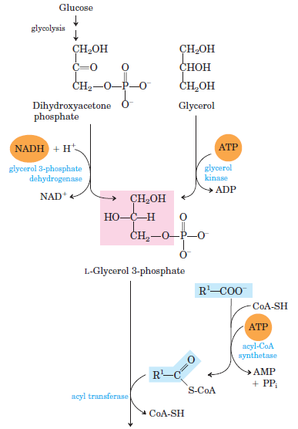
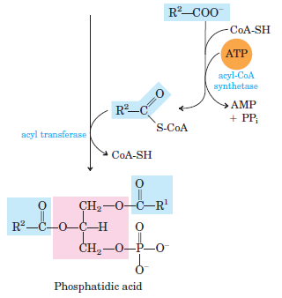
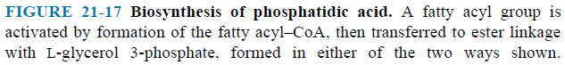

- Phosphatidic acid can be converted either to a triacylglycerol or to a glycerophospholipid (Fig. 21–18).
- In the pathway to triacylglycerols, phosphatidic acid is hydrolyzed by phosphatidic acid phosphatase to form a 1,2-diacylglycerol.
- Diacylglycerols are then converted to triacylglycerols by transesterification with a third fatty acyl–CoA.

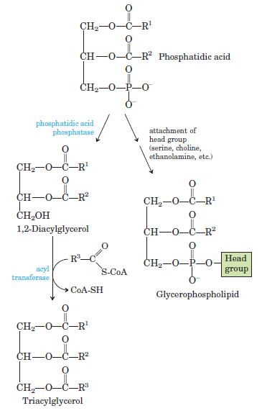

  - Cholesterols Biosynthesis
- The structure of the 27-carbon cholesterol is formed from acetyl-CoA in a complex series of reactions,
- Bile acids and steroid hormones are derived from cholesterol.

Cholesterol Is Made from Acetyl-CoA in Four Stages
- Condensation of three acetate units (3 acetyl-CoA) to form a six-carbon intermediate, mevalonate (Fig. 21–33 and 34).
- Conversion of mevalonate to activated isoprene units
- Polymerization of six 5-carbon isoprene units to form the 30-carbon linear squalene

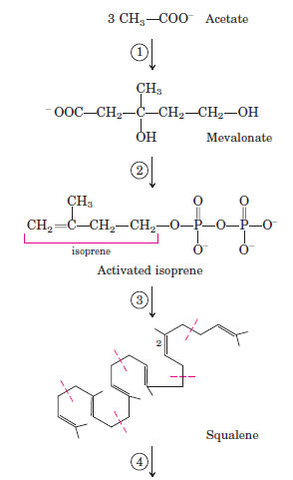
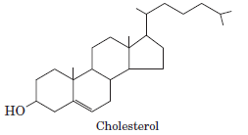

- Cyclization of squalene to form the four rings of the steroid nucleus, with a further series of changes (oxidations, removal or migration of methyl groups) to produce cholesterol.

