17.2 Oxidation of Fatty Acids
- Mitochondrial oxidation of fatty acids takes place in three stages (Fig. 17-7).
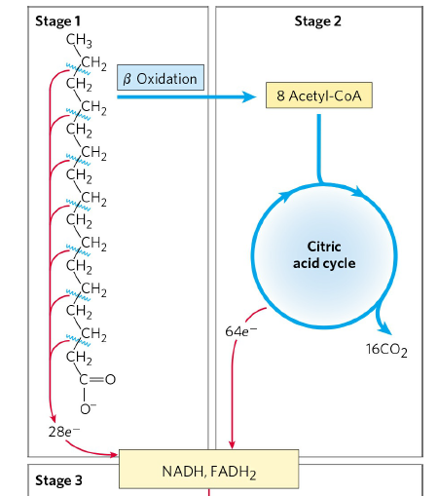
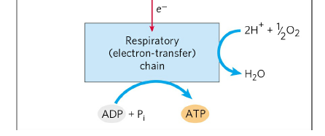
Stage 1 : A long-chain fatty acid is oxidized to yield acetyl residues in the form of acetyl-CoA, starting from the carboxyl end. This process is called β oxidation. For example, the 16-carbon palmitic acid undergoes seven passes, in each pass losing two carbons as acetyl-CoA. At the end of seven cycles, the last four carbons of palmitate give two acetyl-CoA. The overall result is the conversion of the 16-carbon chain of palmitate to 8 acetyl-CoA and production of 7 FADH₂ and 7 NADH.
Stage 2 : The acetyl groups are oxidized to CO₂ via the citric acid cycle.
Stage 3 : Electrons derived from the oxidations of stage 1 and 2 pass to O₂ via the mitochondrial respiration chain, providing the energy for ATP synthesis by oxidative phosphorylation.
- The energy released by fatty acid oxidation is thus conserved as ATP.

The β Oxidation of Saturated Fatty Acids Has Four Basic Steps

- Dehydration of fatty acyl-CoA by acyl-CoA dehydrogenase (Fig. 17-8a)
- Water is added to the double bond by enoyl-CoA hydratase (Fig. 17-8a)
- Dehydration of β-hydroxyacyl-CoA by β-hydroxyacyl-CoA dehydrogenase (Fig. 17-8a)
- Production of acetyl-CoA by acyl-CoA acetyltransferase (thiolase) (Fig. 17-8a)
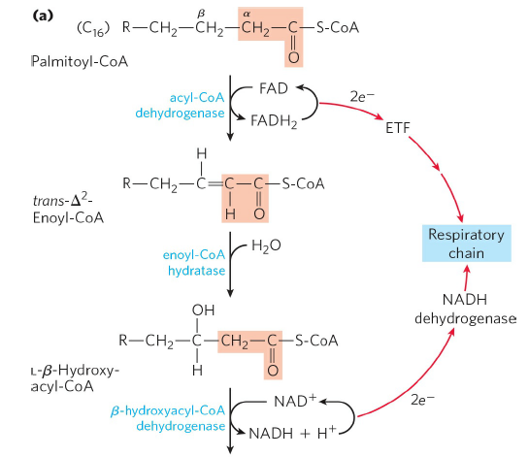
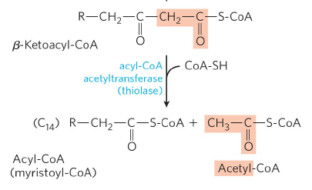
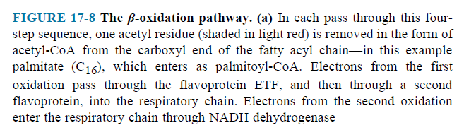
The Four β-Oxidation Steps Are Repeated to Yield Acetyl-CoA and ATP
- Seven passes through the β-oxidation sequence are required to oxidize one molecule of palmitoyl-CoA to eight molecules of acetyl-CoA (Fig. 17-8b).
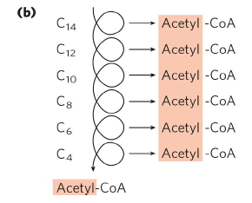
FIGURE 17-8 (b) Six more passes through the β-oxidation pathway yield seven more molecules of acetyl-CoA, the seventh arising from the last two carbon atoms of the 16- carbon chain. Eight molecules of acetyl-CoA are formed in all. The acetyl-CoA may be oxidized in the citric acid cycle, donating more electrons to the respiratory chain.

- The overall equation is
Palmitoyl-CoA + 7 FAD + 7 NAD⁺ + 7 H₂O + 7 CoA

8 Acetyl-CoA + 7 FADH₂ + 7 NADH + 7 H⁺

Acetyl-CoA Can Be Further Oxidized in the Citric Acid Cycle
- 1 Acetyl-CoA produces 3 NADH, 1 FADH₂ and 1 GTP (or ATP).
- 8 Acetyl-CoA produce 24 NADH, 8 FADH₂ and 8 GTP (or ATP).
- 1 Palmitoyl-CoA produces 31 NADH, 15 FADH₂ and 8 GTP (or ATP).
- 31 NADH produce 77.5 ATP and 15 FADH₂ produce 22.5 ATP. Total ATP is 108.
- Remember, 1 ATP was used at activation of fatty acid.
- Because the activation of palmitate to palmitoyl- CoA breaks both phosphoanhydride bonds in ATP, the energetic cost of activating a fatty acid is equivalent to two ATP, and the net gain per molecule of palmitate is 106 ATP.

