Lehninger
Principles of Biochemistry
David L. Nelson
Michael M. Cox

BIOCHEMISTRY 1

Contents
Chapter 1 The Foundations of Biochemistry
Chapter 2 Water
Chapter 3 Amino Acids, Peptides, and Proteins
Chapter 4 The Three-Dimensional Structure of Proteins
Chapter 5 Protein Function
Chapter 6 Enzymes
Chapter 7 Carbohydrates and Glycobiology
Chapter 8 Nucleotides and Nucleic Acids
Chapter 10 Lipids

Chapter 1 The Foundations of Biochemistry
- We live on the earth.
- The earth has chemical elements and compounds.
- More complex biomolecules are made from them.
- Living organisms are composed of lifeless biomolecules.
- Each component of a living organism has a specific function.
- The collection of biomolecules carries out a program.
- A life is come into existence.
- The life itself is a wonder.
- Biochemistry asks how the remarkable properties of living organisms arise from the thousands of different biomolecules.
- Biochemistry describes the structures, mechanisms and chemical processes shared by all organisms.
- Biochemistry explains diverse forms of life in unifying chemical terms.
- Diverse living organisms share common chemical features.
- Birds, plants, microorganisms and humans share
- the same structural units (cells)
- the same kind of macromolecules (DNA, RNA, proteins)
- the same pathways for synthesis of cellular components.
- Biochemistry provides important insights and practical applications in medicine, agriculture, nutrition and industry.
- In this chapter, I will summarize
  - cellular, chemical, physical and genetic backgrounds to biochemistry
  - these backgrounds will help to understand the later discussions of biochemical structure and reactions.

1.1 Cellular Foundations
- The smallest organisms consist of single cells and are microscopic.
- Larger, multicellular organisms contain many different types of cells
  - vary in size, shape and function.

Cells Are the Structural and Functional Units of All Living Organisms
- Cells of all kinds share certain structural features (Fig. 1-3).

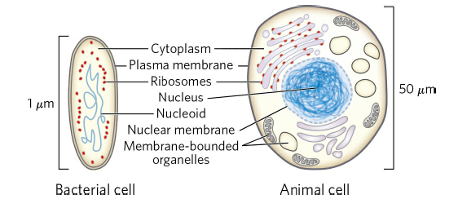

- The plasma membrane defines the periphery of the cell, separating its contents from the surroundings.
- it is composed of lipid and protein molecules that form a hydrophobic barrier to the free passage of inorganic ions and most other charged or polar compounds around the cell.
- in the plasma membrane
  - transport proteins allow the passage of certain ions and molecules
  - receptor proteins transmit signals into the cell
  - enzymes participate in some reaction pathways.
- The cytoplasm (the internal volume bounded by the plasma membrane) contains
- an aqueous solution (cytosol)
- ribosomes (protein-synthesizing machines)
- proteins
- RNA molecules (encodes proteins)
- amino acids and nucleotides (monomers of proteins and nucleic acids)
- metabolites (small organic molecules)
- coenzymes (complex organic molecules)
- inorganic ions
- All cells have either a nucleoid or a nucleus (the complete set of genes called genome)
  - the nucleoid (in bacteria) is not separated from the cytoplasm by a membrane.
  - the nucleus (in eukaryotes) is enclosed within a double membrane.

Cellular Dimensions Are Limited by Diffusion
- The human body contains at least 10¹⁴ cells.
- Most cells are microscopic and invisible. (1 μm = 10 ⁻⁶ m)
- animal and plant cells are typically 5 to 100 μm in diameter.
- many microorganisms are only 1 to 2 μm long and have a volume of about 10⁻¹⁴ mL.

There Are Distinct Domains of Life
- In aerobic cells,
- organisms derive energy from the transfer of electrons from fuel molecules to oxygen.
- In anaerobic cells,
- microorganisms carry out catabolism without oxygen.
- microorganisms obtain energy by transferring electrons to nitrate (forming N₂), sulfate (forming H₂S) or CO₂ (forming methane, CH₄).
Organisms Differ in Their Sources of Energy and Biosynthetic Precursors
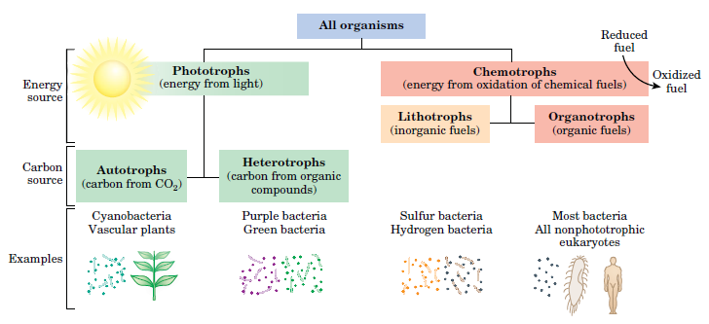

- Organisms can be classified according to their source of
- energy (sunlight or oxidizable chemical compounds)
- carbon for the synthesis of cellular material (Fig. 1-5).

Bacterial Cells Share Common Features
- Escherichia coli is the best-studied bacterium
- The E. coli cell is about 2 μm long and a little less than 1 μm in diameter (Fig. 1-7)
- It has a protective outer membrane and an inner plasma membrane
- encloses the cytoplasm and the nucleoid
- between the inner and outer membranes is a thin but strong layer of a high molecular weight polymer called peptidoglycan (sugar polymers cross-linked by amino acids), which gives the cell its shape and rigidity.
- The plasma membrane and the layers outside it constitute the cell envelope.
- The plasma membranes of bacteria consist of a thin bilayer of lipid molecules penetrated by proteins.
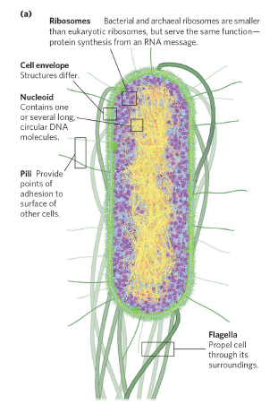
FIGURE 1-7 Some common structural features of bacterial cells.

- Bacterial cells show group-specific specializations because of differences in cell envelope structure (called gram-positive bacteria, gram-negative bacteria).
- Outer membrane protrude hairlike structures
- short is called pili (pili provide points of adhesion to surface of other cells)
- long is called flagella (singular flagellum) (flagella propel cell through its surroundings).
- The cytoplasm of E. coli contains about
- 15,000 ribosomes (protein-synthesizing machines)
- 1,000 different enzymes
- 1,000 organic compounds (metabolites and cofactors)
- inorganic ions.
- The nucleoid contains a single, circular molecule of DNA.
- although the DNA molecule of an E. coli cell is 1,000 times longer than the cell itself, it is packaged which is less than 1 μm (if it is linear 1 mm)
- as in all bacteria, no membrane surrounds the genetic material.

Eukaryotic Cells Have a Variety of Membranous Organelles
- Typical eukaryotic cells (Fig. 1–8) are much larger than bacteria—commonly 5 to 100 μm in diameter.
- The distinguishing characteristics of eukaryotes are
  - the nucleus and
  - membrane-enclosed organelles with specific functions.
- Nucleus contains the genes (chromatin = DNA + Histone proteins)
- is surrounded by a nuclear envelope.
- has a specific region called nucleolus which is the site of ribosomal RNA synthesis
- Cells of each species have a characteristic number of chromosomes
- humans have 23 chromosomes and have two copies of each chromosome.
- the combined length of all 46 chromosomes is only about 200 μm. (if all of them are linear total 2 m)
  - Mitochondria are the site of most of the energy-extracting reactions of the cell.
    - mitochondrian oxidizes fuels to produce ATP.
    - a small amount of DNA is also present in mitochondria.

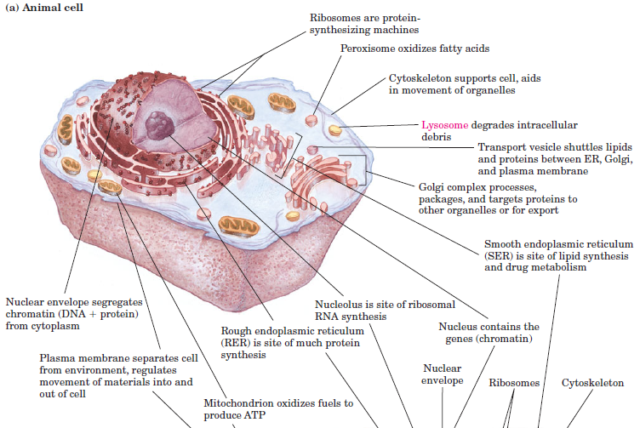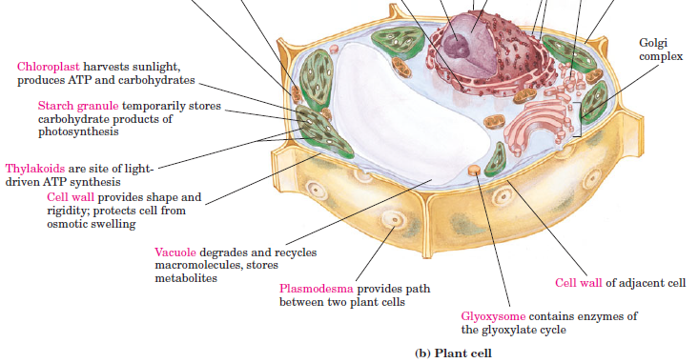
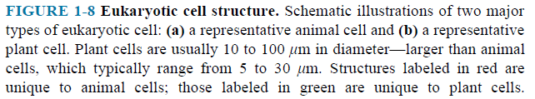

- Smooth endoplasmic reticulum (free of ribosomes) is the site of lipid synthesis and drug metabolism.
- Rough endoplasmic reticulum (attached of ribosomes) is the site of much protein synthesis.
- Golgi complex processes (by adding sulfate, carbohydrate, or lipid moieties to newly synthesized proteins), packages, and targets proteins to other organelles or for export.
- Peroxisomes oxidize very long-chain fatty acids.
- Lysosome (in animal cells) degrades unneeded cellular debris (proteins, polysaccharides, nucleic acids and lipids).
- Vacuole (in plant cells) degrades and recycles macromolecules, stores metabolites.
- Chloroplast (in plant cells) harvests sunlight, produces ATP and carbohydrates.
- a small amount of DNA is also present in chloroplast.
- Glyoxysome (in plant cells) converts stored fats to carbohydrates.
- Ribosomes are protein-synthesizing machines.
- Plasma membrane separates cell from environment, regulates movement of materials into and out of cell.
- Cell wall provides shape and rigidity; protects cell from osmotic swelling.
- Cytoskeletons provide structure and organization to the cytoplasm and shape to the cell. They also help to produce the motion of organelles or of the whole cell.
- these organizations are
  - far from random, dramatic, finely orchestrated reorganizations.

Cells Build Supramolecular Structures
- There is a structural hierarchy in the molecular organization of cells (Fig. 1–12).
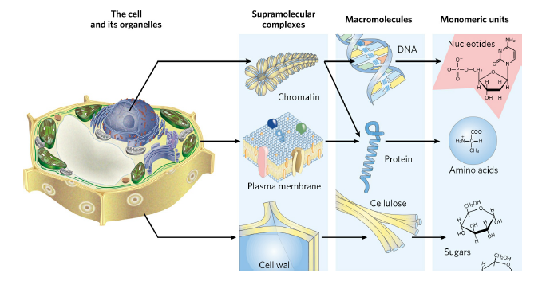

- The monomeric subunits of proteins, nucleic acids and polysaccharides are joined by covalent bonds.
- In supramolecular complexes, however, macromolecules are held together by noncovalent interactions—much weaker, individually, than covalent bonds.
- among these noncovalent interactions are
  - hydrogen bonds (between polar groups)
  - ionic interactions (between charged groups)
  - hydrophobic interactions (among nonpolar groups in aqueous solution)
  - van der Waals interactions (London forces).
1.2 Chemical Foundations
- Biochemistry aims to explain biological form and function in chemical terms.
- Fewer than 30 of the more than 90 naturally occurring chemical elements are essential to organisms.
- H, C, N, O, Na, P, S, Cl, K and Ca are bulk elements.
- Mg, V, Cr, Mn, Fe, Co, Ni, Cu, Zn, Se, Mo, I and W are trace elements.
- The four most abundant elements in living organisms
  - are H, O, N, and C
    - which together make up more than 99% of the mass of most cells.

Biomolecules Are Compounds of Carbon with a Variety of Functional Groups
- The chemistry of living organisms is organized around carbon
  - which accounts for more than half the dry weight of cells.
- Carbon can form
  - single bonds with hydrogen atoms
  - both single and double bonds with oxygen and nitrogen atoms
  - single, double and triple bonds with carbon atoms.
- Most biomolecules can be regarded as derivatives of hydrocarbons.
- Functional groups of biomolecules determine chemical properties of biomolecules.
- Some common functional groups are given in (Fig. 1–17).

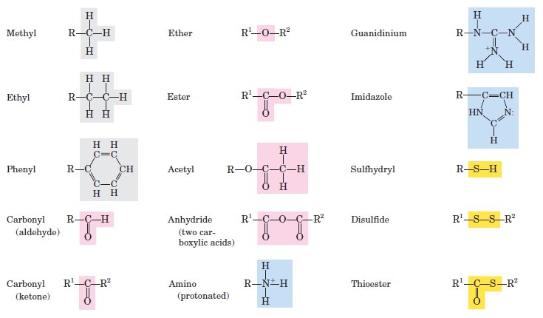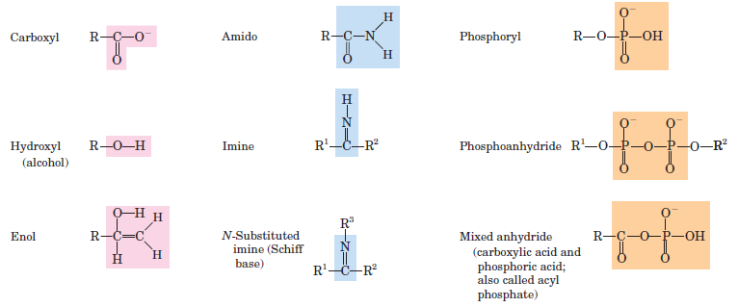

Macromolecules Are the Major Constituents of Cells
- Many biological molecules are macromolecules
- are assembled from relatively simple precursors.
- Shorter polymers are called oligomers.
- Proteins, nucleic acids, and polysaccharides are macromolecules composed of monomers.
- The molecular mass of a particle may be expressed in units of Daltons
- 1 dalton defines the mass of a H atom
- Proteins are composed of 20 different kinds of amino acids.
- Deoxyribonucleic acids (DNA) are constructed from only four different kinds of deoxyribonucleotides.
- Ribonucleic acids (RNA) are composed of just four types of ribonucleotides.
- Polysaccharides are polymers of simple sugars such as glucose.
- Lipids are water insoluble hydrocarbon derivatives.
- (Table 1–1) shows the major classes of biomolecules in an E. coli cell.

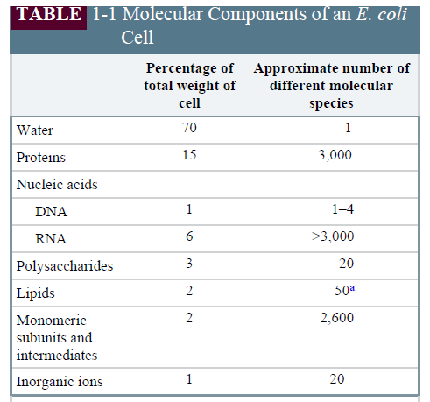

- Proteins, polynucleotides and polysaccharides have large numbers of monomeric subunits and thus high molecular weights — in the range of
  - 5,000 to more than 1 million for proteins
  - up to several billion for nucleic acids
  - in the millions for polysaccharides such as starch.
- Individual lipid molecules are much smaller (750 to 1,500) and are not classified as macromolecules.
- These monomeric subunits can be covalently linked in a limitless variety of sequences,
- just as the 26 letters of the English alphabet can be arranged into a limitless number of words, sentences and books.

Three-Dimensional Structure Is Described by Configuration and Conformation
- The covalent bonds and functional groups of a biomolecule are central to its function
- the arrangement of atoms is also important.
- A carbon containing compound commonly exists as stereoisomers
- molecules with the same chemical bonds but different configuration
  - the fixed spatial arrangement of atoms.
- Interactions between biomolecules are stereospecific
- requiring specific configurations in the interacting molecules.
- (Fig. 1.20) shows the configurations of maleic acid and fumaric acid (cis-trans isomers).
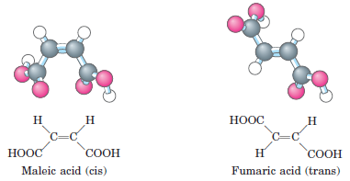
- the two compounds have distinct biological roles despite their similar chemistry.
- A carbon atom with four different substituents is said to be asymmetric
- asymmetric carbons are called chrical centers.
- Some stereoisomers are mirror images of each other
- they are called enantiomers.
- Some stereoisomers are not mirror images of each other
- they are called diastereomers.
- For compounds with more than one chiral center
- the most useful system of nomenclature is the RS system.

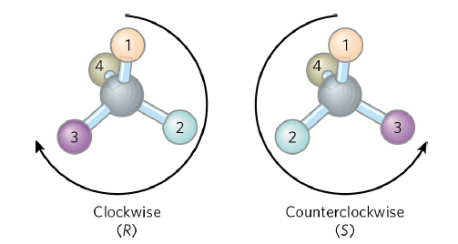

- Another naming system for stereoisomers, the D and L system, is described in Chapter 3.
- Distinct from configuration is molecular conformation
- the spatial arrangement of substituent groups
- are free to assume different positions in space because of the freedom of rotation about single bonds.

Interactions between Biomolecules Are Stereospecific
- The three-dimensional structure of biomolecules (the combination of configuration and conformation)
- is important in their biological interactions.
- When biomolecules interact
- the “fit” between them must be stereochemically correct.
- For example, molecular interactions between enzyme and substrate are stereospesific.
- In living organisms, chiral molecules are usually present in only one of their chiral forms.
- the amino acids occur only as their L isomers
- glucose occurs only as its D isomer.
- Stereospecificity (the ability to distinguish between stereoisomers) is
- a characteristic feature of the molecular logic of living cells.

1.3 Physical Foundations
- Energy is central theme in biochemistry
- cells and organisms depends on a constant supply of energy.
- One goal of biochemistry is to understand the energy (in quantitative and chemical terms)
- the energy is extracted, stored and channeled into useful work in living cells.
- Cells have evolved highly efficient mechanisms
- for coupling the energy obtained from sunlight or fuels to the many energy-consuming processes.

Organisms Transform Energy and Matter from Their Surroundings
- For chemical reactions occurring in solution, we can define a system.
- If system exchanges both energy and matter with its surroundings, it is an open system.
- A living organism is an open system
- Organisms obtain energy from their surroundings in two ways:
- they take up chemical fuels (such as glucose) and extract energy by oxidizing them
- they absorb energy from sunlight.
- Cells are consummate transducers of energy
- capable of interconverting chemical, electromagnetic, mechanical and osmotic energy with great efficiency (Fig. 1-24).
- Living cells are chemical engines.
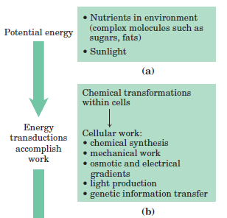
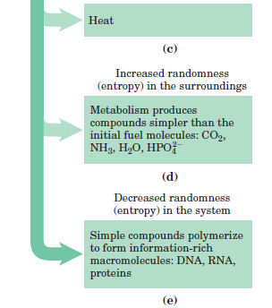
The Flow of Electrons Provides Energy for Organisms
- Nearly all living organisms derive their energy, directly or indirectly, from the radiant energy of sunlight.
- Sunlight is transmitted to the earth and converted into chemical energy by plants and some algae and bacteria.
- Photosynthetic cells absorb light energy and use it to drive electrons from H₂O to CO₂
- forming energy-rich products such as starch and sucrose and releasing O₂ into the atmosphere.
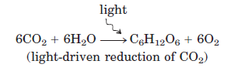
- Nonphotosynthetic organisms obtain the energy
- by oxidizing the energy-rich products of photosynthesis and then passing the electrons to atmospheric O₂ to form H₂O, CO₂ and other products.

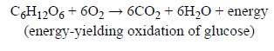
- All these reactions involving electron flow are oxidation-reduction reactions.

Energy Coupling Links Reactions in Biology
- The central issue in bioenergetics is the study of energy transformations in living systems.
- The amount of energy available to do work is the free-energy change, ΔG.
- The energy change as the system moves from its initial state to equilibrium is given by the ΔG.
- In spontaneously reactions, the products have less free energy than the reactants
- the reaction releases free energy
- is then available to do work.
- such reactions are exergonic and ΔG is negative (ΔG < 0).
- Endergonic reactions require an input of energy, ΔG is positive (ΔG > 0).
- In living organisms, an exergonic reaction can be coupled to an endergonic reaction or process to drive otherwise unfavorable reactions (Fig. 1-26).

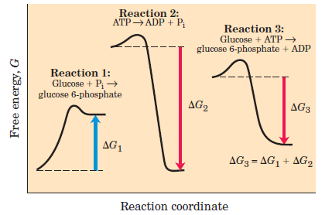
FIGURE 1–26 Energy coupling in chemical processes.

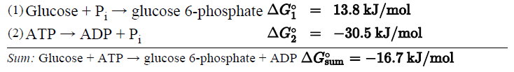
- Reaction 1: (endergonic, ΔG₁ is positive) (P_{i} : inorganic phosphate, HPO₄²⁻)
- Reaction 2: (exergonic, ΔG₂ is negative)
- The two chemical reactions share a common intermediate, P_{i}. The two reactions can be coupled in the form of a third reaction.
- Reaction 3: (exergonic, ΔG₃ is negative). The overall reaction proceeds spontaneously.
- The coupling of exergonic reactions with endergonic ones is absolutely central to the energy exchanges in living systems.
- ATP is the major carrier of chemical energy in all cells.
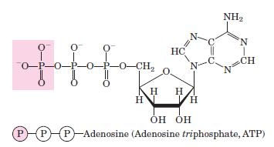
- The removal of the terminal phosphoryl group of ATP by breakage of a phosphoanhydride bond is highly exergonic.
- this reaction is coupled to many endergonic reactions in the cell.

Enzymes Promote Sequences of Chemical Reactions
- Every chemical reaction in a cell occurs at a significant rate only because of the presence of enzymes—biocatalysts
- increase the rate of specific chemical reactions without being consumed in the process.
- The path from reactant(s) to product(s) involves an energy barrier (Fig. 1-27)

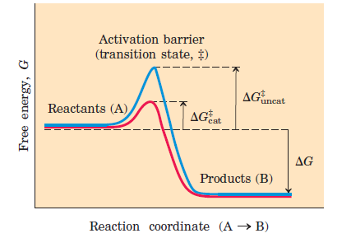
- it is called the activation barrier
- it must be surmounted.
- Enzymes lower the energy barrier between reactant and product.
- Enzyme catalyzed reactions commonly proceed at rates greater than 10¹² times faster than uncatalyzed reactions.
- Cellular catalysts are generally proteins
- each enzyme catalyzes a specific reaction.
- thousands of different enzymes are required by each cell.
- The thousands of enzyme in cells are functionally organized into many sequences of consecutive reactions, called pathways,
- the product of one reaction becomes the reactant in the next.
- Degradative and free-energy-yielding reactions are designated catabolism.
- ATP is synthesized.
- the reduced electron carriers NADH and NADPH are produced.
- Small precursor molecules are converted to larger and more complex molecules, represent anabolism (requires the input of energy)
- The overall network of enzyme-catalyzed pathways, both catabolic and anabolic,
- constitutes cellular metabolism (Fig. 1-28).

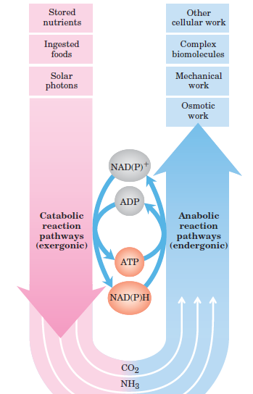

Metabolism is Regulated to Achieve Balance and Economy
- Key enzymes in each metabolic pathway are regulated
- each type of precursor molecule is produced in a quantity appropriate to the current requirements of the cell.
- Living cells are self-regulating chemical engines
- continually adjusting for maximum economy.

  - Genetic Foundations
- Continuity of structure and composition of living organisms is the result of continuity in the structure of the genetic material.
- Genetic material is called deoxyribonucleic acid (DNA).
- DNA is a long and thin organic polymer.
- Genetic information is encoded in the linear sequence of four kinds of deoxyribonucleotides.
- DNA is double-helical molecule (Fig. 1-32).

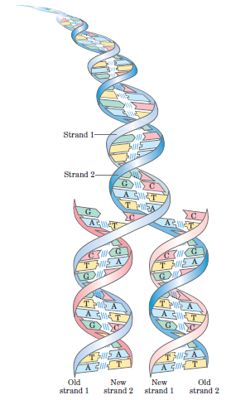

- Changes in the nucleotide sequence represent a genetic mutation.
- Mutations can change the instructions for producing cellular components.
- Many mutations are harmful or even lethal to the organism.
The Linear Sequence in DNA Encodes Proteins with Three-Dimensional Structures
- Linear sequences of deoxyribonucleotides in DNA, known as genes,
- are transcribed into ribonucleic acid (RNA) molecules.
- The RNA sequence is translated into linear sequence of amino acids called protein.
- The protein is folded into a particular three-dimensional shape (Fig. 1-33).

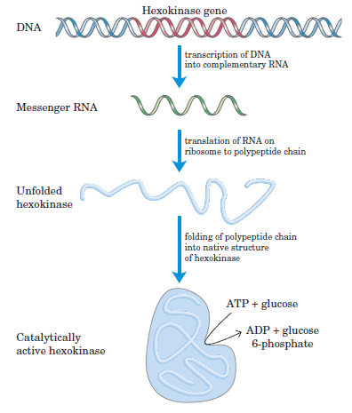

- The entire genetic material of
- E. coli is 4.64 million nucleotide pairs ( ~3,000 different genes and proteins)
- a human is 3 billion nucleotide pairs ( ~20,000 different genes and proteins)
- These monomeric subunits of DNA and proteins can be covalently linked in a limitless variety of sequences,
- just as the 26 letters of the English alphabet can be arranged into a limitless number of words, sentences and books.
- An amazing chemical feat!

