Chapter 8 Nucleotides and Nucleic Acids

8.1 Some Basic
Nucleotides and Nucleic Acids Have Characteristic Bases and Pentoses
- Nucleotides are constituents of nucleic acids (DNA, RNA).
- Nucleotides have three components (Fig. 8-1a)
- a nitrogen-containing base (Adenine, Guanine, Cytosine, Thymine, Uracil) (A, G, C, T in DNA) (A, G, C, U in RNA) (Fig. 8-2).
- a pentose (Ribose in RNA) (2-Deoxyribose in DNA).
- one or more phosphates

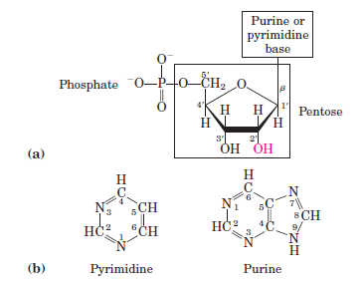

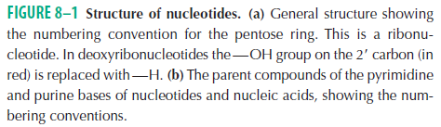

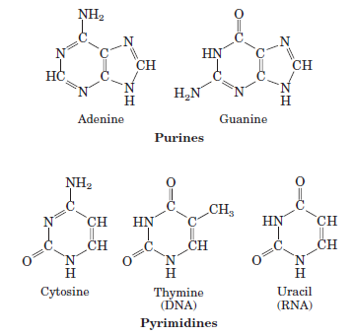

- The molecule without the phosphate group is called a nucleoside.
- In the pentoses, the carbon numbers are given a prime (‘) designation to distinguish them from the numbered atoms of the nitrogenous bases. (Fig. 8-1b)
- The base is joined covalently (at N-1 of pyrimidines and N-9 of purines) in a glycosyl bond to the 1’ carbon of pentose.
- The phosphate is esterified to the 5’ carbon of pentose.
- There are four deoxyribonucleotides
- the structural units of DNA.
- There are four ribonucleotides
- the structural units of RNA. (Fig. 8-4) (Table 8-1).

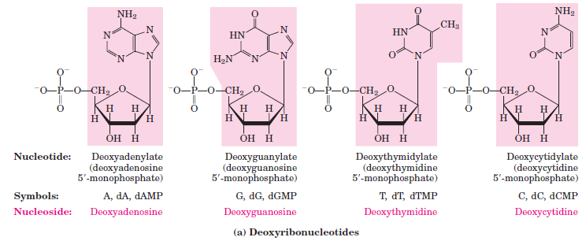
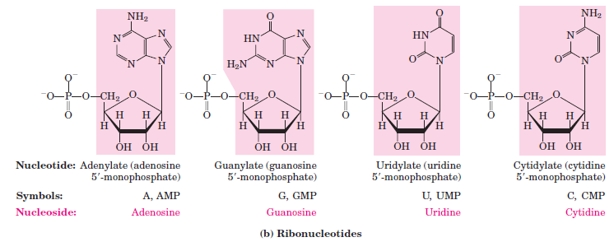

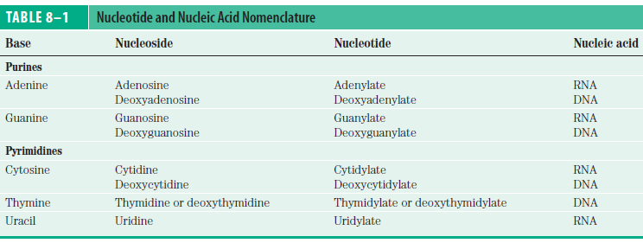
Phosphodiester Bonds Link Successive Nucleotides in Nucleic Acids
- The successive nucleotides of both DNA and RNA are covalently linked through phosphate-group “bridges”.
- The 5’-phosphate group of one nucleotide unit is joined to the 3’-hydroxyl group of the next nucleotide, creating a phosphodiester linkage (Fig. 8–7).

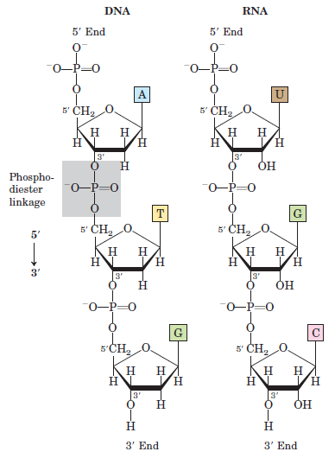

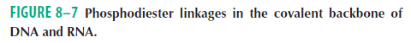

- The backbones of both DNA and RNA are hydrophilic.
- The hydroxyl groups of the sugar residues form hydrogen bonds with water.
- The phosphate groups, with a pKa near 3, are completely ionized and negatively charged at pH 7, and the negative charges are generally neutralized by ionic interactions with positive charges on proteins, metal ions, and polyamines.
- Nucleic acids are polymer of nucleotides.
- A short nucleic acid is referred to as an oligonucleotide (50 or fewer nucleotides).
- A longer nucleic acid is called a polynucleotide.

8.2 Nucleic Acid structure
DNA Is a Double Helix That Stores Genetic Information
- It consists of two helical DNA chains wound around the same axis to form a right-handed double helix (Fig. 8-13).

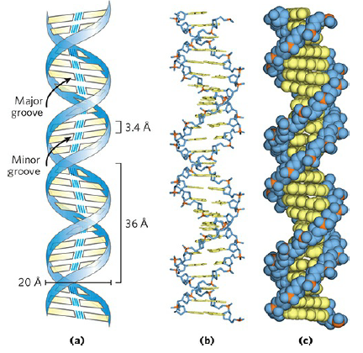
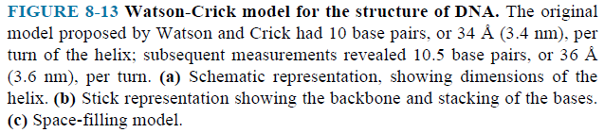

- The hydrophilic backbones of alternating deoxyribose and phosphate groups are on the outside of the double helix.
- The purine and pyrimidine bases of both strands are stacked inside the double helix.
- Each nucleotide base of one strand is paired in the same plane with a base of the other strand.
- H bonds between bases (A = T, 2 H bonds) (C G, 3 H bonds) permit a complementary association of two strands of nucleic acid (Fig. 8-14).
- Orientation of DNA is an antiparallel.

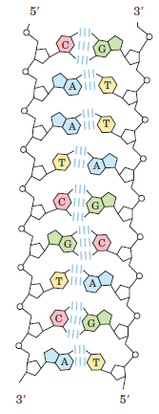

DNA Can Occur in Different Three-Dimensional Forms
- DNA can occur in different three-dimensional forms (A, B and Z forms) (Fig. 8-17).
- The B form is the most stable structure.
- The Z form takes on a zigzag appearance.
- A, and B forms are right handed.
- Z form is left handed.

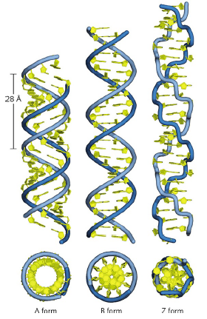

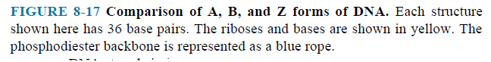

Certain DNA Sequences Adopt Unusual Structures
- Palindromes are sequences of double-stranded nucleic acids with twofold symmetry.
- A mirror repeat has a symmetric sequence within each strand.

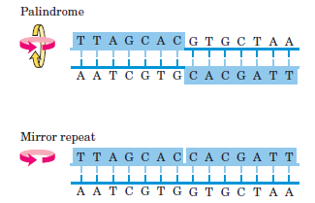

- Such sequences are self-complementary within each strand and therefore have the potential to form hairpin (in single DNA or RNA) or cruciform structures.

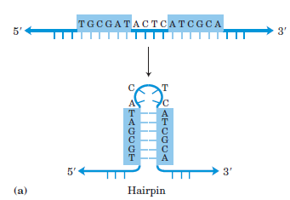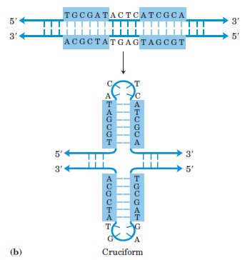

Messenger RNAs Code for Polypeptide Chains
- Messenger RNAs (mRNA) carry the genetic information from DNA to the ribosomes.
- Corresponding proteins can be synthesized.
- The process of forming mRNA on a DNA template is known as transcription.
- In bacteria and archaea, a single mRNA molecule may code for one or several polypeptide chains.
- If it carries the code for only one polypeptide, the mRNA is monocistronic (Fig. 8-21).
- If it codes for two or more different polypeptides, the mRNA is polycistronic.

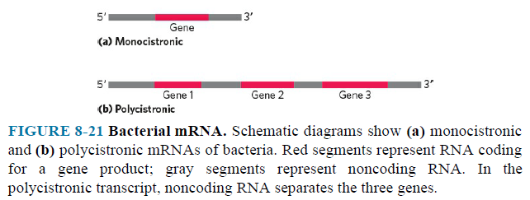

- In eukaryotes, most mRNAs are monocistronic.

Many RNAs Have More Complex Three-Dimensional Structures
- Transfer RNAs (tRNA) are adapter molecules in protein synthesis.
- They translate the information in mRNA into a specific sequence of amino acids.
- Ribosomal RNAs (rRNA) are structural components of ribosomes.
- They carry out the synthesis of proteins.

8.3 Nucleic Acid Chemistry
Double-Helical DNA and RNA Can Be Denatured
- When a solution is subjected to extremes of pH or to temperatures above 80 ºC, the DNA has undergone a physical change.
- Disruption of the hydrogen bonds between paired bases causes unwinding of the double helix to form two single strands.
- When the temperature or pH is returned to the range, the unwound segments of the two strands spontaneously rewind, or anneal.

The Sequences of Long DNA Strands Can Be Determined
- In 1977, two techniques made possible the sequencing of larger DNA molecules.
- Alan Maxam and Walter Gilbert
- Frederick Sanger
- The techniques depend on electrophoretic methods for separating DNA strands differing in size by only one nucleotide.
- Electrophoresis of DNA is similar to that of proteins.
- Polyacrylamide is often used as the gel matrix in work with short DNA molecules (up to a few hundred nucleotides)
- Agarose is generally used for longer pieces of DNA.
- The Sanger method is technically easier and is in more widespread use.
- In DNA sequencing by the Sanger method, the general principle is to reduce the DNA to four sets of labeled (radioactive) fragments.
- The deoxynucleotides and dideoxynucleotides are used.
- When the sets of fragments are electrophoretically separated side by side, they produce a ladder of bands from which the sequence can be read directly (Fig. 8–33).
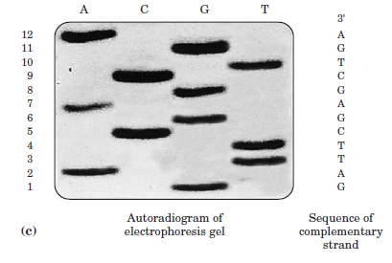

- DNA sequencing is now automated by a variation of Sanger’s sequencing method.
- The dideoxynucleotides used for each reaction are labeled with a differently colored fluorescent tag (Fig. 8–34).
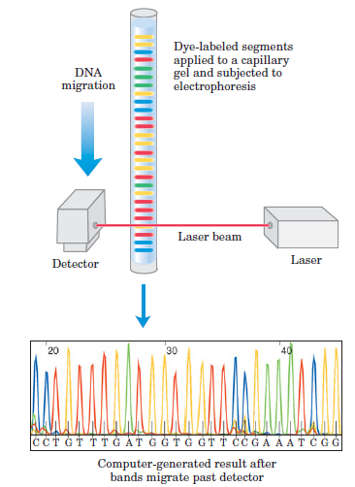

- The DNA sequence is read by determining the sequence of colors in the peaks as they pass the detector.
- With this technology, researchers can sequence DNA molecules containing thousands of nucleotides in a few hours.
- It is still used for routine sequencing of genes or DNA segments.

8.4 Other Functions of Nucleotides
- Nucleotides have a variety of other functions in every cell: as
- energy carriers,
- components of enzyme cofactors,
- chemical messengers.

Nucleotides Carry Chemical Energy in Cells
- The phosphate group covalently linked at the 5’ hydroxyl of a ribonucleotide may have one or two additional phosphates attached (Fig. 8–36).

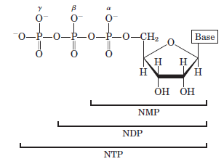

- Hydrolysis of nucleoside triphosphates provides the chemical energy to drive many cellular reactions.
- ATP is the most used for this purpose.
- UTP, GTP and CTP are also used in some reactions.
- Hydrolysis of a phosphoanhydride bond yields more energy than hydrolysis of the phosphate ester.
- Hydrolysis of the ester linkage yields about 14 kJ/mol.
- Hydrolysis of each anhydride bond yields about 30 kJ/mol.
- ATP hydrolysis often plays an important thermodynamic role in biosynthesis. (Remember)
- Nucleoside triphosphates also serve as the activated precursors of DNA and RNA synthesis.

Adenine Nucleotides Are Components of Many Enzyme Cofactors
- Some coenzymes contain adenosine (Fig. 8–38).
- Coenzyme A (CoA) functions in acyl group transfer reactions.
- Nicotinamide adenine dinucleotide (NAD⁺) functions in hydride transfers.
- Flavin adenine dinucleotid (FAD) functions in electron transfers.

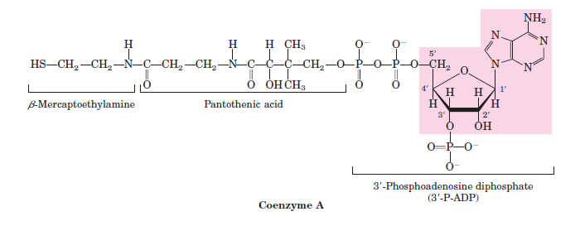
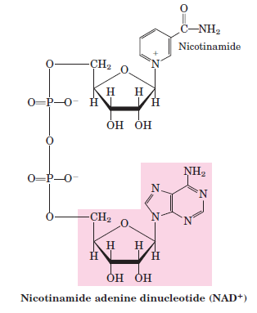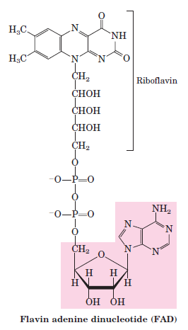

Some Nucleotides Are Regulatory Molecules
- Cells respond to their environment by taking cues from hormones or other external chemical signals.
- The interaction of these extracellular chemical signals (“first messengers”) with receptors on the cell surface often leads to the production of second messengers inside the cell.
- They lead to adaptive changes in the cell interior by doing regulatory functions.
- Often, the second messenger is a nucleotide.
- One of the most common is adenosine 3’,5’-cyclic monophosphate (cyclic AMP or cAMP).
- One of them is guanosine 3’,5’-cyclic monophosphate (cyclic GMP or cGMP).

