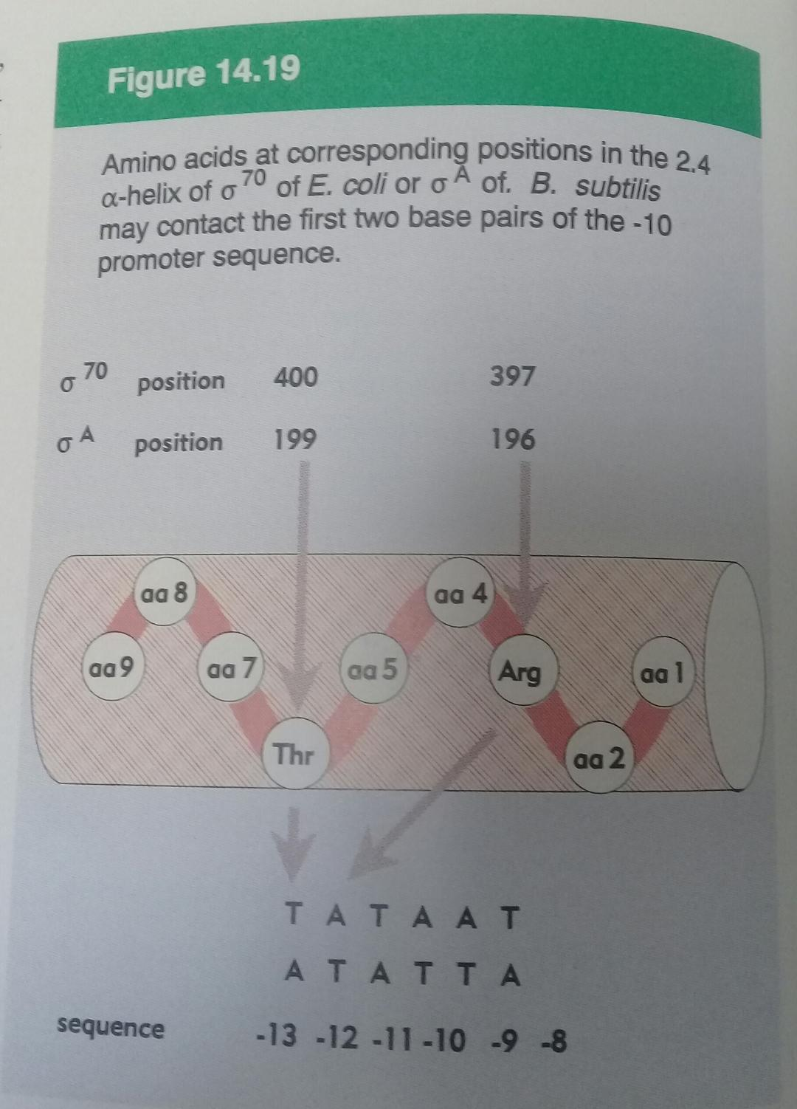
Transcription Is Regulated at Several Levels
- Regulation can occur at any step in transcription, including elongation and termination.
- The binding of proteins to sequences both near to and distant from the promoter can also affect levels of gene expression.
- Protein binding can activate transcription by facilitating either RNA polymerase binding or steps further along in the initiation process, or it can repress transcription by blocking the activity of the polymerase.
- Repressors are proteins that block the synthesis of RNA at specific genes.

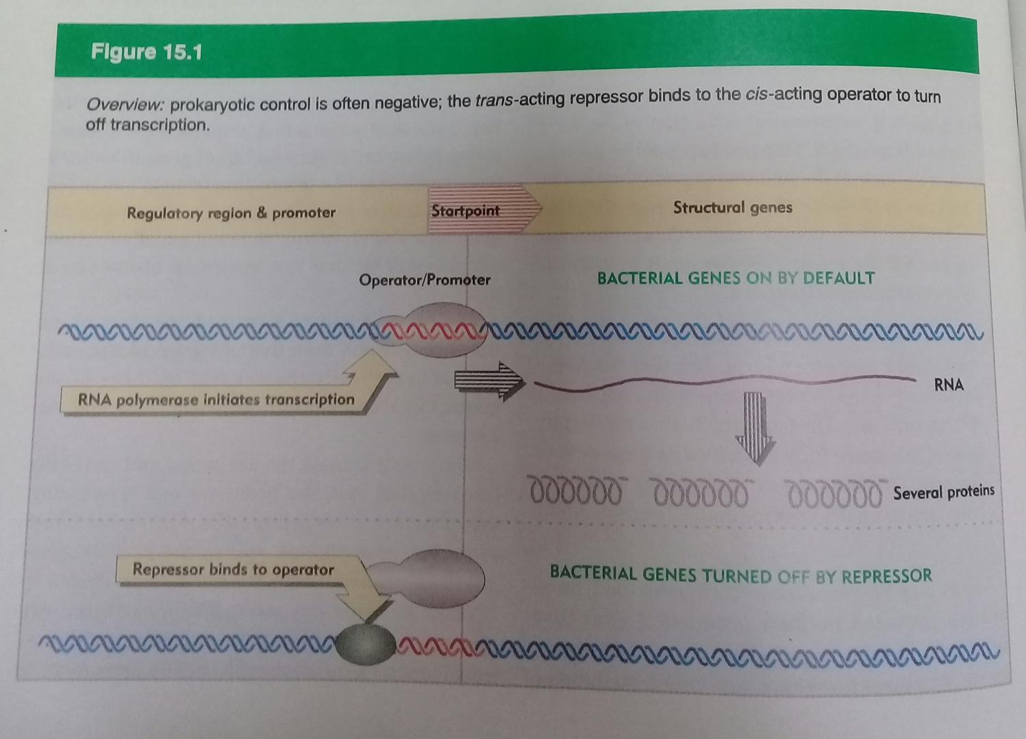
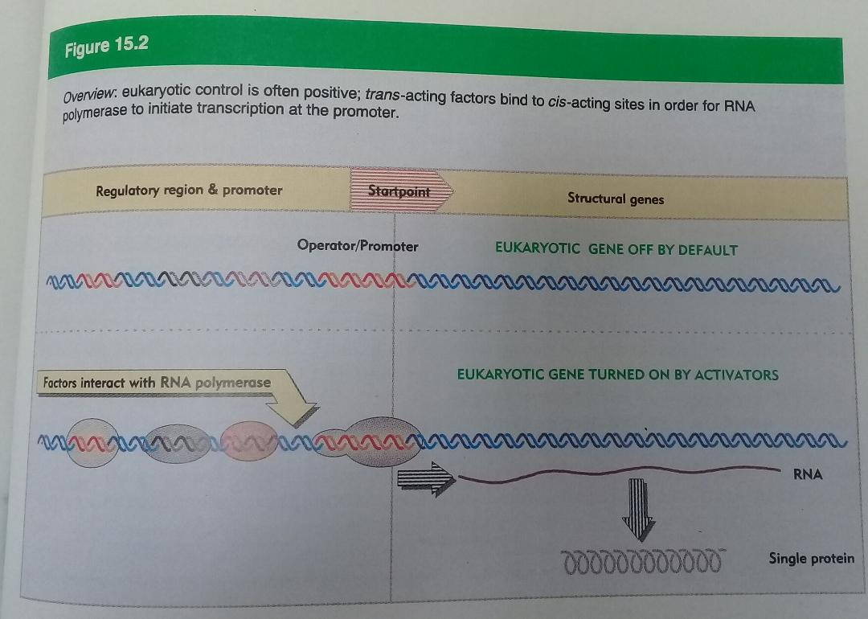
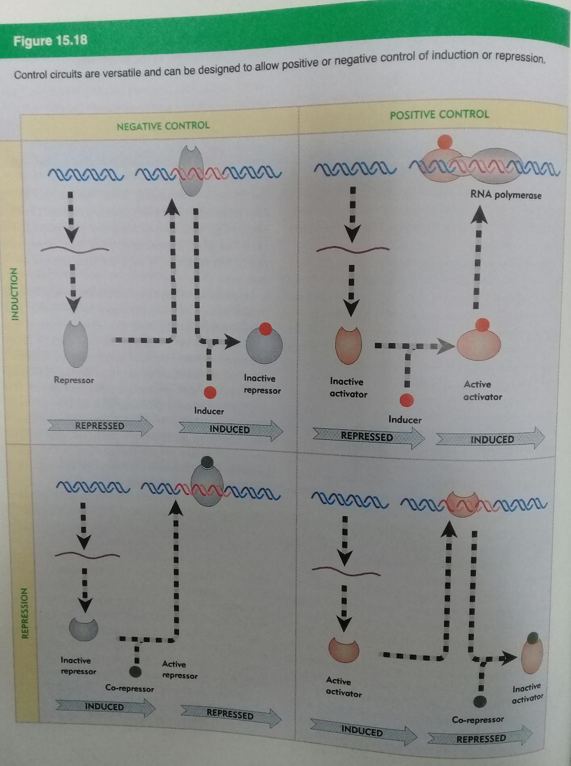
- In E. coli, one protein that activates transcription is the cAMP receptor protein (CRP), (CAP, catabolite activator protein), which increases the transcription of genes coding for enzymes.
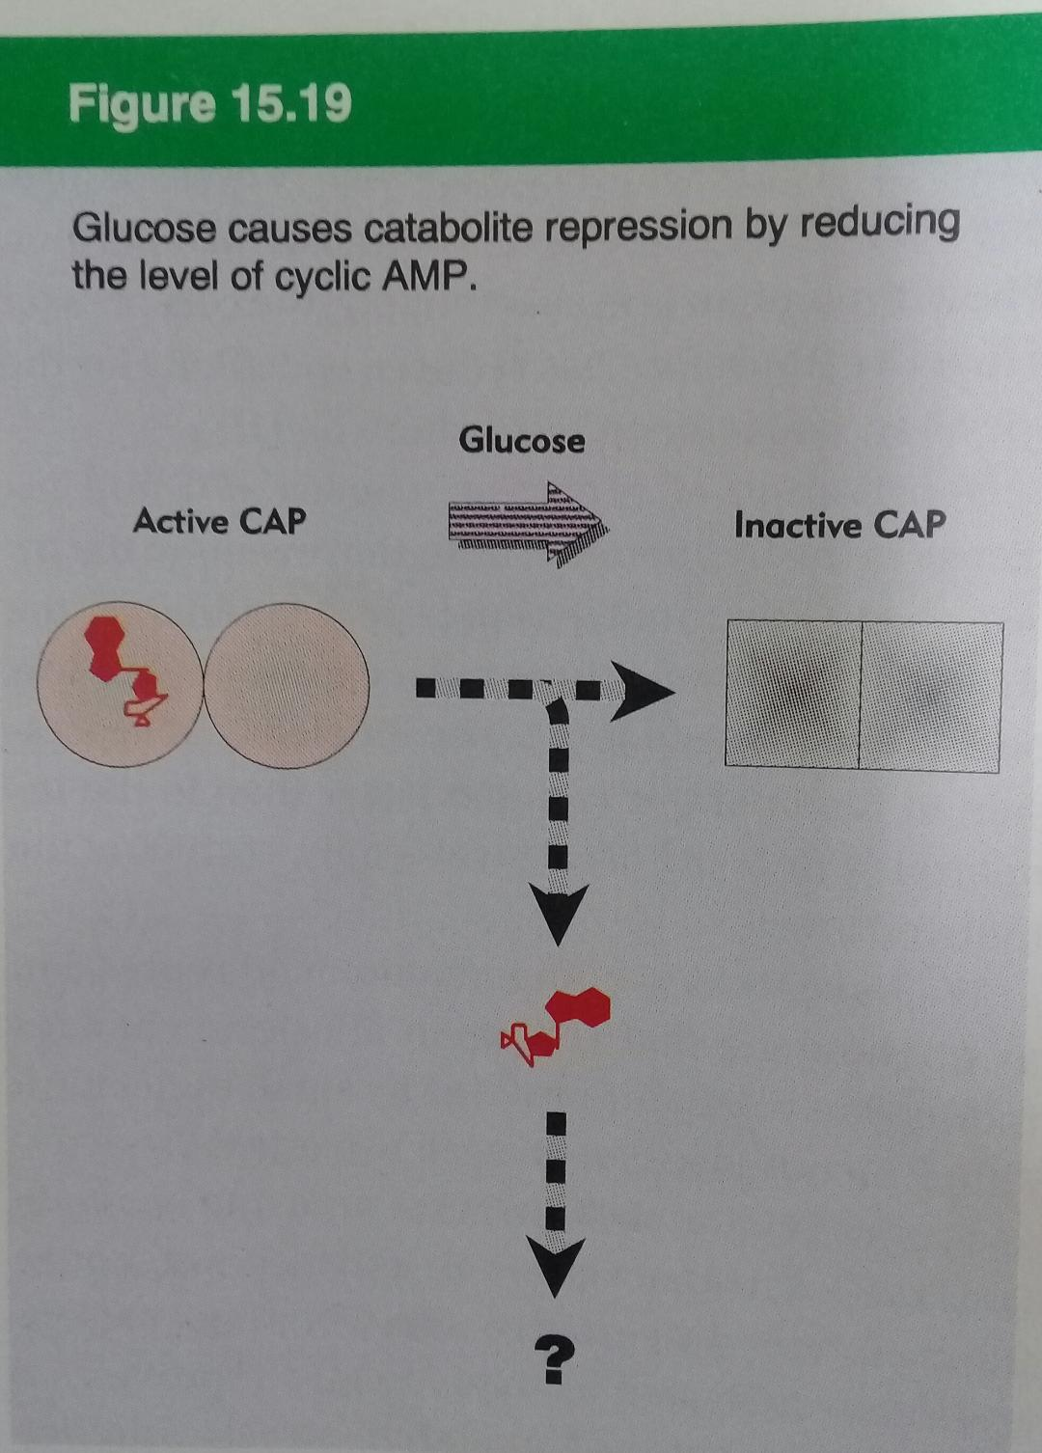
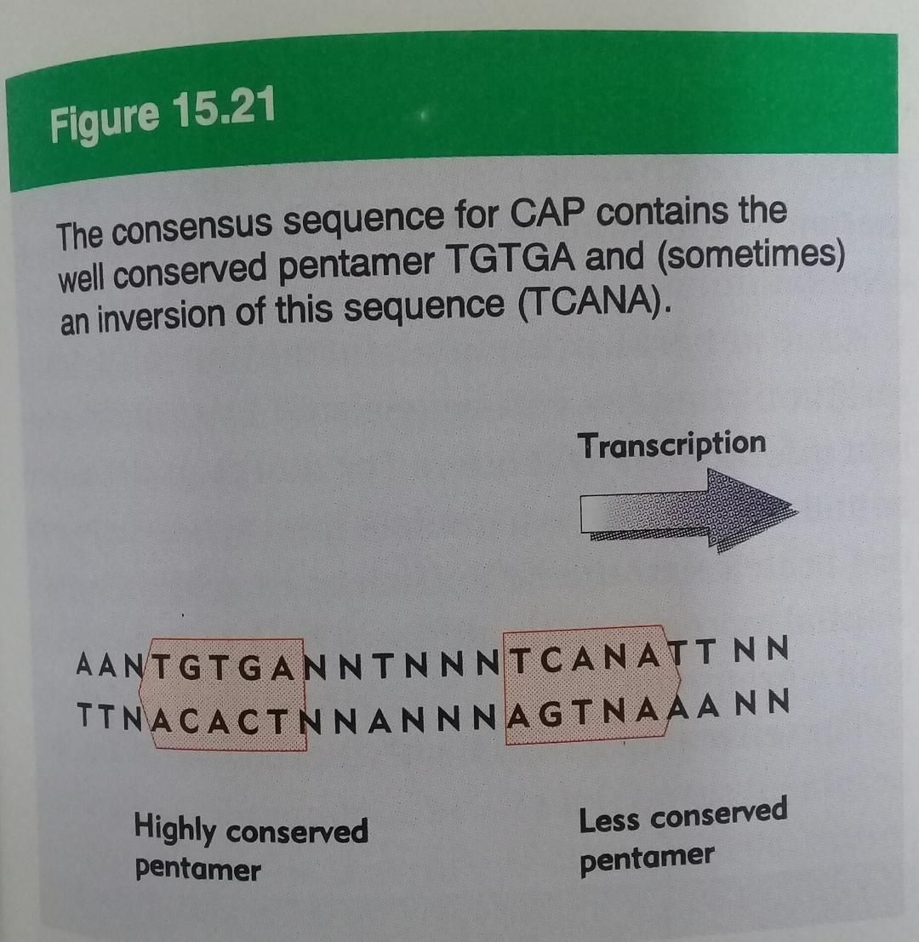
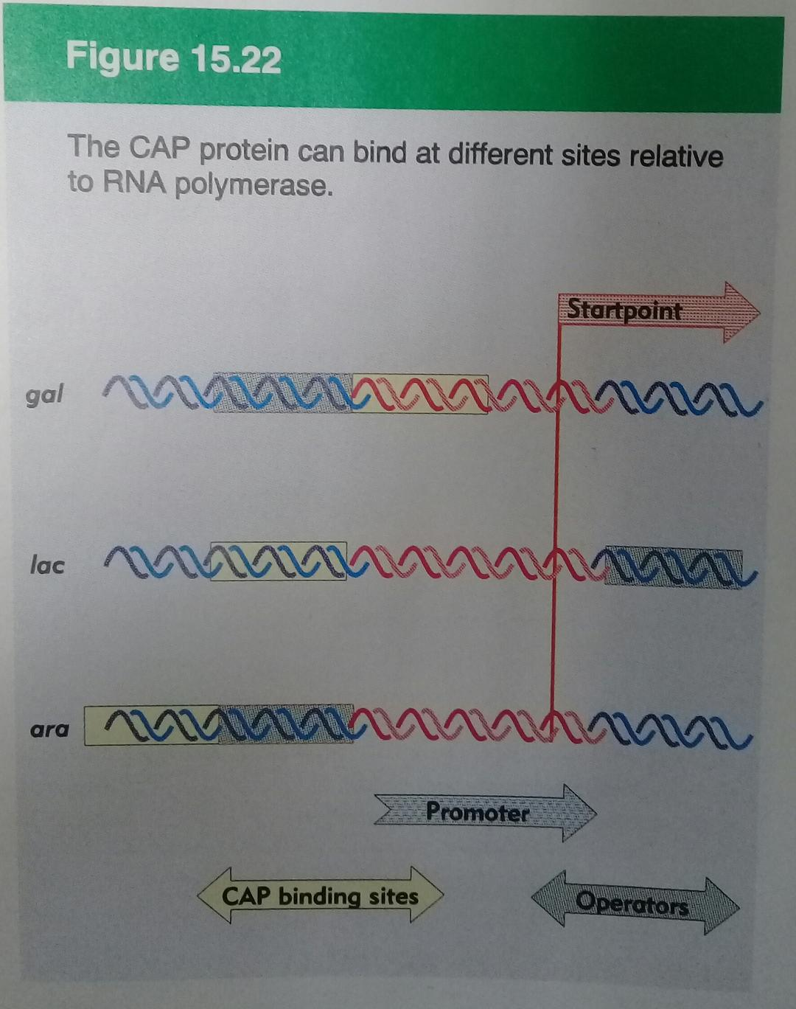
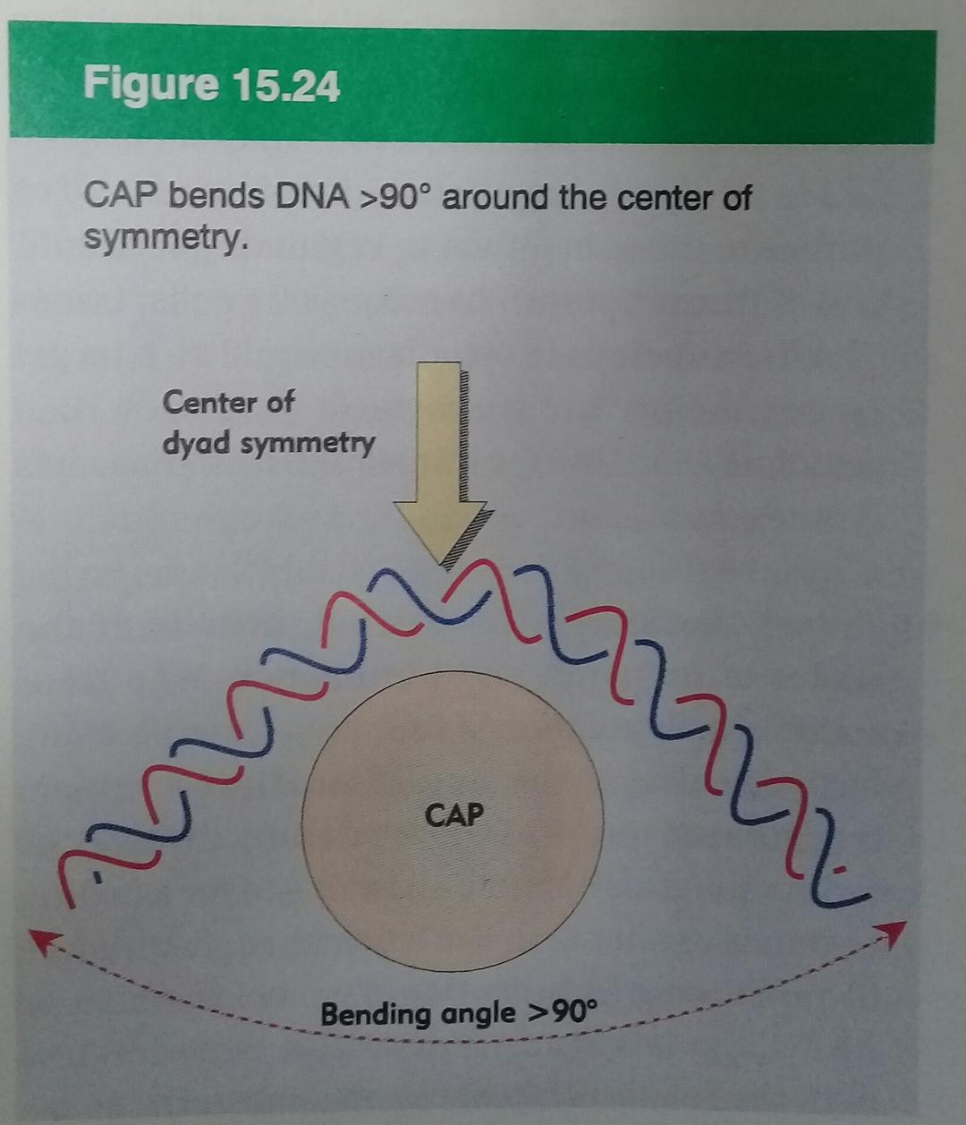
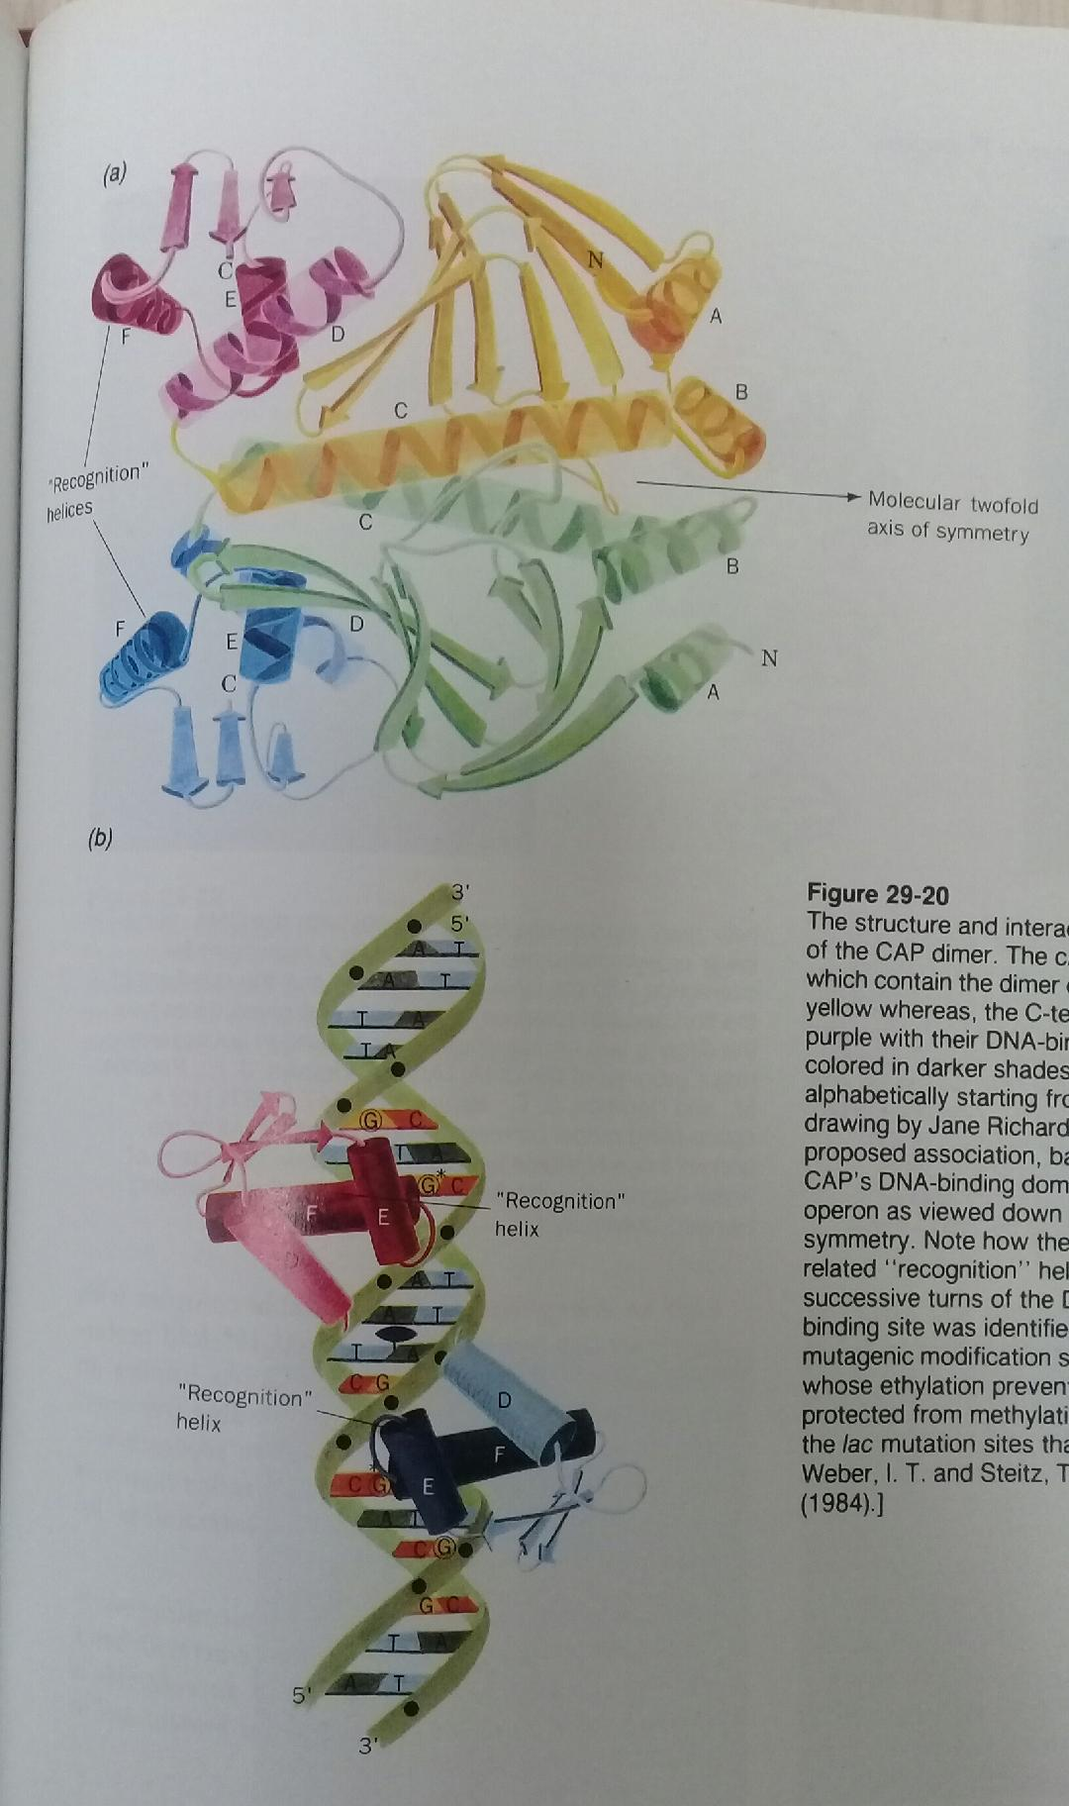
Specific Sequences Signal Termination of RNA Synthesis
- E. coli has at least two classes of termination signals: one class relies on a protein factor called ρ (rho) and the other is ρ-independent.
- Most ρ -independent terminators have two distinguishing features.
- The first is a region that produces an RNA transcript with self-complementary sequences, permitting the formation of a hairpin structure centered 15 to 20 nucleotides before the projected end of the RNA strand (Fig. 8–19a).

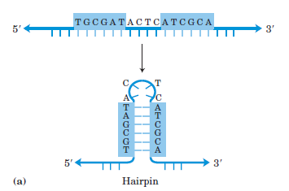

- The second feature is a highly conserved string of three A residues in the template strand that are transcribed into U residues near the 3’ end of the hairpin (Fig. 26–7a).
- When a polymerase arrives at a termination site with this structure, it pauses.
- Formation of the hairpin structure in the RNA disrupts several A=U base pairs in the RNA-DNA hybrid segment and may disrupt important interactions between RNA and the RNA polymerase, facilitating dissociation of the transcript.

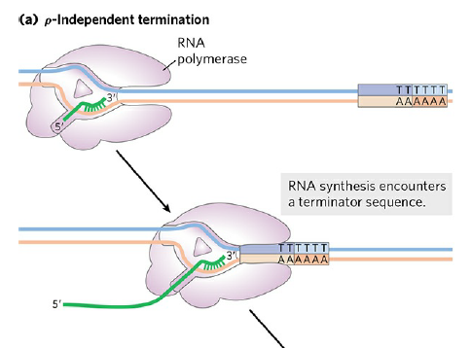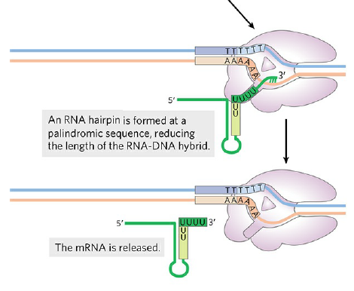
- The ρ-dependent terminators lack the sequence of repeated A residues in the template strand but usually include a CA-rich sequence called a rut (rho utilization) element (Fig. 26–7b).
- The ρ protein associates with the RNA at specific binding sites and migrates in the 5’ 3’ direction until it reaches the transcription complex that is paused at a termination site.
- Here it contributes to release of the RNA transcript.

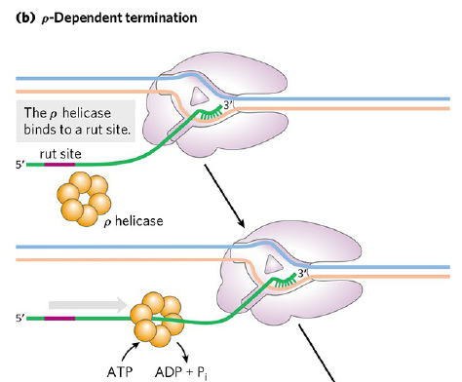
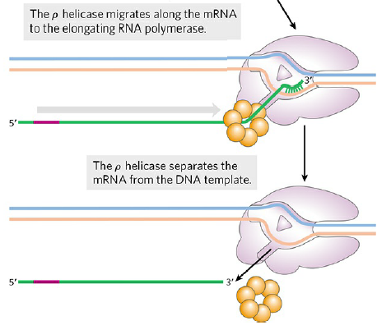

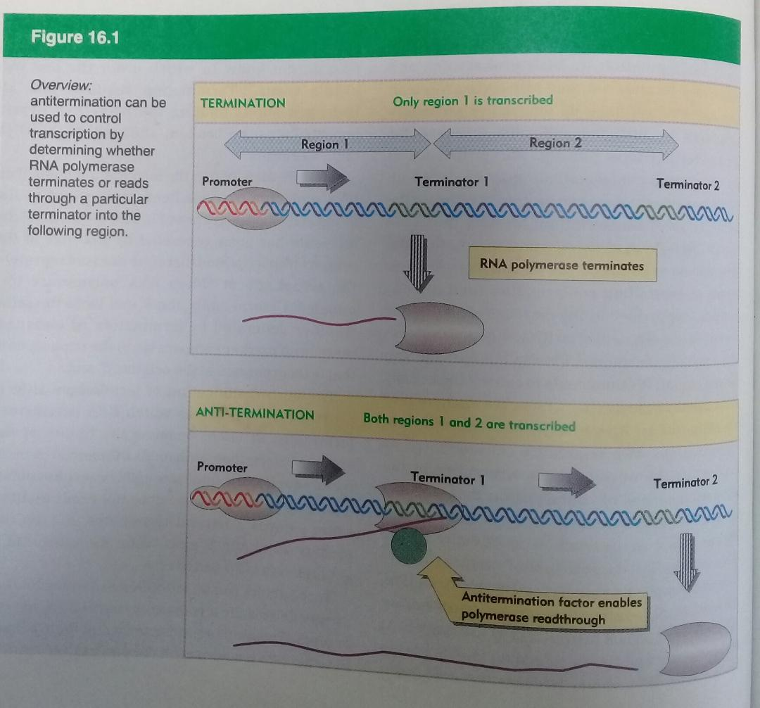
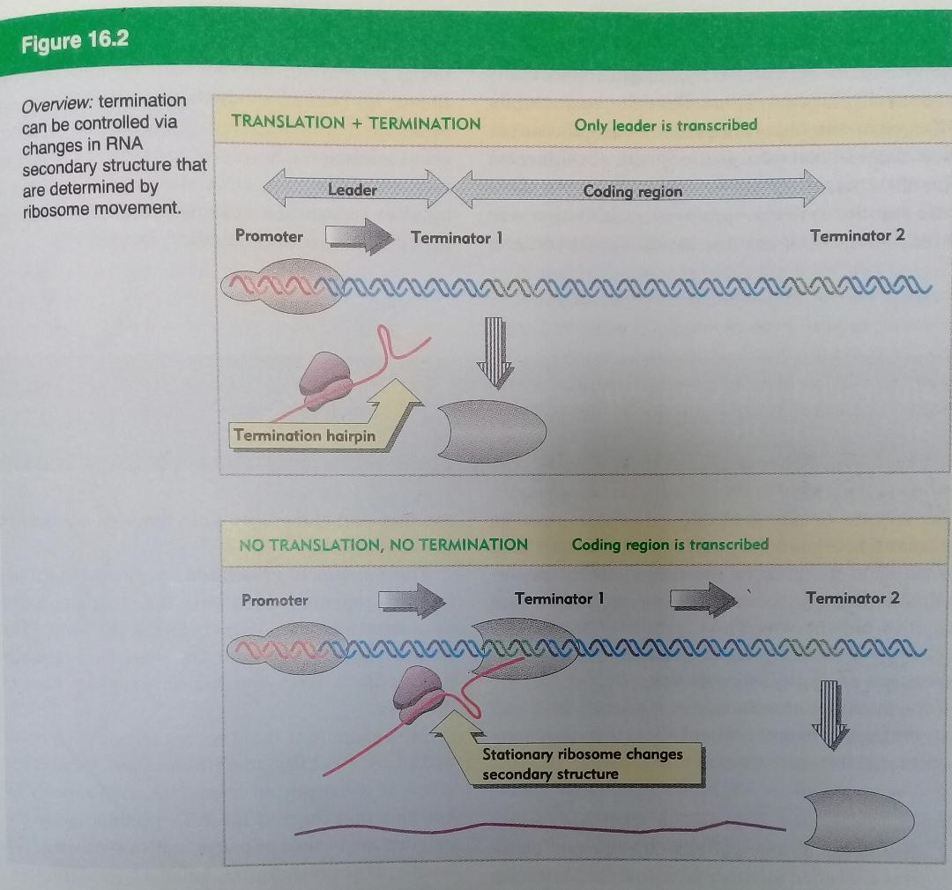

Lambda DNA
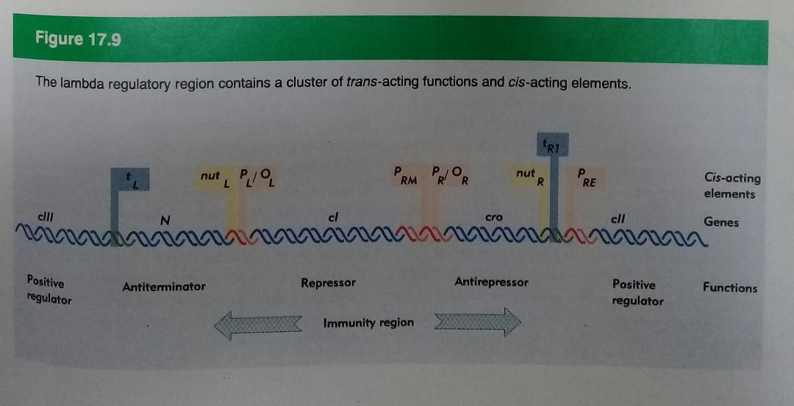

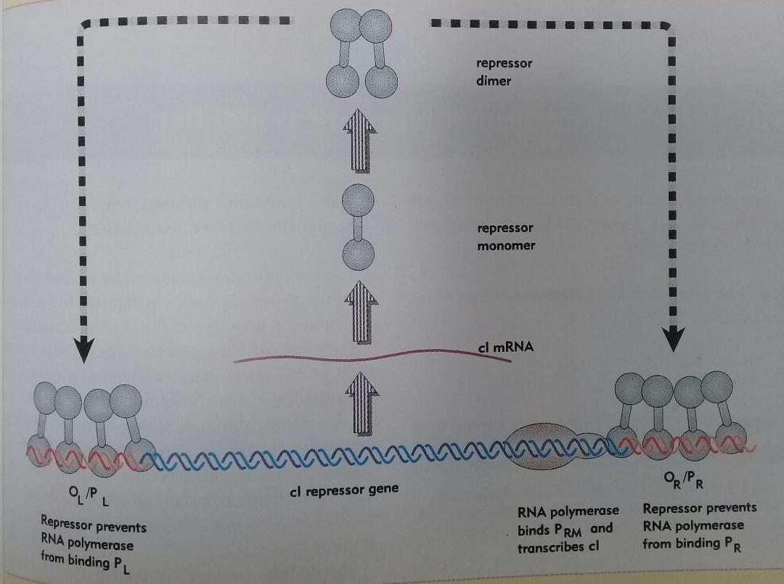
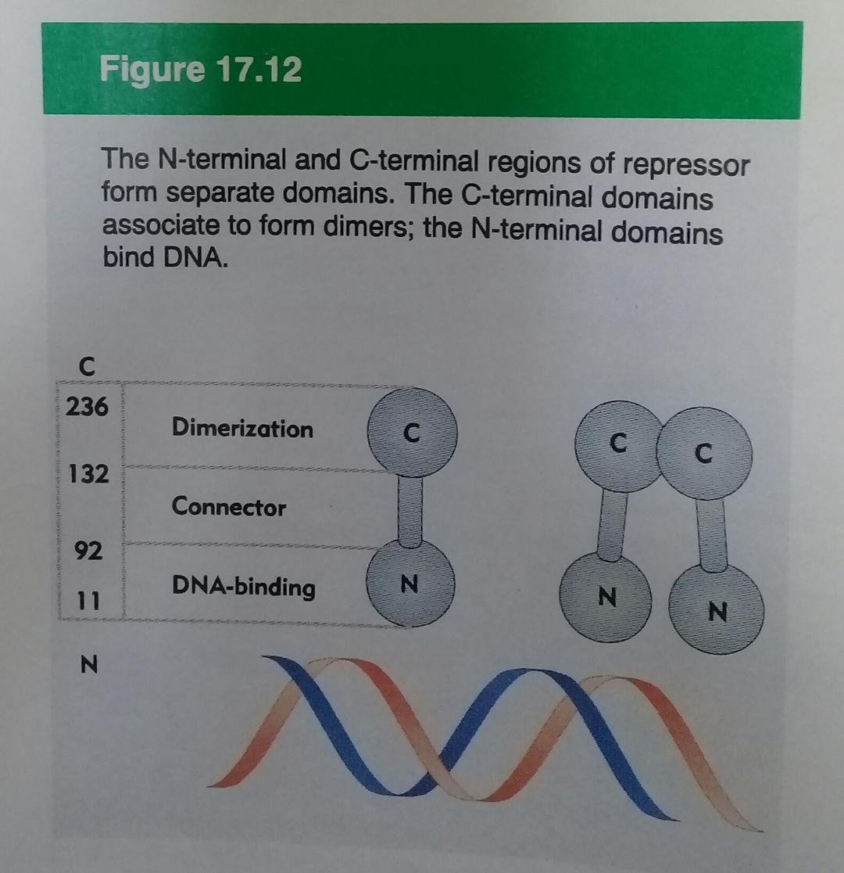
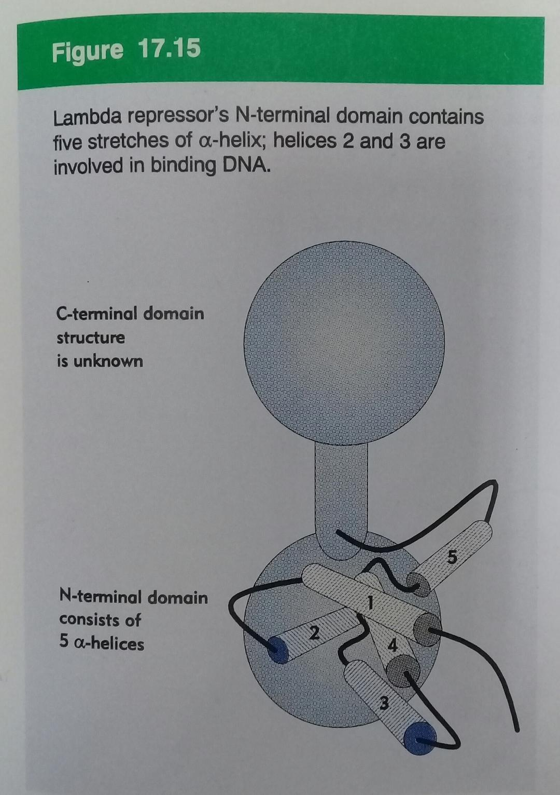
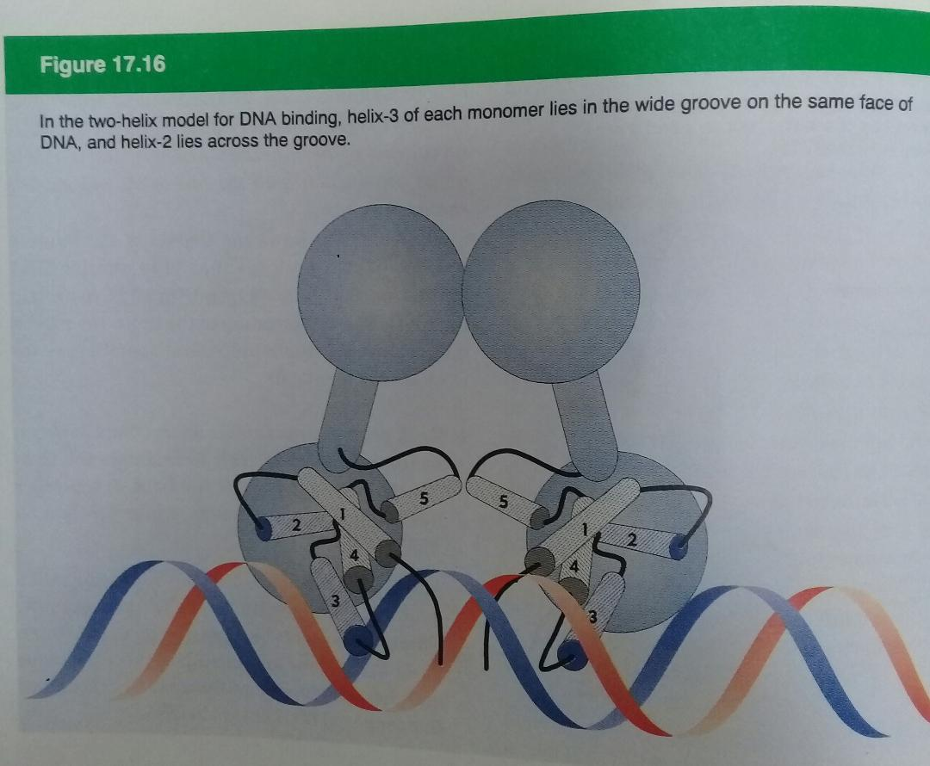
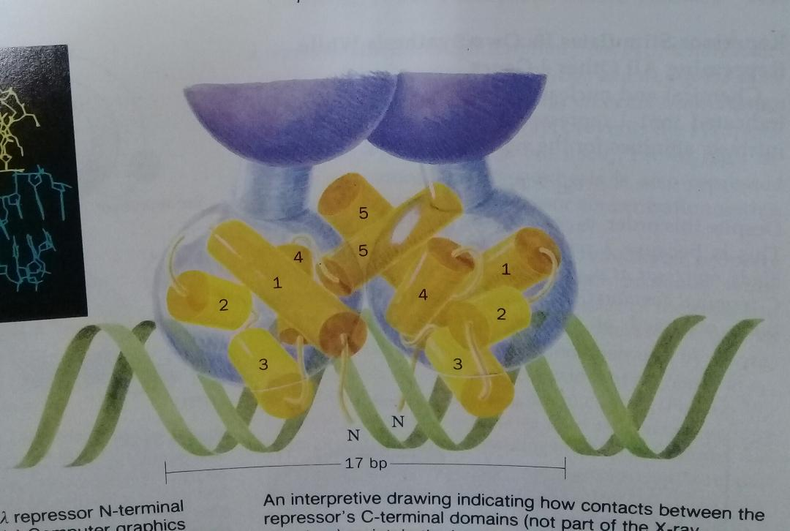
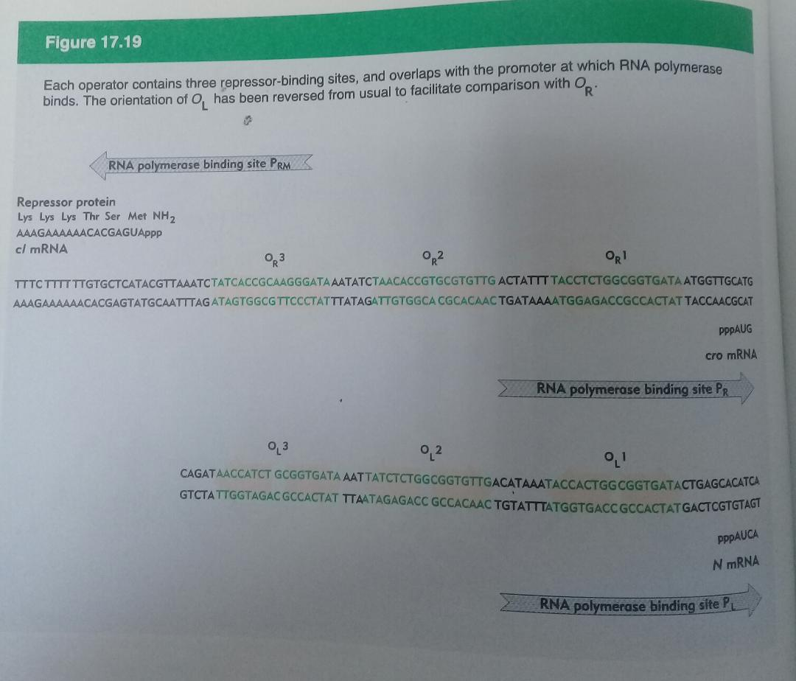

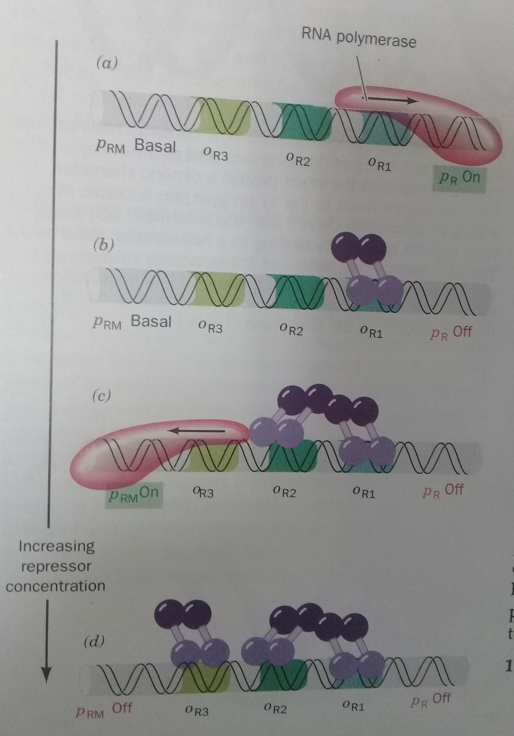
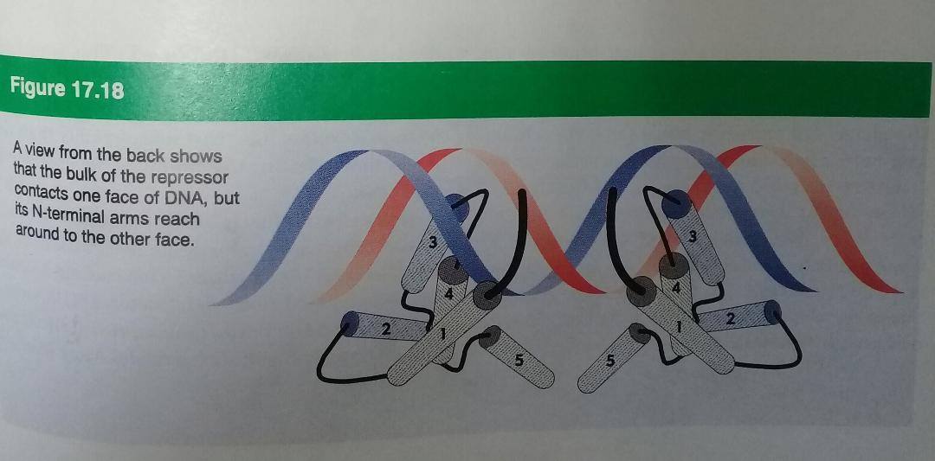

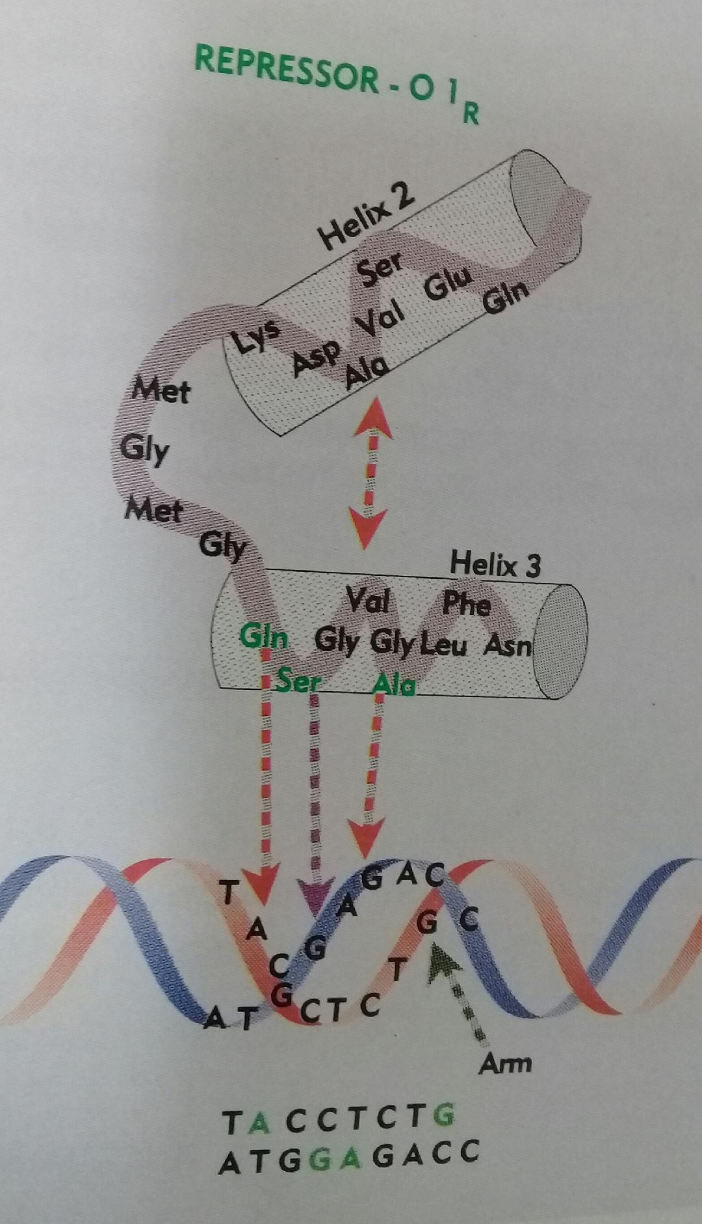

- Lysine residues in the arm make contacts with G residues in the major groove and also with the phosphate backbone. The interaction between arm and DNA contributes heavily to DNA binding.
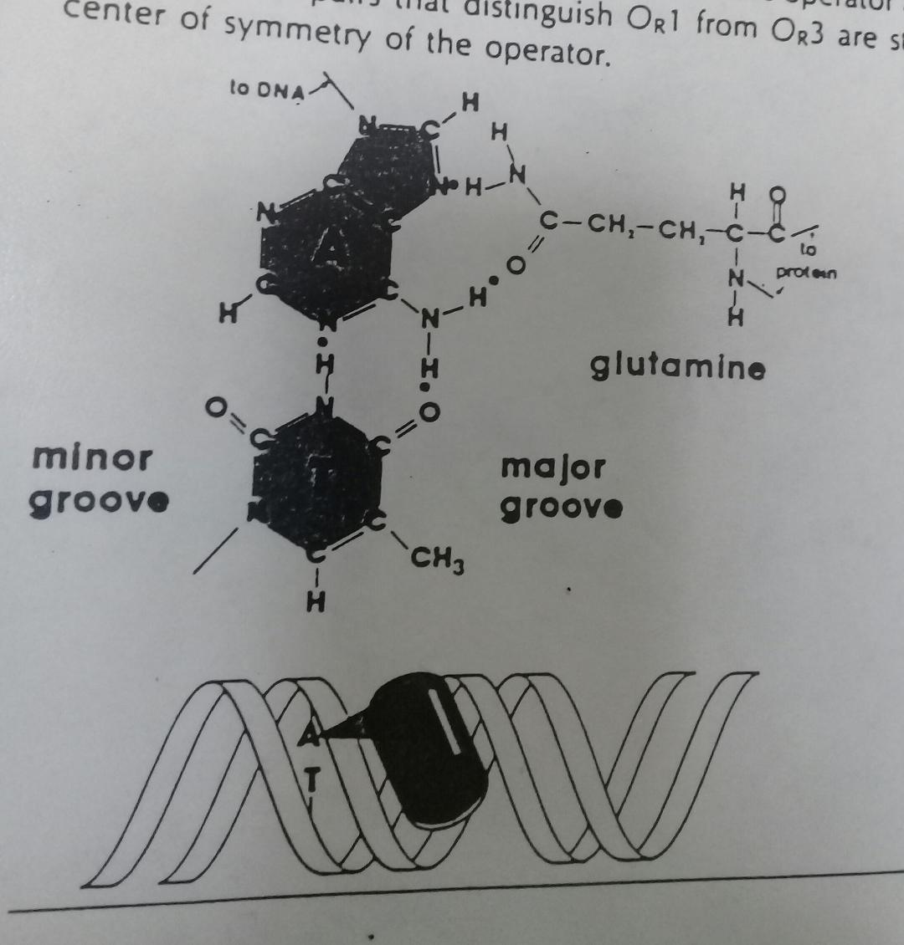

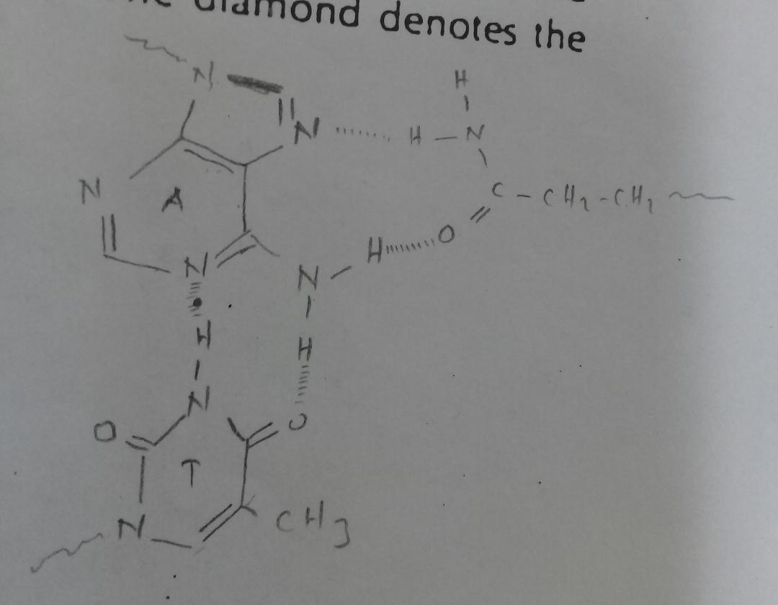
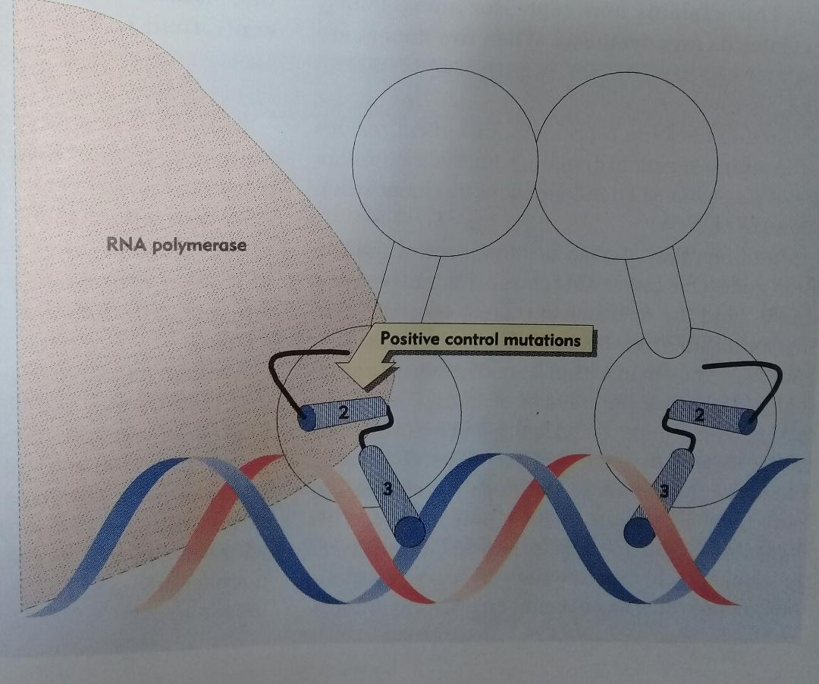

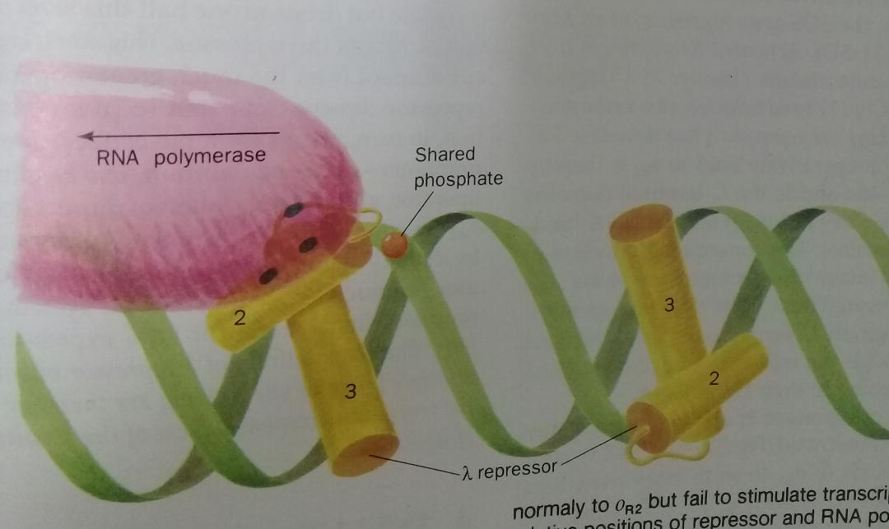

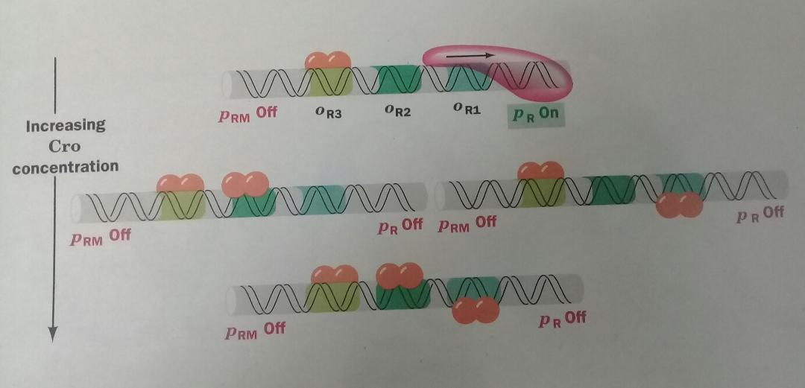

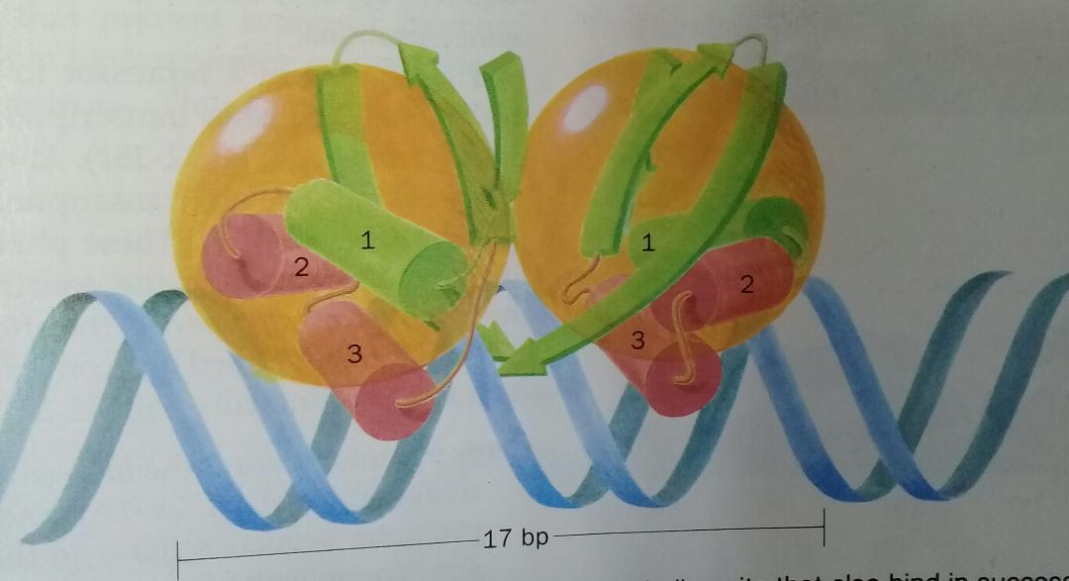

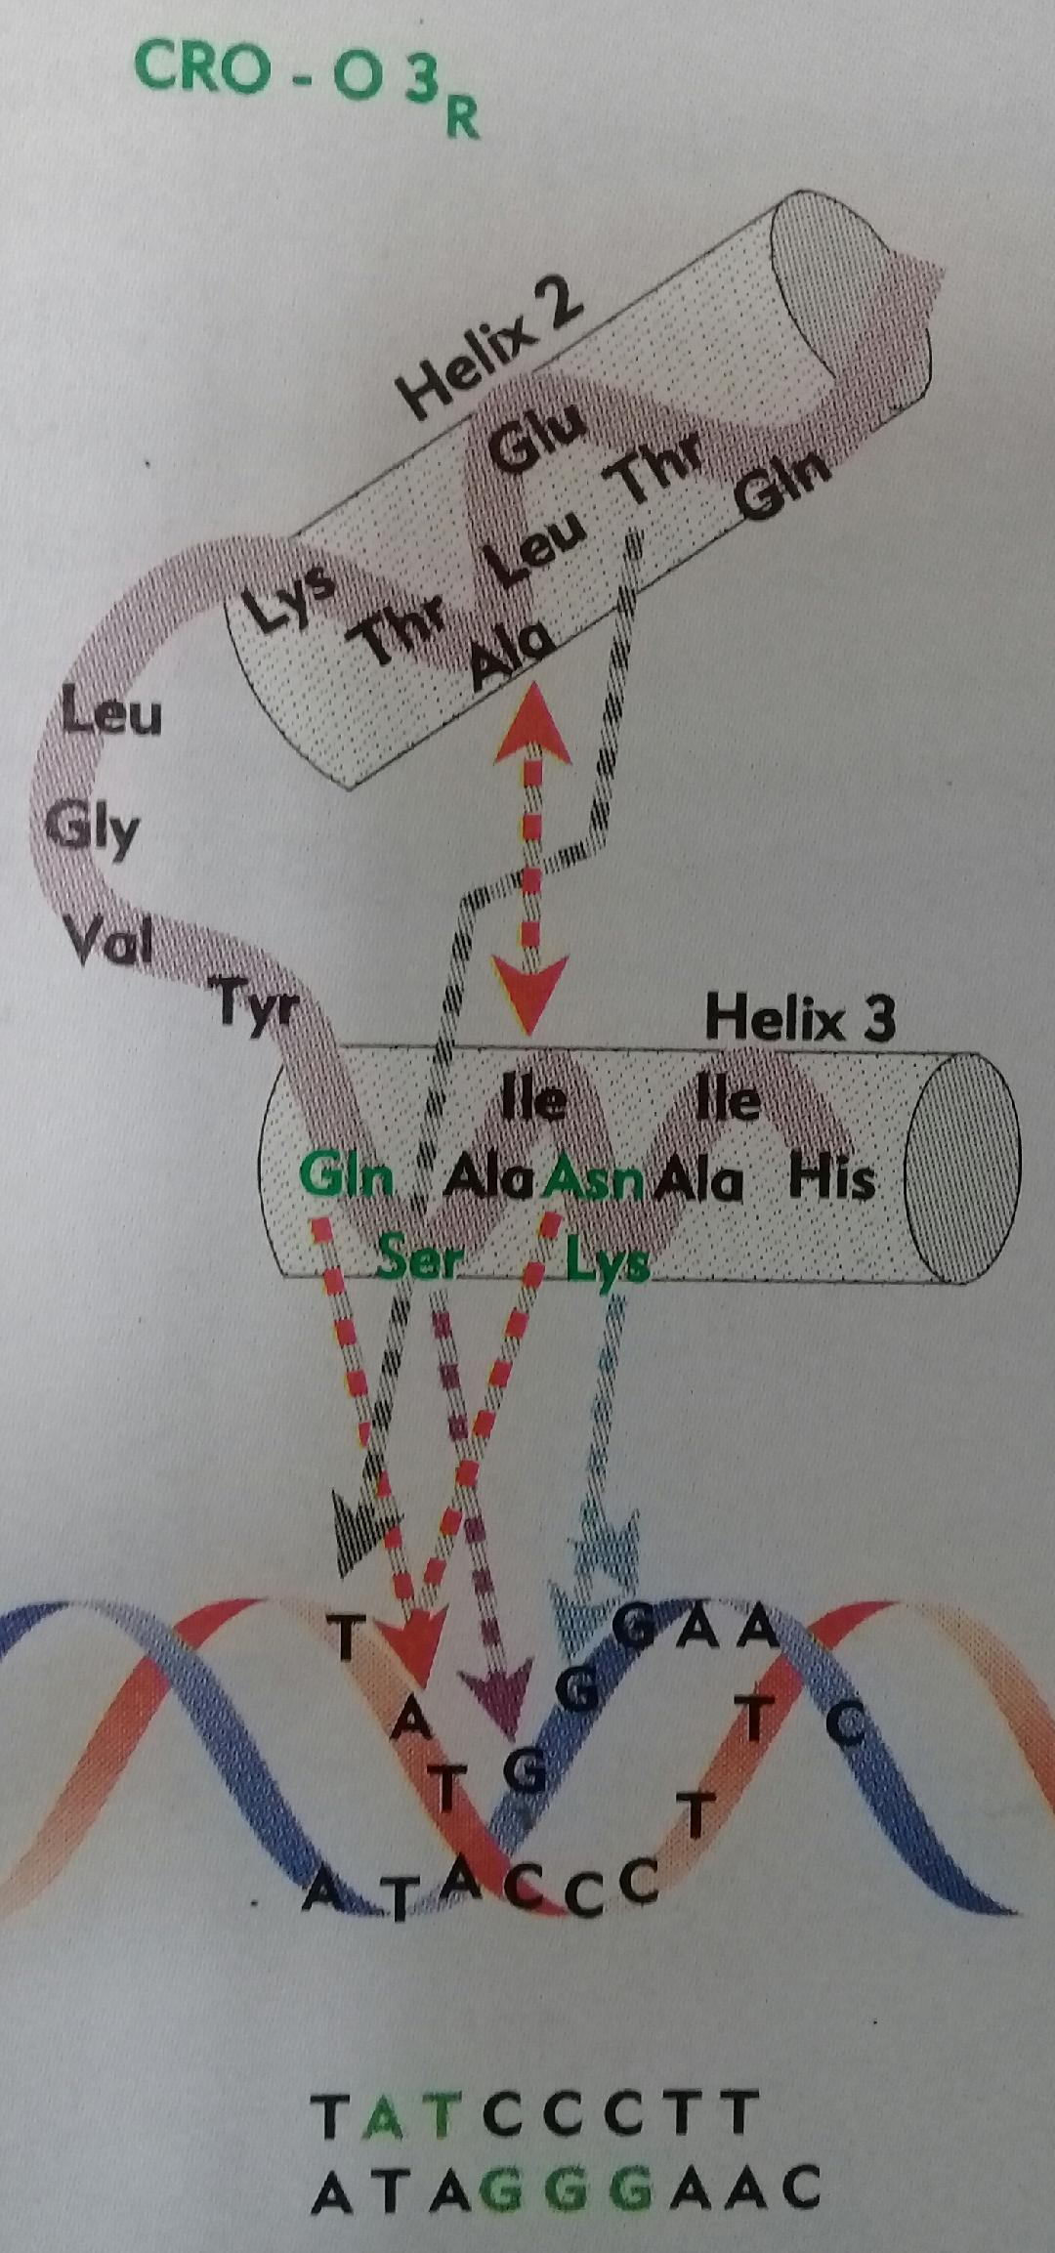

Eukaryotic Cells Have Three Kinds of Nuclear RNA Polymerases
- RNA polymerases are designated RNA Pol I, RNA Pol II and RNA Pol III.
- RNA Pol I is responsible for the synthesis of rRNAs (5.8S, 18S and 28S rRNAs).
- RNA Pol II is responsible for the synthesis of mRNAs.
- RNA Pol III is responsible for the synthesis of tRNAs and 5S rRNA.

RNA Polymerases Require Many Other Protein Factors for Its Activity
- The other proteins are called general transcription factors.
- Transcription factors are required for initiation of transcription at the RNA polymerase promoters.
- Activation factors are also required.
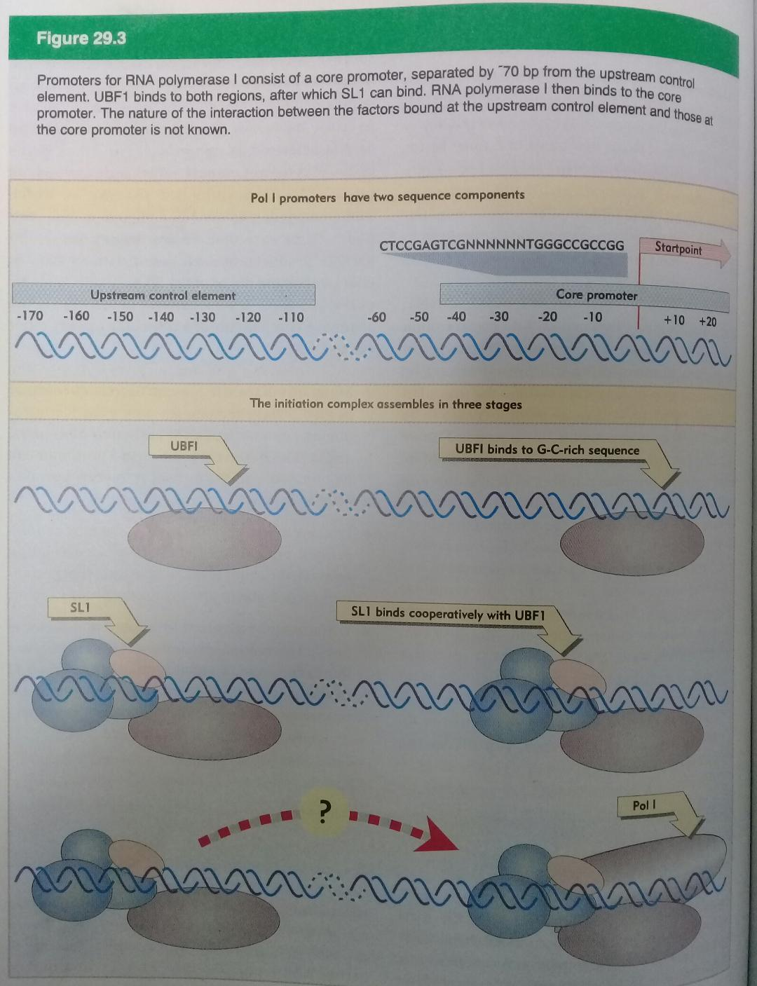
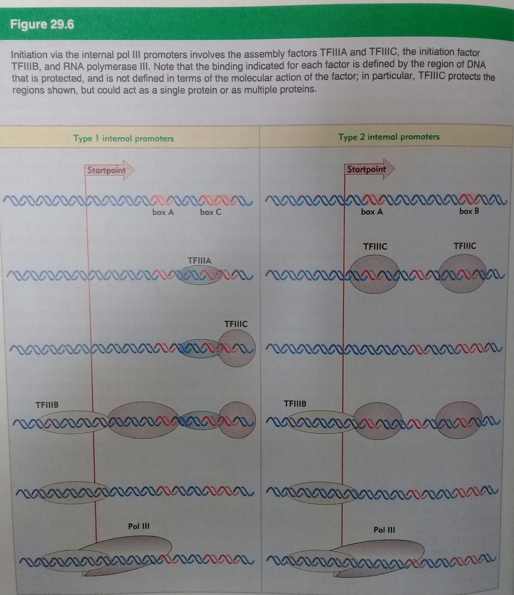

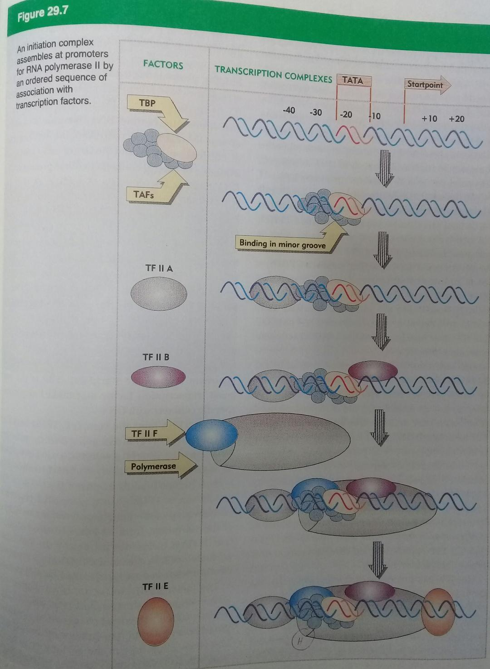
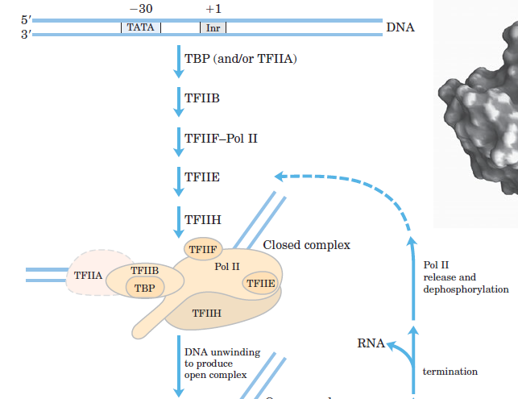
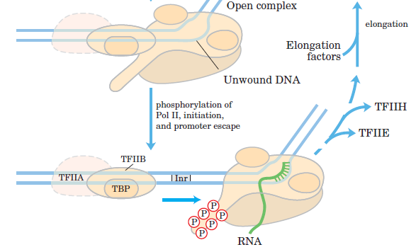
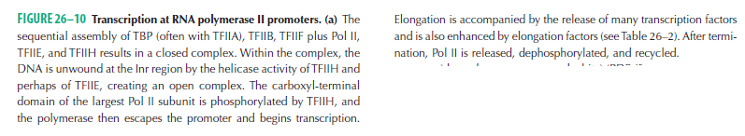

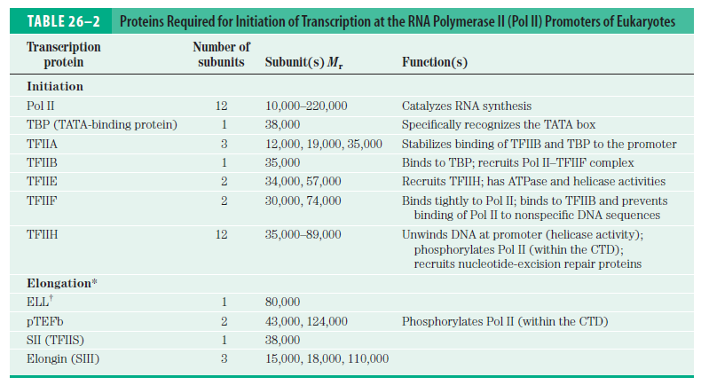

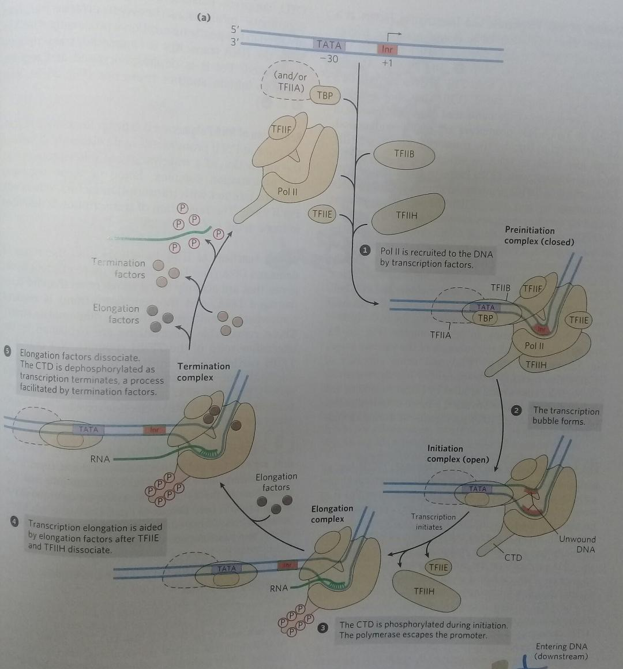

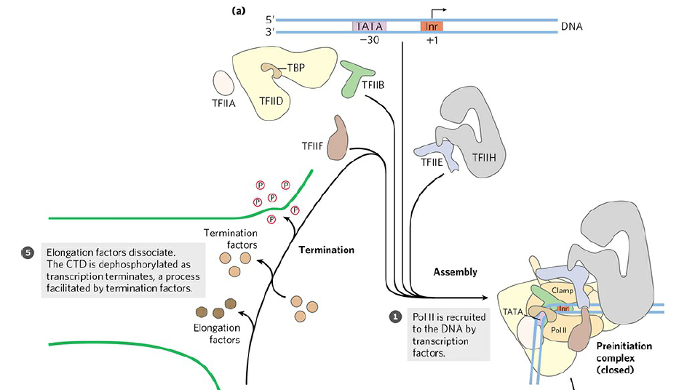

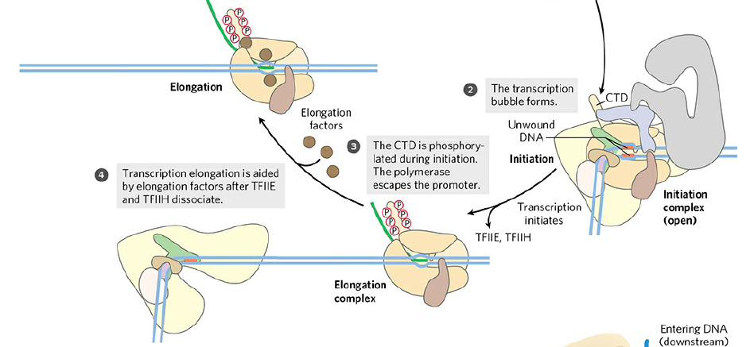

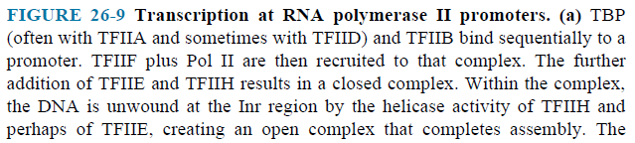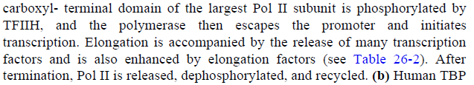

Metallothionein (MT) Geninin Organizasyonu

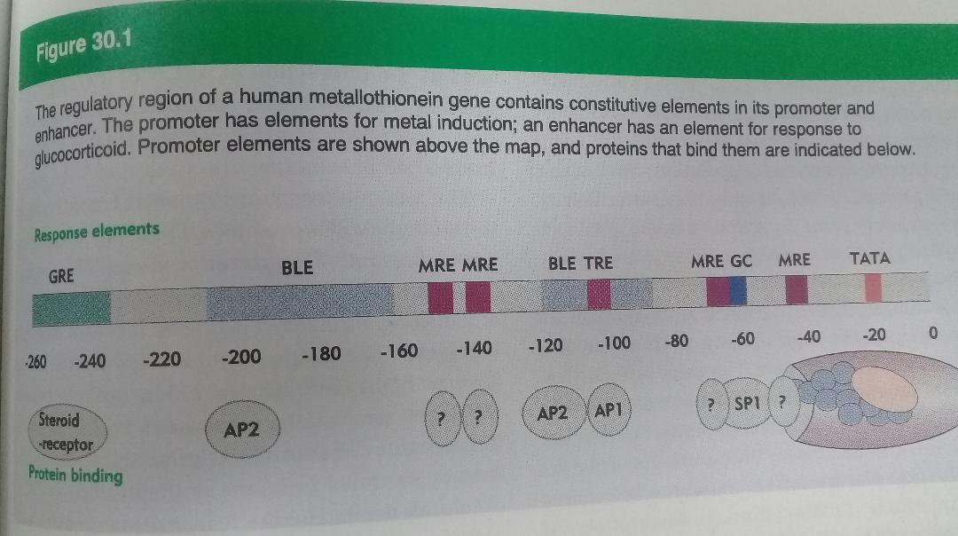

MT proteini hücreyi ağır metallerden korumaktadır. Metale bağlanıp fazlasının hücreden dışarı atmaktadır.
Cd ve glukokortikoidler vasıtasıyla gen uyarılır ve aktivasyon başlar.
MRE : Metallere cevap veren element
Transkripsiyon Faktörleri DNA’ya Bağlanır ve Bağımsız Bölgeler Vasıtasıyla Transkripsiyonu Aktive Eder

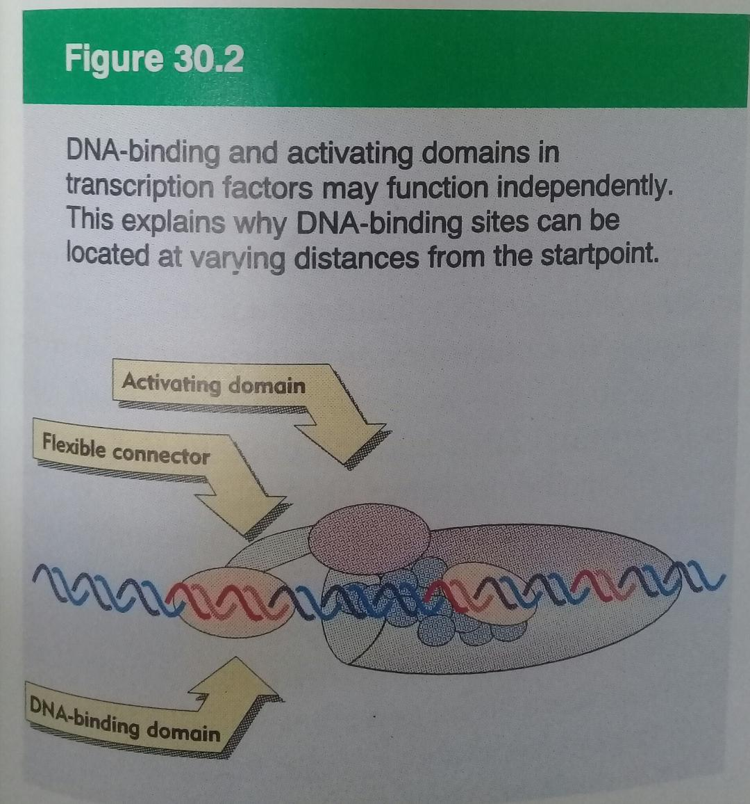
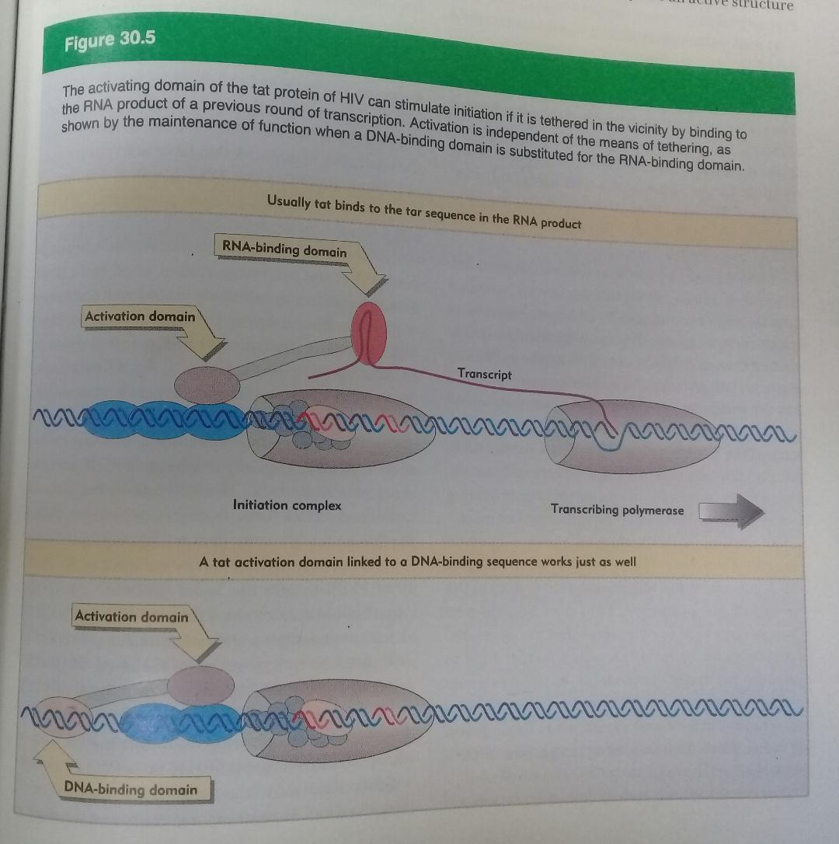

tat proteini tar dizisine bağlanarak başlangıcı hızlandırır ve uyarır.

Proteinlerin DNA’ya Bağlanma Modelleri
Proteinlerin küçük bir parçası bu işi görmeye yetebilir.
- Helix-turn-helix modeli : Repressor ve cro proteinleri gibi
- Zinc fingers (Çinko parmak) modeli
Cys - X₂₋₄ – Cys – X₃ – Phe – X₅ – Leu – X₂ – His- X₃ – His
Bu motif Cys₂ / His₂ olarak tanımlanır.

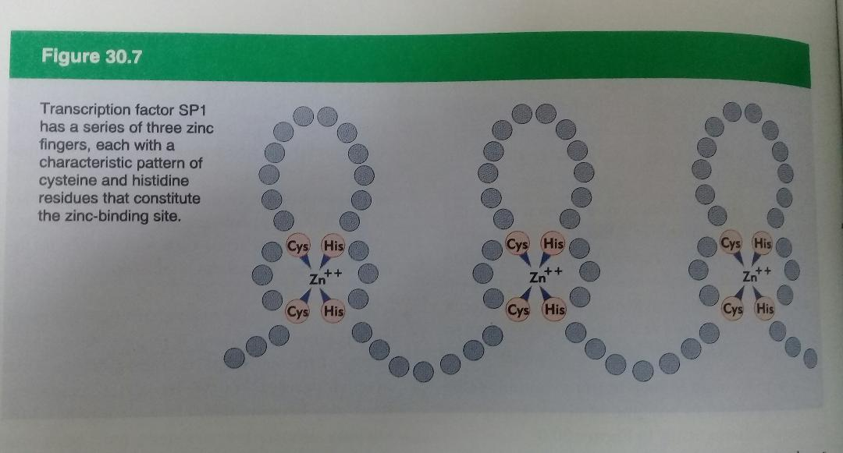

TFIIIA 5S RNA’nın transkripsiyonunda rol alır. 9 tane finger vardır.
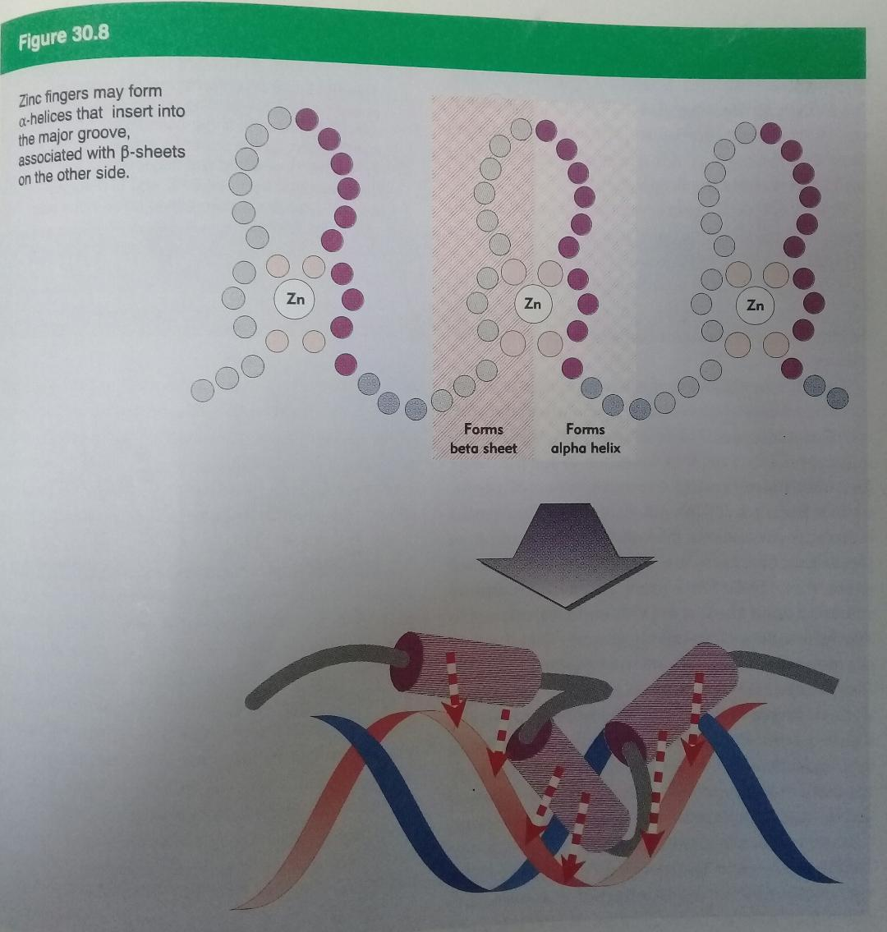
Her bir helix 2 yerden DNA’ya bağlanır. 3 helix büyük oyuğa sığmaktadır.
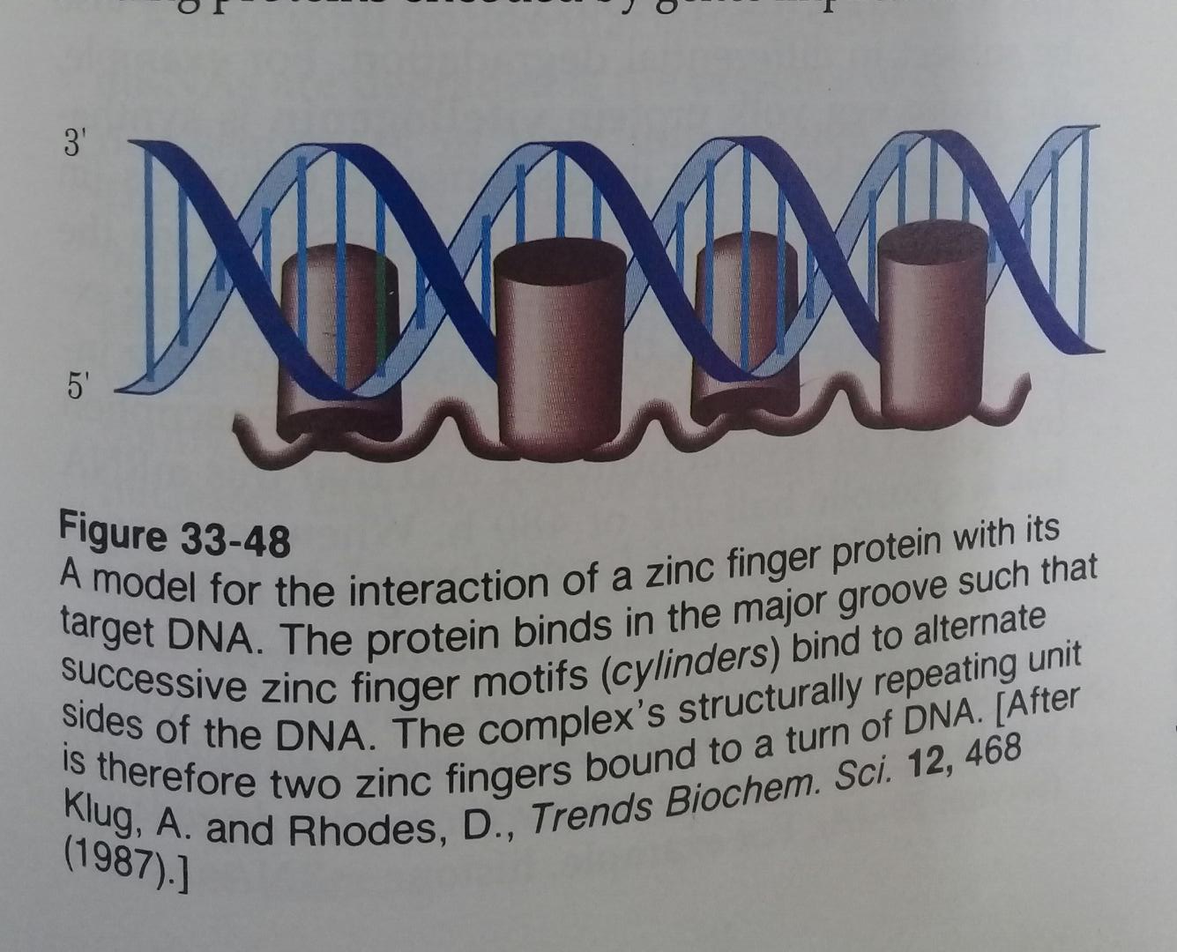
- Steroid reseptörleri modeli : Farklı çinko parmak modeline sahipler.
Cys – X₂– Cys – X₁₋₃ – Cys – X₂ – Cys
Bu motif Cys₂ / Cys₂ olarak tanımlanır.

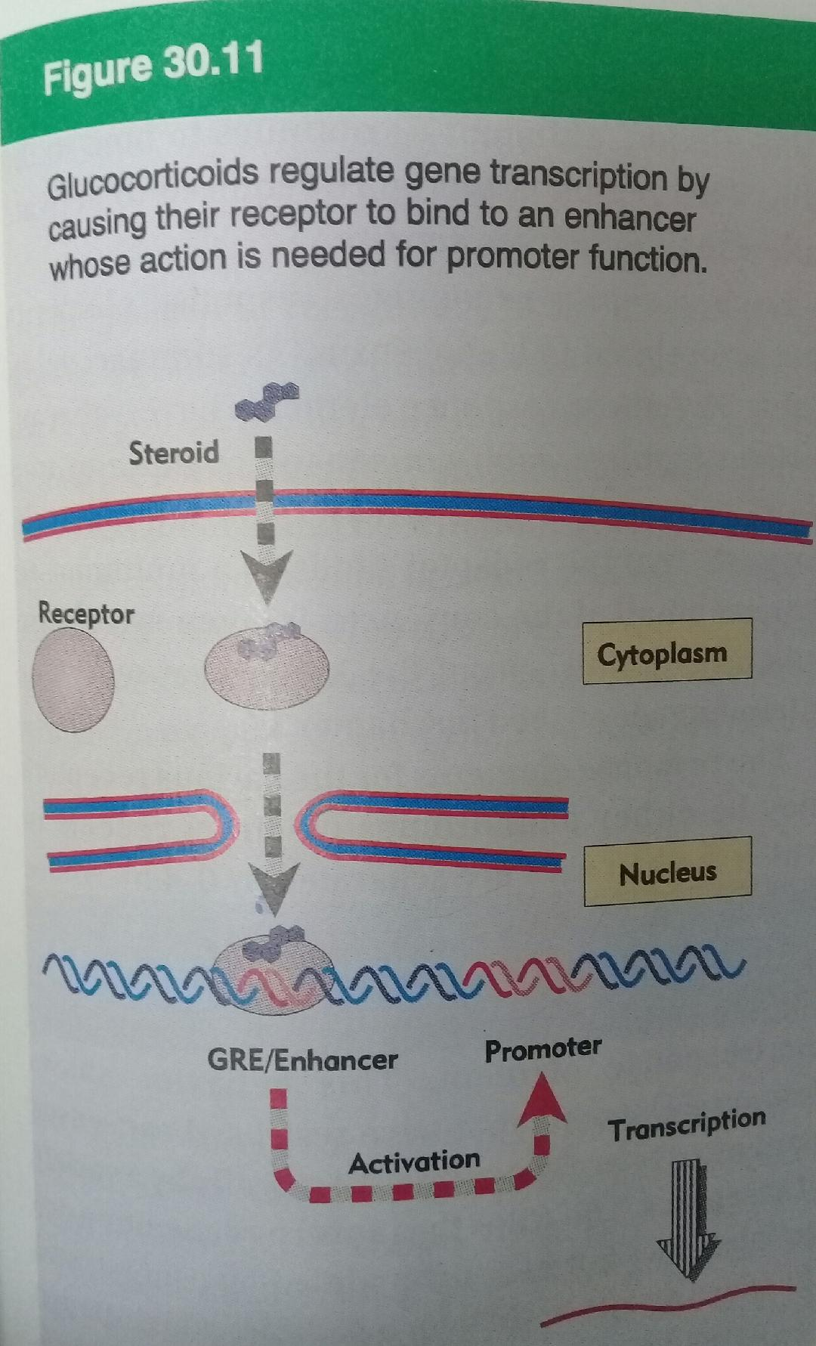
Steroid reseptörleri
hormonu bağlama, DNA’ya bağlanma ve transkripsiyonu aktive etme bölgelerine sahiptir.

Glukokortikoid ve östrojen reseptörleri 2 finger bulundurur.
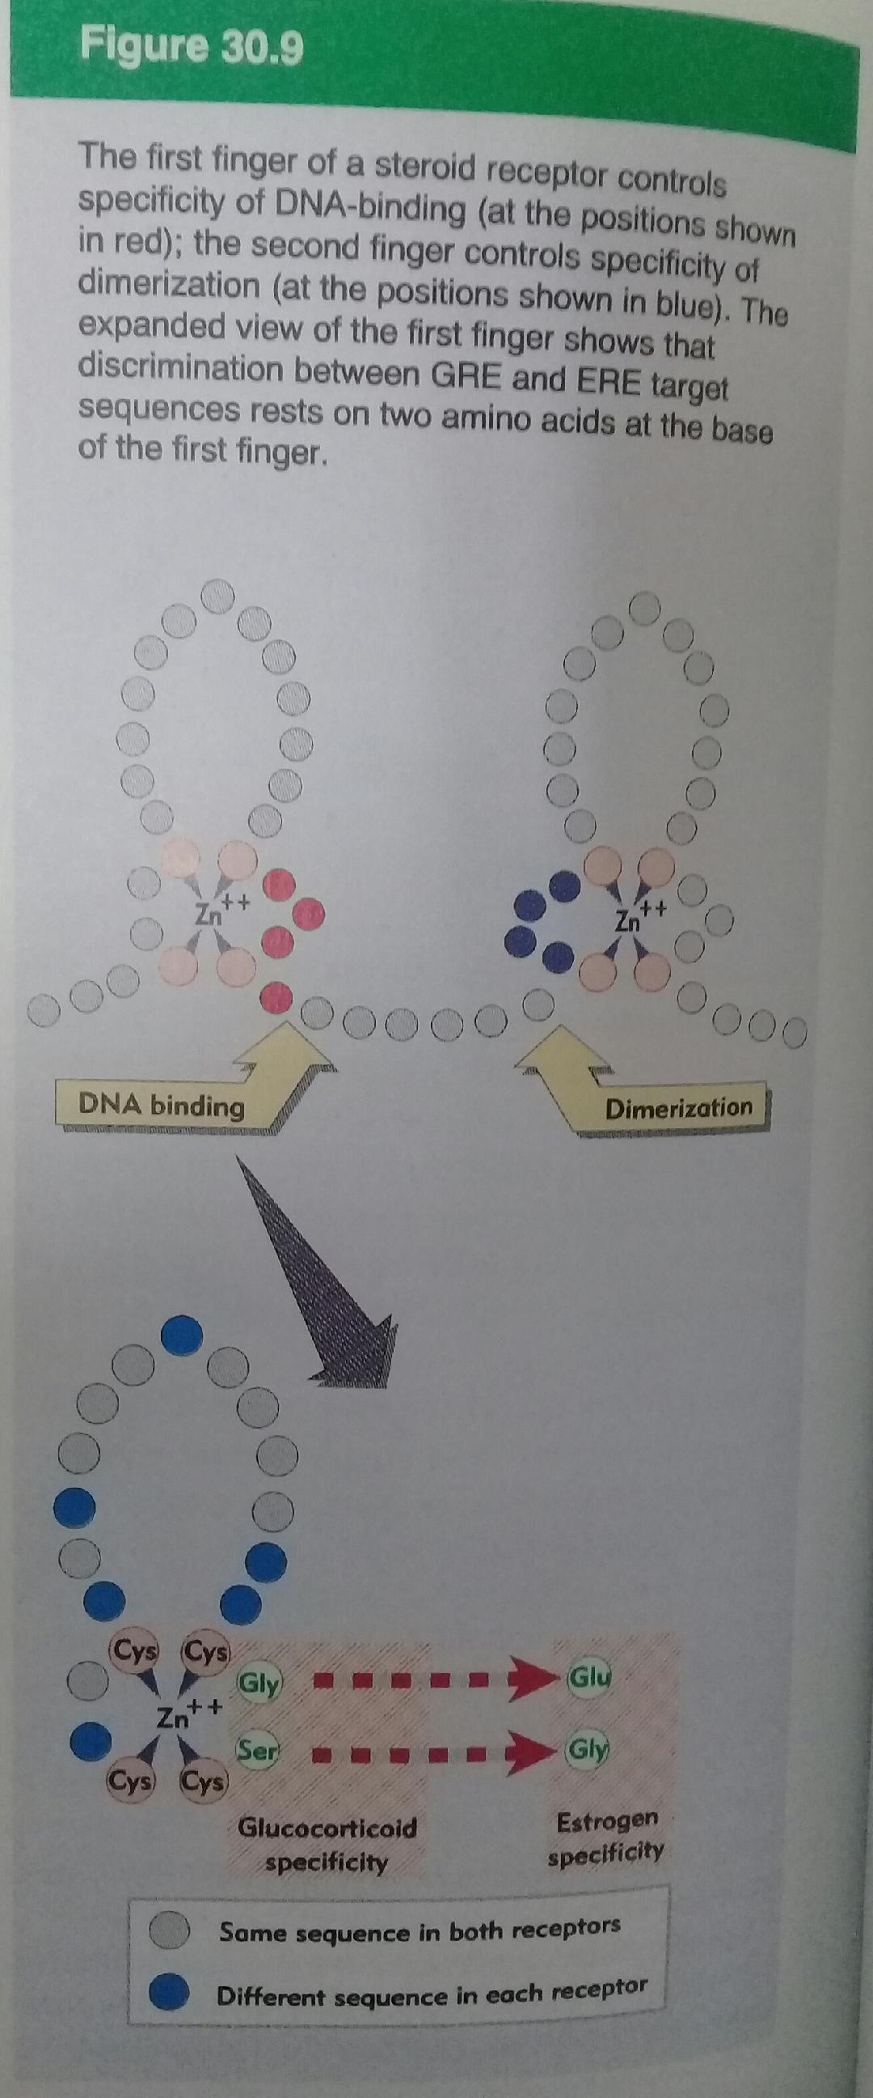

- Helix-loop-helix modeli : Dimer yapıdadır.
Bir helix’de hidrofobik residüler diğerinde pozitif yüklü rezidüler vardır.
Hidrofobik rezidüler dimerleşmeyi sağlar.
Yüklü rezidüler iyonik etkileşme ile DNA’ya bağlanmayı sağlar.

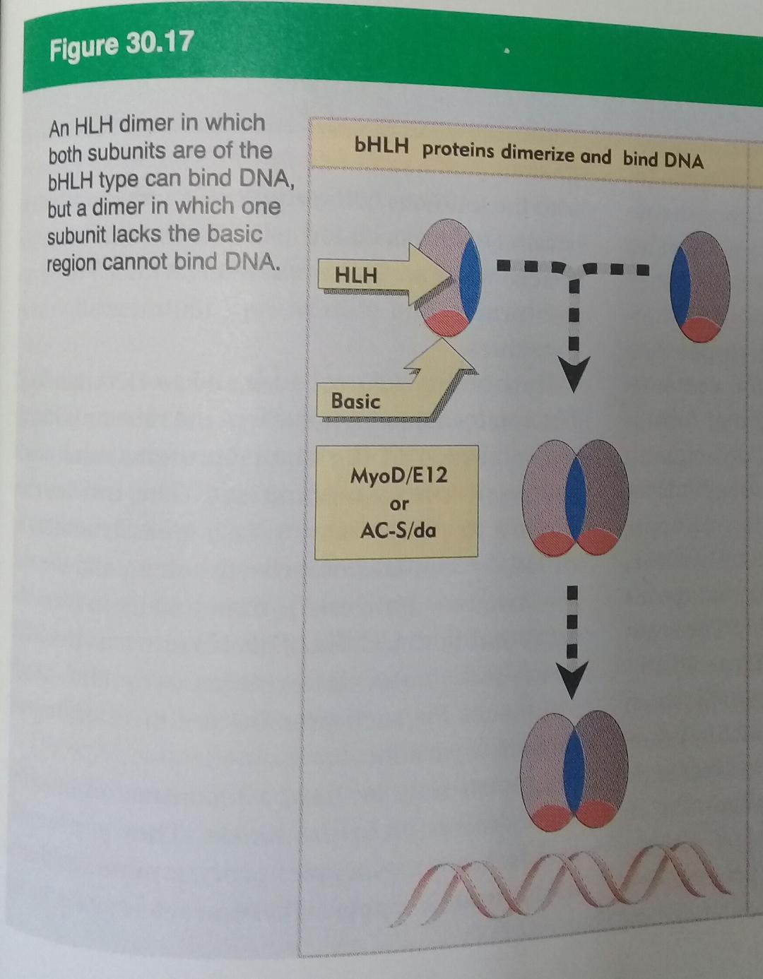

- Lösin fermuar (zipper) modeli
