Chapter 14 Glycolysis, Gluconeogenesis and the Pentose Phosphate Pathway
- In animals and higher plants, glucose has four major fates; it may be
- used in the synthesis of complex polysaccharides destined for the extracellular space
- stored in cells (as a polysaccharide or as sucrose)
- oxidized to a three-carbon compound (pyruvate) via glycolysis to provide ATP and metabolic intermediates
- oxidized via the pentose phosphate pathway to yield ribose 5-phosphate for nucleic acid synthesis and NADPH for reductive biosynthetic processes (Fig. 14-1).
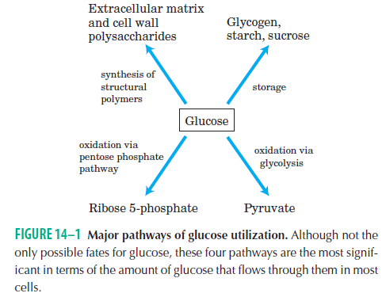
14.1 Glycolysis
- Glycolysis occurs in the cytosol.
- In glycolysis,
- a molecule of glucose is degraded in a series of enzyme-catalyzed reactions to yield two molecules of the three-carbon compound pyruvate.
- some of the free energy released from glucose is conserved in the form of ATP and NADH.
- Fermentation is a general term for the anaerobic degradation of glucose or other organic nutrients to obtain energy, conserved as ATP.

Glycolysis Has Two Phases
- The breakdown of the six-carbon glucose into two molecules of the three-carbon pyruvate occurs in 10 steps.
- The first 5 of them constitute the preparatory phase (Fig. 14-2a).
- Phosphorylation of glucose (1 ATP is used)
- Conversion of glucose 6-phosphate

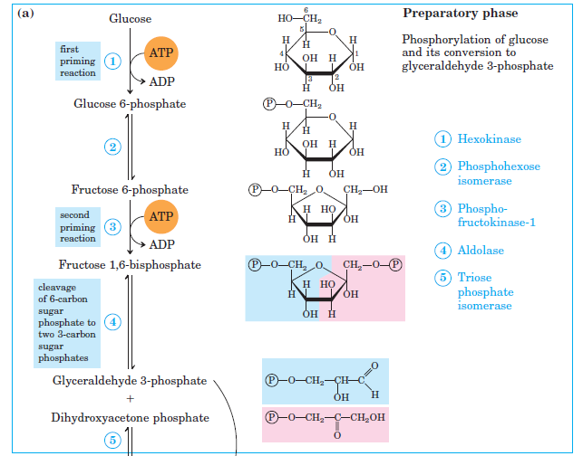

- Phosphorylation of fructose 6-phosphate (1 ATP is used)
- Cleavage of fructose 1,6-bisphosphate
- Interconversion of the triose phosphates
(1 Glucose and 2 ATP are used) (2 glyceraldehyde 3-phosphate are produced)
- The last 5 of them constitute the payoff phase (Fig. 14-2b).

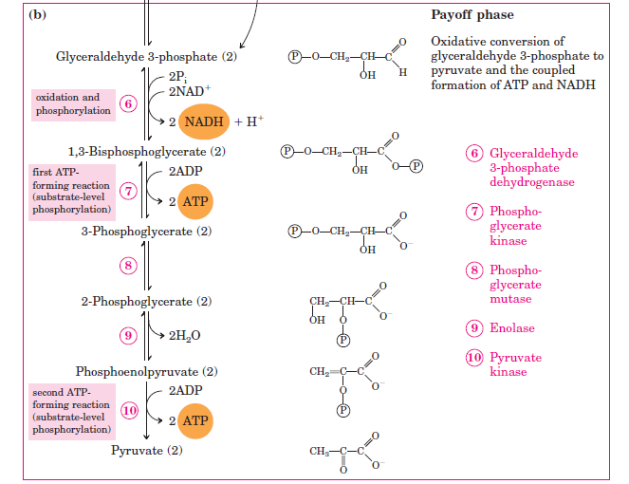

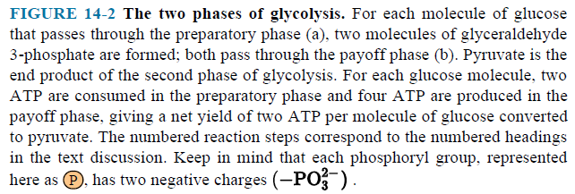
- Oxidation and phosphorylation of glyceraldehyde 3-phosphate
- Phosphoryl transfer from 1,3-bisphosphoglycerate
The formation of ATP by phosphoryl group transfer from a substrate such as1,3-bisphosphoglycerate is referred to as a substrate-level phosphorylation.
- Conversion of 3-phosphoglycerate
- Dehydration of 2-phosphoglycerate
- Transfer of the phosphoryl group from phosphoenolpyruvate
A substrate-level phosphorylation occurs.
- The overall equation for glycolysis under aerobic conditions :
Glucose + 2NAD⁺ + 2ADP + 2P_{i} 2pyruvate + 2NADH + 2H⁺ + 2ATP + 2H₂O
2 NADH (four electrons) will be used for synthesis of ATP.
- Glycolysis releases only a small fraction of the total available energy of the glucose molecule
- The two molecules of pyruvate still contain most of the chemical potential energy of glucose.
- Energy can be extracted by oxidative reactions in the citric acid cycle and oxidative phosphorylation.

14. 2 Feeder Pathways for Glycolysis
- The most significant are
- the storage polysaccharides : glycogen and starch
- the disaccharides : maltose, lactose and sucrose
- the monosaccharides : fructose, galactose and mannose
- Dietary polysaccharides and disaccharides undergo hydrolysis to monosaccharides.
- Endogenous glycogen and starch are degraded by phosphorolysis.
- Other monosaccharides enter the glycolytic pathway at several points (Fig. 14-11).

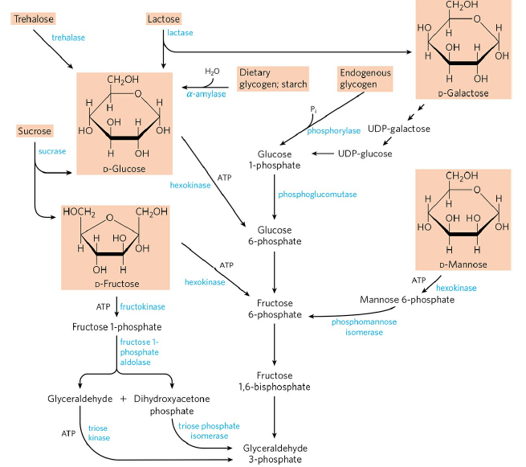

- The liver enzyme fructokinase catalyzes the phosphorylation of fructose at C-1 rather than C-6.

14.3. Fates of Pyruvate under Anaerobic Conditions: Fermentation
- There are three possible catabolic fates of the pyruvate formed in glycolysis (Fig. 14-4).
- Under aerobic conditions, the pyruvate is oxidized to acetyl-CoA.
- Acetyl-CoA enters the citric acid cycle and is oxidized to CO₂ and H₂O.

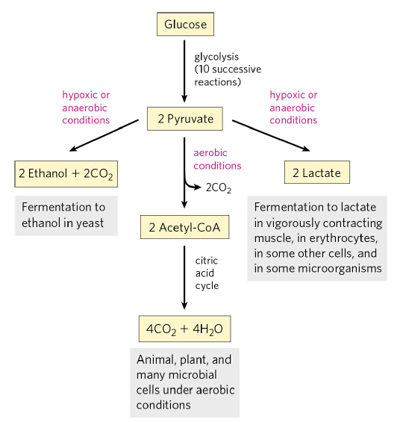

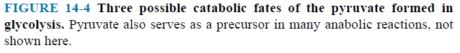

- Under hypoxic (low-oxygen) conditions,
- Pyruvate is the terminal electron acceptor in lactic acid fermentation (p. 563).

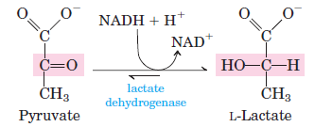

- Fermentation is the general term, which extracts energy (as ATP) but do not consume oxygen or change the concentrations of NAD⁺ or NADH.
- Pyruvate is converted to ethanol and CO₂ in a two-step process. Ethanol is the reduced product in alcohol fermentation.

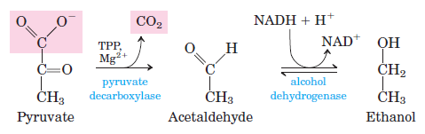

14.4 Gluconeogenesis
- The human brain alone requires over 120 g of glucose each day - more than half of all the glucose stored as glycogen in muscle and liver.
- Gluconeogenesis is the pathway for synthesis of glucose from simpler precursors (Fig. 14–16).
- Gluconeogenesis occurs in all animals, plants, fungi and microorganisms.
- In mammals, gluconeogenesis takes place mainly in the liver.
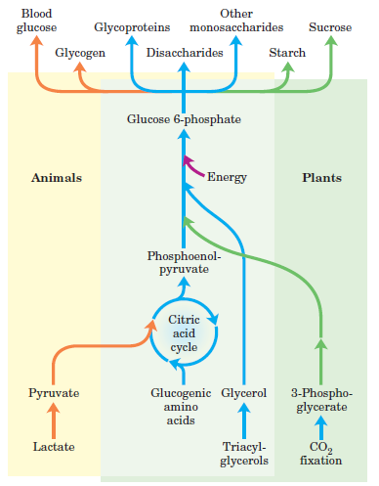

- The glucose produced passes into the blood to supply other tissues.
- Gluconeogenesis and glycolysis are not identical pathways running in opposite directions, although they do share several steps (Fig. 14–17).
- 7 of the 10 enzymatic reactions of gluconeogenesis are the reverse of glycolytic reactions.
- Three reactions of glycolysis are essentially irreversible in vivo and cannot be used in gluconeogenesis.
- In gluconeogenesis, the three irreversible steps are bypassed by a separate set of enzymes.
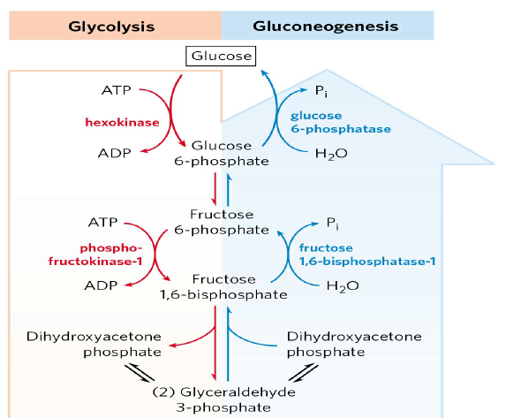
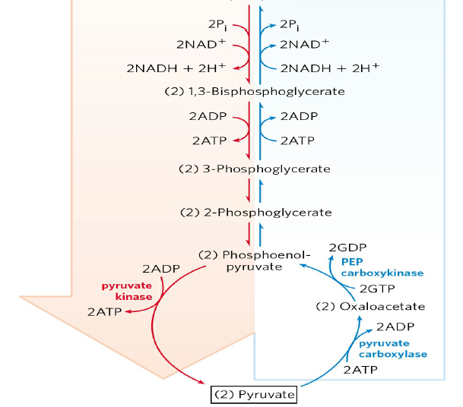
- In animals, both pathways occur largely in the cytosol.
- Conversion of pyruvate to phosphoenolpyruvate (PEP) requires enzymes in both the cytosol and mitochondria.
- Pyruvate is first transported from the cytosol into mitochondria or is generated from alanine within mitochondria.
- Then, pyruvate carboxylase, a mitochondrial enzyme that requires the coenzyme biotin, converts the pyruvate to oxaloacetate (Fig. 14–18a).

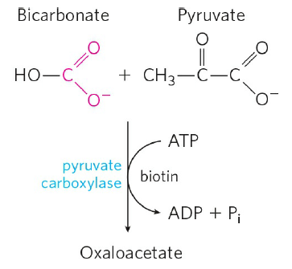
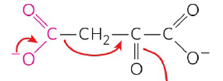

FIGURE 14–18 a Synthesis of oxaloacetate from pyruvate.

- Because the mitochondrial membrane has no transporter for oxaloacetate, before export to the cytosol the oxaloacetate must be reduced to malate by mitochondrial malate dehydrogenase.
Oxaloacetate + NADH + H⁺ Malate + NAD⁺
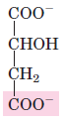
- Malate leaves the mitochondrion through a specific transporter in the inner mitochondrial membrane and in the cytosol it is reoxidized to oxaloacetate.
Malate + NAD⁺ Oxaloacetate + NADH + H⁺
- The oxaloacetate is then converted to PEP by phosphoenolpyruvate carboxykinase (Fig. 14–18b).

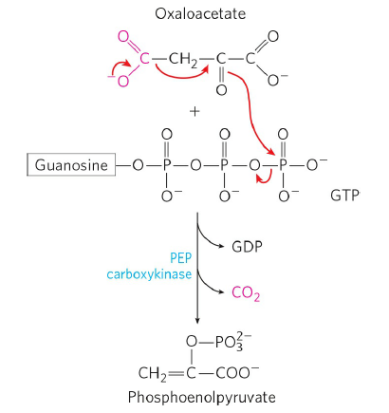

FIGURE 14–18 b Synthesis of phosphoenolpyruvate from oxaloacetate.

- A second pyruvate PEP bypass predominates when lactate is the glucogenic precursor (Fig. 14-20). This pathway makes use of lactate produced by glycolysis in erythrocytes or anaerobic muscle.

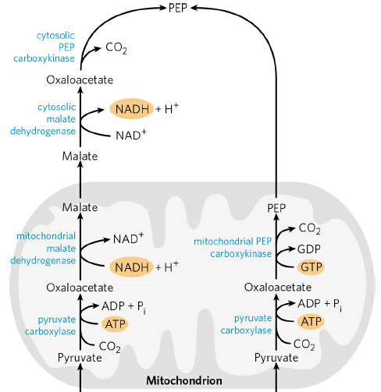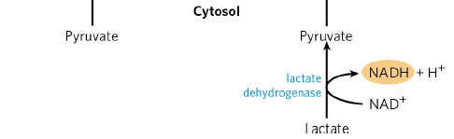

- After the pyruvate produced by the lactate dehydrogenase is transported into the mitochondrion, it is converted to oxaloacetate by pyruvate carboxylase.
- This oxaloacetate is converted directly to PEP by a mitochondrial isozyme of PEP carboxykinase, and the PEP is transported out of the mitochondrion to continue on the gluconeogenic path.
- Conversion of fructose 1,6-bisphosphate to fructose 6-phosphate is the second bypass.
- This reaction is catalyzed by fructose 1,6-bisphosphatase (FBPase-1).
Fructose 1,6-bisphosphate + H₂O fructose 6-phosphate + P_{i}
- Conversion of glucose 6-phosphate to glucose is the third bypass.
- This reaction is catalyzed by glucose 6-phosphatase.
Glucose 6-phosphate + H₂O glucose + P_{i}

Gluconeogenesis Is Energetically Expensive, but Essential
- The sum of the biosynthetic reactions leading from pyruvate to free blood glucose is
2 Pyruvate + 4ATP + 2GTP + 2NADH + 2H⁺ + 4H₂O

Glucose + 4ADP + 2GDP + 6P_{i} + 2NAD⁺
- Clearly, this equation is not simply the reverse of the equation for conversion of glucose to pyruvate by glycolysis. Remember
Glucose + 2ADP + 2P_{i} + 2NAD⁺ 2 pyruvate + 2ATP + 2NADH + 2H⁺ + 2H₂O
- Gluconeogenesis requires additional 2 ATP and 2 GTP molecules.

14.5 Pentose Phosphate Pathway of Glucose Oxidation
- Glucose 6-phosphate does have other catabolic fates.
- Oxidation of glucose 6-phosphate to pentose phosphates is occurred by the pentose phosphate pathway.
- In this oxidative pathway, NADP⁺ is the electron acceptor, yielding NADPH.
- Pentose phosphate and NADPH products are needed by the cell (Fig. 14-20).

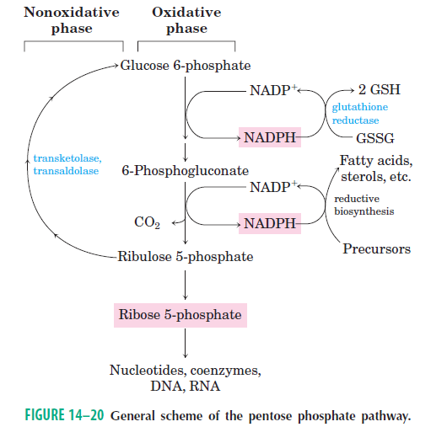

- All the enzymes in the pentose phosphate pathway are located in the cytosol.

The Oxidative Phase Produces Pentose Phosphates and NADPH
- The first reaction is the oxidation of glucose 6-phosphate to form 6-phosphoglucono-δ−lactone (Fig. 14–21).
- The lactone is hydrolyzed to 6-phosphogluconate.
- 6-phosphogluconate undergoes oxidation and decarboxylation to form ribulose 5-phosphate.
- Ribulose 5-phosphate is converted to ribose 5-phosphate.
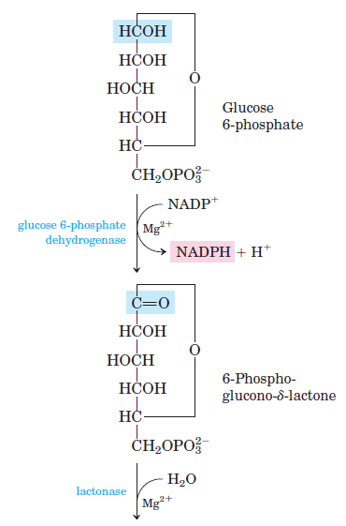

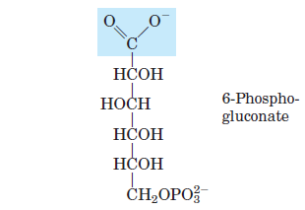
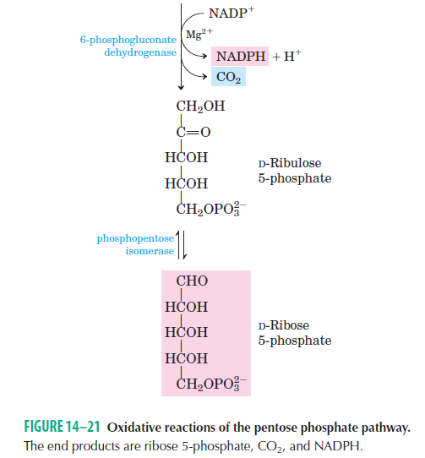

- Its overall equation is
Glucose 6-phosphate + 2NADP⁺ + H₂O ribose 5-phosphate + CO₂ + 2NADPH + 2H⁺

The Nonoxidative Phase Recycles Pentose Phosphates to Glucose 6-Phosphate
- Ribulose 5-phosphate is epimerized to xylulose 5-phosphate.
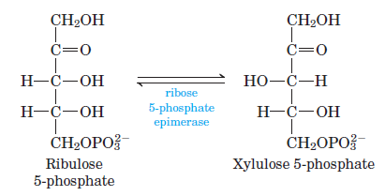
- Nonoxidative reactions are shown in (Fig. 14-23a).
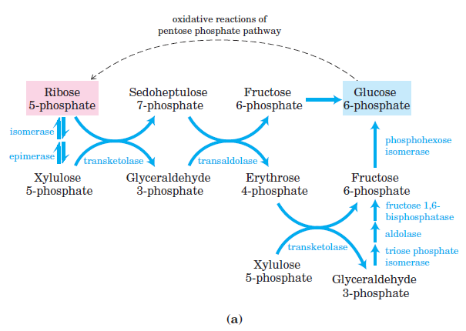

- Two pentose phosphates are converted to a triose phosphate and a seven-carbon sugar phosphate (Fig. 14-24b).

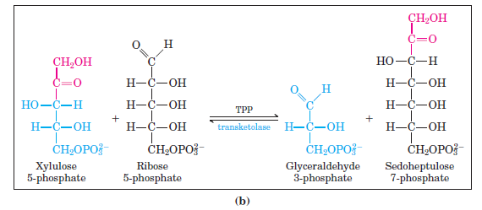
- Sedoheptulose 7-phosphate and glyceraldehyde 3-phosphate are converted to fructose 6-phosphate and erythrose 4-phosphate (Fig. 14-25).

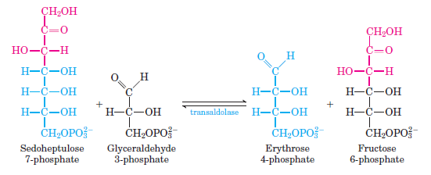

- Erythrose 4-phosphate and xylulose 5-phosphate are converted to fructose 6-phosphate and glyceraldehyde 3-phosphate (Fig. 14-26).

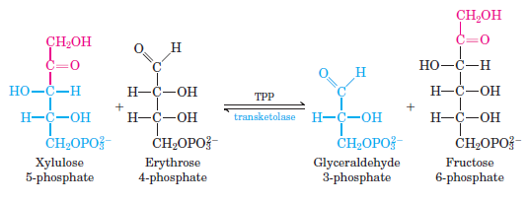

Glucose 6-Phosphate Is Partitioned between Glycolysis and the Pentose Phosphate Pathway
- Entry of glucose 6-phosphate either into glycolysis or into the pentose phosphate pathway is largely determined by the relative concentrations of NADP⁺ and NADPH.
- Without this electron acceptor, the first reaction of the pentose phosphate pathway cannot proceed (Fig. 14-27).

