Chapter 6 Enzymes
- A bag of sugar can remain on the shelf for years without any obvious conversion to CO₂ and H₂O. Although this chemical process is thermodynamically favorable, it is very slow.
- When sucrose is consumed by a human (or almost any other organism), it releases its chemical energy in seconds.
- The difference is catalysis.
- Without catalysis, chemical reactions such as sucrose oxidation could not occur on a useful time scale, and thus could not sustain life.
- The reaction catalysts of biological systems are called enzymes.

6.1 An Introduction to Enzymes
Most Enzymes Are Proteins
- With the exception of a small group of catalytic RNA molecules, all enzymes are proteins.
- Enzymes have molecular weights ranging from about 12,000 to more than 1 million.
- Some enzymes require no chemical groups for activity other than amino acid residues.
- Others require an additional chemical component called a cofactor
- inorganic ions (Fe²⁺, Mg²⁺, Zn²⁺) (Table 6-1).
- complex organic or metalloorganic molecule called a coenzyme (Table 6-2).
  - most are derived from vitamins, organic nutrients required in small amounts in the diet.

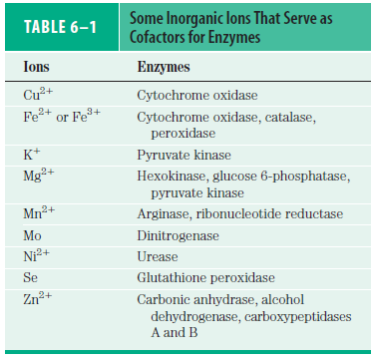

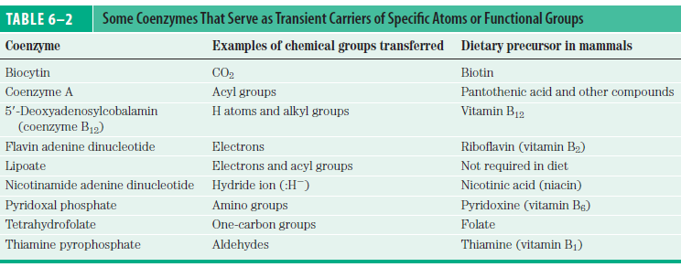

- Some enzymes require both a coenzyme and one or more metal ions for activity.
- A cofactor is very tightly or covalently bound to the enzyme, it is called a prosthetic group.
- Enzyme with its cofactor is called a holoenzyme.
- Enzyme without its cofactor is called the apoenzyme or apoprotein.
- Some enzymes are modified covalently by phosphorylation, glycosylation, and other processes.

Enzymes Are Classified by the Reactions They Catalyze
- Many enzymes have been named by adding the suffix “-ase” to the name of their substrate or to a word or phrase describing their activity (urease catalyzes hydrolysis of urea).
- Other enzymes have names that do not denote their substrates or reactions (pepsin catalyzes digestion of foods).
- Sometimes the same enzyme has two or more names, or two different enzymes have the same name.
- Because of such ambiguities, a system for naming and classifying enzymes has been adopted by international agreement.
- This system divides enzymes into six classes, each with subclasses, based on the type of reaction catalyzed (Table 6-3).

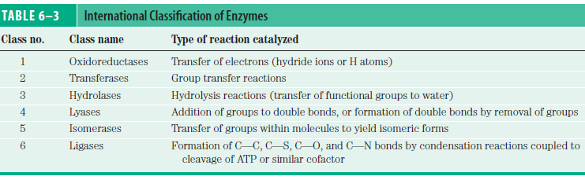

- Each enzyme is assigned a four-part classification number and systematic name.
- For example, ATP + Glucose ADP + Glucose 6-phosphate
ATP : glucose phosphotransferase
  - it catalyzes the transfer of a phosphoryl group from ATP to glucose.
  - its Enzyme Commission number (E.C. number) is 2.7.1.1.
  - (2) denotes the class name (transferase).
  - (7) denotes the subclass (phosphotransferase).
  - (1) denotes a phosphotransferase with a hydroxyl group as acceptor.
  - (1) denotes glucose as the phosphoryl-group acceptor.
- For many enzymes, a trivial name is more commonly used (hexokinase).

  - How Enzyme Works
- The enzymatic catalysis of reactions is essential to living systems.
- An enzyme-catalyzed reaction takes place within the confines of a pocket on the enzyme which is called the active site.
- amino acid residues at the active site are important.
- The molecule is bound in the active site and acted upon by the enzyme which is called the substrate (Fig. 6-1).

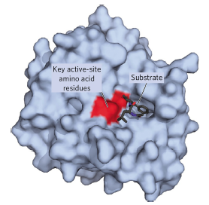

Enzymes Affect Reaction Rates, Not Equilibria
- A simple enzymatic reaction might be written
E + S ES EP E + P
- E, S and P represent the enzyme, substrate and product.
- ES and EP are transient complexes of the enzyme with the substrate and with the product.
- The function of a catalyst is to increase the rate of a reaction.
- Catalysts do not affect reaction equilibria.
- There is an energy barrier between S and P.
- The activation energy can be lowered by adding a catalyst.
- Enzymes increase reaction rates by lowering activation energies (Fig. 6-3).

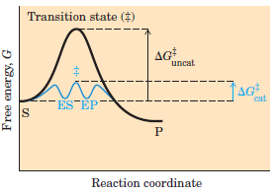
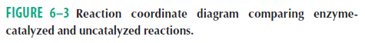
A Few Principles Explain the Catalytic Power and Specificity of Enzymes
- Covalent bonds and non-covalent interactions between enzyme and substrate occur during an enzyme-catalyzed reaction.
- Weak interactions between enzyme and substrate are optimized in the transition state.
- The weak interactions make the primary contribution to catalysis.
- There are two models for binding between S and E.
- the lock and key model
- the enzyme is completely complementary to its substrate.
- the induced fit model is used by almost every enzyme.
- the enzyme itself usually undergoes a change in conformation when the substrate binds.

Specific Catalytic Groups Contribute to Catalysis
- When a substrate is bound to an enzyme, catalytic functional groups aid in bond cleavage and formation by a variety of mechanisms.
- General acid-base catalysis, it uses only the H⁺ or OH⁻ ions present in water, organic acids and organic bases.
- Covalent catalysis, a transient covalent bond is formed between the enzyme and the substrate.
- Metal ion catalysis, metals (bound to the enzyme or taken up from solution along with the substrate) can participate in catalysis.

6.3 Enzyme Kinetics as an Approach to Understand Mechanism
- Central approach to studying the mechanism of an enzyme-catalyzed reaction is to determine the rate of a reaction.
- How is the rate changed in experimental parameters, a discipline known as enzyme kinetics.

Substrate Concentration Affects the Rate of Enzyme-Catalyzed Reaction
- The effect on V₀ of varying [S] when the enzyme concentration is held constant is shown in (Fig. 6-11).
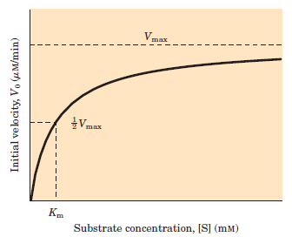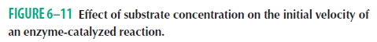
k₁
k₂

E + S ES E + P
k-₂

k-₁

- At low [S],
- V₀ increases linearly with an increase in [S].
- most of the E is in the uncombined form E.
- [S] at which V₀ is half maximal is Km, the Michaelis constant.
- At higher [S],
- V₀ increases by smaller with an increase in [S].
- most of the E is in form ES.
- The ES complex is the key to understanding this kinetic behavior.
- At the highest [S],
- V₀ increases by vanishingly small as [S] increases.
- all of the E is in form ES. E is saturated with its S. Further increases in [S] have no effect on rate.
- V₀ is close to the maximum velocity, V_{max}.

The Relationship between Substrate Concentration and Reaction Rate Can Be Expressed Quantitatively
- k₋₂ can be ignored.
- ( k₂ + k₋₁ ) / k₁ = K_{m}, Michaelis constant
- It can be expressed by the Michaelis-Menten equation
V_{max} [S]
V₀ =
K_{m} + [S]

V_{max} [S]
V₀ =
K_{M} + [S]

Kinetic Parameters Are Used to Compare Enzyme Activities
- Both the magnitude and the real meaning of V_{max} and K_{m} can differ from one enzyme to the next.
- The K_{m} can vary greatly from enzyme to enzyme and even for different substrates of the same enzyme (Table 6–6).

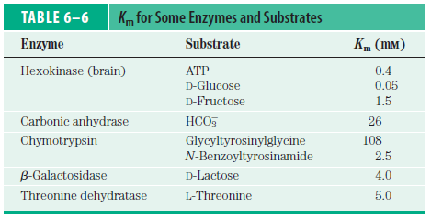

- It is useful to define a more general rate constant, k_{cat}, to describe the limiting rate of any enzyme-catalyzed reaction at saturation.
- When the single enzyme molecule is saturated with substrate, the number of substrate molecule is converted to product in a second. It is called turnover number (Table 6-7).
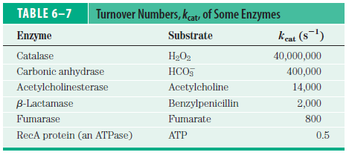

- The Michaelis-Menten equation can be transformed into Lineweaver-Burk equation
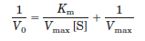

- is more useful in plotting experimental data (Lineweaver-Burk plot).

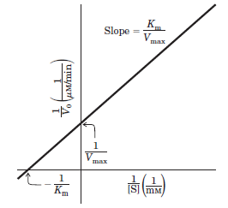

- is more useful in practical accurate determination K_{m} and of V_{max}.
- is very useful in distinguishing between certain types of enzymatic reaction mechanisms.
- is very useful in analyzing enzyme inhibition.
Enzymes Are Subject to Reversible or Irreversible Inhibition
- Enzyme inhibitors are molecular agents.
- They interfere with catalysis, slowing or halting enzymatic reactions.
- There are two classes of enzyme inhibitors: reversible and irreversible.
- Reversible inhibition can be competitive, uncompetitive or mixed (Fig. 6-15).
- A competitive inhibitor competes with the substrate for the active site of an enzyme.
- An uncompetitive inhibitor binds at a site distinct from the substrate active site, binds only the ES complex.
- A mixed inhibitor also binds at a site distinct from the substrate active site, but it binds to either E or ES.

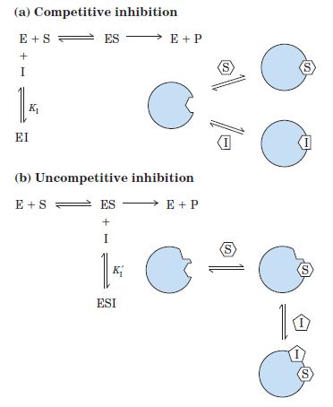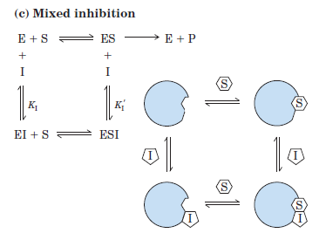
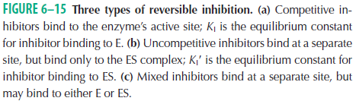

- Lineweaver-Burk plot offers an easy way of determining whether an enzyme inhibitor is competitive, uncompetitive or mixed. (Fig. 1, 2, 3) (Table 6-9).

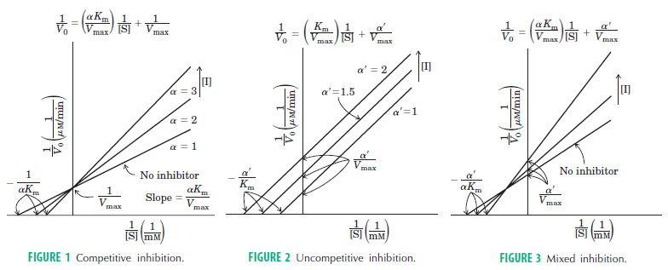

[E] [I]
K_{I} =
[EI]
[I]
α = 1 +
K_{I}
- Competitive inhibition
- V_{max} is unchanged
- K_{m} is increased by the factor α
- Uncompetitive inhibition
[ES] [I]
K_{I}’ =
[ESI]
[I]
α' = 1 +
K_{I}’
- V_{max} is decreased by the factor α'
- K_{m} is decreased by the factor α'
- Mixed inhibition
- V_{max} is decreased by the factor α'
- K_{m} is increased by the factor α and decreased by the factor α'
- The special case of α = α', rarely, classically has been defined as noncompetitive inhibition. V_{max} is decreased by the factor α and K_{m} is unchanged.
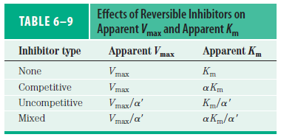
Noncompetitive V_{max}/α’ K_{M}

- Irreversible inhibitors bind covalently with or destroy a functional group on an enzyme that is essential for the enzyme’s activity, or form a particularly stable noncovalent association.

Enzyme Activity Depends on pH
- Enzymes have an optimum pH (or pH range) at which their activity is maximal (Fig. 6-18); at higher or lower pH, activity decreases.

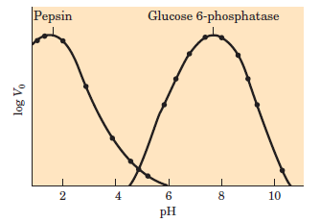

- Amino acid side chains in the active site may act as weak acids and bases with critical functions.

