Lehninger
Principles of Biochemistry
David L. Nelson
Michael M. Cox

BIOCHEMISTRY 2

Bioenergetics and Biochemical Reaction Types (Chapter 13)
Glycolysis, Gluconeogenesis, and the Pentose Phosphate Pathway (Chapter 14)
Principles of Metabolic Regulation (Chapter 15)
The Citric Acid Cycle (Chapter 16)
Fatty Acid Catabolism (Chapter 17)
Amino Acid Oxidation and the Production of Urea (Chapter 18)
Oxidative Phosphorylation (Chapter 19)

- Living organisms are composed of lifeless molecules.
- Biosphere is all the living matter on or in
- the earth
- the seas
- the atmosphere.
- Autotroph is an organism
- it can synthesize its own complex molecules from very simple C and N sources, such as CO₂ and NH₃.
- Heterotroph is an organism that
- it requires complex nutrient molecules, such as glucose, as a source of energy and C.
- Carbon, oxygen and water are cycled between the heterotrophic and autotrophic worlds, with solar energy as the driving force for this massive process (Fig. 1).
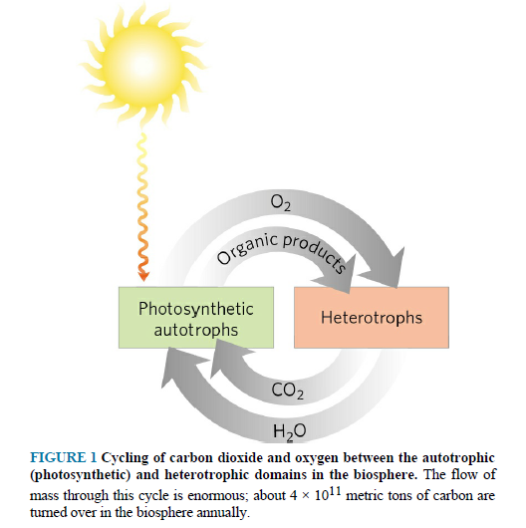
- All living organisms require a source of nitrogen
- it is necessary for the synthesis of amino acids, nucleotides, and other compounds (Fig. 2).
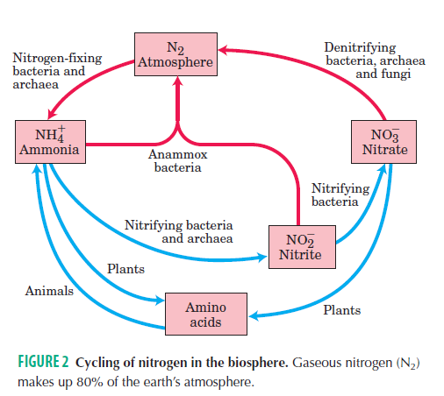

- Catabolism is the degradative phase of metabolism
- organic molecules are converted into smaller and simpler end products (Fig. 3).
- Catabolic pathways release energy some of which
- is conserved in the formation of ATP
- is reduced electron carriers
- the rest is lost as heat.
- In anabolism, also called biosynthesis
- small and simple precursors are built up into larger and more complex molecules (requires the input of energy).
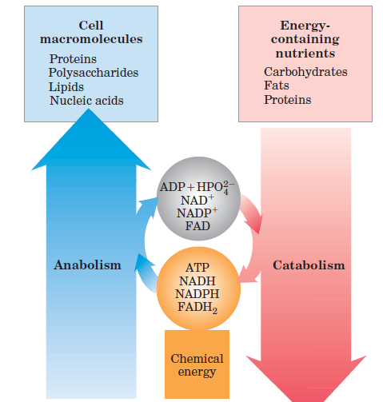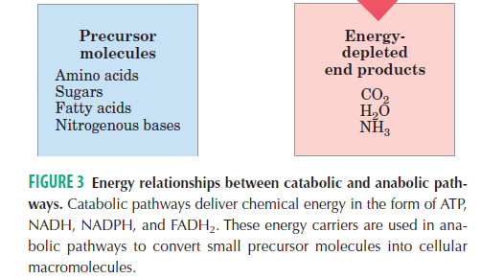
- Metabolism = catabolism + anabolism
- Metabolism is a highly coordinated cellular activity.
Chapter 13 Bioenergetics and Biochemical Reaction Types
- Living cells and organisms must perform work to stay alive, to grow and to reproduce.
- Living cells are chemical engines.
- Cells and organisms depend on a constant supply of energy.
- Energy is central theme in biochemistry.
- Cells have evolved highly efficient mechanisms for coupling the energy obtained from sunlight or fuels to the many energy-consuming processes.

13.1 Bioenergetics and Thermodynamics
- Bioenergetics is the quantitative study of the energy transductions - changes of one form of energy into another - that occur in living cells.

Biological Energy Transformations Obey the Laws of Thermodynamics
- The first law is the principle of the conservation of energy
- for any physical or chemical change, the total amount of energy in the universe remains constant
- energy may change form or it may be transported from one region to another, but it cannot be created or destroyed.
- The second law of thermodynamics says that the universe always tends toward increasing disorder
- in all natural processes, the entropy of the universe increases.
- Living cells and organisms are open systems
- they are exchanging both material and energy with their surroundings.
- Gibbs free energy, (G), expresses the amount of an energy capable of doing work during a reaction at constant temperature and pressure.
- When a reaction proceeds with the release of free energy, the free-energy change
- ΔG has a negative value and the reaction is said to be exergonic.
- In endergonic reactions, the system gains free energy and ΔG is positive.
- Enthalpy, H, is the heat content of the reaction system.
- it reflects the number and kinds of chemical bonds in the reactants and products.
- When a chemical reaction releases heat, it is said to be exothermic
- ΔH has a negative value.
- Reaction systems that take up heat from their surroundings are endothermic
- ΔH has a positive value.
- Entropy, S, is a quantitative expression for the randomness or disorder in a system.
- When the products of a reaction are less complex and more disordered than the reactants, the reaction is said to proceed with a gain in entropy.
- In biological systems (constant temperature and pressure),
ΔG = ΔH - TΔS
- ΔG of spontaneously reacting system is always negative.

Standard Free-Energy Change Is Directly Related to the Equilibrium Constant
- The concentrations of reactants and products at equilibrium define the equilibrium constant, K_{eq}.
aA + bB cC + dD K_{eq} = [C]^{c} [D]^{d} / [A]ª [B]^{b}
- Under standard conditions (298 K = 25 ºC, 1 atm), the force driving the system toward equilibrium is defined as the standard free-energy change, ΔGº.
- There is a simple relationship between K_{eq} and ΔGº :
ΔGº = - RTlnK_{eq}
- The standard free-energy change is directly related to the equilibrium constant (Table 13- 2 and 3).

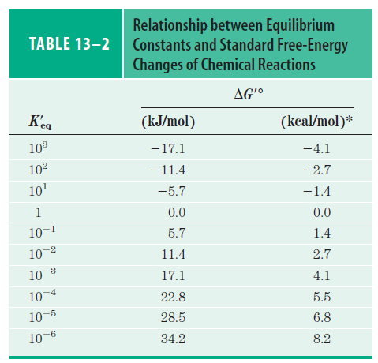

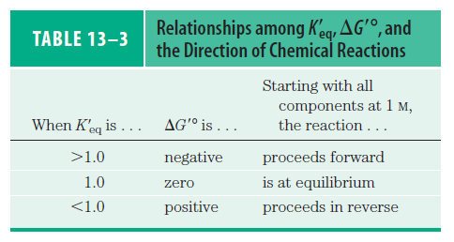
- (Table 13-4) gives the standard free-energy changes for some representative chemical reactions.

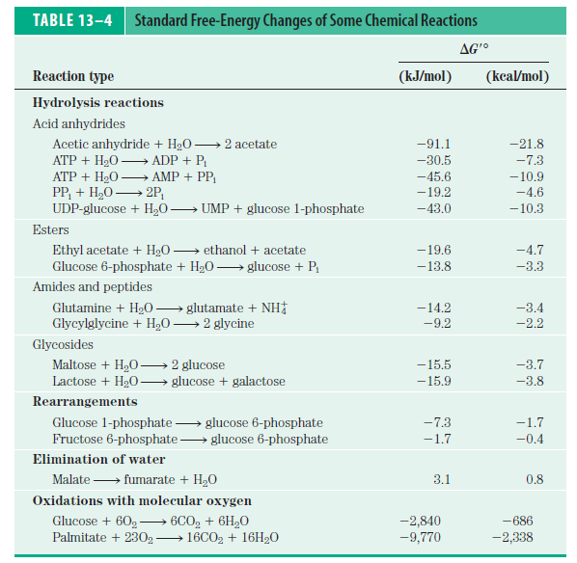

Standard Free-Energy Changes Are Additive
- The ΔGº values of sequential chemical reactions are additive.
- This principle of bioenergetics explains
- how a thermodynamically unfavorable (endergonic) reaction can be driven in the forward direction by coupling it to a highly exergonic reaction through a common intermediate.
- For example, (P_{i} : inorganic phosphate, HPO₄²⁻)

Glucose + P_{i} glucose 6-phosphate + H₂O ΔGº = 13.8 kJ/mol
ATP + H₂O ADP + P_{i} ΔGº = - 30.5 kJ/mol
ATP + glucose ADP + glucose 6-phosphate ΔGº = - 16.7 kJ/mol

- The two reactions can be coupled in the form of a third reaction.
- The overall reaction is exergonic.
- This common-intermediate strategy is employed by all living cells in the synthesis of metabolic intermediates and cellular components.

13. 2 Chemical Logic and Common Biochemical Reactions
- Most of the reactions in living cells fall into one of five general categories:
1) reactions that make or break carbon–carbon bonds
2) internal rearrangements, isomerizations, and eliminations
3) free-radical reactions
4) group transfer reactions
5) oxidation-reduction reactions

- Oxidation-Reduction Reactions
- Carbon atoms can exist in five oxidation states (Fig. 13.9).
- CO₂ is the most oxidized form.
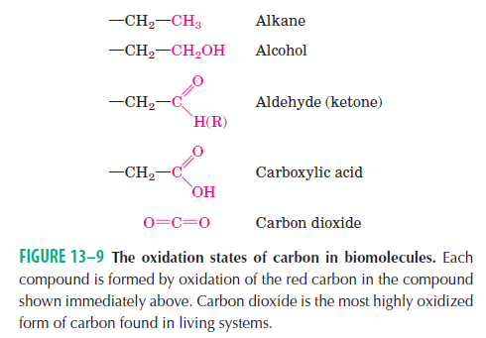

- In many biological oxidations, a compound loses two electrons and two hydrogen ions (i.e. two hydrogen atoms).
- These reactions are commonly called dehydrogenations.
- The enzymes are called dehydrogenases (Fig. 13.10).

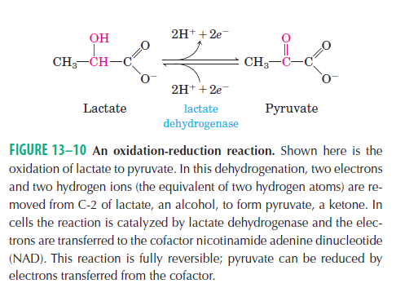

- In some biological oxidations,
- a carbon atom becomes covalently bonded to an oxygen atom and the enzymes are called oxidases.
- If the oxygen atom is derived directly from molecular oxygen (O₂), the enzymes are called oxygenases.
- The catabolic (energy-yielding) pathways are oxidative reaction sequences.
- They result in the transfer of electrons from fuel molecules, through a series of electron carries, to oxygen.
- The high affinity of O₂ for electrons makes the overall electron-transfer process highly exergonic.
- It provides the energy (ATP).
  - ATP is the central goal of catabolism.

13.3 Phosphoryl Group Transfers and ATP
- ATP is the major carrier of chemical energy in all cells (Fig. 13-11).
- The terminal phosphoryl group having phosphoanhydride bond is removed.
- Standard free energy of hydrolysis of ATP is the relatively large and negative (exergonic)
- This reaction is coupled to many endergonic reactions in the cell such as
  - the synthesis of metabolic intermediates
  - the synthesis of macromolecules from smaller precursors
  - the transport of substances across membranes against concentration gradients
  - mechanical motion.
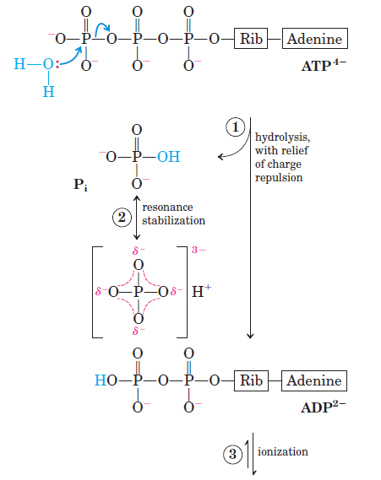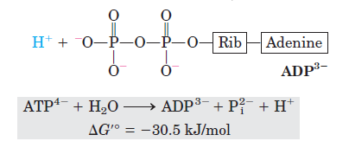

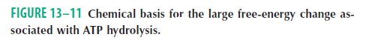

- Other biologically important phosphorylated compounds and thioesters also have large free energies of hydrolysis (Table 13- 6) (Fig. 13-13 and 16).
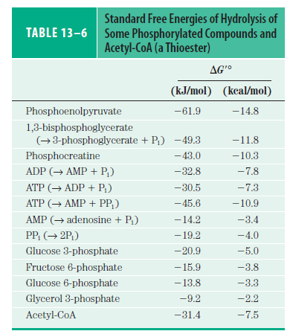

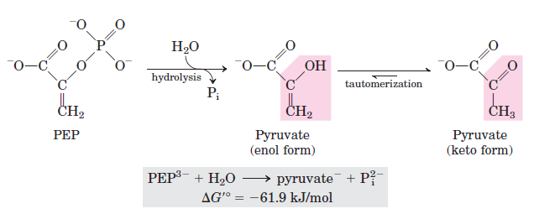

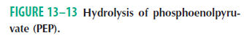
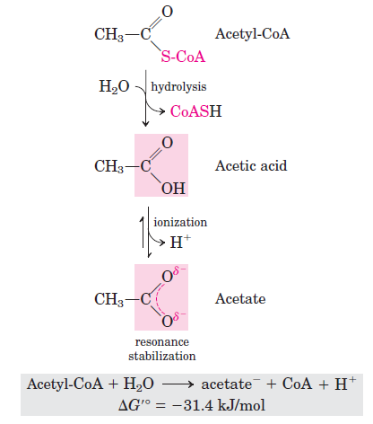
13.4 Biological Oxidation-Reduction Reactions
- The transfer of phosphoryl groups is a central feature of metabolism.
- Another kind of transfer is electron transfer in oxidation-reduction reactions.
- Some reactant is oxidized (loses electrons) as another is reduced (gains electrons).
- The flow of electrons provides energy for organisms.
- In nonphotosynthetic organisms, the sources of electrons are reduced compounds (foods).
- In photosynthetic organisms, the initial electron donor is a chemical species excited by the absorption of light.
- The path of electron flow in metabolism is complex.
- Electrons move from various metabolic intermediates to specialized electron carriers in enzyme-catalyzed reactions.
- Cells contain a variety of molecular energy transducers, which convert the energy of electron flow into useful work.

The Flow of Electrons Can Do Biological Work
- In living cells, reduced compound such as glucose is used as the source of electrons.
- Glucose is enzymatically oxidized.
- The released electrons flow spontaneously through a series of electron-carrier intermediates to another chemical species, such as O₂.
- The resulting electromotive force provides energy.
- The principles of electrochemistry are used in living cells. (motor and battery)

Biological Oxidations Often Involve Dehydrogenation
- The carbon in living cells exists in a range of oxidation states.
- Oxidation is coincident with the loss of hydrogen.
- The more reduced compounds are richer in hydrogen than in oxygen.
- The more oxidized compounds have more oxygen and less hydrogen.
- Not all biological oxidation-reduction reactions involve carbon.
- For example, the nitrogen atoms are reduced
6H⁺ + 6e⁻ + N₂ 2NH₃
- In cells, electrons are transferred from one molecule to another in one of four different ways:
- Directly as electrons.
Fe²⁺ + Cu²⁺ Fe³⁺ + Cu⁺
- As hydrogen atoms. A hydrogen atom consists of a proton (H⁺) and a single electron (e⁻).
AH₂ A + 2e⁻ + 2H⁺
AH₂ + B A + BH₂
B is reduced by transfer of hydrogen atoms
- As a hydride ion (:H⁻), which has two electrons. This occurs in the case of NAD-linked dehydrogenases.
NAD⁺ + 2e⁻ + 2H⁺ NADH + H⁺
- Through direct combination with oxygen.
R-CH₃ + 1/2O₂ R-CH₂-OH
The hydrocarbon is the electron donor and the oxygen atom is the electron acceptor. The hydrocarbon is oxidized to an alcohol.

Reduction Potentials Measure Affinity for Electrons
- Walter Nernst derived an equation related to standard reduction potential (Eº) to actual reduction potential (E).
E = Eº + 0.026 V / n ln [electron acceptor] / [electron donor]
n is the number of electrons transferred per molecule

Standard Reduction Potentials Can Be Used to Calculate Free-Energy Change
ΔGº = -nFΔEº or ΔG= -nFΔE
F is the Faraday constant

Cellular Oxidation of Glucose to Carbon Dioxide Requires Specialized Electron Carries
- In many organisms, the oxidation of glucose supplies energy for the production of ATP.
- The complete oxidation of glucose :
C₆H₁₂O₆ + 6O₂ 6CO₂ + 6H₂O ΔGº = - 2,480 kJ/mol
- Electrons removed in these oxidation steps are transferred to coenzymes specialized for carrying electrons, such as
- NAD⁺ (Nicotinamide Adenine Dinucleotide)
- FAD (Flavin Adenine Dinucleotide)
A Few Types of Coenzymes and Proteins Serve as Universal Electron Carriers
- Some of them are
- NAD⁺
- NADP⁺ (Nicotinamide Adenine Dinucleotide Phosphate)
- FMN (Flavin Mononucleotide)
- FAD
- Quinones
- Iron-sulfur proteins
- Cytochromes
- NAD⁺ and NADP⁺ are the freely diffusible coenzymes of many dehydrogenases.
- Both of them accept two electrons and one proton. (Fig. 13-24a).
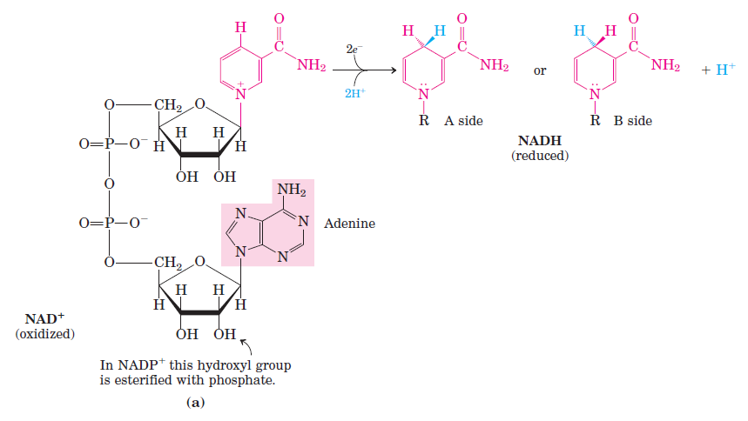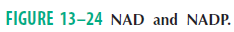
NAD⁺ + 2e⁻ + 2H⁺ NADH + H⁺
NADP⁺ + 2e⁻ + 2H⁺ NADPH + H⁺
- More than 200 enzymes use NAD⁺ or NADP⁺.
- They are called oxidoreductase or dehydrogenase.
- For example, alcohol dehydrogenase catalyzes
CH₃CH₂OH + NAD⁺ CH₃CHO + NADH + H⁺
Ethanol Acetaldehyde
- FAD and FMN serve as tightly bound prosthetic groups of flavoproteins.
- They can accept either one or two electrons and one or two protons (Fig. 13-27).
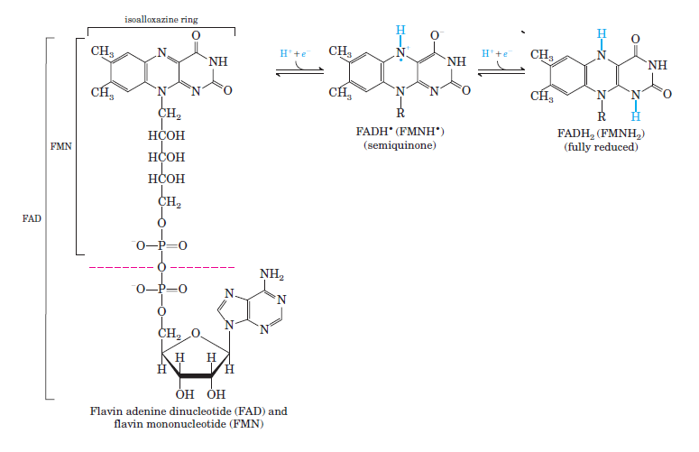

FMN + 2e⁻ + 2H⁺ FMNH₂
FAD + 2e⁻ + 2H⁺ FADH₂

