  - Nitrogen Excretion and the Urea Cycle

- In ureotelic organisms, the ammonia deposited in the mitochondria of liver is converted to urea in the urea cycle.
- The urea passes into the blood and thus to the kidneys and is excreted into the urine.

Urea Is Produced from Ammonia in Five Enzymatic Steps
- The urea cycle begins inside liver mitochondria, but three of the subsequent steps take place in the cytosol (Fig. 18-10).
- NH₄ and CO₂ (as HCO₃⁻) are converted to carbamoyl phosphate by carbamoyl phosphate synthetase I.
- The cycle has four enzymatic steps.
- Carbamoyl phosphate and ornithine are converted to citrulline by ornithine transcarbamoylase. The citrulline passes into the cytosol.
- The second amino group now enters from aspartate. Citrulline and aspartate are converted to argininosuccinate by argininosuccinate synthetase.
- The argininosuccinate is then cleaved by argininosuccinase to form free arginine and fumarate.
- Arginase cleaves arginine to yield urea and ornithine.
- Ornithine is transported into the mitochondrion to initiate another round of the urea cycle.

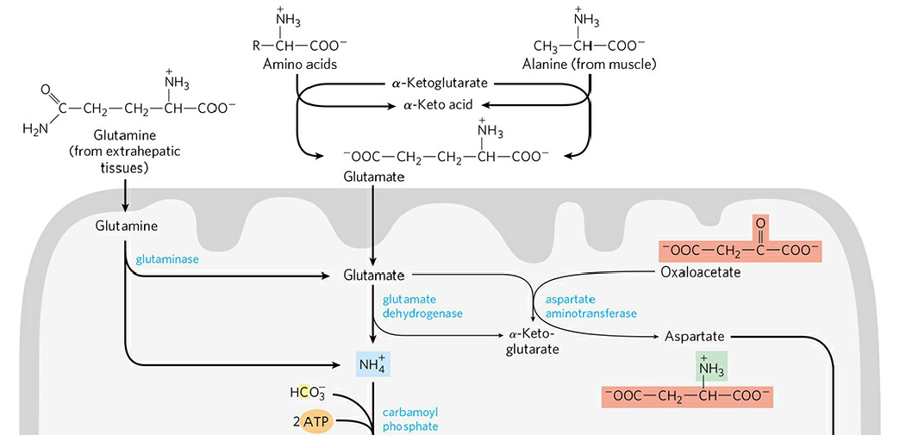
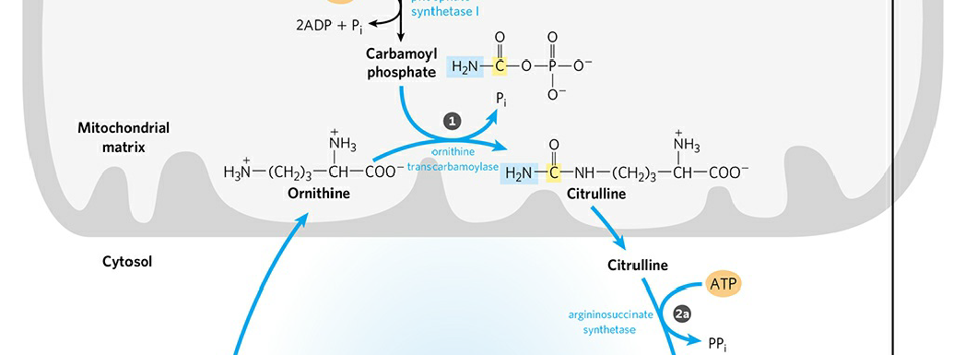
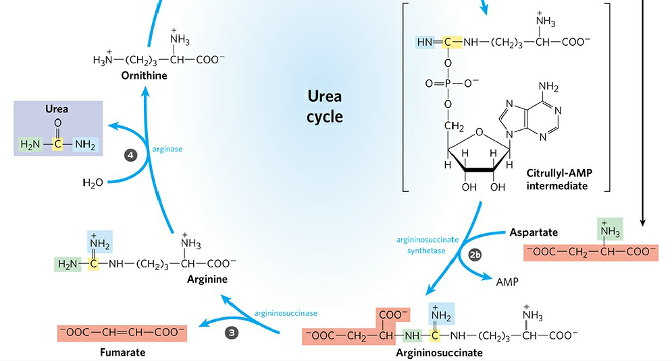
FIGURE 18-10 The urea cycle and reactions that feed amino groups into the cycle.

