Chapter 26 RNA Metabolism

- All RNA molecules except the RNA genomes of certain viruses are derived from information permanently stored in DNA.
- During transcription, an enzyme system converts the genetic information in a segment of double-stranded DNA into an RNA strand with a base sequence complementary to one of the DNA strands.
- Three major kinds of RNA are produced.
- Messenger RNAs (mRNAs) encode the amino acid sequence of one or more polypeptides speciﬁed by a gene or set of genes.
- Transfer RNAs (tRNAs) read the information encoded in the mRNA and transfer the appropriate amino acid to a growing polypeptide chain during protein synthesis.
- Ribosomal RNAs (rRNAs) are constituents of ribosomes that synthesize proteins.
- During replication the entire chromosome is usually copied, but transcription is more selective.
- Only particular genes or groups of genes are transcribed at any one time, and some portions of the DNA genome are never transcribed.
- Speciﬁc regulatory sequences mark the beginning and end of the DNA segments to be transcribed and designate which strand in duplex DNA is to be used as the template.

26.1 DNA-Dependent Synthesis of RNA
- Transcription has initiation, elongation, and termination phases.

RNA Is Synthesized by RNA Polymerases
- E. coli RNA polymerase helped to define the fundamental properties of transcription.
- DNA-dependent RNA polymerase requires, in addition to a DNA template, all four ribonucleoside 5’-triphosphates (ATP, GTP, UTP, and CTP) as precursors of the nucleotide units of RNA (Fig. 26–1a).
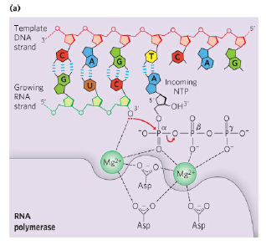

- RNA polymerase elongates an RNA strand by adding ribonucleotide units to the 3’- hydroxyl end, building RNA in the 5’ 3’ direction.
- The overall reaction is
(NMP)_{n} + NTP (NMP)_{n+1} + PP_{i}
RNA Lengthened RNA
- The two complementary DNA strands have different roles in transcription (Fig. 26–1b, c).
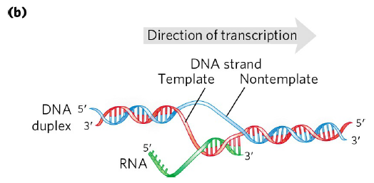
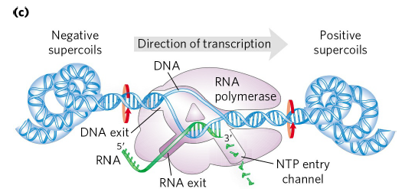

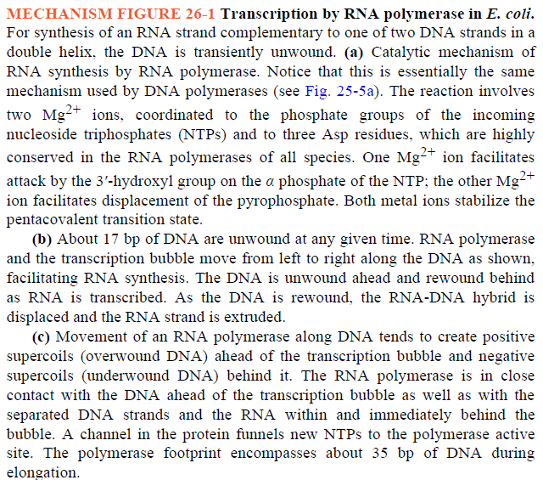

- The strand that serves as template for RNA synthesis is called the template strand.
- The DNA strand complementary to the template, the nontemplate strand, or coding strand,
  - is identical in base sequence to the RNA transcribed from the gene, with U in the RNA in place of T in the DNA (Fig. 26–2).
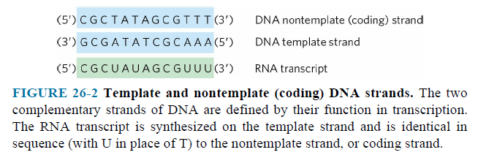
- The coding strand for a particular gene may be located in either strand of a given chromosome (Fig. 26–3).
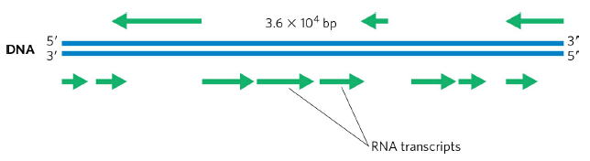
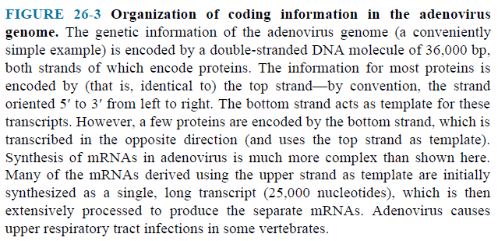
- The template DNA strand is copied in the 3’ 5’ direction (antiparallel to the new RNA strand).
- Each nucleotide in the newly formed RNA is selected by base-pairing interactions; U residues are inserted in the RNA to pair with A residues in the DNA template, G residues are inserted to pair with C residues, and so on.
- Unlike DNA polymerase, RNA polymerase does not require a primer to initiate synthesis.
- Initiation occurs when RNA polymerase binds at specific DNA sequences called promoters.
- During the elongation phase of transcription, the growing end of the new RNA strand base-pairs temporarily with the DNA template to form a short hybrid RNA-DNA double helix, estimated to be 8 bp long (Fig. 26–1b, c).
- Elongation of a transcript by E. coli RNA polymerase proceeds at a rate of 50 to 90 nucleotides/s.
- The DNA-dependent RNA polymerase of E. coli is a large, complex enzyme with ﬁve core subunits (α₂ββ'ω) and a sixth subunit, one of a group designated σ (Fig. 26–4)

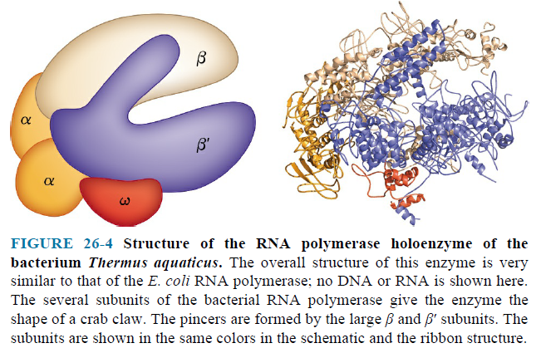
- The σ subunit binds transiently to the core and directs the enzyme to speciﬁc binding sites on the DNA.
- These six subunits constitute the RNA polymerase holoenzyme.

RNA Synthesis Begins at Promoters
- RNA polymerase binds to speciﬁc sequences in the DNA called promoters.
- The promoter region extends between positions -70 and +30.
- Bacterial promoters have similarities in two short sequences centered about positions -10 and -35.
- These sequences of the nontemplate strand, read in the 5’ 3’ direction, are important interaction sites for the σ subunit (Fig. 26–5).
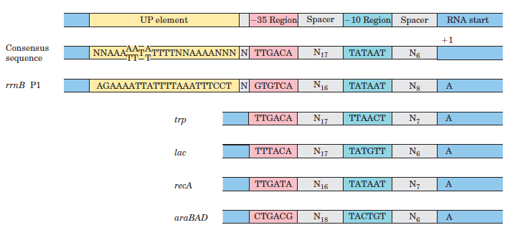
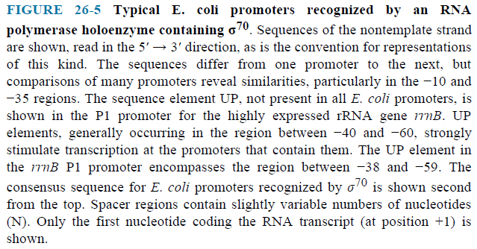
- The consensus sequence at the -10 region is (5’)TATAAT(3’); the consensus sequence at the -35 region is (5’)TTGACA(3’).
- RNA polymerase core binds to the DNA promoter (Fig. 26–6).
- Transcription bubble forms.
- Transcription is initiated.
- Promoter clearance is followed by elongation.
- Elongation continues. σ dissociates, and is replaced by protein NusA.
- Transcription is terminated. NusA dissociates, and the RNA polymerase is recycled.
- σ factor can again bind to the enzyme to initiate transcription.

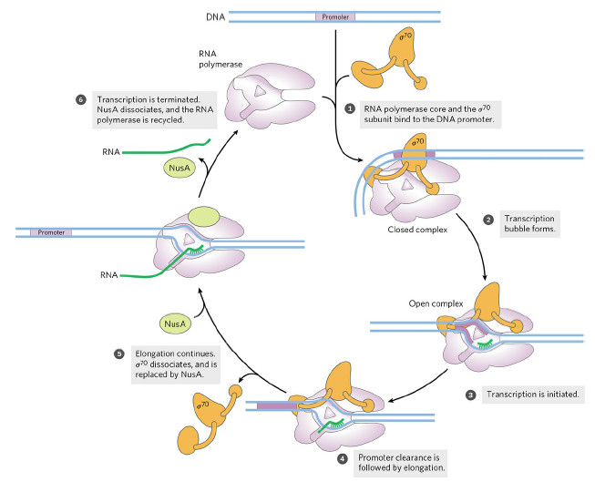
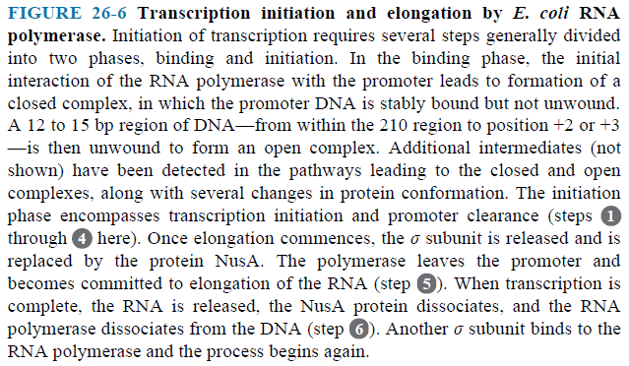

Transcription Is Regulated at Several Levels
- Regulation can occur at any step in transcription, including elongation and termination.
- The binding of proteins to sequences both near to and distant from the promoter can also affect levels of gene expression.
- Protein binding can activate transcription by facilitating either RNA polymerase binding or steps further along in the initiation process, or it can repress transcription by blocking the activity of the polymerase.
- In E. coli, one protein that activates transcription is the cAMP receptor protein (CRP), which increases the transcription of genes coding for enzymes.
- Repressors are proteins that block the synthesis of RNA at specific genes.

Specific Sequences Signal Termination of RNA Synthesis
- E. coli has at least two classes of termination signals: one class relies on a protein factor called ρ (rho) and the other is ρ-independent.
- Most ρ -independent terminators have two distinguishing features.
- The first is a region that produces an RNA transcript with self-complementary sequences, permitting the formation of a hairpin structure centered 15 to 20 nucleotides before the projected end of the RNA strand (Fig. 8–19a).

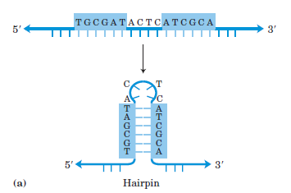

- The second feature is a highly conserved string of three A residues in the template strand that are transcribed into U residues near the 3’ end of the hairpin (Fig. 26–7a).
- When a polymerase arrives at a termination site with this structure, it pauses.
- Formation of the hairpin structure in the RNA disrupts several A=U base pairs in the RNA-DNA hybrid segment and may disrupt important interactions between RNA and the RNA polymerase, facilitating dissociation of the transcript.

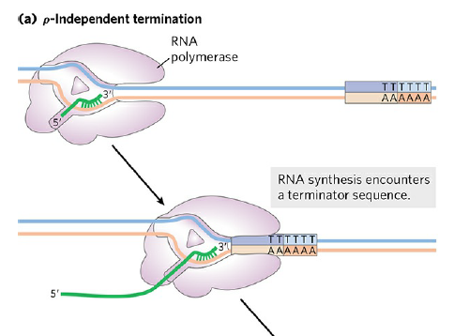
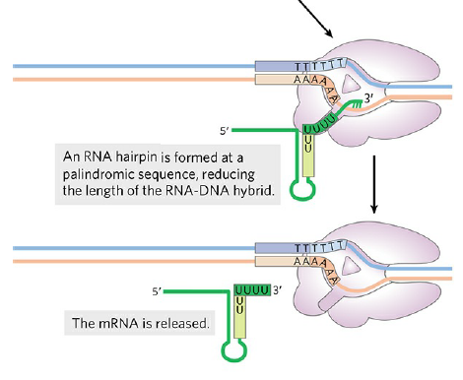

- The ρ-dependent terminators lack the sequence of repeated A residues in the template strand but usually include a CA-rich sequence called a rut (rho utilization) element (Fig. 26–7b).

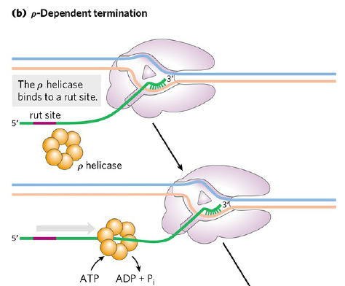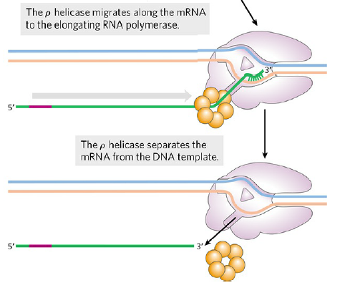
- The ρ protein associates with the RNA at specific binding sites and migrates in the 5’ 3’ direction until it reaches the transcription complex that is paused at a termination site.
- Here it contributes to release of the RNA transcript.

Eukaryotic Cells Have Three Kinds of Nuclear RNA Polymerases
- RNA polymerases are designated RNA Pol I, RNA Pol II and RNA Pol III.
- RNA Pol I is responsible for the synthesis of rRNAs (5.8S, 18S and 28S rRNAs).
- RNA Pol II is responsible for the synthesis of mRNAs.
- RNA Pol III is responsible for the synthesis of tRNAs and 5S rRNA.

RNA Polymerases Require Many Other Protein Factors for Its Activity
- The other proteins are called general transcription factors.
- Transcription factors are required for initiation of transcription at the RNA polymerase promoters.

