Three-Dimensional Structure of Proteins
Overview of Protein Structure
- Every protein has a three-dimensional structure that reflects its function.

The Peptide Bond Is Rigid and Planar
- Peptide bonds are important for primary structure of proteins.
- Peptide bond (Fig. 4-2).
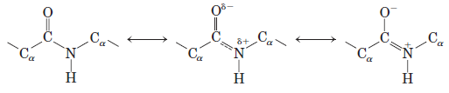
- has some double-bond character due to resonance.
- cannot rotate freely.
- has trans position (O and H atoms).
- is rigid and planar.

Protein Secondary Structure
- Secondary structure refers coiled primary structure by H bonds.
- H bonds are formed between C=O and N-H groups of the peptide bonds.
- The most common regular secondary structures are the α helix, the β conformation and β turns.

The α Helix Is a Common Protein Secondary Structure
- Polypeptide chain is a helical structure called the α helix (right-handed) (Fig. 4-4).
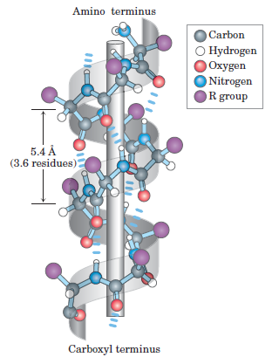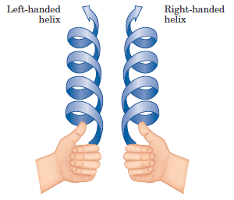
- R groups of the amino acid residues protrude outward from the helical backbone.
- The repeating unit is a single turn of the helix, which extends about 5.4 Å (Ångström, is equal to 0.1 nm) and each helical turn includes 3.6 amino acid residues.
- Amino acid sequence affects stability of the α helix.

The β Conformation Organizes Polypeptide Chains into Sheets
- Polypeptide chain is extended into a zigzag rather than helical structure called a β sheet.
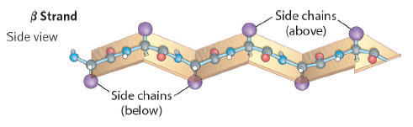
- Hydrogen bonds form between adjacent segments of polypeptide chain within the sheet.
- The R groups of adjacent amino acids protrude from the zigzag structure in opposite directions.
- The adjacent polypeptide chains in a β sheet can be either parallel or antiparallel (having the same or opposite amino-to-carboxyl orientations, respectively) (Fig. 4-6).

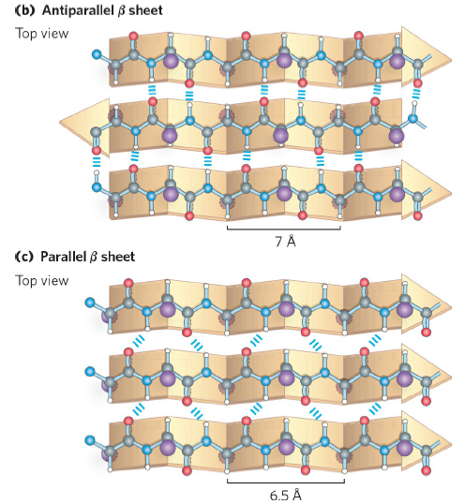

- Repeat period is shorter for the parallel conformation (6.5 Å, vs. 7 Å for antiparallel) and the hydrogen-bonding patterns are different (in-line or not in-lane).

β Turns Are Common in Proteins
- β turns connect the ends of two adjacent segments of an antiparallel β sheet (Fig. 4-7).
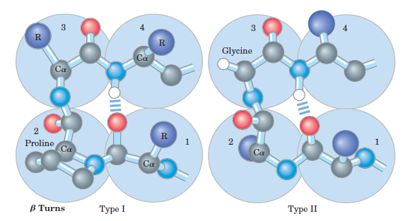

4.3 Protein Tertiary and Quaternary Structures
- Tertiary structure describes three-dimensional folding by noncovalent weak interactions between R groups (and sometimes by covalent bonds such as disulfide crosslinks).
- is the complete three-dimensional structure of a polypeptide chain.
- Quaternary structure results from noncovalent interactions and disulfide bonds between R groups of two or more polypeptide chains (identical or different) having tertiary structure.
- Proteins are classified into two major groups according to their structure.
- fibrous proteins have polypeptide chains arranged in long strand or sheets.
- insoluble in water, high concentration of hydrophobic amino acid residues (example : α-keratin in hair, collagen in bone).
- globular proteins have polypeptide chains folded into a spherical or globular shape.
- soluble in water (example : enzymes, transport protein).
- a variety of tertiary structures (Table 4-3).
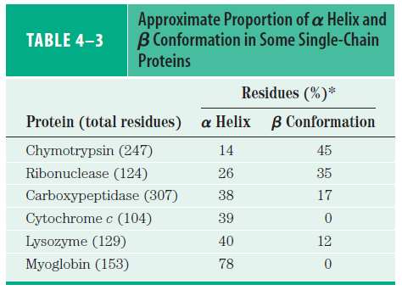
- To understand a complete three-dimensional structure, it is needed to analyze its folding.
- There are four classes of protein structure:
- all α
- all β
- α / β (with α and β segments interspersed or alternating)
- α + β (with α and β regions somewhat segregated). (Fig. 4-22).

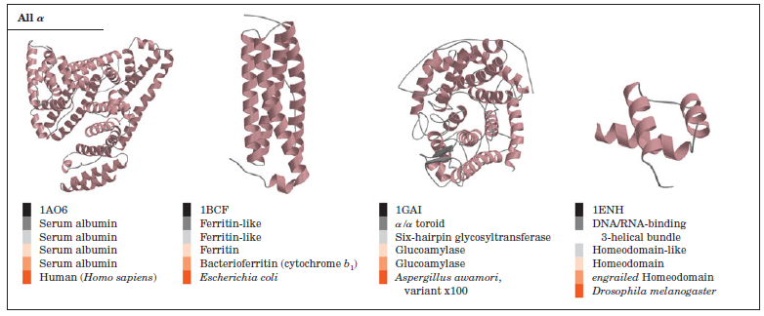

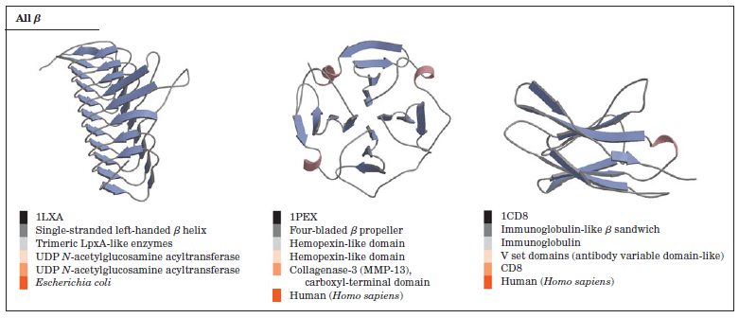
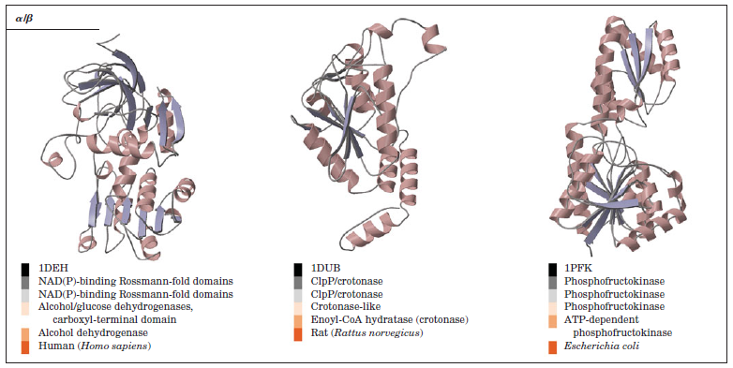
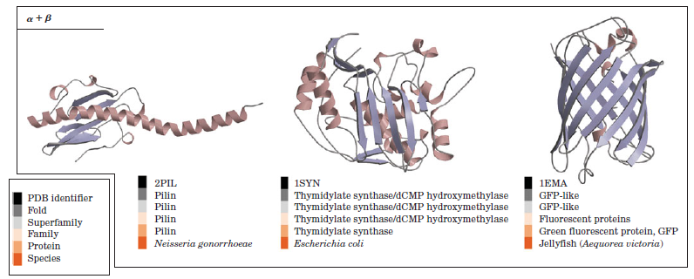
4.4 Protein Denaturation and Folding
- A loss of three-dimensional structure sufficient to cause loss of function is called denaturation.
- Most proteins can be denatured by breaking the weak interactions (primarily hydrogen bonds).
- Denaturation agents are
- heat, pH, organic solvent (alcohol or acetone), solutes (urea, detergents).
- Denaturated globular proteins can regain their native structure and their biological activity which is called renaturation (Fig. 4-27).

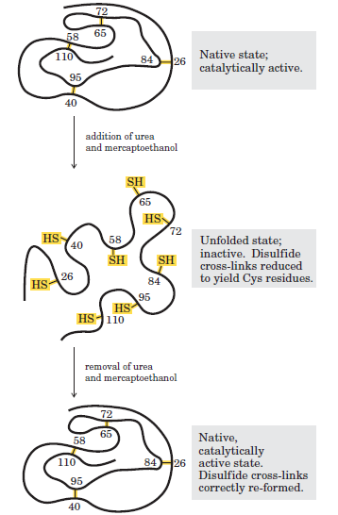

Polypeptides Fold Rapidly by a Stepwise Process
- Proteins are assembled from amino acids at very high rate.
- E.coli cells can make a complete, biologically active protein molecule containing 100 amino acid residues in about 5 seconds at 37 ºC.
- However, the synthesis of peptide bonds on the ribosome is not enough; the protein must fold.
- How does the polypeptide chain arrive at its native conformation?
- Let’s assume
- each of the amino acid residues could take up 10 different conformations on average, giving 10¹⁰⁰ different conformations for the polypeptide.
- its native and biologically active form would take about 10⁷⁷ years.
- Protein folding is not a completely random, trial-and-error process. There must be shortcuts.
- A native protein has one folded conformation stabilized largely by weak interactions.
- thermodynamically the most stable, having the lowest Gibbs free energy.
- As our understanding of protein folding and protein structure improves,
- increasingly sophisticated computer programs for predicting the structure of proteins from their amino acid sequence are being developed.
- Not all proteins fold spontaneously as they are synthesized in the cell.
- Folding for many proteins is facilitated by the action of specialized proteins called chaperones.
- are facilitating correct folding pathways or providing microenvironments.
- Protein misfolding is a substantial problem in all cells.
- The misfolding causes or contributes to the development of serious disease.

