Chapter 16 The Citric Acid Cycle
- The pyruvate produced by glycolysis is oxidized to H₂O and CO₂.
- This aerobic phase of catabolism is called respiration.
- Catabolism of proteins, fats and carbohydrates occurs in the three stages of cellular respiration (Fig. 16-1).

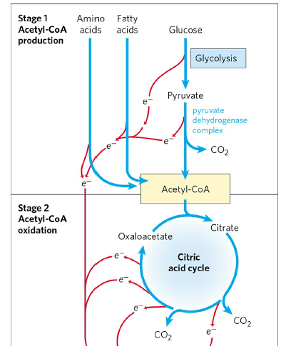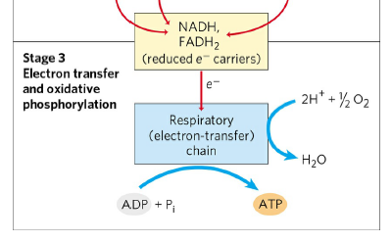
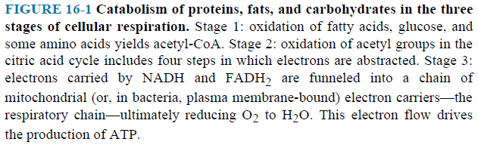

- Stage 1 : Oxidation of fatty acids, glucose and some amino acids yields acetly-CoA.
- Stage 2 : Oxidation of acetyl groups in the citric acid cycle yields CO₂ and energy.
- The energy released is conserved in the reduced electron carriers NADH and FADH₂.
- Stage 3 : The electrons are transferred to O₂ (the final electron acceptor) via a chain of electron-carrying molecules known as the respiratory chain.
- In the course of electron transfer, the energy is conserved in the form of ATP by a process called oxidative phosphorylation.
- Citric acid cycle is also called the tricarboxylic acid (TCA) cycle or the Krebs cycle.

16.1 Production of Acetyl-CoA (Activated Acetate)

- Pyruvate is oxidized to acetly-CoA and CO₂ by the pyruvate dehydrogenase (PDH) complex in the mitochondria of eukaryotic cells.
- The overall reaction is an oxidative decarboxylation (Fig. 16-2).
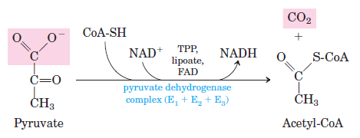
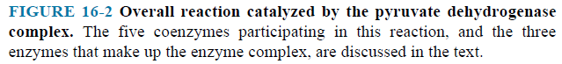

- Pyruvate dehydrogenase complex requires five coenzymes.
- FAD
- NAD⁺
- CoA : Coenzyme A (an acyl carrier) (Fig. 16-3).
- TPP : Thiamine pyrophosphate
- Lipoate

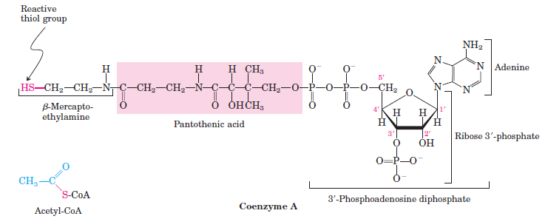

- Pyruvate dehydrogenase complex consists of three distinct enzymes.
- E₁ : Pyruvate dehydrogenase
- E₂ : Dihydrolipoyl transacetylase
- E₃ : Dihydrolipoyl dehydrogenase
- PDH complex carries out the five consecutive reactions in the decarboxylation and dehydrogenation of pyruvate (Fig. 16-6).
- E₁ catalyzes first the decarboxylation of pyruvate, producing hydroxyethyl-TPP, and then the oxidation of the hydroxyethyl group to an acetyl group. The electrons from this oxidation reduce the disulfide of lipoate bound to E₂, and the acetyl group is transferred into thioester linkage with one —SH group of reduced lipoate.
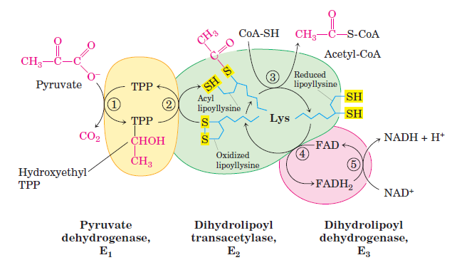

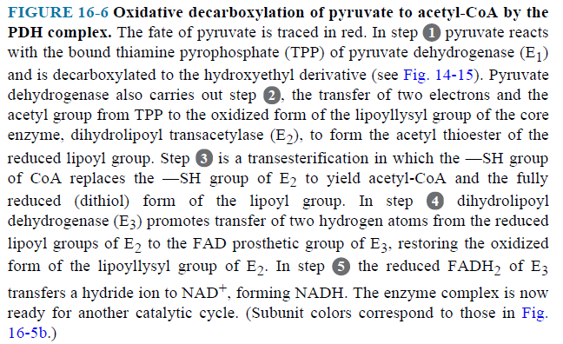
- E₂ catalyzes the transfer of the acetyl group to coenzyme A, forming acetyl-CoA.
- E₃ catalyzes the regeneration of the disulfide (oxidized) form of lipoate; electrons pass first to FAD, then to NAD⁺.
  - Reactions of the Citric Acid Cycle

- Oxidation of acetyl- CoA is carried out by the citric acid cycle (eight steps) (Fig. 16-7).
- In each turn of the cycle, one acetyl group (two carbons) enters as acetyl-CoA and two molecules of CO₂ leave; one molecule of oxaloacetate is used to form citrate and one molecule of oxaloacetate is regenerated.
- The energy of this oxidation is conserved in the reduced coenzymes NADH and FADH₂.
- Reactions occur in the mitochondria of eukaryotic cells.

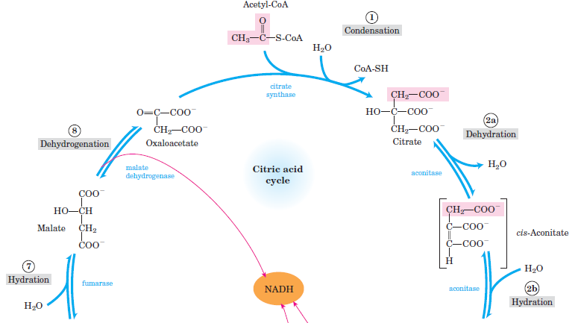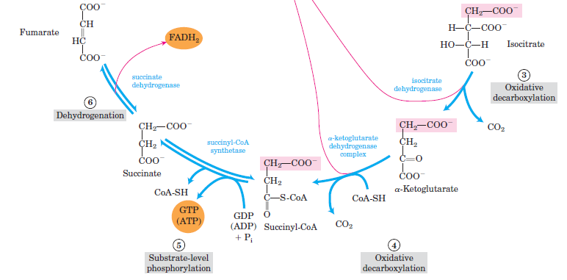

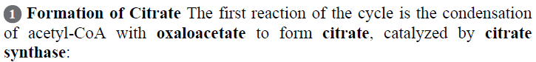

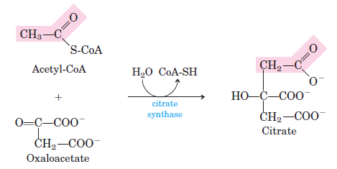

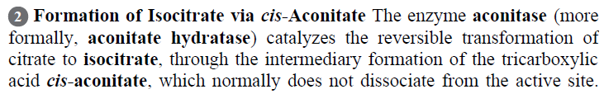

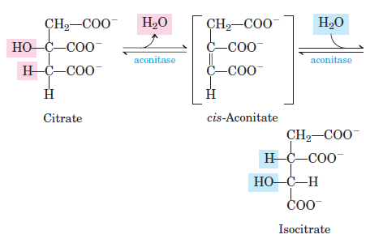

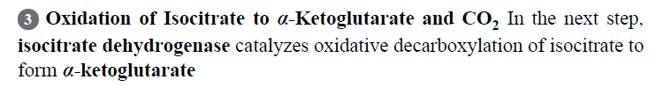

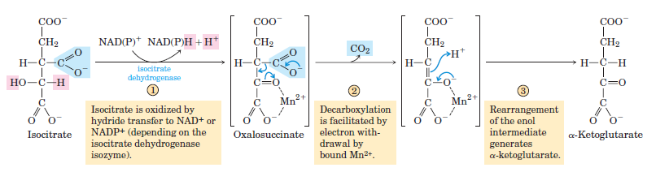

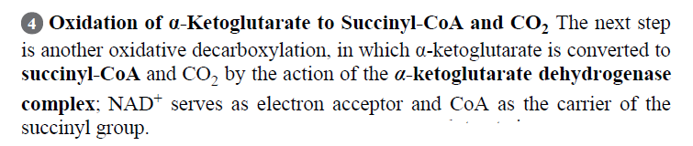

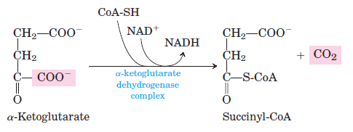

- α-ketoglutarate dehydrogenase complex (E₁+E₂+E₃) is similar to pyruvate dehydrogenase complex in both structure and function.

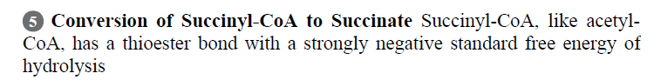

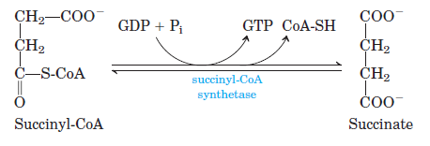

- A substrate-level phosphorylation occurs.
- The GTP formed by succinyl- CoA synthetase can donate its terminal phosphoryl group to ADP to form ATP, in a reversible reaction catalyzed by nucleoside diphosphate kinase.

GTP + ADP GDP + ATP

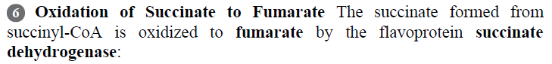

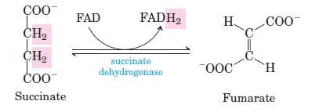

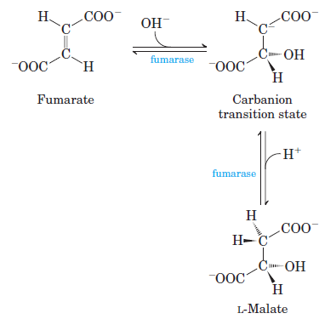

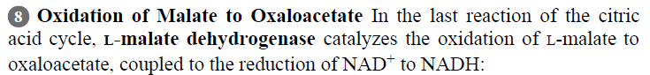

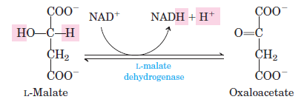

The Energy of Oxidations in the Cycle Is Efficiently Conserved
- The energy released by these oxidations was conserved in the reduction of 3 NAD⁺ and 1 FAD and the production of 1 ATP or GTP.
- At the end of the cycle a molecule of oxaloacetate was regenerated.
- Products of one turn of the citric acid cycle (Fig. 16-14).

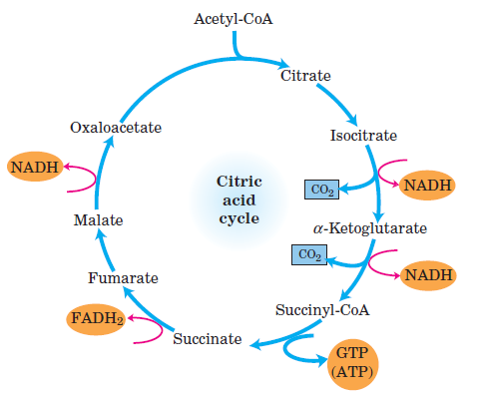

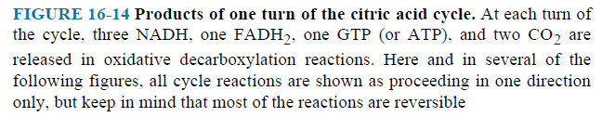

- 3 NADH, 1 FADH₂, 1 GTP (or ATP) and 2 CO₂ are released in the oxidative decarboxylation reactions of 1 acetyl-CoA.
- Stoichiometry of NADH, FADH₂ and ATP formation in the aerobic oxidation of 1 glucose
NADH FADH₂ ATP (or GTP) CO₂
Glycolysis 2 2
PDH Reaction 2 2
Citric Acid Cycle 6 2 2 4
- In oxidative phosphorylation,
- passage of two electrons from NADH to O₂ yields about 2.5 ATP
- passage of two electrons from FADH₂ to O₂ yields about 1.5 ATP
- After oxidative phosphorylation, 32 ATP are obtained per glucose.

Citric Acid Cycle Components Are Important Biosynthetic Intermediates
- Besides its role in the oxidative catabolism of carbohydrates, fatty acids, and amino acids, the cycle provides precursors for many biosynthetic pathways in anabolism (Fig. 16-16).

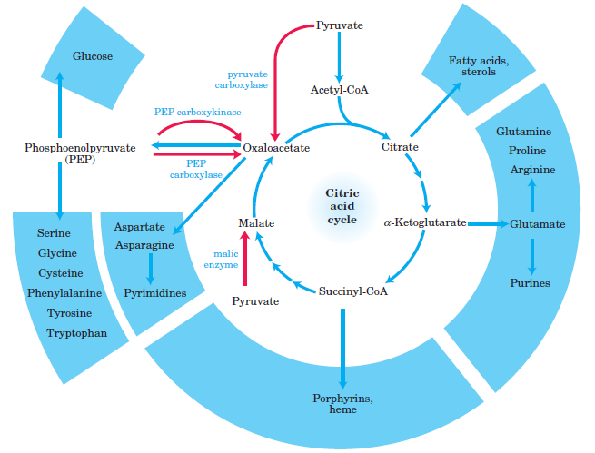

16.3 Regulation of the Citric Acid Cycle
- Pyruvate dehydrogenase complex of mammals
- is inhibited by ATP, acetyl-CoA, NADH and fatty acids
- is activated by AMP, CoA, NAD⁺ and Ca²⁺ (Fig. 16-19).
- The citric acid cycle is regulated at its three exergonic steps catalyzed by citrate synthase, isocitrate dehydrogenase and α-ketoglutarate dehydrogenase complex.
- Citrate synthase
- is inhibited by NADH, succinyl-CoA, citrate and ATP
- is activated by ADP (Fig. 16-19).
- Isocitrate dehydrogenase
- is inhibited by ATP
- is activated by Ca²⁺ and ADP (Fig. 16-19).
- α-ketoglutarate dehydrogenase complex
- is inhibited by succinyl-CoA and NADH
- is activated by Ca²⁺ (Fig. 16-19).

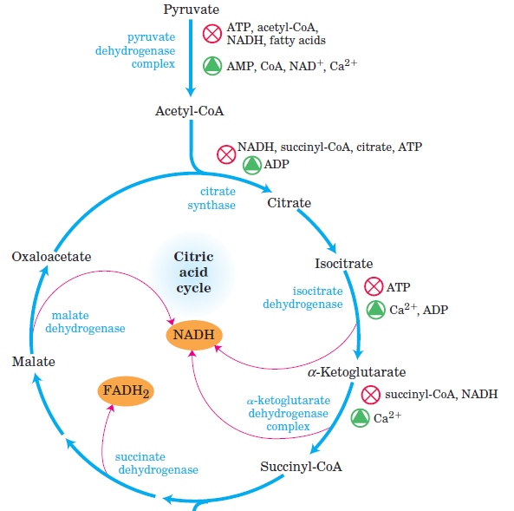
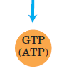
16.4 The Glyoxylate Cycle
- Conversion of phosphoenolpyruvate to pyruvate and of pyruvate to acetyl-CoA are irreversible.
- Phosphoenolpyruvate can be synthesized from oxaloacetate in gluconeogenesis.
- A cell or organism is unable to convert fuels or metabolites that are degraded to acetate (fatty acids and certain amino acids) into carbohydrates.
- In many organisms other than vertebrates, the glyoxylate cycle serves as a mechanism for converting acetate to carbohydrate.
- In plants, the pathway takes place in glyoxysomes (specialized peroxisomes).
- The glyoxylate cycle produces four-carbon compounds from acetate (Fig. 16-20).

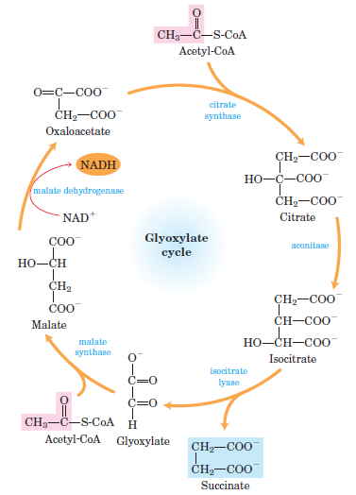
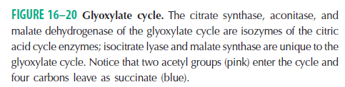

- Enzymes of the glyoxylate cycle catalyze the net conversion of acetate to succinate or other four-carbon intermediates of the citric acid cycle.
- Acetyl-CoA condenses with oxaloacetate to form citrate, and citrate is converted to isocitrate, exactly as in the citric acid cycle.
- The next step is not the breakdown of isocitrate by isocitrate dehydrogenase but the cleavage of isocitrate by isocitrate lyase, forming succinate and glyoxylate.
- The glyoxylate condenses with a second molecule of acetyl-CoA to yield malate by malate synthase.
- The malate is oxidized to oxaloacetate.
- Each turn of the glyoxylate cycle consumes two molecules of acetyl-CoA and produces one molecule succinate, available for biosynthetic purposes.
2 Acetyl-CoA + NAD⁺ succinate + 2 CoA + NADH + H⁺
- There is a relationship between the glyoxylate and citric acid cycle (Fig. 16-24).
- Succinate may be converted through fumarate and malate into oxaloacetate.
- Oxaloacetate is converted to phosphoenolpyruvate and thus to glucose by gluconeogenesis.
- Vertebrates do not have the enzymes specific to the glyoxylate cycle.
- They cannot bring about the net synthesis of glucose from (acetyl-CoA) lipids.
- Germinating seeds can convert the carbon of stored lipids into glucose.
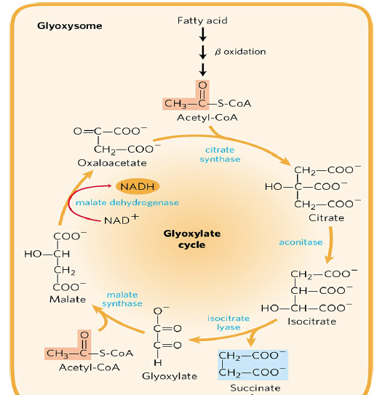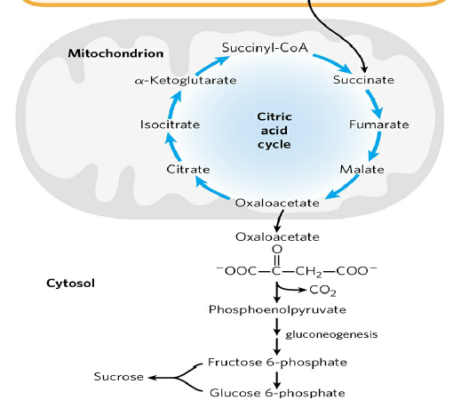
FIGURE 16-24 Relationship between the glyoxylate and citric acid cycles.

