Chapter 15 Principles of Metabolic Regulation
- Every pathway is inextricably intertwined with all the other cellular pathways (Fig. 15–1).

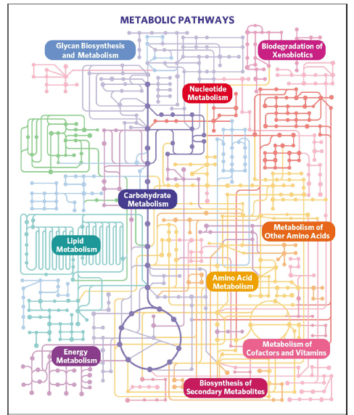

- A typical eukaryotic cell has the capacity to make about 30,000 different proteins
- they catalyze thousands of different reactions involving many hundreds of metabolites, most shared by more than one “pathway.”

15.1 Regulation of Metabolic Pathways
- Cells and organisms maintain a dynamic steady state.
- For each metabolic reaction in a pathway, the substrate is provided by the preceding reaction at the same rate at which it is converted to product.
- Both the amount and the catalytic activity of an enzyme can be regulated.
- Such changes occur on time scales from milliseconds to many hours, in response to signals from within or outside the cell.
- Various signals activate or inactivate transcription factors, which act in the nucleus to regulate gene expression.

15.3 Coordinated Regulation of Glycolysis and Gluconeogenesis
- Glycolysis and gluconeogenesis are different at the three points (Fig. 15–13).
- Three reactions of glycolysis are irreversible: those catalyzed by hexokinase, phosphofructokinase-1 and pyruvate kinase which play a regulatory role.

Hexokinase Isozymes of Muscle and Liver Are Affected Differently by Their Product, Glucose 6-Phosphate
- Hexokinase is a regulatory enzyme.
- Hexokinase isozymes are allosterically inhibited by their product, glucose 6-phosphate, so whenever the cellular concentration of glucose 6-phosphate rises above its normal level, these isozymes are inhibited.

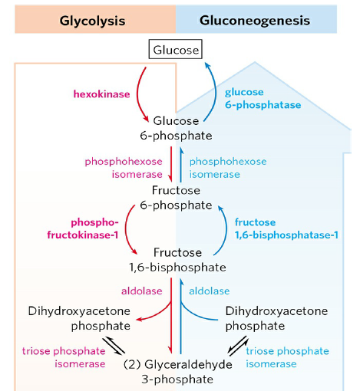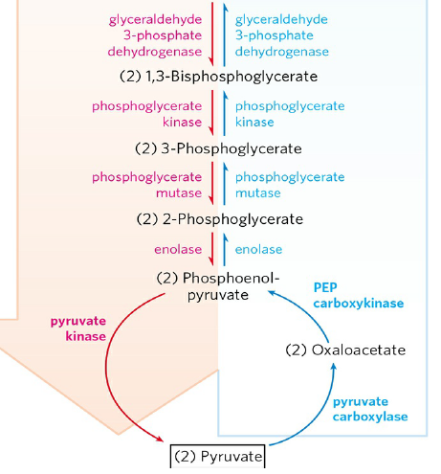

Phosphofructokinase-1 and Fructose 1,6-bisphosphatase Are Reciprocally Regulated
- PFK-1 has several regulatory sites at which allosteric activators or inhibitors bind.
- FBPase-1 is allosterically inhibited by AMP.
- Thus these opposing steps in the glycolytic and gluconeogenic pathways are regulated in a coordinated and reciprocal manner (Fig. 15–15).

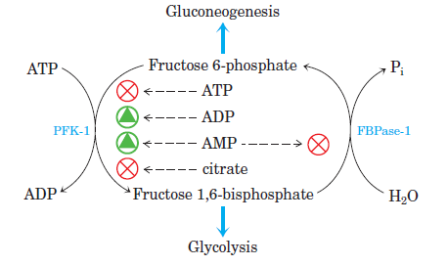
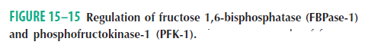

Fructose 2,6-Bisphosphate Is a Potent Allosteric Regulator of PFK-1 and FBPase-1
- The special role of liver in maintaining a constant blood glucose level requires additional regulatory mechanisms to coordinate glucose production and consumption.
- When the blood glucose level decreases, the hormone glucagon signals the liver to produce and release more glucose and to stop consuming it.
- When blood glucose is high, insulin signals the liver to use glucose.
- The rapid hormonal regulation of glycolysis and gluconeogenesis is mediated by fructose 2,6-bisphosphate.

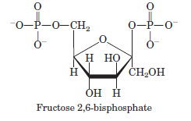

- It is an allosteric effector for the enzymes PFK-1 and FBPase-1 (Fig. 15–18c).
- Fructose 2,6-bisphosphate has the opposite effect on PFK-1 and FBPase-1.

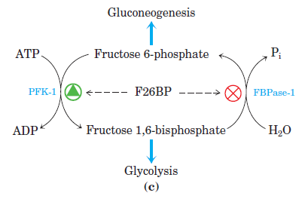

- It is formed by phosphorylation of fructose 6-phosphate, catalyzed by phosphofructokinase- 2 (PFK-2), and is broken down by fructose 2,6-bisphosphatase (FBPase-2) (Fig. 15–19a).
- PFK-2 and FBPase-2 are two separate enzymatic activities of a single, bifunctional protein.
- The balance of these two activities in the liver is regulated by glucagon and insulin (Fig. 15–19b).

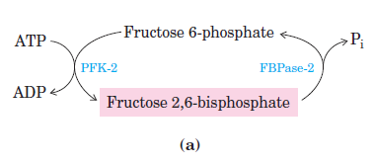
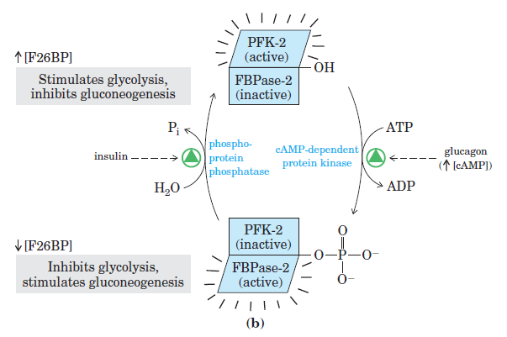

The Glycolytic Enzyme Pyruvate Kinase Is Allosterically Regulated
- ATP, acetyl-CoA, long-chain fatty acids and alanine allosterically inhibit and fructose 1,6- bisphosphate activities all isozymes of pyruvate kinase (Fig. 15–21).
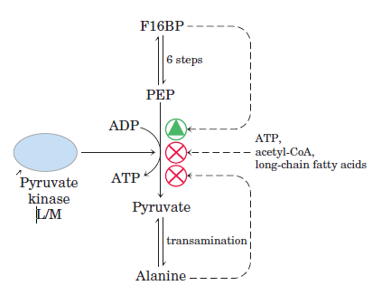

The Gluconeogenic Enzyme Pyruvate Carboxylase Is Allosterically Regulated
- Acetyl-CoA stimulates pyruvate carboxylase and inhibits pyruvate dehydrogenase (Fig. 15–22).
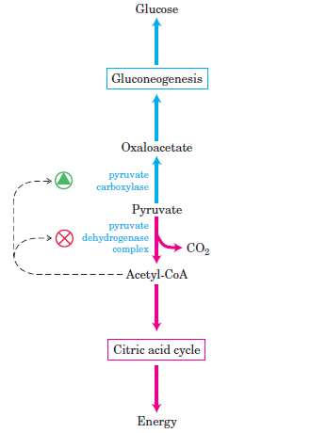

15.4 The Metabolism of Glycogen in Animals
- Glycogen is found primarily in the liver and skeletal muscle
- It may represent up to 10% of the weight of liver and 1% to 2% of the weight of muscle.
- The elementary particle of glycogen is about 21 nm in diameter and consists of up to 55,000 glucose residues with about 2,000 nonreducing ends.
- Liver glycogen can be depleted in 12 to 24 hours.
- Glycogen is also obtained in the diet and broken down in the gut, and this involves a separate set of hydrolytic enzymes that convert glycogen to free glucose.
- The breakdown of glycogen to glucose 1-phosphate is called glycogenolysis.
- The turn to synthesis of glycogen is called glycogenesis.

Glycogen Breakdown Is Catalyzed by Glycogen Phosphorylase
- Glycogen phosphorylase catalyzes glucose 1-phosphate from nonreducing end of glycogen having an (α1 4) glycosidic linkage (Fig. 15–27).

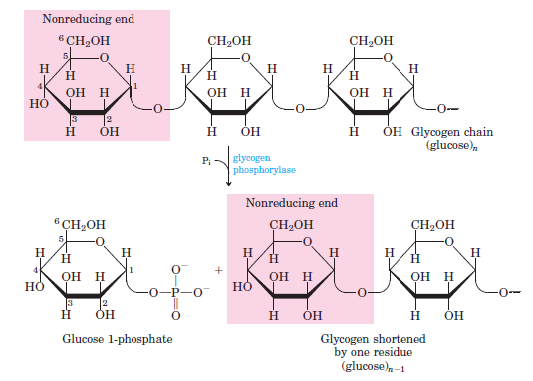

- Glycogen phosphorylase acts repetitively on the nonreducing ends of glycogen branches until it reaches a point four glucose residues away from an (α1 6) branch point (Fig. 15–28).
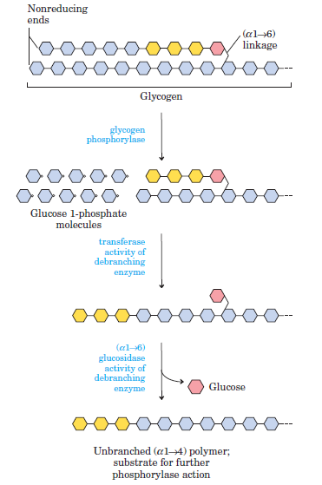

- Further degradation by glycogen phosphorylase can occur only after the debranching enzyme, formally known as (α1 6) to (α1 4) glucan-transferase, catalyzes two successive reactions that transfer branches.
- First, the transferase activity of the enzyme shifts a block of three glucose residues from the branch to a nearby nonreducing end, to which they are reattached in (α1 4) linkage.
- The single glucose residue remaining at the branch point, in (α1 6) linkage, is then released as free glucose by the debranching enzyme’s (α1 6) glucosidase activity.

Glucose 1-Phosphate Can Enter Glycolysis or, in Liver, Replenish Blood Glucose
- Glucose 1-phosphate is converted to glucose 6-phosphate by phosphoglucomutase.

- Glucose 6-phosphatase present in liver and kidney but not in other tissues. The enzyme is an integral membrane protein of the endoplasmic reticulum.
- Glucose 6- phosphate formed in the cytosol is transported into the ER lumen and hydrolyzed at the lumenal surface by the glucose 6- phosphatase. Glucose is carried back into the cytosol.

The Sugar Nucleotide UDP-Glucose Donates Glucose for Glycogen Synthesis
- The starting point for synthesis of glycogen is glucose 6-phosphate.
- To initiate glycogen synthesis, the glucose 6-phosphate is converted to glucose 1-phosphate by phosphoglucomutase.

- The glucose 1-phosphate is converted to UDP-glucose by UDP-glucose pyrophosphorylase.

- The transfer of the glucose residue from UDP-glucose to a nonreducing end of a branched glycogen molecule is catalyzed by glycogen synthase (Fig. 15–30).

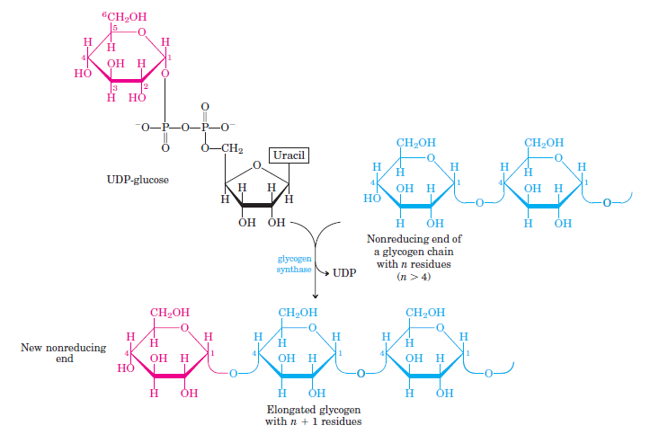

- Glycogen synthase cannot make the (α1 6) bonds found at the branch points of glycogen: these are formed by the glycogen-branching enzyme, also called amylo (1 4) to (1 6) transglycosylase, or glycosyl-(4 6) transferase.
- The glycogen-branching enzyme catalyzes transfer of a terminal fragment of 6 or 7 glucose residues from the nonreducing end of a glycogen branch having at least 11 residues (Fig. 15–31).

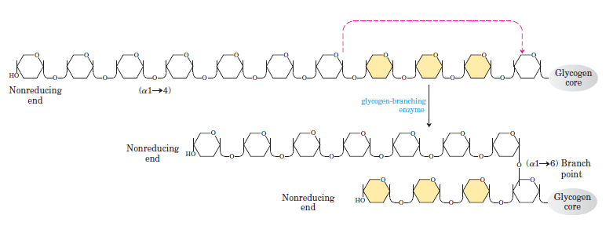

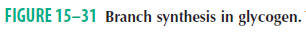

15.5 Coordinated Regulation of Glycogen Synthesis and Breakdown
- Glycogen phosphorylase is regulated allosterically and hormonally. The glycogen phosphorylase of skeletal muscle exists in two interconvertible forms: glycogen phosphorylase a, which is catalytically active, and glycogen phosphorylase b, which is less active (Fig. 15–34).

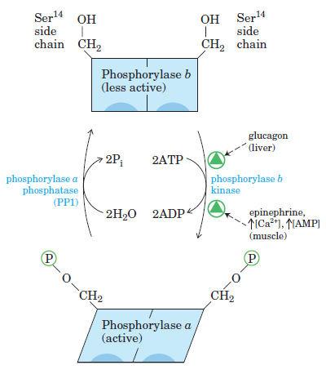

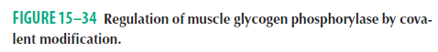

- Glycogen synthase is also regulated by phosphorylation and dephosphorylation. Its active form, glycogen synthase a, is unphosphorylated. Phosphorylation converts glycogen synthase a to glycogen synthase b, which is inactive (Fig. 15–36).

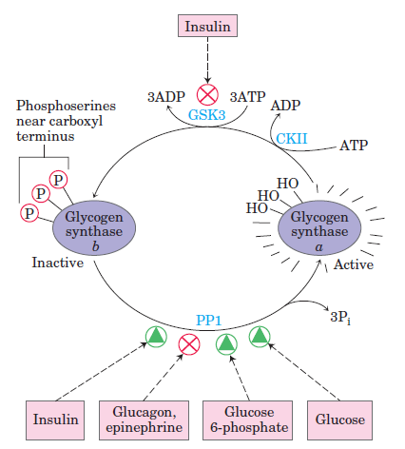

Figure 15-36. Regulation of glycogen synthase by covalent modification.

