Amino Acids, Peptides and Proteins
- Cells can produce proteins (enzymes, hormones, antibodies)
- with different properties and activities by joining the same 20 amino acids in many different combinations and sequences.
Amino Acids
- Proteins are polymers of amino acids.

Amino Acids Share Common Structural Features
- All 20 amino acids are α-amino acids.
- They have a carboxyl group and an amino group bonded to the same carbon atom (the α carbon).
- They differ from each other in their side chains (R groups),
- vary in structure, size and electric charge.
- The common amino acids of proteins have been assigned three-letter abbreviations and one-letter symbols (Table 3–1).
- The α carbon is bonded to four different groups (except glycine)
- a carboxyl group, an amino group, an R group and a hydrogen atom.
- is a chiral center.
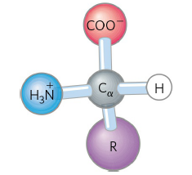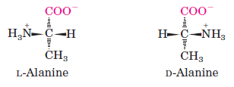
- All molecules with a chiral center are also optically active,
- rotate plane-polarized light.
The Amino Acid Residues in Proteins Are L Stereoisomers
- The term “residue” reflects the loss of the elements of water when one amino acid is joined to another.
- L stereoisomers rotate plane-polarized light to the left.
- D-amino acids residues have been found only in a few.
Amino Acids Can Be Classified by R Group
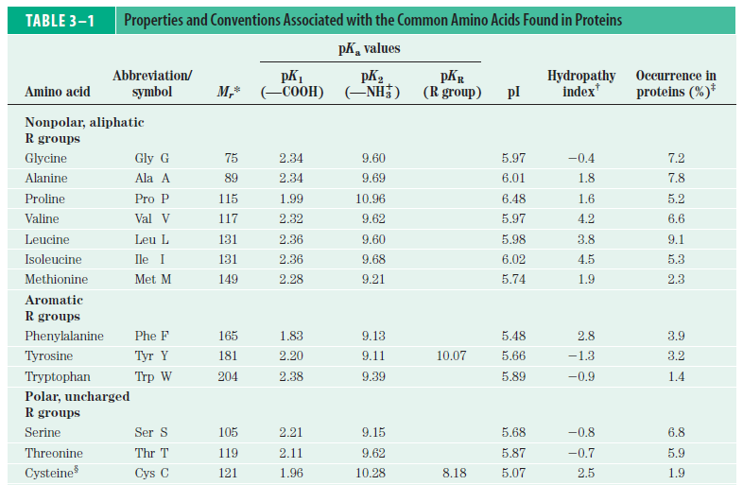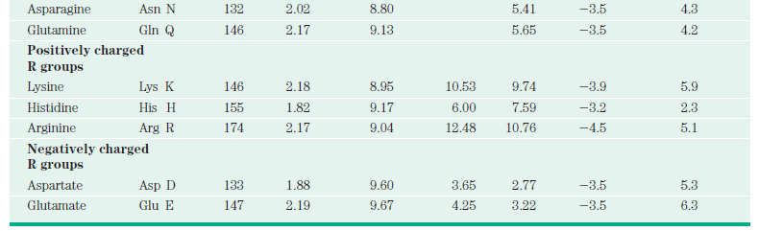

- They differ from each other in their side chains (R groups)
  - vary in structure, polarity, size, electric charge
  - are grouped into five classes (Fig. 3-5).
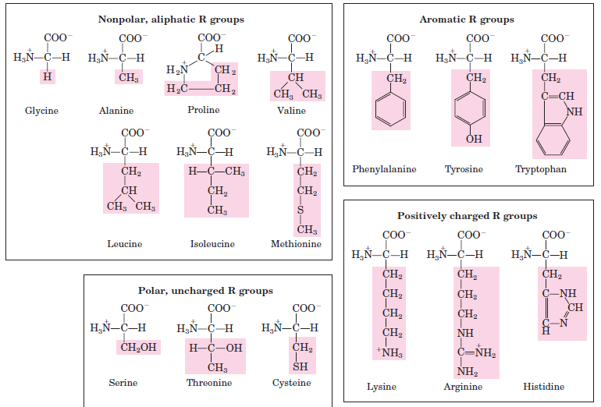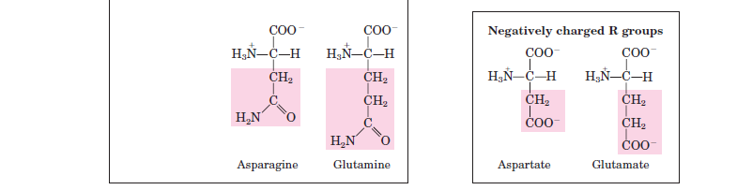

- Nonpolar, aliphatic R groups stabilize protein structure by hydrophobic interactions.
- proline has a distinctive cyclic structure.
- Aromatic R groups participate in hydrophobic interactions and hydrogen bonds
- absorb ultraviolet light at 280 nm.
- Polar, uncharged R groups form hydrogen bonds.
- cysteine is oxidized to form cystine by a disulfide bond (Fig. 3-7).

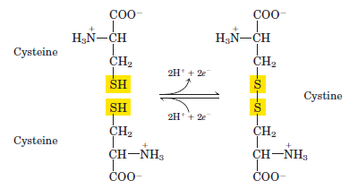

- Positively charged (basic) R groups participate in ionic interactions and hydrogen bonds.
- Negatively charged (asidic) R groups participate in ionic interactions and hydrogen bonds.

Uncommon Amino Acids Also Have Important Functions
- In addition to the 20 common amino acids, proteins may contain residues created by modification of common residues.
- some of them are 4-hydroxyproline, 5-hydroxylysine, ornithine, citrulline
- 300 additional amino acids have been found in cells.

Amino Acids Can Act as Acids and Bases
- When an amino acid lacking an ionizable R group is dissolved in water at neutral pH
- it exists as dipolar ion or zwitterion
- a zwitterion can act as either an acid or a base (Fig. 3-9).
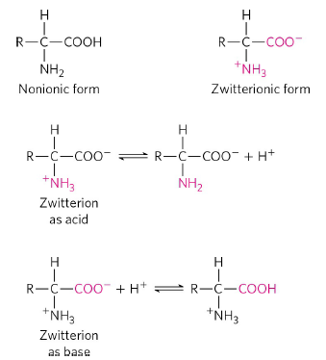
- Alanine, is a diprotic acid when fully protonated
- the —COOH group and the —NH₃⁺ group can yield protons.

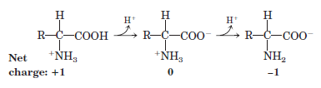
Amino Acids Differ in Their Acid-Base Properties
- Amino acids with an ionizable R group have more complex titration curves.

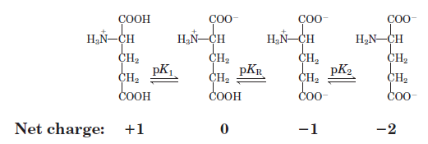

- Only histidine has an R group (pKa = 6.0) providing significant buffering power near the neutral pH
- usually found in the intracellular and extracellular fluids of most animals and bacteria.
Peptides and Proteins
- Peptides and proteins are polymers of amino acids.

Peptides Are Chains of Amino Acids
- Two amino acids are covalently joined
- peptide bond is formed to yield a dipeptide (Fig. 3-13).
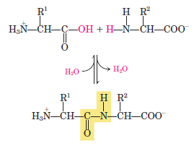

- When a few amino acids are joined, the structure is called an oligopeptide.
- When many amino acids are joined, the product is called a polypeptide.
- The structure of a pentapeptide is shown in (Fig. 3-14).
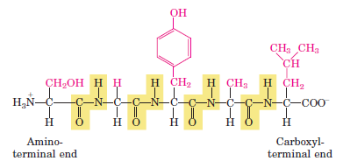
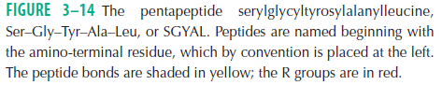

- In a peptide
- the amino acid residue at the end with a free amino group is the amino-terminal (or N-terminal) residue
- the residue at the other end, which has a free carboxyl group, is the carboxyl-terminal (C-terminal) residue.
- The amino-terminal end is placed on the left, the carboxyl-terminal end on the right.
- The sequence is read left to right, beginning with the amino-terminal end.

Biologically Active Peptides and Polypeptides Occur in a Vast Range of Sizes and Compositions
- Naturally occurring peptides range in length from two to many thousands of amino acid residues (Table 3-2).
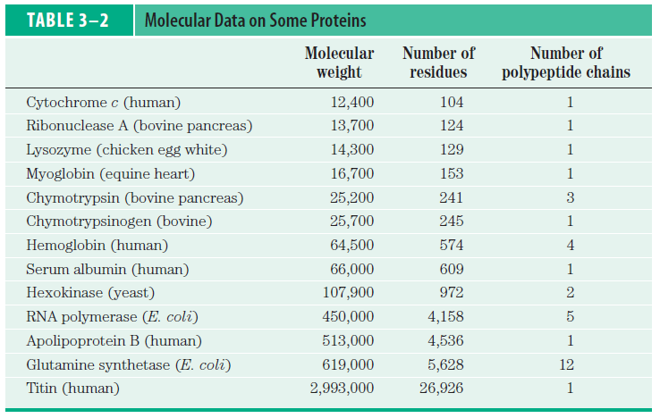
- Even the smallest peptides can have biologically important effects.
- for example, a number of hormones are small peptides (oxytocin -nine amino acid residues).
- Some proteins
- consist of a single polypeptide chain
- have two or more polypeptides (multisubunit proteins) (Table 3-2).
- The amino acid composition of proteins is also highly variable (Table 3-3).
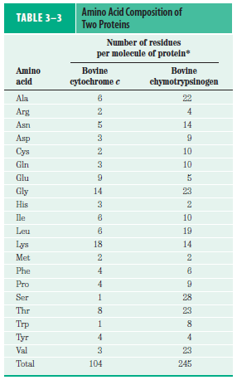

Some Proteins Contain Chemical Groups Other Than Amino Acids
- These are called conjugated proteins.
  - chemical group is called its prosthetic group
- Conjugated proteins are classified on the basis of the chemical nature of their prosthetic groups (Table 3-4). For example,
  - lipoproteins contain lipids,
  - glycoproteins contain sugar groups,
  - metalloproteins contain a specific metal.
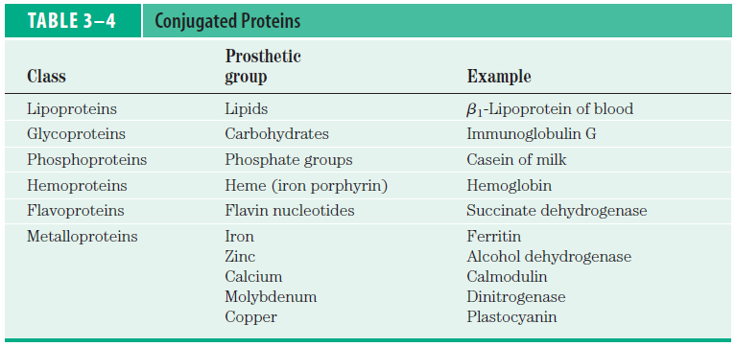
- Some proteins contain more than one prosthetic group.
- Usually the prosthetic group plays an important role in the protein’s biological function.

3.4 The Structure of Proteins: Primary Structure
- There are several levels of protein structure (Fig. 3-23).
- primary structure consists of a sequence of amino acids by peptide and disulfide bonds (covalent bonds).
- secondary structure refers coiled primary structure by H bonds.
- tertiary structure describes three-dimensional folding by noncovalent interactions.
- quaternary structure refers noncovalent interactions and disulfide bonds of two or more polypeptide subunits having tertiary structure.
