Chapter 17 Fatty Acid Catabolism

- The oxidation of long-chain fatty acids to acetyl-CoA is a central energy-yielding pathway in many organisms and tissues.
- In mammalian heart and liver, it provides as much as 80% of the energetic needs under all physiological circumstances.
- The electrons removed from fatty acids during oxidation pass through the respiratory chain, driving ATP synthesis.
- The acetyl-CoA produced from the fatty acids may be completely oxidized to CO₂ in the citric acid cycle, resulting in further energy conservation.
- Triacylglycerols (also called triglycerides or neutral fats) are suitable as storage fuels.
- The long alkyl chains of fatty acids are essentially hydrocarbons and have an energy more than twice that for the same weight of carbohydrate or protein.

17.1 Digestion, Mobilization and Transport of Fats

- Cells can obtain fatty acid fuels from three sources:
- fats consumed in the diet,
- fats stored in cells as lipid droplets,
- fats synthesized in one organ for export to another.

Dietary Fats Are Absorbed in the Small Intestine
- Triacylgycerols (Fig. 10-2) are degraded to fatty acids and glycerols by intestinal lipases.
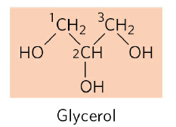
R-COOH
Fatty acid
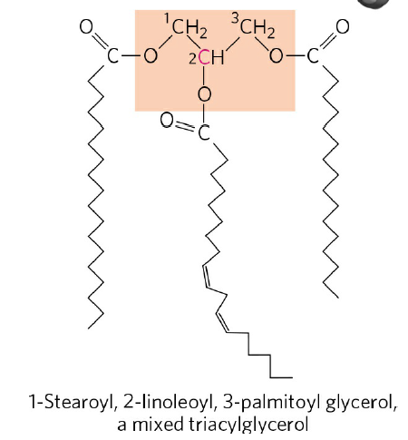

FIGURE 10-2 The mixed triacylglycerol shown here has three different fatty acids attached to the glycerol backbone.

- The fatty acids are packaged and delivered to muscle and adipose tissues by blood.
- In muscle, the fatty acids are oxidized for energy.
- In adipose tissue, they are reesterified for storage as triacylglycerols.
- The glycerols enter into the glycolytic pathway (Fig. 17-4).

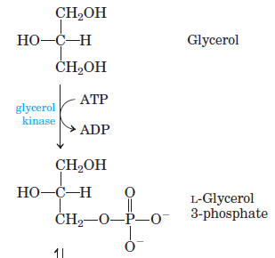
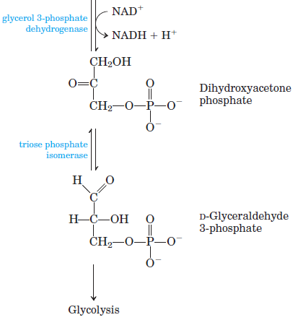

Fatty Acids Are Activated and Transported into Mitochondria
- The enzymes of fatty acid oxidation in animal cells are located in the mitochondrial matrix.
- The fatty acids with chain lengths of 12 or fewer carbons enter mitochondria without the help of membrane transporters.
- Those with 14 or more carbons cannot pass directly through the mitochondrial membranes and three enzymatic reactions are required to transport into mitochondria.
- The first reaction is catalyzed by fatty acyl-CoA synthetase present in the outer mitochondrial membrane. Fatty acyl–CoA esters are formed at the cytosolic side of the outer mitochondrial membrane (Fig. 17-5).
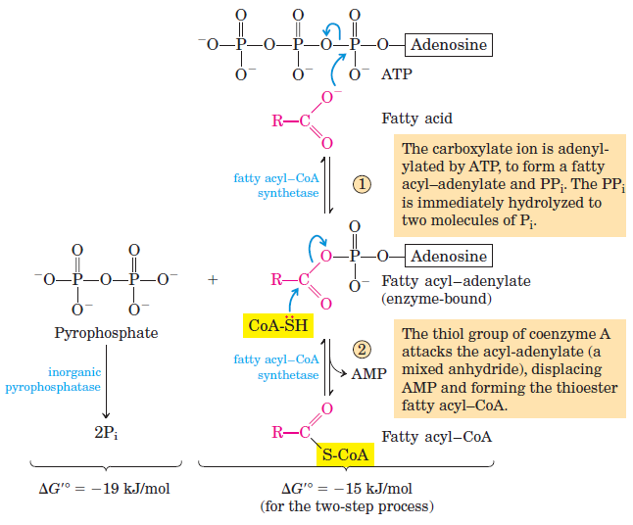
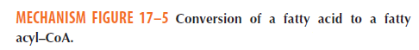
Fatty acid + CoA + ATP fatty acyl-CoA + AMP + 2 P_{i}
- The second reaction is catalyzed by carnitine acyltransferase I. Fatty acyl–carnitine is formed at the outer membrane or in the intermembrane space (Fig. 17-6).

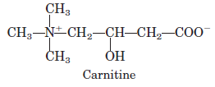

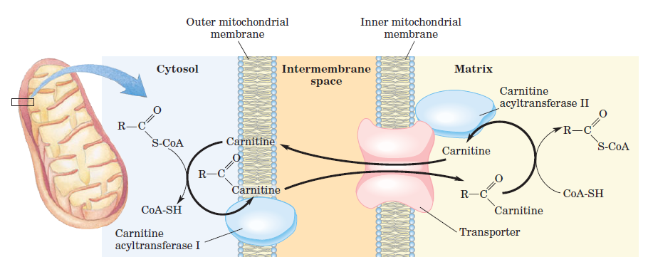
- The fatty acyl-carnitine enters the matrix by acyl-carnitine/carnitine transporter of the inner mitochondrial membrane (Fig. 17-6).
- The third reaction is regeneration of fatty acyl-CoA by carnitine acyltransferase II on the inner face of the inner mitochondrial membrane (Fig. 17-6).
- Carnitine reenters the intermembrane space via the acyl-carnitine/carnitine transporter (Fig. 17-6).
17.2 Oxidation of Fatty Acids
- Mitochondrial oxidation of fatty acids takes place in three stages (Fig. 17-7).
Stage 1: A long-chain fatty acid is oxidized to yield acetyl residues in the form of acetyl-CoA, starting from the carboxyl end. This process is called β oxidation. For example, the 16-carbon palmitic acid undergoes seven passes, in each pass losing two carbons as acetyl-CoA. At the end of seven cycles, the last four carbons of palmitate give two acetyl-CoA. The overall result is the conversion of the 16-carbon chain of palmitate to 8 acetyl-CoA and production of 7 FADH₂ and 7 NADH.

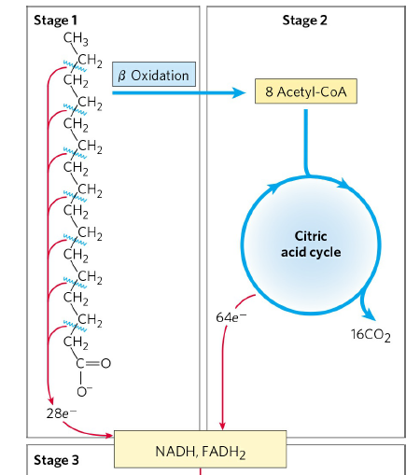
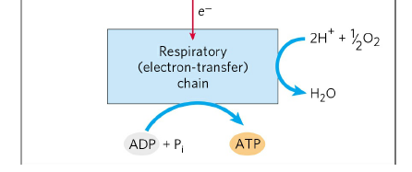

Stage 2: The acetyl groups are oxidized to CO₂ via the citric acid cycle.
Stage 3: Electrons derived from the oxidations of stage 1 and 2 pass to O₂ via the mitochondrial respiration chain, providing the energy for ATP synthesis by oxidative phosphorylation.
- The energy released by fatty acid oxidation is thus conserved as ATP.

The β Oxidation of Saturated Fatty Acids Has Four Basic Steps

- Dehydration of fatty acyl-CoA by acyl-CoA dehydrogenase (Fig. 17-8a)
- Water is added to the double bond by enoyl-CoA hydratase (Fig. 17-8a)
- Dehydration of β-hydroxyacyl-CoA by β-hydroxyacyl-CoA dehydrogenase (Fig. 17-8a)
- Production of acetyl-CoA by acyl-CoA acetyltransferase (thiolase) (Fig. 17-8a)

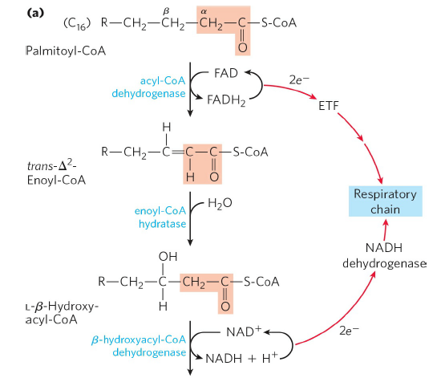
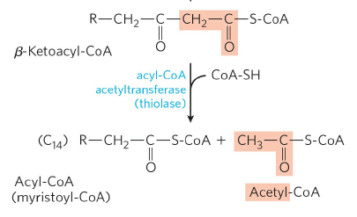
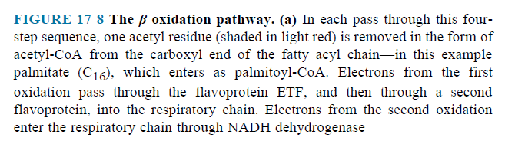

The Four β-Oxidation Steps Are Repeated to Yield Acetyl-CoA and ATP
- Seven passes through the β-oxidation sequence are required to oxidize one molecule of palmitoyl-CoA to eight molecules of acetyl-CoA (Fig. 17-8b).
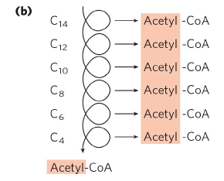

FIGURE 17-8 (b) Six more passes through the β-oxidation pathway yield seven more molecules of acetyl-CoA, the seventh arising from the last two carbon atoms of the 16- carbon chain. Eight molecules of acetyl-CoA are formed in all. The acetyl-CoA may be oxidized in the citric acid cycle, donating more electrons to the respiratory chain.
- The overall equation is
Palmitoyl-CoA + 7 FAD + 7 NAD⁺ + 7 H₂O + 7 CoA

8 Acetyl-CoA + 7 FADH₂ + 7 NADH + 7 H⁺

Acetyl-CoA Can Be Further Oxidized in the Citric Acid Cycle
- 1 Acetyl-CoA produces 3 NADH, 1 FADH₂ and 1 GTP (or ATP).
- 8 Acetyl-CoA produce 24 NADH, 8 FADH₂ and 8 GTP (or ATP).
- 1 Palmitoyl-CoA produces 31 NADH, 15 FADH₂ and 8 GTP (or ATP).
- 31 NADH produce 77.5 ATP and 15 FADH₂ produce 22.5 ATP. Total ATP is 108.
- Remember, 1 ATP was used at activation of fatty acid.
- Because the activation of palmitate to palmitoyl- CoA breaks both phosphoanhydride bonds in ATP, the energetic cost of activating a fatty acid is equivalent to two ATP, and the net gain per molecule of palmitate is 106 ATP.
Oxidation of Monounsaturated Fatty Acids Requires One Additional Reaction
- Oleate is an 18-carbon monounsaturated fatty acid with a cis double bond between C-9 and C-10.
- Oleoyl-CoA undergoes three passes through the fatty acid oxidation cycle to yield three molecules of acetyl-CoA (Fig. 17- 10).
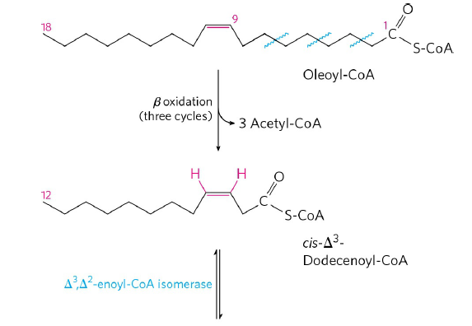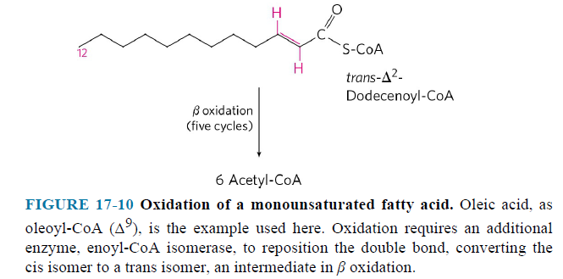

- 12-carbon unsaturated fatty acid cannot serve as a substrate for enoyl-CoA hydratase, which acts only on trans double bonds.
- Enoyl-CoA isomerase isomerizes the cis-enoyl-CoA to the trans-enoyl-CoA.
- This intermediate is now acted upon by the remaining enzymes of β oxidation to yield acetyl-CoA.
- Altogether, nine acetyl-CoAs are produced from one molecule of the 18-carbon oleate.
Complete Oxidation of Odd-Number Fatty Acids Requires Three Extra Reactions
- Long-chain odd-number fatty acids are oxidized in the same pathways as the even-number fatty acids. For example, 17-carbon
- at the last pass, fatty acyl-CoA has five carbon atoms.
- the products are acetyl-CoA and propionyl-CoA.
- the acetyl-CoA can be oxidized in the citric acid cycle, but propionyl-CoA enters a different pathway having three enzymes (Fig. 17-12).
- Carboxylation of propionyl-CoA
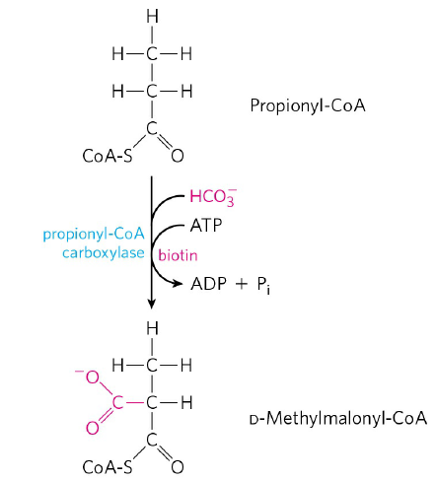
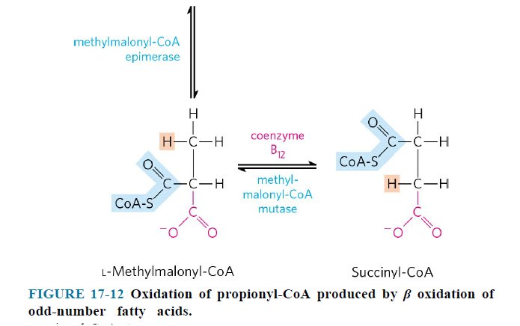

- Epimerization of D-Methylmalonyl-CoA
- Production of succinyl-CoA which can enter the citric acid cycle
- 17-carbon fatty acid gives 2 NADH less than 16-carbon fatty acid.
Fatty Acid Oxidation is Regulated
- Carnitine acyltransferase 1 is inhibited by malonyl-CoA.
- β-hydroxyacyl-CoA dehydrogenase is inhibited by [NADH/NAD⁺] ratio.
- Thiolase is inhibited by high concentrations of acetyl-CoA.

17.3 Ketone Bodies

- In humans and most other mammals, acetyl-CoA formed in the liver during oxidation of fatty acids
- can enter the citric acid cycle or
- can be converted the ketone bodies (acetoacetate, acetone and β-hydroxybutyrate) (Fig. 17-18).

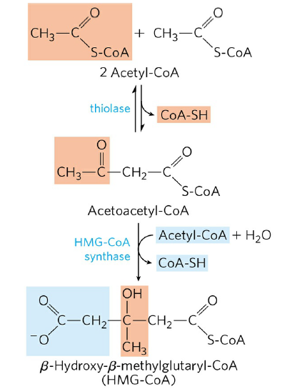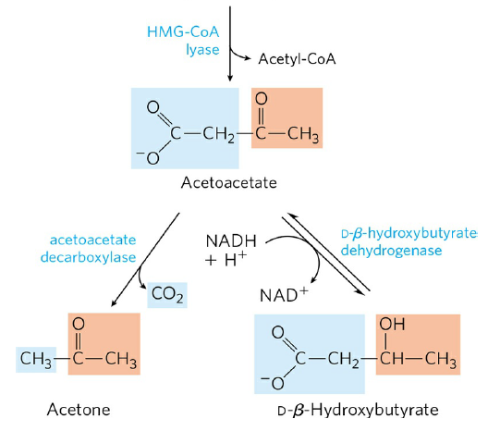
FIGURE 17-18 Formation of ketone bodies from acetyl-CoA.
- Acetoacetate and β-hydroxybutyrate are transported by the blood to tissues as fuels.
- They are converted to acetyl-CoA (Fig. 17-20).

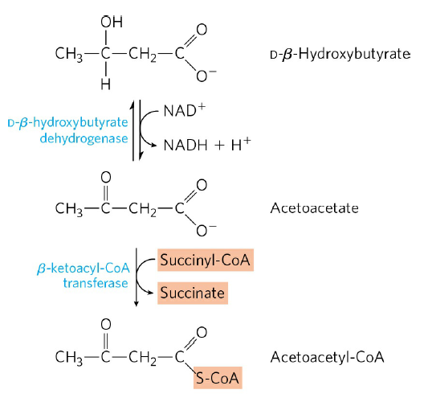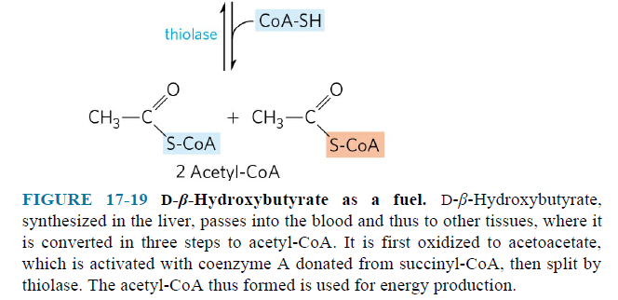
- Liver does not have β-ketoacyl-CoA transferase.
- Acetyl-CoAs are oxidized in the citric acid cycle to provide much of the energy required by tissues such as skeletal and heart muscle, kidney and brain.

