Glutamine Transports Ammonia in the Blood
- Ammonia is toxic to animal tissues.
- In most animals, much of the free ammonia is converted to a nontoxic compound.
- The free ammonia is combined with glutamate to yield glutamine by the action of glutamine synthetase (Fig. 18-8).
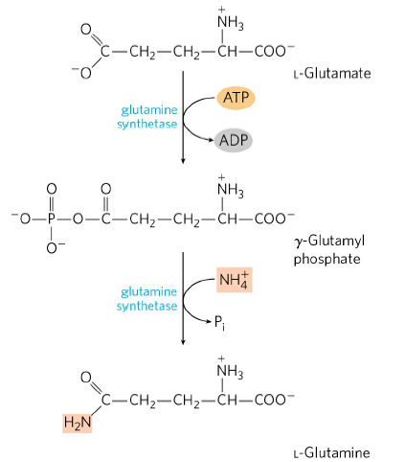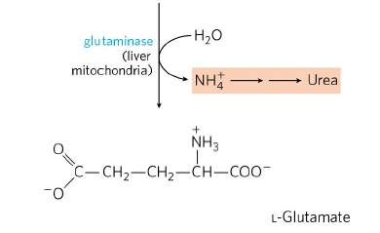
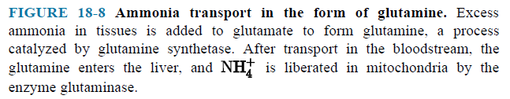

Alanine Transports Ammonia from Skeletal Muscles to the Liver
- Alanine plays a special role in transporting amino groups to the liver in a nontoxic form, via a pathway called the glucose-alanine cycle (Fig. 18–9).
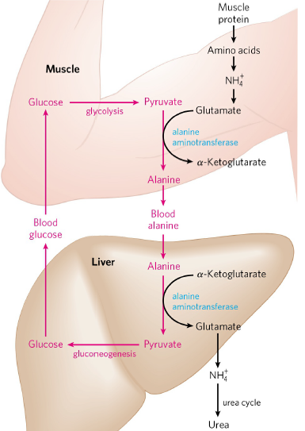
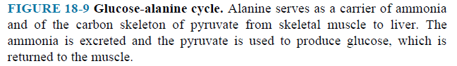
- In muscle, amino acids are degraded for fuel. Amino groups are collected in the form of glutamate.
- Glutamate can transfer its α-amino group to pyruvate. Alanine is formed.
- The alanine passes into the blood and travels to the liver.
- The amino group is transferred from alanine to α-ketoglutarate, forming pyruvate and glutamate.
- The pyruvate, in the liver, is converted to glucose, which is transported back to muscle as part of the glucose alanine cycle.
- Glutamate can enter mitochondria, where the glutamate dehydrogenase reaction releases NH₄⁺. NH₄⁺ is converted to urea by urea cycle.
- Glutamate can undergo transamination with oxaloacetate to form aspartate.

