Electron Carriers Function in Multienzyme Complexes
- The electron carriers of the respiratory chain are organized into membrane-embedded supramolecular complexes.
- The inner mitochondrial membrane has four electron carrier complexes (Table 19-3).

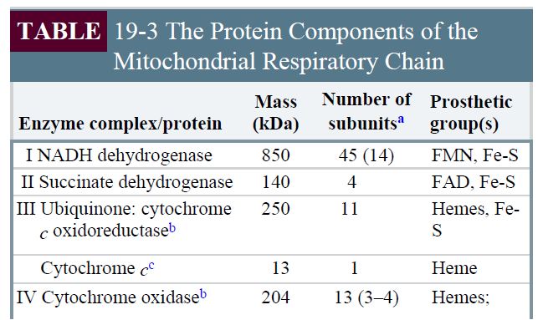

- Complex I catalyzes electron transfer to ubiquinone from NADH. (Fig. 19-8).
- It is also called NADH:ubiquinone oxidoreductase or NADH dehydrogenase.
- It contains an FMN and at least six iron-sulfur centers.
- It moves protons from the matrix to the intermembrane space.

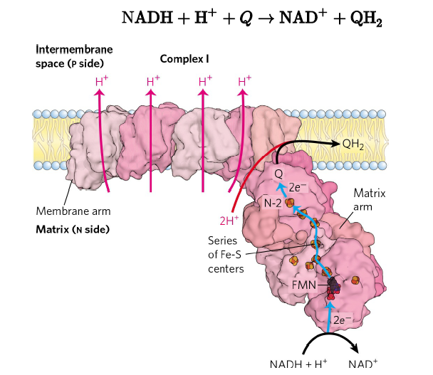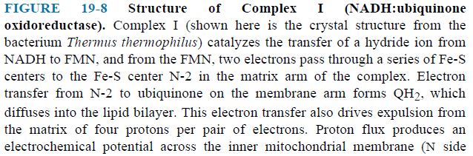

- Complex II catalyzes electron transfer to ubiquinone from succinate (FADH₂) (Fig. 19-9).
- It is also called succinate dehydrogenase, the only membrane-bound enzyme in the citric acid cycle.
- It contains an FAD and three iron-sulfur centers.
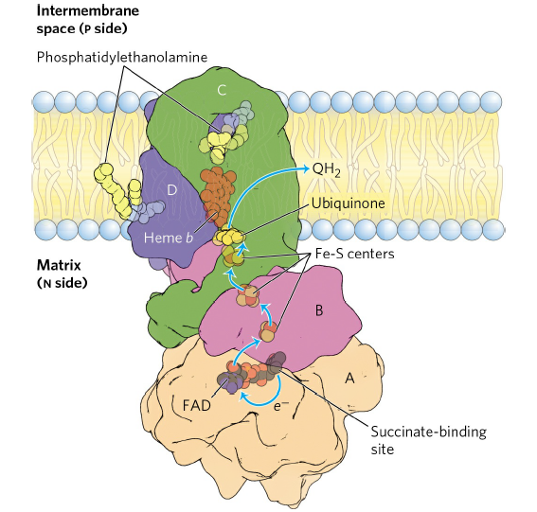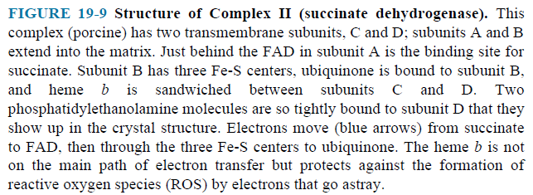

- Other substrates pass electrons into the respiratory chain at the level of ubiquinone (Fig. 19-15).
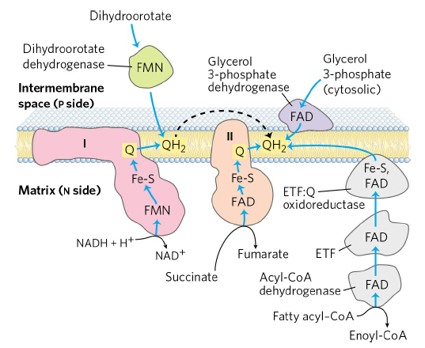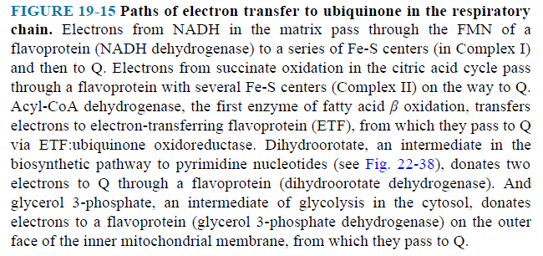
- The first step in the β oxidation of fatty acyl–CoA, catalyzed by the acyl-CoA dehydrogenase, involves transfer of electrons from the substrate to the FAD of the dehydrogenase, then to electron-transferring flavoprotein (ETF), which in turn passes its electrons to ETF:ubiquinone oxidoreductase. This enzyme transfers electrons into the respiratory chain by reducing ubiquinone.
- Glycerol 3-phosphate, formed either from glycerol released by triacylglycerol breakdown or by the reduction of dihydroxyacetone phosphate from glycolysis, donates electrons to a glycerol 3-phosphate dehydrogenase on the outer face of the inner mitochondrial membrane, from which they pass to Q.
- Complex III carries electrons from reduced ubiquinone to cytochrome c. (Fig. 19-10).
- It is also called cytochrome bc₁ complex or ubiquinone:cytochrome c oxidoreductase.
- It contains six hemes and two iron-sulfur centers.
- It moves protons from the matrix to the intermembrane space.

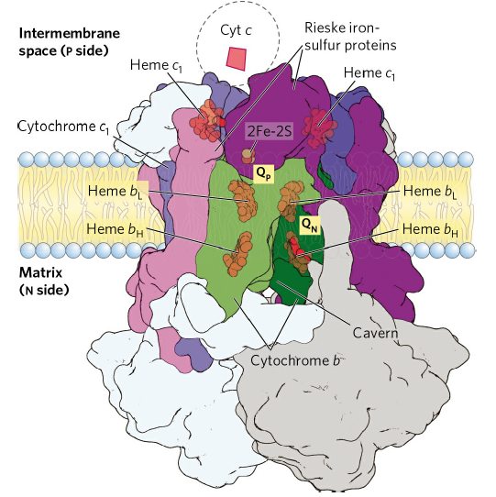

- Cytochrome c is a soluble protein of the intermembrane space.
- After its single heme accepts an electron from Complex III, cytochrome c moves to Complex IV to donate the electron to a copper center.
- Complex IV, also called cytochrome oxidase, carries electrons from cytochrome c to molecular oxygen, reducing it to H₂O. (Fig. 19-13).
- It contains two hemes and three Cu ions.
- It moves protons from the matrix to the intermembrane space.
