RNA Metabolism
- All RNA molecules except the RNA genomes of certain viruses are derived from information permanently stored in DNA.
- During transcription, an enzyme system converts the genetic information in a segment of double-stranded DNA into an RNA strand with a base sequence complementary to one of the DNA strands.
- Three major kinds of RNA are produced.
- Messenger RNAs (mRNAs) encode the amino acid sequence of one or more polypeptides speciﬁed by a gene or set of genes.
- Transfer RNAs (tRNAs) read the information encoded in the mRNA and transfer the appropriate amino acid to a growing polypeptide chain during protein synthesis.
- Ribosomal RNAs (rRNAs) are constituents of ribosomes that synthesize proteins.
- During replication the entire chromosome is usually copied, but transcription is more selective.
- Only particular genes or groups of genes are transcribed at any one time, and some portions of the DNA genome are never transcribed.
- Speciﬁc regulatory sequences mark the beginning and end of the DNA segments to be transcribed and designate which strand in duplex DNA is to be used as the template.

DNA-Dependent Synthesis of RNA
- Transcription has initiation, elongation, and termination phases.
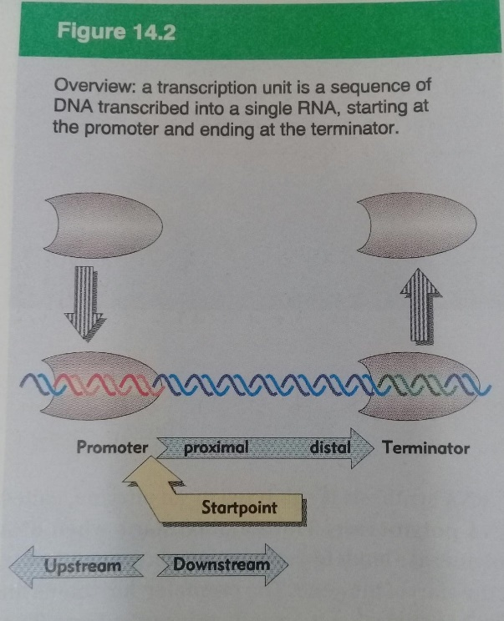
RNA Is Synthesized by RNA Polymerases
- E. coli RNA polymerase helped to define the fundamental properties of transcription.
- DNA-dependent RNA polymerase requires, in addition to a DNA template, all four ribonucleoside 5’-triphosphates (ATP, GTP, UTP, and CTP) as precursors of the nucleotide units of RNA (Fig. 26–1a).
- RNA polymerase elongates an RNA strand by adding ribonucleotide units to the 3’- hydroxyl end, building RNA in the 5’ 3’ direction.
- The overall reaction is
(NMP)_{n} + NTP (NMP)_{n+1} + PP_{i}
RNA Lengthened RNA
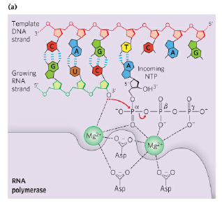
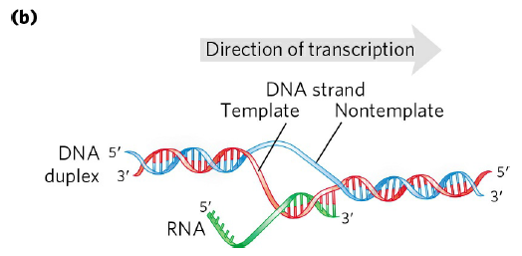
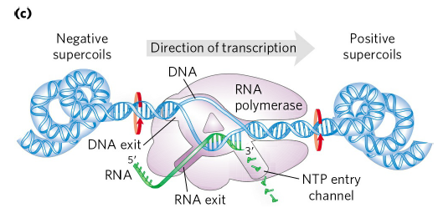

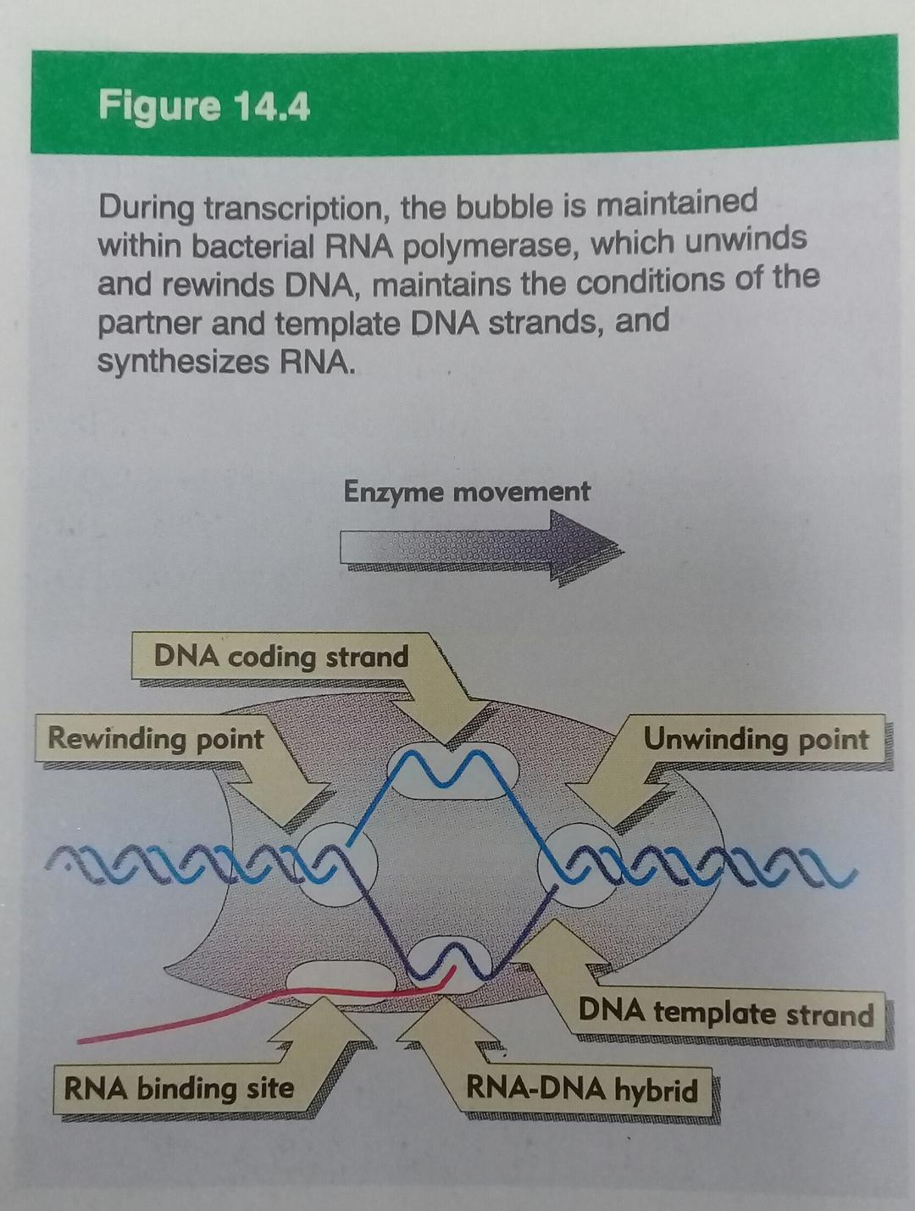
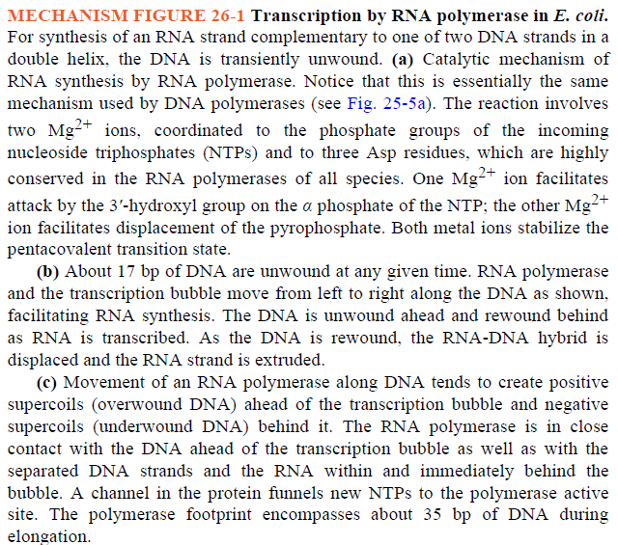

- The two complementary DNA strands have different roles in transcription (Fig. 26–1b).
- The strand that serves as template for RNA synthesis is called the template strand.
- The DNA strand complementary to the template, the nontemplate strand, or coding strand,
  - is identical in base sequence to the RNA transcribed from the gene, with U in the RNA in place of T in the DNA (Fig. 26–2).

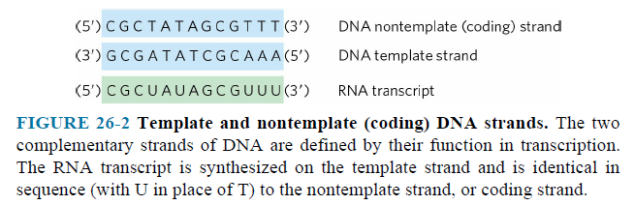
- The coding strand for a particular gene may be located in either strand of a given chromosome (Fig. 26–3).
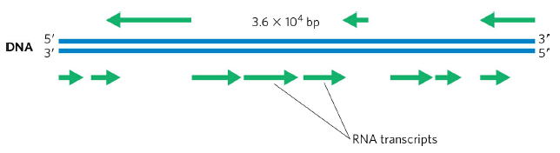
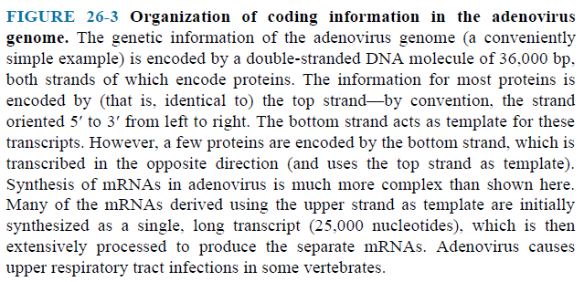

- The template DNA strand is copied in the 3’ 5’ direction (antiparallel to the new RNA strand).
- Each nucleotide in the newly formed RNA is selected by base-pairing interactions; U residues are inserted in the RNA to pair with A residues in the DNA template, G residues are inserted to pair with C residues, and so on.
- Unlike DNA polymerase, RNA polymerase does not require a primer to initiate synthesis.
- Initiation occurs when RNA polymerase binds at specific DNA sequences called promoters.
- During the elongation phase of transcription, the growing end of the new RNA strand base-pairs temporarily with the DNA template to form a short hybrid RNA-DNA double helix, estimated to be 8 bp long (Fig. 26–1b).
- Elongation of a transcript by E. coli RNA polymerase proceeds at a rate of 50 to 90 nucleotides/s.
- The DNA-dependent RNA polymerase of E. coli is a large, complex enzyme with ﬁve core subunits (α₂ββ'ω) and a sixth subunit, one of a group designated σ.
- The σ subunit binds transiently to the core and directs the enzyme to speciﬁc binding sites on the DNA.
- These six subunits constitute the RNA polymerase holoenzyme (Fig. 26–4).
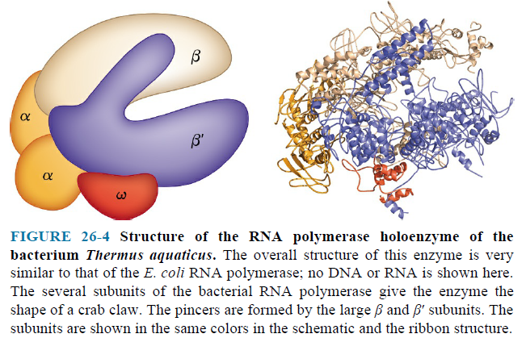
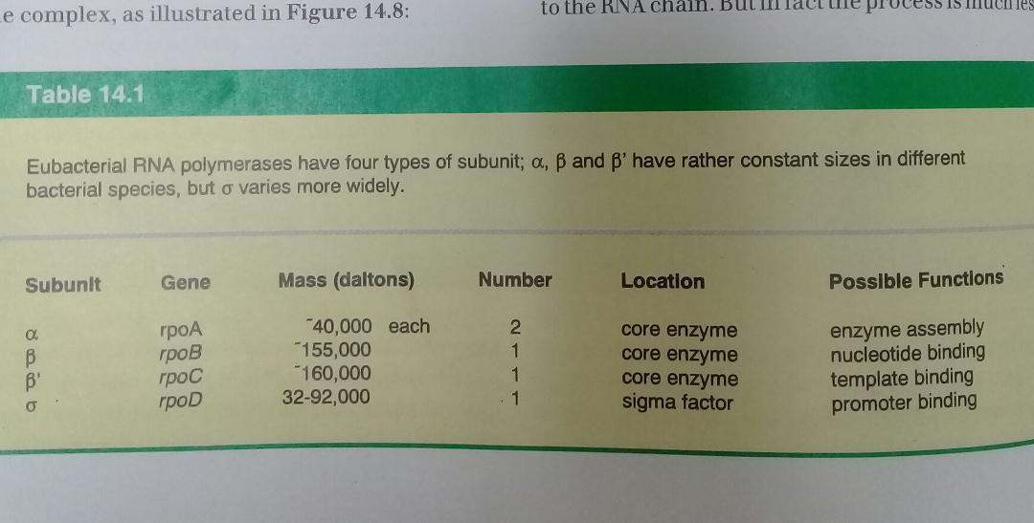

RNA Synthesis Begins at Promoters
- RNA polymerase binds to speciﬁc sequences in the DNA called promoters.
- The promoter region extends between positions -70 and +30.
- Bacterial promoters have similarities in two short sequences centered about positions -10 and -35.
- These sequences of the nontemplate strand, read in the 5’ 3’ direction, are important interaction sites for the σ subunit (Fig. 26–5).
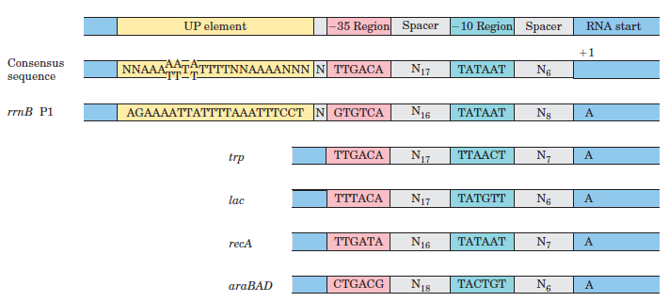
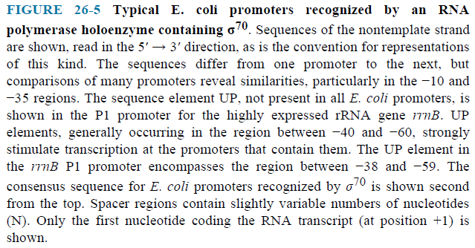
- The consensus sequence at the -10 region is (5’)TATAAT(3’); the consensus sequence at the -35 region is (5’)TTGACA(3’).
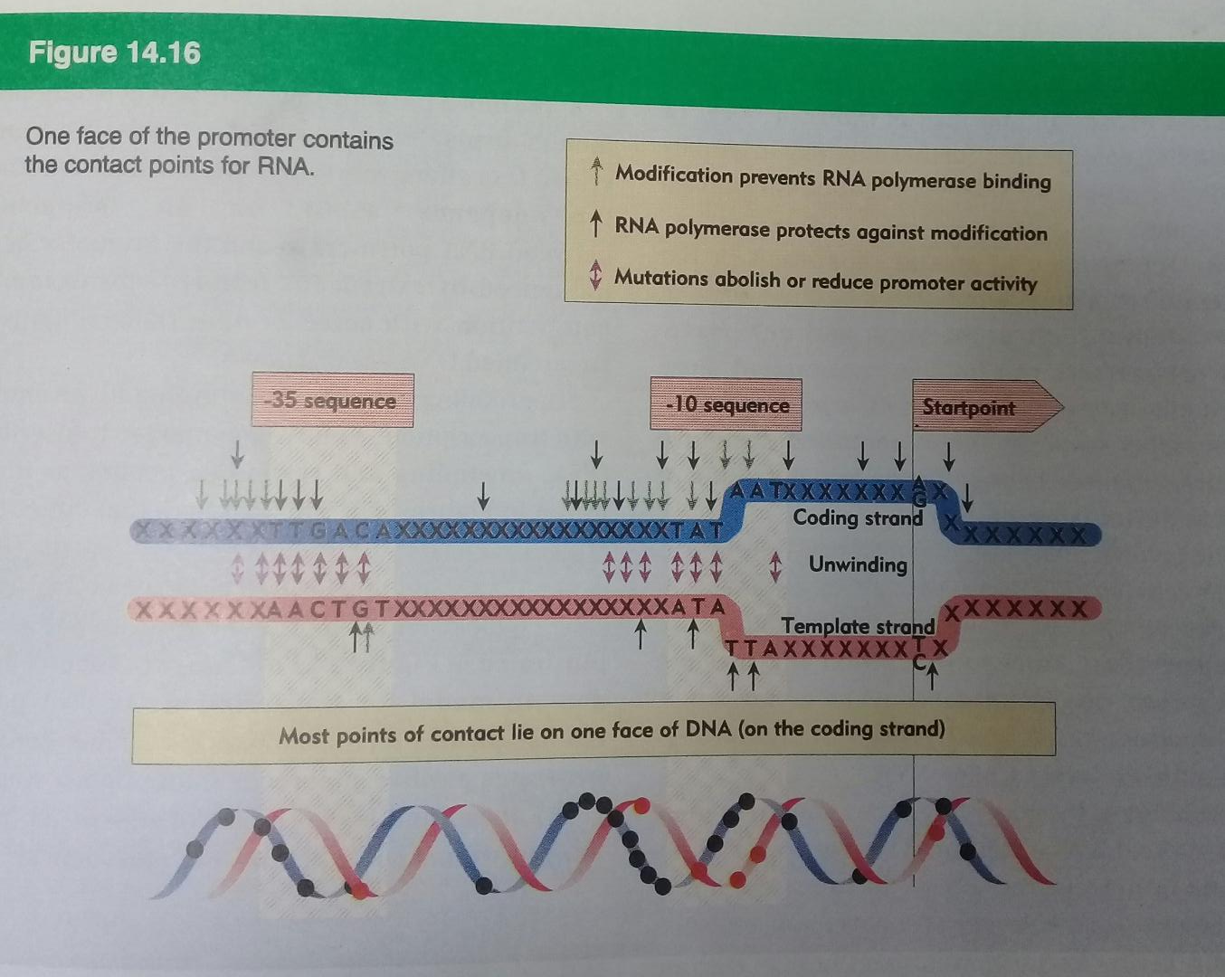
- RNA polymerase core binds to the DNA promoter (Fig. 26–6).

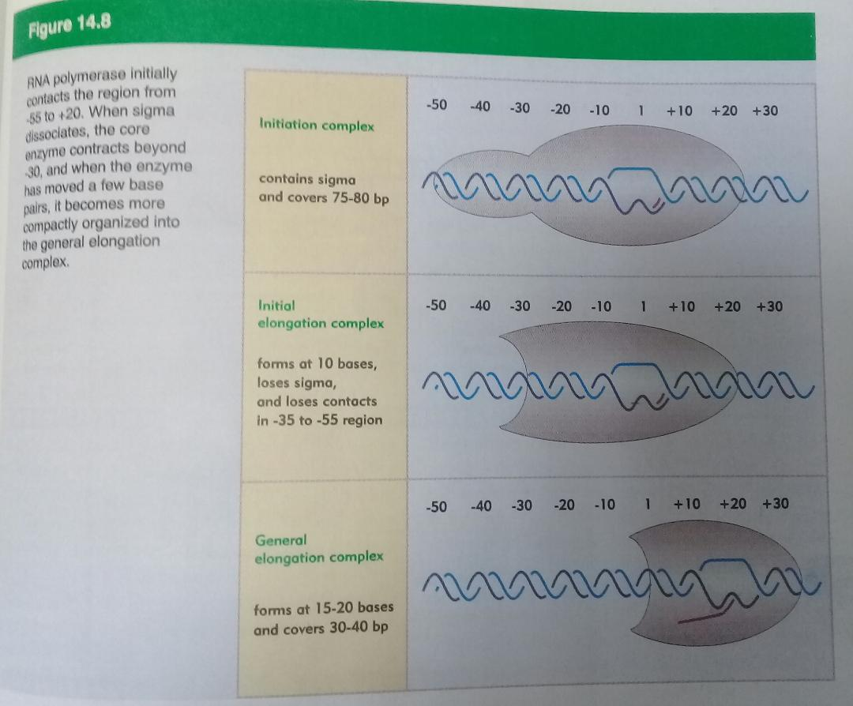

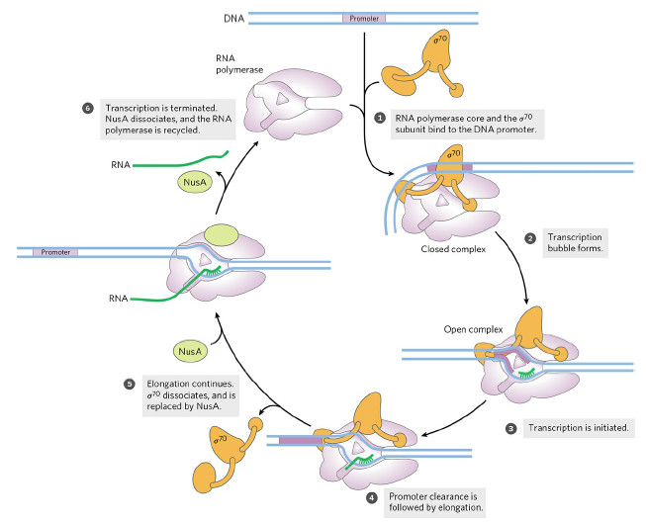

- Transcription bubble forms.
- Transcription is initiated.
- Promoter clearance is followed by elongation.
- Elongation continues. σ dissociates, and is replaced by protein NusA.
- Transcription is terminated. NusA dissociates, and the RNA polymerase is recycled.
- σ factor can again bind to the enzyme to initiate transcription.

