Chapter 2 Water
- Water is important for living systems.
- Properties of water affect the structure and function of all other cellular constituents.
- Water is the most abundant substance in living systems
- making up 70% or more of the weight of most organisms.

  - Weak Interactions in Aqueous Systems
Hydrogen Bonding Gives Water Its Unusual Properties
- Water has a higher
- melting point (0ºC)
- boiling point (100ºC)
- heat of vaporization (2,260 J/g) than most other common solvents.
- Structure of the water shows dipolar nature.
- the two H atoms have localized partial positive charges (δ⁺)
- the O atom has a partial negative charge (δ⁻) (Fig. 2-1a).
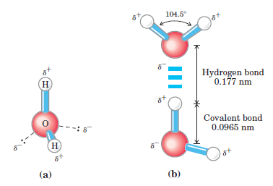
- There is an electrostatic attraction between the O atom of one water molecule and the H of another, called a hydrogen bond (Fig. 2-1b).
- two H₂O molecules are joined by a hydrogen bond.
- H bonds are longer and weaker than covalent O-H bonds.
- Hydrogen bonds between water molecules provide the cohesive forces that make water a liquid at room temperature and a crystalline solid (ice) with a highly ordered arrangement of molecules at cold temperatures.
- Hydrogen bonds are formed between an electronegative atom (the hydrogen acceptor, usually oxygen or nitrogen) and a hydrogen atom covalently bonded to another electronegative atom (the hydrogen donor) in the same or another molecule (Fig. 2-3).

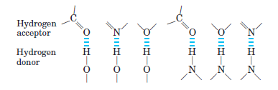

- Polar biomolecules dissolve readily in water forming hydrogen bonds
- because they can replace water-water interactions with more energetically favorable water-solute interactions.
- Some biologically important hydrogen bonds (Fig. 2-4).
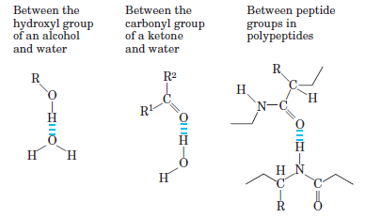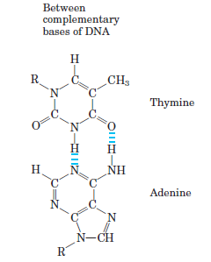

Water Interacts Electrostatically with Charged Solutes
- Water is a polar solvent.
- It dissolves most biomolecules, which are generally charged or polar hydrophilic compounds (Table 2-2).

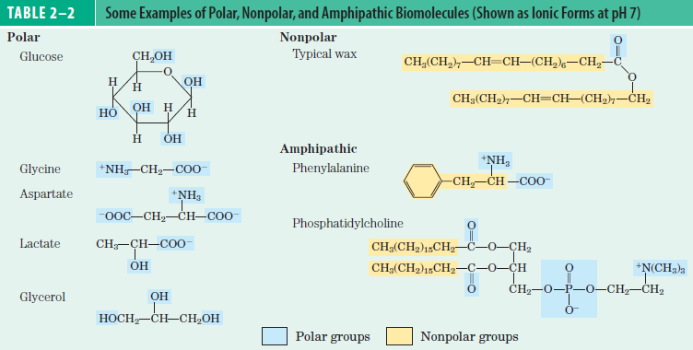

- Water dissolves salts such as NaCl.

Nonpolar Gases Are Poorly Soluble in Water
- The molecules of the biological important gases CO₂, O₂, and N₂ are nonpolar.
- Two other gases, NH₃ and H₂S, also have biological roles in some organisms
- these gases are polar and dissolve in water (Table 2-3).

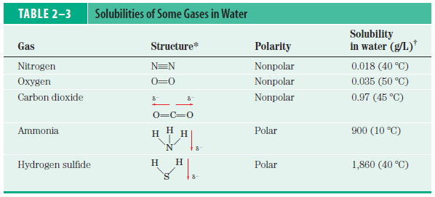

Nonpolar Compounds Force Energetically Unfavorable Changes in the Structure of Water
- Amphipathic compounds contain regions
- polar (or charged) and nonpolar (Table 2-2).
- When an amphipathic compound is mixed with water
- polar (hydrophilic) region interacts with the water and tends to dissolve.
- nonpolar hydrophobic region tends to avoid contact with water.
- the nonpolar regions of the molecules cluster together to present the smallest hydrophobic area.
- These stable structures of amphipathic compounds in water, called micelles,
- may contain hundreds or thousands of molecules.
- Structures of amphipathic compounds
- are stabilized by hydrophobic interactions among the nonpolar regions (Fig. 2-7 b).
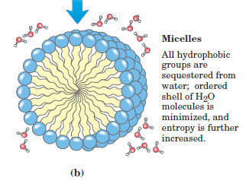

Van der Waals Interactions Are Weak Interatomic Attractions
- When two uncharged atoms are brought very close together
- their surrounding electron clouds influence each other.
- Random variations in the positions of the electrons around one nucleus
- may create a transient electric dipole, which induces a transient and opposite electric dipole in the nearby atom.
- The two dipoles weakly attract each other, bringing the two nuclei closer.
- These weak interactions are called van der Waals interactions (also known as London forces).
Weak Interactions Are Crucial to Macromolecular Structure and Function
- The noncovalent interactions
- hydrogen bonds
- ionic interactions
- hydrophobic interactions
- van der Waals interactions are individually much weaker than covalent bonds.
- The noncovalent interactions are continually formed and broken.
- The cumulative effect of many such interactions among biomolecules in aqueous solutions can be very significant.
Solutes Affect the Colligative Properties of Aqueous Solutions
- Solutes of all kinds alter physical properties of the solvent (water).
- These properties are vapor pressure (lowered), boiling point (increased), melting point or freezing point (decreased) and osmotic pressure.
- They are called colligative properties
- depends only on the number of solute particles (molecules or ions).
- When two different aqueous solutions are separated by a semipermeable membrane (allows the passage of water but not solute molecules)
- water molecules diffusing from the region of higher water concentration to the region of lower water concentration produce osmotic pressure.
- Plasma membranes are more permeable to water than to most other small molecules, ions, and macromolecules.
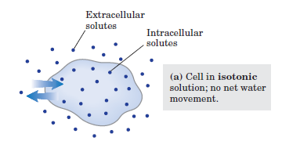
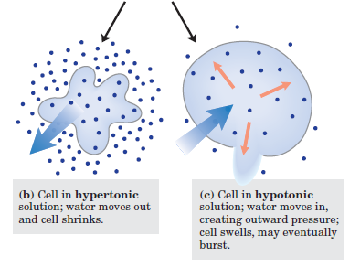
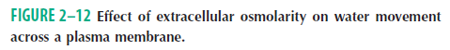

- Solutions of equal osmolarity are said to be isotonic (Fig. 2-12a).
- Cell in a hypertonic solution (higher osmolarity than the cytosol) (Fig. 2-12b).
- Cell in hypotonic solution (lower osmolarity than the cytosol) (Fig. 2-12c).
- Osmosis is an important factor in the life of most cells.
- In natural environments of cells,
- cells generally contain higher concentrations of biomolecules and ions than their surroundings.

  - Ionization of Water, Weak Acids and Weak Bases
Pure Water Is Slightly Ionized
- Water molecules have a slight reversible ionization to yield a hydrogen ion (proton) and a hydroxide ion
H₂O H⁺ + OH⁻
- Free protons do not exist in solution
- H ions in water are immediately hydrated to hydronium ions (H₃O⁺)
- Reversible ionization is crucial to the role of water in cellular function.

The Ionization of Water Is Expressed by an Equilibrium Constant
- The equilibriım constant for the reversible ionization of water
K_{eq} = [H⁺] [OH⁻] / [H₂O]
[H₂O] = (1000 g/L) / (18 g/mol) = 55.5 M
K_{eq} = [H⁺] [OH⁻] / 55.5 M
(55.5M) (K_{eq}) = [H⁺] [OH⁻] = K_{w} = ion product of water
K_{eq} is determined by electrical-conductivity measurements of pure water
K_{eq} = 1.8 x 10⁻¹⁶ M
(55.5 M) (1.8 x 10⁻¹⁶ M) = 1.0 x 10⁻¹⁴ M² = [H⁺] [OH⁻] = K_{w}
- When [H⁺] = [OH⁻], the solution is said to be at neutral pH
[H⁺] = [OH⁻] = 10⁻⁷ M

The pH Scale Designates the H⁺ and OH⁻ Concentrations
- The term pH is defined by the expression
pH = - log [H⁺]
the symbol p denotes “negative logarithm of “
- The pH of some common aqueous fluids is given in (Fig. 2-14).
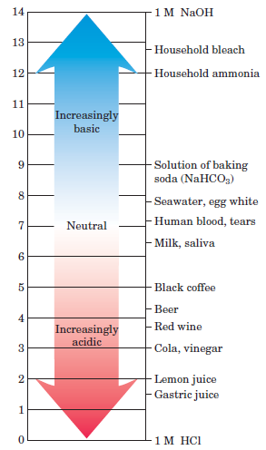
- a cola drink (pH 3.0) has approximately 10,000 times higher H⁺ concentration than blood (pH 7.4)
- Measurement of pH is one of the most important and frequently used procedures in biochemistry.
- Measurements of the pH of blood and urine are commonly used in medical diagnoses.
- The pH affects the structure and activity of biological macromolecules.

Weak Acids and Bases Have Characteristic Acid Dissociation Constants
- Weak acids and bases are not completely ionized in water.
- They play important roles in metabolism and its regulation.
- The tendency of any weak acid (HA) to lose a proton and form its conjugate base (A⁻)
- is defined by the equilibrium constant (K_{eq}) for the reversible reaction
HA H⁺ + A⁻
K_{eq} = [H⁺] [A⁻] / [HA] = K_{a} = acid dissociation constant
pK_{a} = - log K_{a}
- Stronger acid has lower pK_{a}.

Titration Curves Reveal the pKa of Weak Acids
- Comparison of the titration curves of three weak acids (Fig. 2-17).
- acetic acid (pK_{a} = 4.76), dihydrogen phosphate (pK_{a} = 6.86) and ammonium ion (pK_{a} = 9.25)
- The titration curve of a weak acid shows
- a weak acid and its anion (—a conjugate acid-base pair)
- they can act as a buffer.
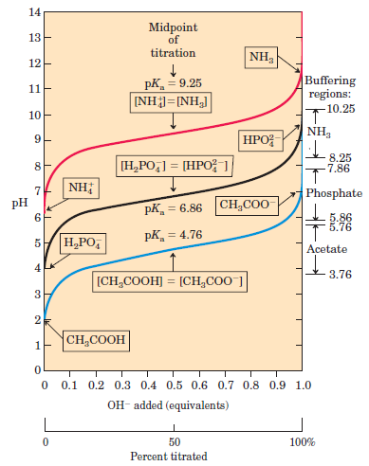
2.3 Buffering against pH Changes in Biological Systems
- Almost every biological process is pH dependent
- a small change in pH produces a large change in the rate of the process.
- Cells and organisms maintain a specific and constant cytosolic pH, usually near pH 7.
- it keeps biomolecules in their optimal ionic state.
- Constancy of pH is achieved by biological buffers.

Buffers Are Mixtures of Weak Acids and Their Conjugate Bases
- Buffers are aqueous systems
- tend to resist changes in pH when a small amounts of acid (H⁺) or base (OH⁻) are added.
- This change is very small change in pH compared with no buffering systems (pure water, NaCl solution).

The Henderson-Hasselbalch Equation Relates pH, pKa, and Buffer Concentration
- For the ionization of a weak acid HA, the Henderson-Hasselbalch equation can be derived
K_{a} = [H⁺] [A⁻] / [HA]
solve for [H⁺] [H⁺] = K_{a} [HA] / [A⁻]
the negative logarithm of both sides - log [H⁺] = - log K_{a} - log[HA] / [A⁻]
pH = pK_{a} - log[HA] / [A⁻]
invert - log[HA] / [A⁻] pH = pK_{a} + log[A⁻] / [HA]
generally pH = pK_{a} + log[proton acceptor] / [proton donor]
when [HA] = [A⁻] pH = pK_{a} + log 1.0 = pK_{a} + 0 = pK_{a}
buffer has maximum capacity

Weak Acids or Bases Buffer Cells and Tissues against pH Changes
- The cytoplasm of most cells contains high concentrations of proteins.
- proteins contain many amino acids with functional groups that are weak acids or weak bases.
- Two important biological buffers are the phosphate and bicarbonate systems.
H₂PO₄⁻ H⁺ + HPO₄²⁻
- phosphate buffer works between 5.9 and 7.9.
- phosphate buffer is effective in extracellular fluids and most cytoplasmic compartments.
- bicarbonate buffer is effective in blood and lung
H₂CO₃ H⁺ + HCO₃⁻

Water as a Reactant
- Water is not only the solvent
- it is a direct participant in chemical reactions of living cells.
- The addition of the elements of water is a hydrolysis reaction.
- for example, ATP + H₂O ADP + P_{i}
- Hydrolysis reactions are also responsible for the enzymatic depolymerization of proteins, carbohydrates, and nucleic acids.
- H₂O and CO₂ are the end products of the oxidation of fuels such as glucose
C₆H₁₂O₆ + 6O₂ 6 CO₂ + 6 H₂O
- metabolic water is formed by oxidation of foods and stored fats
  - it is enough to allow some animals in very dry habitats (camels) to survive for extended periods without drinking water.
- Green plants and algae use the energy of sunlight to split water in the process of photosynthesis
- H₂O gives its electrons to electron-accepting species.

