The Energy of Electron Transfer Is Efficiently Conserved in a Proton Gradient
- The transfer of two electrons from NADH through the respiratory chain to molecular oxygen can be written as
NADH + H⁺ + ½ O₂ NAD⁺ + H₂O
- This net reaction is highly exergonic. ΔGº = - 220 kJ/mol
- Much of this energy is used to pump protons out of the matrix (Fig. 19-16).

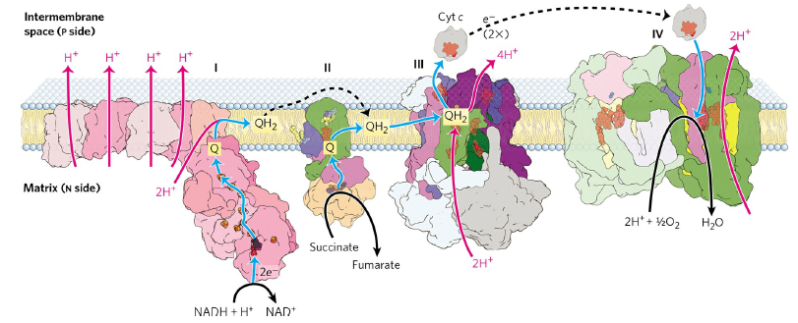

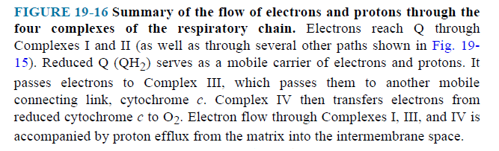

- The energy of electron transfer is efficiently conserved in a proton gradient.
- The energy stored in such a gradient, called the proton-motive force.
- In mitochondria, the electrochemical energy in the proton gradient drives the synthesis of ATP from ADP and Pi.

Reactive Oxygen Species Are Generated during Oxidative Phosphorylation
- Several steps in the path of oxygen reduction in mitochondria have the potential to produce highly reactive free radicals that can damage cells.
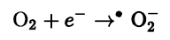
- The superoxide free radical thus generated is highly reactive; its formation also leads to production of the even more reactive hydroxyl free radical,.
- To prevent oxidative damage by superoxide free radical, cells have superoxide dismutase, which catalyzes the reaction (Fig. 19-18).
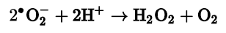
- The hydrogen peroxide is rendered harmless by the action of glutathione peroxidase (Fig. 19-18).
