Oxidation of Monounsaturated Fatty Acids Requires One Additional Reaction
- Oleate is an 18-carbon monounsaturated fatty acid with a cis double bond between C-9 and C-10.
- Oleoyl-CoA undergoes three passes through the fatty acid oxidation cycle to yield three molecules of acetyl-CoA (Fig. 17- 10).
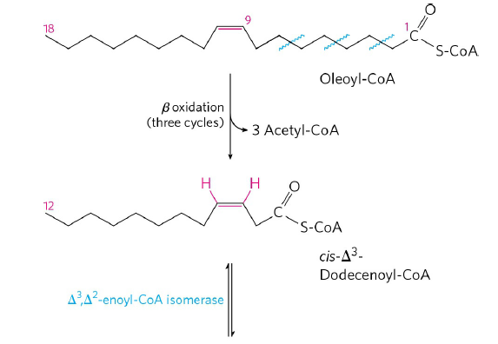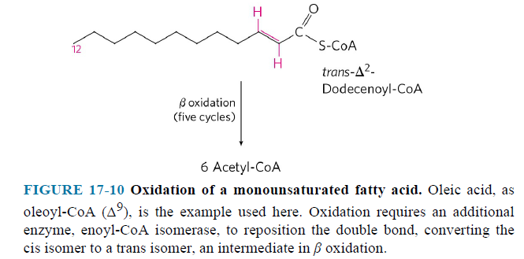

- 12-carbon unsaturated fatty acid cannot serve as a substrate for enoyl-CoA hydratase, which acts only on trans double bonds.
- Enoyl-CoA isomerase isomerizes the cis-enoyl-CoA to the trans-enoyl-CoA.
- This intermediate is now acted upon by the remaining enzymes of β oxidation to yield acetyl-CoA.
- Altogether, nine acetyl-CoAs are produced from one molecule of the 18-carbon oleate.

Complete Oxidation of Odd-Number Fatty Acids Requires Three Extra Reactions
- Long-chain odd-number fatty acids are oxidized in the same pathways as the even-number fatty acids. For example, 17-carbon
- at the last pass, fatty acyl-CoA has five carbon atoms.
- the products are acetyl-CoA and propionyl-CoA.
- the acetyl-CoA can be oxidized in the citric acid cycle, but propionyl-CoA enters a different pathway having three enzymes (Fig. 17-12).
- Carboxylation of propionyl-CoA
- Epimerization of D-Methylmalonyl-CoA
- Production of succinyl-CoA which can enter the citric acid cycle
- 17-carbon fatty acid gives 2 NADH less than 16-carbon fatty acid.
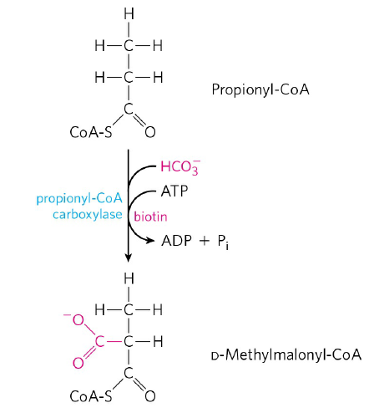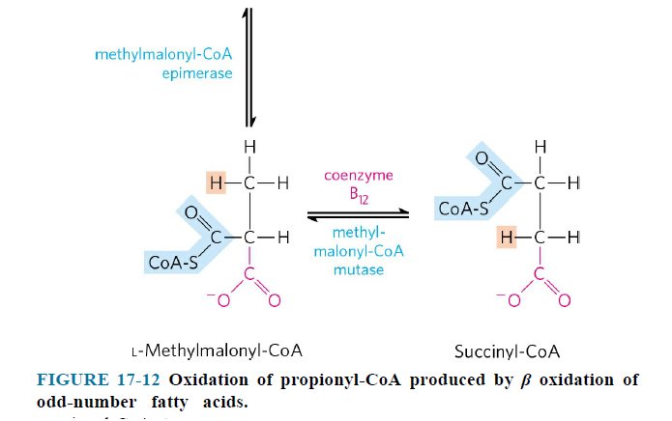

Fatty Acid Oxidation is Regulated
- Carnitine acyltransferase 1 is inhibited by malonyl-CoA.
- β-hydroxyacyl-CoA dehydrogenase is inhibited by [NADH/NAD⁺] ratio.
- Thiolase is inhibited by high concentrations of acetyl-CoA.

17.3 Ketone Bodies

- In humans and most other mammals, acetyl-CoA formed in the liver during oxidation of fatty acids
- can enter the citric acid cycle or
- can be converted the ketone bodies (acetoacetate, acetone and β-hydroxybutyrate) (Fig. 17-18).
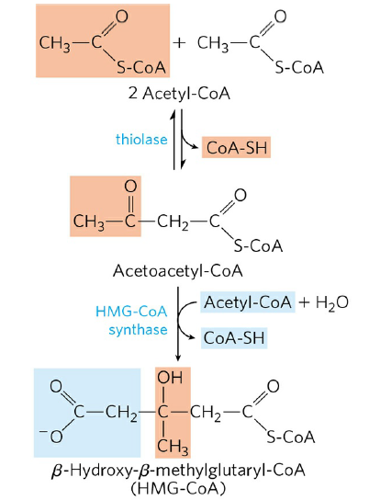
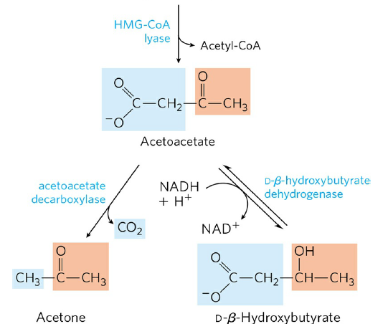
FIGURE 17-18 Formation of ketone bodies from acetyl-CoA.
- Acetoacetate and β-hydroxybutyrate are transported by the blood to tissues as fuels.
- They are converted to acetyl-CoA (Fig. 17-20).
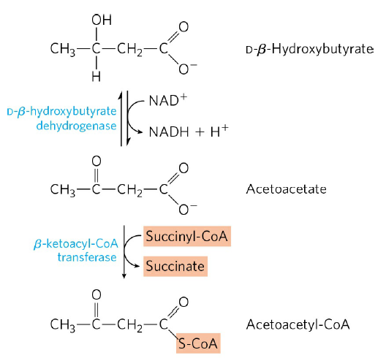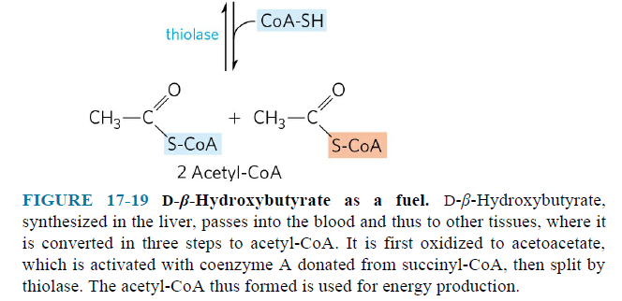
- Liver does not have β-ketoacyl-CoA transferase.
- Acetyl-CoAs are oxidized in the citric acid cycle to provide much of the energy required by tissues such as skeletal and heart muscle, kidney and brain.

