Chapter 19 and 20
Photosynthesis
- Photosynthesis is the capture of solar energy by photosynthetic organisms and its conversion to the chemical energy of reduced organic compounds.
- Photosynthetic and heterotrophic organisms live in a balanced steady state in the biosphere (Fig. 19-43).
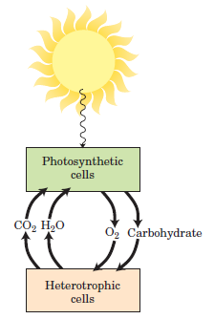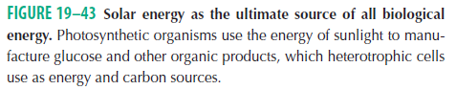

- Solar energy is the ultimate source of all biological energy.
- Photosynthetic organisms trap solar energy and form ATP and NADPH, which they use as energy sources to make carbohydrates and other organic compounds from CO₂ and H₂O; simultaneously, they release O₂ into the atmosphere.

- Photosynthesis occurs in a variety of bacteria and in unicellular eukaryotes (algae) as well as in plants.
- The overall equation for photosynthesis in plants describes an oxidation-reduction reaction in which H₂O donates electrons (as hydrogen) for the reduction of CO₂ to carbohydrate (CH₂O):

light
CO₂ + H₂O O₂ + (CH₂O)

  - General Features of Photophosphorylation
- Photophosphorylation differs from oxidative phosphorylation.
- In higher plants, photophosphorylation occurs in chloroplasts (Fig. 20-3).

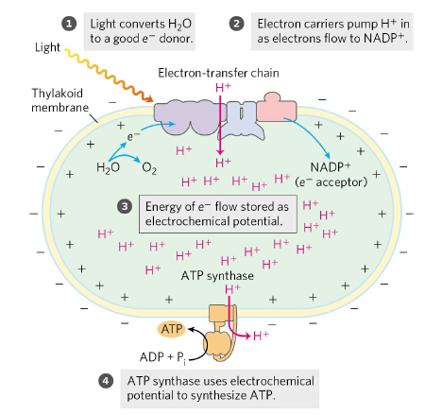
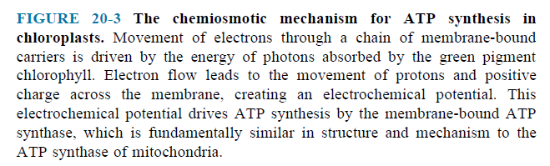

- In photophosphorylation, electrons flow through a series of membrane-bound carriers including cytochromes, quinones, and iron-sulfur proteins, while protons are pumped across a membrane to create an electrochemical potential.
- Photosynthesis in plants encompasses two processes: (Fig. 20-22).

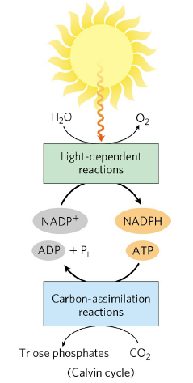
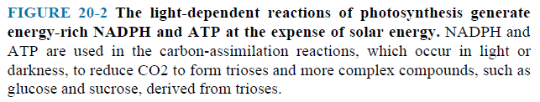
- In the light-dependent reactions, or light reactions, chlorophyll and other pigments of photosynthetic cells absorb light energy and conserve it as ATP and NADPH; simultaneously, O₂ is evolved.
- In the carbon-assimilation reactions (or carbon-fixation reactions), sometimes misleadingly called the dark reactions, ATP and NADPH are used to reduce CO₂ to form triose phosphates, starch, sucrose and other products.

Photosynthesis in Plants Takes Place in Chloroplasts
- In photosynthetic eukaryotic cells, both the light-dependent and the carbon-assimilation reactions take place in the chloroplasts (Fig. 19–45).
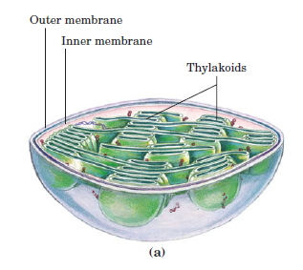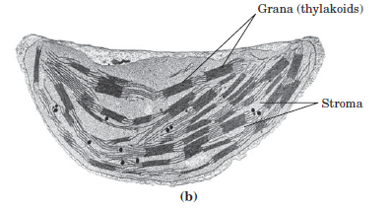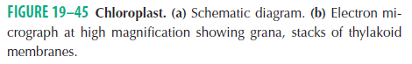
- They are surrounded by two membranes, an outer membrane that is permeable to small molecules and ions, and an inner membrane that encloses the internal compartment.
- This compartment contains many flattened, membrane-surrounded vesicles, the thylakoids, usually arranged in stacks called grana.
- The photosynthetic pigments and the enzyme complexes that carry out the light reactions and ATP synthesis are embedded in the thylakoid membranes.
- The stroma (the aqueous phase enclosed by the inner membrane) contains most of the enzymes required for the carbon-assimilation reactions.

Light Drives Electron Flow in Chloroplasts
- NADP⁺ is the biological electron acceptor in chloroplasts, according to the equation
light
2H₂O + 2NADP⁺ 2NADPH + 2H⁺ + O₂

  - Light Absorption
- The energy of a photon of visible light ranges from 150 kJ/einstein for red light to - 300 kJ/einstein for violet light. One einstein is 6.022 x 10²³ photons.
- When a photon is absorbed, an electron in the absorbing molecule (chromophore) is lifted to a higher energy level.
- This molecule is in an excited state, which is generally unstable.

Chlorophylls Absorb Light Energy for Photosynthesis
- The most important light-absorbing pigments in the thylakoid membranes are the chlorophylls, green pigments with polycyclic, planar structures resembling the protoporphyrin of hemoglobin, except that Mg²⁺, not Fe²⁺, occupies the central position (Fig. 20–8a).
- Chloroplasts always contain both chlorophyll a and chlorophyll b.
- Chlorophyll is always associated with specific binding proteins, forming light-harvesting complexes (LHCs).
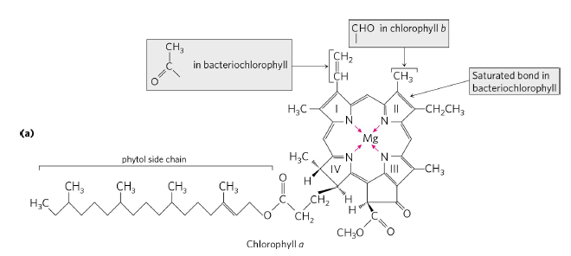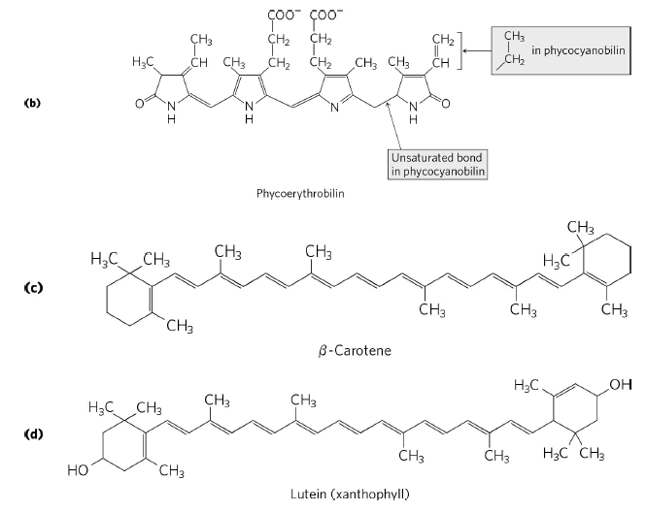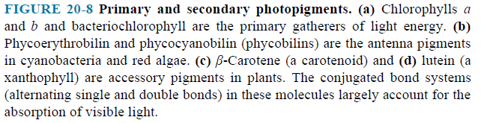
Accessory Pigments Extend the Range of Light Absorption
- In addition to chlorophylls, thylakoid membranes contain secondary light-absorbing pigments, or accessory pigments, called carotenoids.
- The most important are β-carotene and lutein (Fig. 20–8c,d).
- The carotenoid pigments absorb light at wavelengths not absorbed by the chlorophylls and thus are supplementary light receptors.
- One light-harvesting complex (LHCII); contains seven molecules of chlorophyll a, five of chlorophyll b, and two of the accessory pigment lutein (Fig. 20–12).

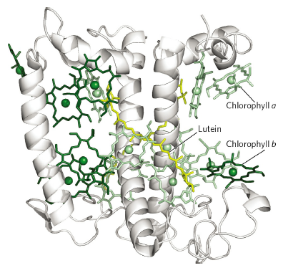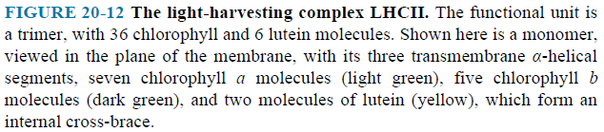

Chlorophyll Funnels the Absorbed Energy to Reaction Centers by Exciton Transfer
- The light-absorbing pigments of thylakoid or bacterial membranes are arranged in functional arrays called photosystems.
- In spinach chloroplasts, for example, each photosystem contains about 200 chlorophyll and 50 carotenoid molecules.
- All the pigment molecules in a photosystem can absorb photons, but only a few chlorophyll molecules associated with the photochemical reaction center are specialized to transduce light into chemical energy.
- The other pigment molecules in a photosystem are called light-harvesting or antenna molecules.
- They absorb light energy and transmit it rapidly and efficiently to the reaction center (Fig. 20–11).
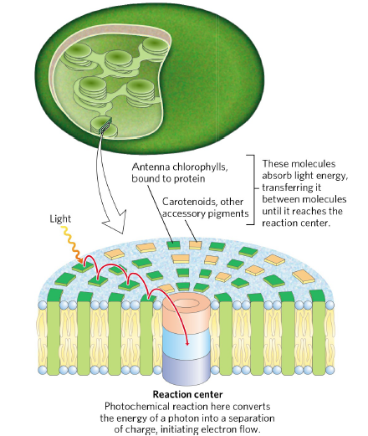
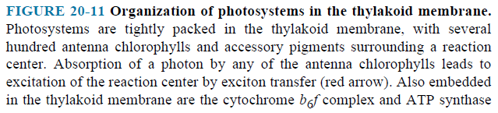

  - Light excites an antenna molecule (chlorophyll or accessory pigment), raising an electron to a higher energy level (Fig. 20–13).
  - The excited antenna chlorophyll transfers energy directly to a neighboring chlorophyll molecule, which becomes excited as the first molecule returns to its ground state.
  - This energy is transferred to a reaction-center chlorophyll, exciting it.
  - The excited reaction-center chlorophyll passes an electron to an electron acceptor.
  - The electron hole in the reaction center is filled by an electron from an electron donor.
  - The absorption of a photon has caused separation of charge in the reaction center.
  - In this way, excitation by light causes electric charge separation and initiates an oxidation-reduction chain.

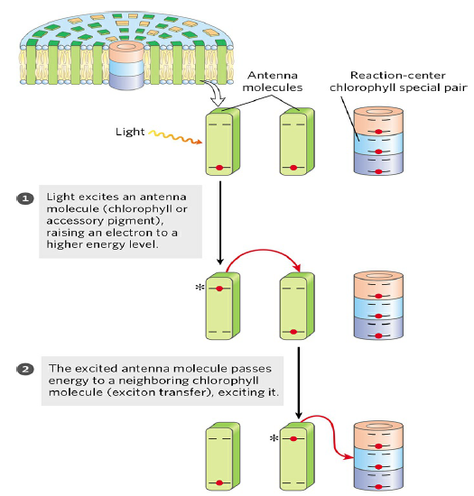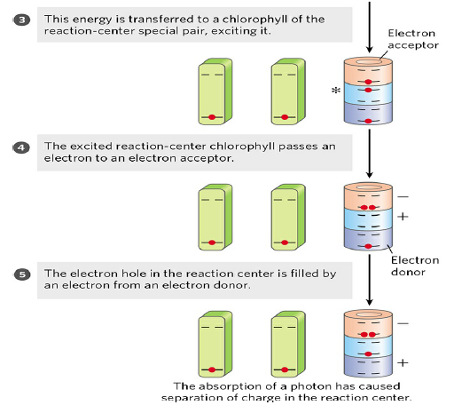
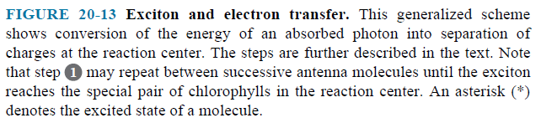

  - The Central Photochemical Event : Light-Driven Electron Flow
- Light-driven electron transfer in plant chloroplasts during photosynthesis is accomplished by multienzyme systems in the thylakoid membrane.

In Plants, Two Reaction Centers Act in Tandem
- The thylakoid membranes of chloroplasts have two different kinds of photosystems, each with its own type of photochemical reaction center and set of antenna molecules (Fig. 20–16).
- This “Z scheme” shows the pathway of electron transfer from H₂O to NADP⁺ in noncyclic photosynthesis.
  - Photosystem II (PSII) is a pheophytin (chlorophyll lacking the central Mg²⁺ ion)-quinone type of system containing equal amounts of chlorophylls a and b. Excitation of its reaction-center P680 drives electrons through the cytochrome b₆f complex with concomitant movement of protons across the thylakoid membrane.
  - Photosystem I (PSI) has a reaction center designated P700 and a high ratio of chlorophyll a to chlorophyll b. Excited P700 passes electrons to the Fe-S protein ferredoxin, then to NADP⁺, producing NADPH.
- The thylakoid membranes of a single spinach chloroplast have many hundreds of each kind of photosystem.
- These two reaction centers in plants act in tandem to catalyze the light-driven movement of electrons from H₂O to NADP⁺.
- Electrons are carried between the two photosystems by the soluble protein plastocyanin.
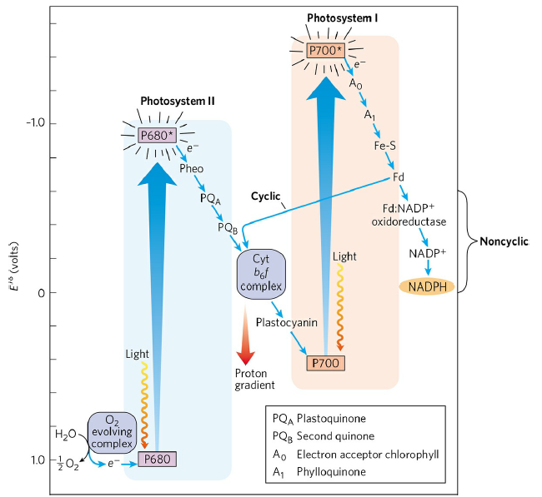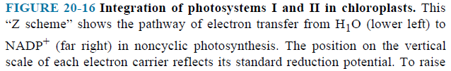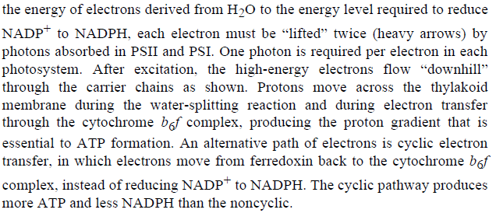
- To replace the electrons that move from PSII through PSI to NADP⁺, plants oxidize H₂O, producing O₂. This process is called oxygenic photosynthesis.
- The Z scheme thus describes the complete route by which electrons flow from H₂O to NADP⁺, according to the equation
2H₂O + 2NADP⁺ + 8 photons O₂ + 2NADPH + 2H⁺
- A total of eight photons must be absorbed, four by each photosystem.
- In PSII, there are D1 and D2 proteins, to which all the electron-carrying cofactors are bound.
- Excitation of P680 in PSII produces P680*, an excellent electron donor that transfers an electron to pheophytin.
- Pheo passes its extra electron to a protein-bound plastoquinone (PQ_{A}) which passes its electron to bound plastoquinone (PQ_{B}).
- When PQ_{B} has acquired two electrons and two protons from the solvent water, it is in its fully reduced quinol form, PQ_{B}H₂.
- Eventually, the electrons in PQ_{B}H₂ pass through the cytochrome b₆ f complex.
- The electron initially removed from P680 is replaced with an electron obtained from the oxidation of water.
- The photochemical events of PSI at the reaction-center P700 are similar to those in PSII.
- The excited reaction-center P700* loses an electron to an acceptor, A₀ (chlorophyll).
- P700⁺ is a strong oxidizing agent, which quickly acquires an electron from plastocyanin, a soluble Cu-containing electron-transfer protein.
- First, phylloquinone (A₁) accepts an electron and passes it to an iron-sulfur protein.
- From here, the electron moves to ferredoxin (Fd), another iron-sulfur protein.
- The fourth electron carrier in the chain is the flavoprotein ferredoxin:NADP⁺ oxidoreductase, which transfers electrons from reduced ferredoxin (Fd_{red}) to NADP⁺:
2Fd_{red} + 2H⁺ + NADP⁺ 2Fd_{ox} + NADPH + H⁺

The Cytochrome b₆f Complex Links Photosystems II and I
- The function of this complex involves a Q cycle (Fig. 20–21c).

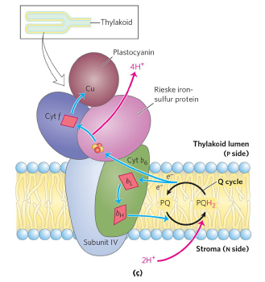

- This cycle results in the pumping of protons across the membrane; in chloroplasts, the direction of proton movement is from the stromal compartment to the thylakoid lumen, up to four protons moving for each pair of electrons.
- The result is production of a proton gradient across the thylakoid membrane as electrons pass from PSII to PSI.
- The measured difference in pH between the stroma (pH 8) and the thylakoid lumen (pH 5) represents a 1,000-fold difference in proton concentration—a powerful driving force for ATP synthesis.

Cyclic Electron Flow between PSI and the Cytochrome b₆f Complex Increases the Production of ATP Relative to NADPH
- Electron flow from PSII through the cytochrome b₆f complex, then through PSI to NADP⁺, is sometimes called noncyclic electron flow, to distinguish it from cyclic electron flow.
- The noncyclic path produces a proton gradient, which is used to drive ATP synthesis, and NADPH, which is used in reductive biosynthetic processes.
- Electrons passing from P700 to ferredoxin do not continue to NADP⁺, but move back through the cytochrome b₆f complex to plastocyanin.
- Plastocyanin then donates electrons to P700, which transfers them to ferredoxin.
- In this way, electrons are repeatedly recycled through the cytochrome b₆f complex and the reaction center of PSI.
- Cyclic electron flow is not accompanied by net formation of NADPH or evolution of O₂.
- However, it is accompanied by proton pumping by the cytochrome b₆f complex and by phosphorylation of ADP to ATP, referred to as cyclic photophosphorylation.
- By regulating the partitioning of electrons between NADP⁺ reduction and cyclic photophosphorylation, a plant adjusts the ratio of ATP to NADPH produced in the light-dependent reactions to match its needs for these products in the carbon-assimilation reactions and other biosynthetic processes.

Water Is Split by the Oxygen-Evolving Complex
- The ultimate source of the electrons passed to NADPH in plant (oxygenic) photosynthesis is water.
- Having given up an electron to pheophytin, P680⁺ (of PSII) must acquire an electron to return to its ground state in preparation for capture of another photon.
- Two water molecules are split, yielding four electrons, four protons, and molecular oxygen:
- H₂O 4 H⁺ + 4 e⁻ + O₂
- A single photon of visible light does not have enough energy to break the bonds in water; four photons are required in this photolytic cleavage reaction.
- The four electrons abstracted from water do not pass directly to P680⁺, which can accept only one electron at a time (Fig. 20–24).

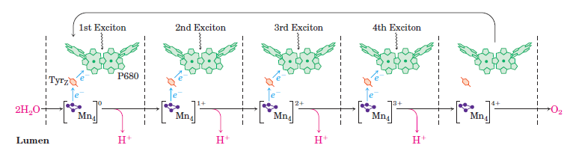

- The oxygen-evolving complex (also called the water-splitting complex) passes four electrons one at a time to P680⁺.
- In the complex, the Mn₄Ca cluster can take four electrons from a pair of water molecules, releasing 4 H⁺ and O₂:
[Mn₄Ca]⁴⁺ + 2H₂O [Mn₄Ca]⁰ + 4H⁺ + O₂
- The electron donor to P680⁺ is a Tyr residue (often designated Z or Tyr_{z}) in the PSII reaction center.
- Because the four protons produced in this reaction are released into the thylakoid lumen, the oxygen-evolving complex acts as a proton pump, driven by electron transfer.
- Electron flow through the cytochrome b₆f complex drives protons across the plasma membrane, creating a proton-motive force that provides the energy for ATP synthesis by an ATP synthase.

  - ATP Synthesis by Photophosphorylation
- The combined activities of the two plant photosystems move electrons from water to NADP⁺, conserving some of the energy of absorbed light as NADPH.
- Simultaneously, protons are pumped across the thylakoid membrane and energy is conserved as an electrochemical potential.
- This proton gradient drives the synthesis of ATP, the other energy conserving product of the light-dependent reactions.
- Some of the light energy captured by the photosynthetic systems of these organisms is transformed into the phosphate bond energy of ATP. This process is called photophosphorylation, to distinguish it from oxidative phosphorylation in respiring mitochondria.

A Proton Gradient Couples Electron Flow and Phosphorylation
- Several properties of photosynthetic electron transfer and photophosphorylation in chloroplasts indicate that a proton gradient plays the same role as in mitochondrial oxidative phosphorylation (Fig. 20–25).
- Electron-transferring molecules in the chain of carriers connecting PSII and PSI are in the thylakoid membrane, so photoinduced electron flow results in the net movement of protons across the membrane, from the stromal side to the thylakoid lumen.
- As protons moved out of the thylakoids into the medium, ATP was generated from ADP and Pi.

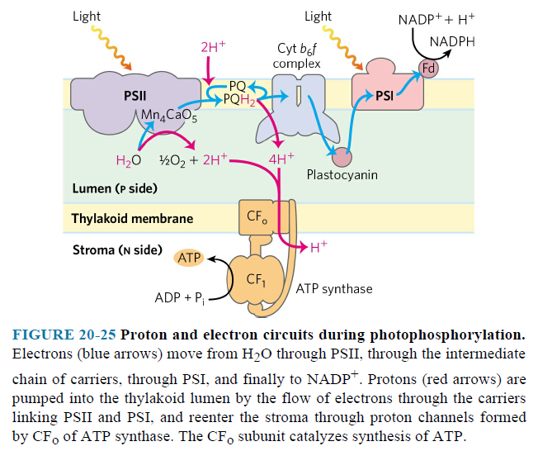

- Electrons move from H₂O through PSII, through the intermediate chain of carriers, through PSI, and finally to NADP⁺.
- Protons are pumped into the thylakoid lumen by the flow of electrons through the carriers linking PSII and PSI, and reenter the stroma through proton channels formed by the Fo (CFo) of ATP synthase. The F1 subunit (CF1) catalyzes synthesis of ATP.

The Approximate Stoichiometry of Photophosphorylation Has Been Established
- As electrons move from water to NADP⁺ in plant chloroplasts, about 12 H⁺ move from the stroma to the thylakoid lumen per four electrons passed (that is, per O₂ formed).
- At least eight photons must be absorbed to drive four electrons from H₂O to NADPH (one photon per electron at each reaction center).
- The energy in eight photons of visible light is more than enough for the synthesis of three molecules of ATP.
- ATP synthesis is not the only energy-conserving reaction of photosynthesis in plants; the NADPH formed in the final electron transfer is also energetically rich.
- The overall equation for noncyclic photophosphorylation is

2 H₂O + 8 photons + 2 NADP⁺ + 3 ADP ⁺ + 3 P_{i} O₂ + 3 ATP + 2 NADPH

  - Photosynthetic Carbohydrate Synthesis
- The synthesis of carbohydrates in animal cells always employs precursors having at least three carbons, all of which are less oxidized than the carbon in CO₂.
- Plants and photosynthetic microorganisms, by contrast, can synthesize carbohydrates from CO₂ and water, reducing CO₂ at the expense of the energy and reducing power furnished by the ATP and NADPH that are generated by the light-dependent reactions of photosynthesis.
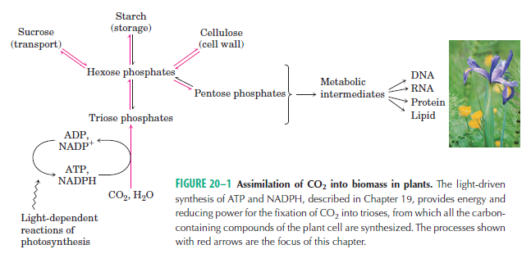
- Plants (and other autotrophs) can use CO₂ as the sole source of the carbon atoms required for the biosynthesis of cellulose and starch, lipids and proteins, and the many other organic components of plant cells (Fig. 20–1).
- Green plants contain in their chloroplasts unique enzymatic machinery that catalyzes the conversion of CO₂ to simple (reduced) organic compounds, a process called CO₂ assimilation. This process has also been called CO₂ fixation or carbon fixation.
- Carbon dioxide is assimilated via a cyclic pathway and is often called the Calvin cycle or the photosynthetic carbon reduction cycle.
- Chloroplasts are the sites of CO₂ assimilation.
- The enzymes for this process are contained in the stroma, the soluble phase bounded by the inner chloroplast membrane.

Carbon Dioxide Assimilation Occurs in Three Stages
Stage 1: Fixation of CO₂ into 3-Phosphoglycerate
- The first stage in the assimilation of CO₂ into biomolecules is the carbon-fixation reaction: condensation of CO₂ with a five-carbon acceptor, ribulose 1,5-bisphosphate, to form two molecules of 3-phosphoglycerate (Fig. 20–31).
- The enzyme is ribulose 1,5-bisphosphate carboxylase/oxygenase, a name mercifully shortened to rubisco. The enzyme’s oxygenase activity is discussed in Section 20.2.
- To achieve high rates of CO₂ fixation, plants therefore need large amounts of this enzyme. In fact, rubisco makes up almost 50% of soluble protein in chloroplasts and is probably one of the most abundant enzymes in the biosphere.
Stage 2: Conversion of 3-Phosphoglycerate to Glyceraldehyde 3-Phosphate
- This conversion occurs in two steps (Fig. 20–36).
- In the first step, ATP transfers a phosphoryl group and 3-phosphoglycerate is converted to 1,3-bisphosphoglycerate by 3-phosphoglycerate kinase.
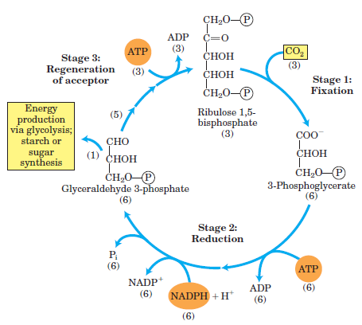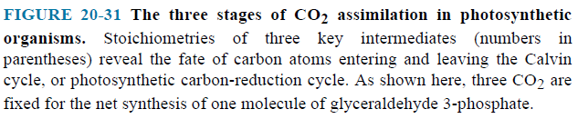

- In the second step, NADPH donates electrons and 1,3-bisphosphoglycerate is converted to glyceraldehyde 3-phosphate by glyceraldehyde 3-phosphate dehydrogenase.
- Triose phosphate isomerase then interconverts glyceraldehyde 3-phosphate and dihydroxyacetone phosphate.
- In the second stage, the 3-phosphoglycerate is reduced to triose phosphates. Overall, three molecules of CO₂ are fixed to three molecules of ribulose 1,5-bisphosphate to form six molecules of glyceraldehyde 3-phosphate (18 carbons) in equilibrium with dihydroxyacetone phosphate.

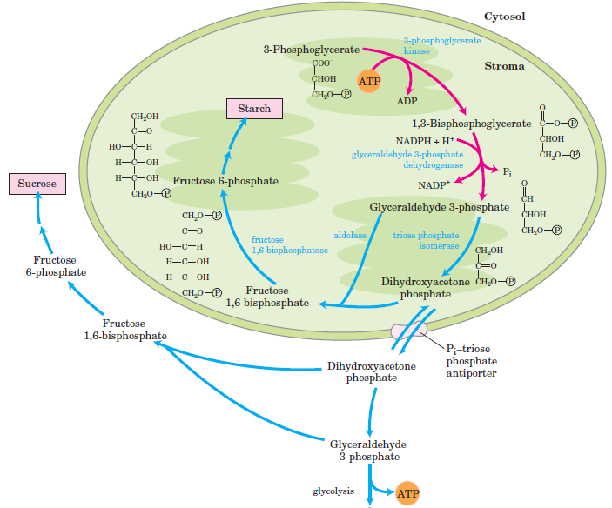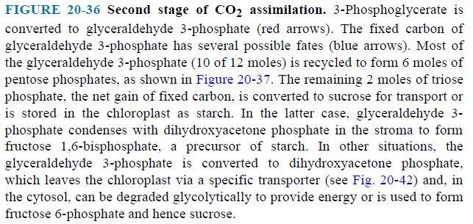
Stage 3: Regeneration of Ribulose 1,5-Bisphosphate from Triose Phosphates
- The first reaction in the assimilation of CO₂ into triose phosphates consumes ribulose 1,5-bisphosphate and, for continuous flow of CO₂ into carbohydrate, ribulose 1,5-bisphosphate must be constantly regenerated.
- In the third stage, five of the six molecules of triose phosphate (15 carbons) are used to regenerate three molecules of ribulose 1,5-bisphosphate (15 carbons), the starting material.
- This is accomplished in a series of reactions (Fig. 20–37).
- The pentose phosphates (ribose 5-phosphate and xylulose 5-phosphate) are converted to ribulose 5-phosphate.
- In the final step of the cycle, ribulose 5-phosphate is phosphorylated to ribulose 1,5-bisphosphate by ribulose 5-phosphate kinase.

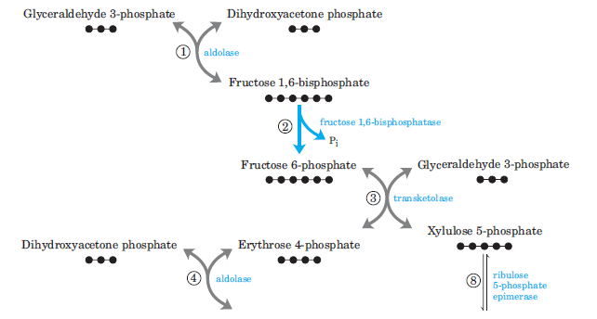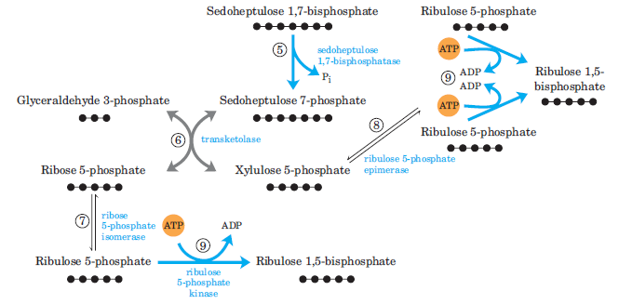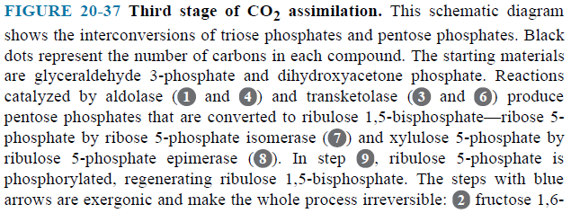
Synthesis of Each Triose Phosphate from CO₂ Requires Six NADPH and Nine ATP
- The net result of three turns of the Calvin cycle is the conversion of three molecules of CO₂ and one molecule of phosphate to a molecule of triose phosphate.
- The stoichiometry of the overall path from CO₂ to triose phosphate, with regeneration of ribulose 1,5-bisphosphate, is shown in (Fig. 20–41).
- One molecule of glyceraldehyde 3-phosphate is the net product of the carbon assimilation pathway.
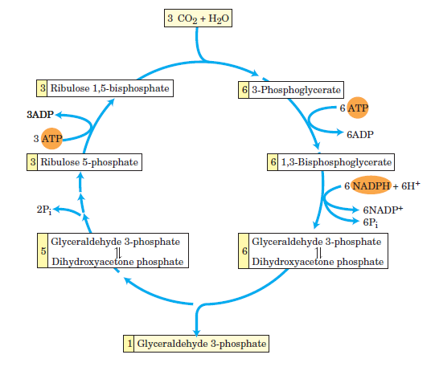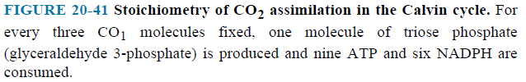

20.2 Oxygenase Activity of Rubisco
- Rubisco is not absolutely specific for CO₂ as a substrate.
- Molecular oxygen (O₂) competes with CO₂ at the active site.
- Rubisco catalyzes the condensation of O₂ with ribulose 1,5-bisphosphate to form 3-phosphoglycerate and 2-phosphoglycolate (Fig. 20–47).

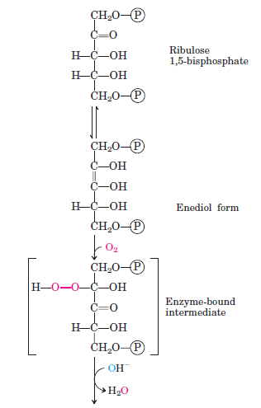
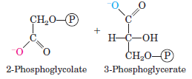

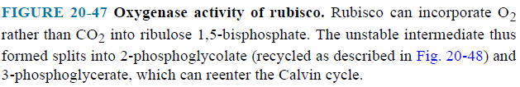
- The Km for CO₂ is about 9 μM, and that for O₂ is about 350 μM.

20.3-4 Biosynthesis of Some Molecules
- Plants (and other autotrophs) can use CO₂ as the sole source of the carbon atoms required for the biosynthesis of sucrose, starch, cellulose, lipids, proteins and the many other organic components of plant cells (Fig. 20–1).

