Chapter 27 Protein Metabolism

- The particular amino acid sequence of a protein is constructed through the translation of information encoded in mRNA. This process is carried out by ribosomes.
- A polypeptide of 100 residues is synthesized in an E. coli cell (at 37 ºC) in about 5 seconds.

27.1 The Genetic Code
- The amino acids attach to transfer RNA (tRNA) to form aminoacyl-tRNAs.
- The genetic information encoded in the 4 letter language of nucleic acids is translated into the 20-letter language of proteins.
- The tRNA adaptor “translates” the nucleotide sequence of an mRNA into the amino acid sequence of a polypeptide (Fig. 27–2).

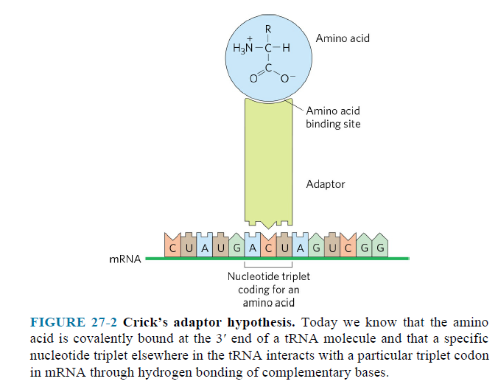
- A codon is a triplet of nucleotides that codes for a speciﬁc amino acid.
- There are 64 different codons (Fig. 27–7).

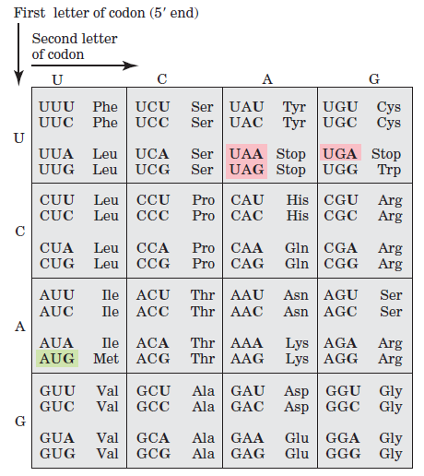

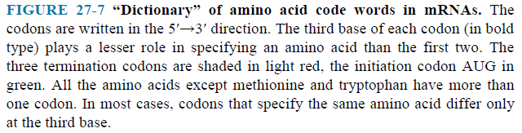

- The genetic code is nearly universal.
- Several codons serve special functions.
- The initiation codon AUG is the most common signal for the beginning of a polypeptide in all cells, in addition to coding for Met residues in internal positions of polypeptides.
- The termination codons (UAA, UAG, and UGA), also called stop codons or nonsense codons, normally signal the end of polypeptide synthesis and do not code for any known amino acids.
- A speciﬁc ﬁrst codon in the sequence establishes the reading frame.
- Each reading frame gives a different sequence of codons, but only one is likely to encode a given protein (Fig. 27–5).

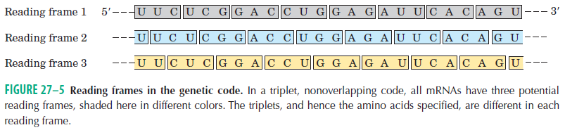

- A reading frame without a termination codon is referred to as an open reading frame (ORF).
- Long open reading frames usually correspond to genes that encode proteins.
- When several different codons specify one amino acid, the difference between them usually lies at the third base position (at the 3’ end).
- Transfer RNAs base-pair with mRNA codons at a three-base sequence on the tRNA called the anticodon.
- The ﬁrst base of the codon in mRNA (read in the 5’→3’ direction) pairs with the third base of the anticodon (Fig. 27–8a).
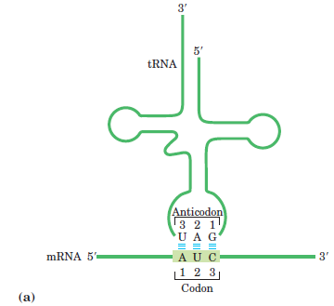

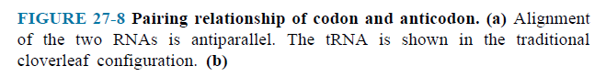

27.2 Protein Synthesis
The Ribosome Is a Complex Supramolecular Machine

- Each E. coli cell contains 15,000 or more ribosomes, accounting for almost a quarter of the dry weight of the cell.
- Bacterial ribosomes contain about 65% rRNA and 35% protein.
- They are composed of two unequal subunits with sedimentation coefﬁcients of 30S and 50S and a combined sedimentation coefficient of 70S.
- Both subunits contain dozens of ribosomal proteins and at least one large rRNA.
- The ribosomes of eukaryotic cells are larger and more complex than bacterial ribosomes (Fig. 27–16).
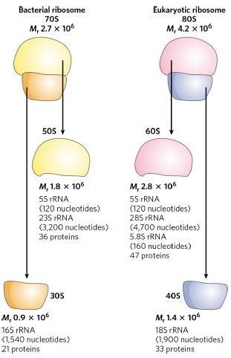

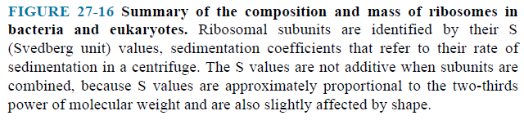

Transfer RNAs Have Characteristic Structural Features
- The tRNAs have between 73 and 93 nucleotide residues (Fig. 27–17).
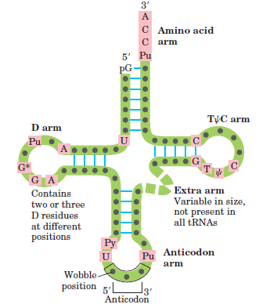

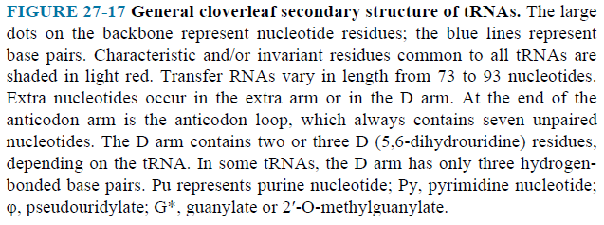

- Cells have at least one kind of tRNA for each amino acid; at least 32 tRNAs are required to recognize all the amino acid codons (some recognize more than one codon), but some cells use more than 32.
- The amino acid arm can carry a speciﬁc amino acid esteriﬁed by its carboxyl group to the 2’ or 3’-hydroxyl group of the A residue at the 3’ end of the tRNA.
- The anticodon arm contains the anticodon.

Protein Biosynthesis in E. coli Takes Place in Five Stages
Stage 1: Activation of Amino Acid
- Aminoacyl-tRNA synthetases attach the correct amino acids to their tRNAs in cytosol.
- Most organisms have one aminoacyl-tRNA synthetase for each amino acid.
- The reaction catalyzed by an aminoacyl-tRNA synthetase is

Amino acid + tRNA + ATP aminoacyl-tRNA + AMP + 2 Pi

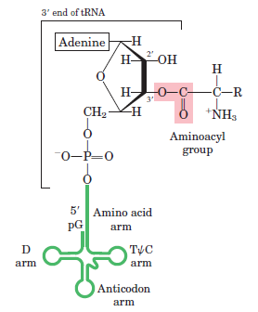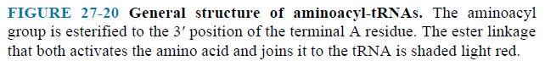

Stage 2: Initiation
- A speciﬁc amino acid initiates protein synthesis.
- Protein synthesis begins at the amino-terminal end and proceeds by the stepwise addition of amino acids to the carboxyl-terminal end of the growing polypeptide.
- The AUG initiation codon specifies an amino-terminal methionine residue.
- Although methionine has only one codon, (5’)AUG, all organisms have two tRNAs for methionine.
- One is used for the initiation codon and the other is used an internal position in a polypeptide.
- In bacteria, the two types of tRNA speciﬁc for methionine are designated tRNA^{Met} and tRNA^{fMet}.
- First, methionine is attached to tRNA^{fMet} by the Met-tRNA synthetase (which in E. coli aminoacylates both tRNA^{fMet} and tRNA^{Met}).

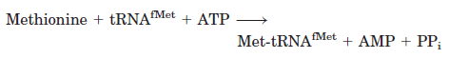

- Next, a transformylase transfers a formyl group from N¹⁰-formyltetrahydrofolate to the amino group of the Met residue.

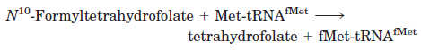

- Product is fMet-tRNA^{fMet}.
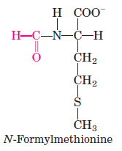

- The transformylase is speciﬁc for Met residues attached to tRNA^{fMet}.

The Three Steps of Initiation
- In step 1 (Fig. 27–25),
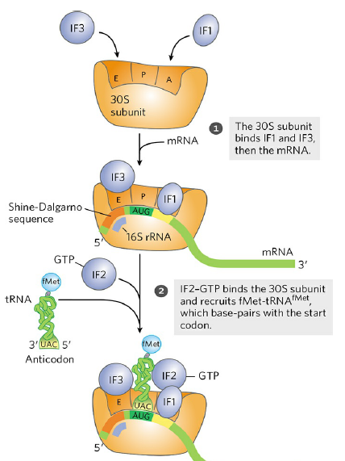
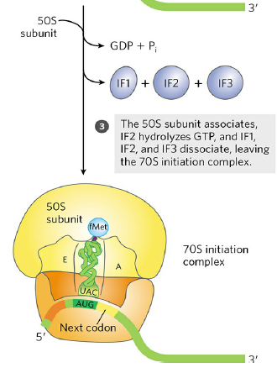
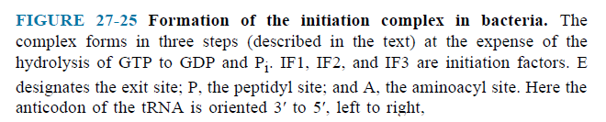
- 30S ribosomal subunit binds two initiation factors, IF-1 and IF-3.
- IF-3 prevents the 30S and 50S subunits from combining prematurely.
- The mRNA then binds to the 30S subunit.
- The initiating (5’)AUG is guided to its correct position by the Shine-Dalgarno sequence in the mRNA.
- The sequence base-pairs with a complementary sequence near the 3’end of the 16S rRNA of the 30S ribosomal subunit.
- Bacterial ribosomes have three sites that bind tRNAs, the aminoacyl (A) site, the peptidyl (P) site, and the exit (E) site.
- The fMet-tRNA^{fMet} is the only aminoacyl-tRNA that binds ﬁrst to the P site.
- Factor IF-1 binds at the A site and prevents tRNA binding at this site during initiation.
- In step 2 (Fig. 27–25),
- GTP-bound IF-2 facilitates binding of fMet-tRNA^{fMet} to 30S ribosomal subunit.
- In step 3 (Fig. 27–25),
- 50S subunit associates,
- IF-2 hydrolyzes to GTP,
- IF-1, IF-2, and IF-3 dissociate, leaving the initiation complex.
- Completion of the steps produces a functional 70S ribosome called the initiation complex.
Stage 3: Elongation
- Peptide bonds are formed.
The Three Steps of Elongation
- In step 1 (Fig. 27–29),
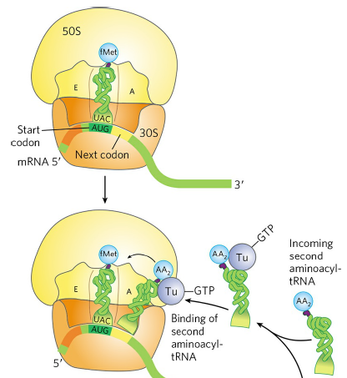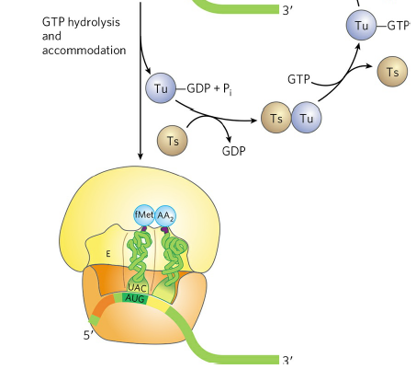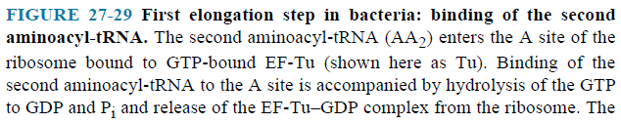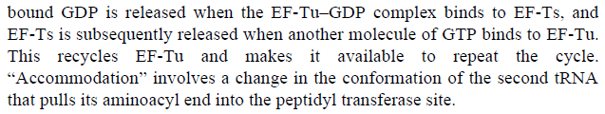

- Aminoacyl-tRNA binds to a complex of GTP-bound EF-Tu (Elongation Factor).
- Aminoacyl-tRNA–EF-Tu–GTP complex binds to the A site.
- GTP is hydrolyzed and an EF-Tu–GDP complex is released.
- EF-Tu–GTP complex is regenerated in a process involving EF-Ts and GTP.
- In step 2 (Fig. 27–30),
- Peptide bonds are formed by peptidyl transferase in the large ribosomal subunit.
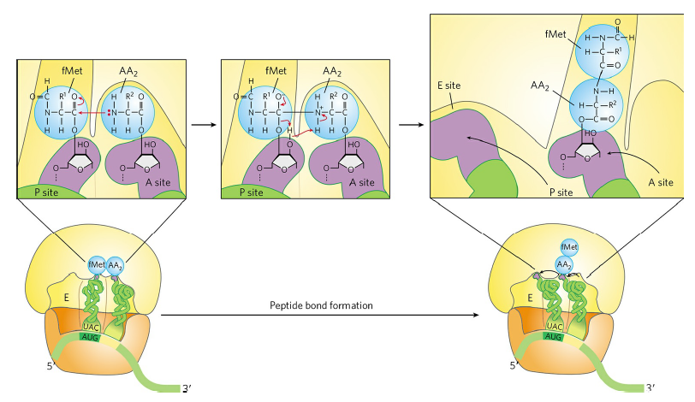
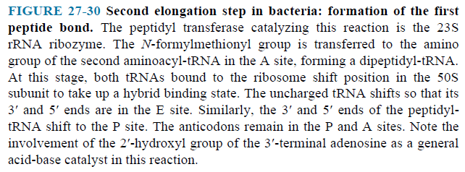

- In step 3 (Fig. 27–31),
- Ribosome moves one codon toward the 3’ end of the mRNA, translocation.
- Movement of the ribosome along the mRNA requires EF-G and GTP.
- EF-G can bind the A site and displace the peptidyl-tRNA.
- Deacylated tRNA dissociates from the ribosomal E site.
- This process occurs in the same way for the next elongation cycles.
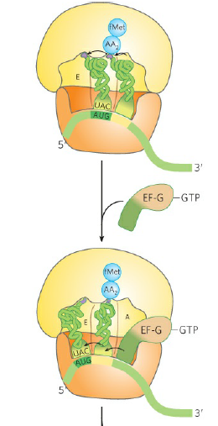
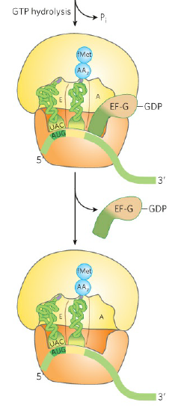
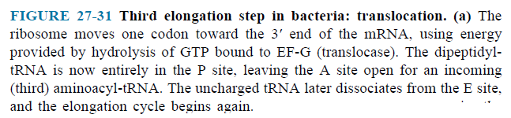

Stage 4: Termination and Ribosome Recycling
- Elongation continues until the ribosome adds the last amino acid coded by the mRNA.
- Termination is signaled by the presence of one of three termination codons in the mRNA.
- Once a termination codon occupies the ribosomal A site, three termination factors, or release factors (RF-1, RF-2, and RF-3) contribute to termination (Fig. 27–32).
- RF-1 recognizes UAG and UAA, and RF-2 recognizes UGA and UAA.
- Either RF-1 or RF-2 binds at a termination codon and induces peptidyl transferase to hydrolyze the growing polypeptide. The polypeptide is released.
- The release factors are replaced by EF-G and ribosome recycling factor (RF-3).
- Hydrolysis of GTP by EF-G leads to dissociation of the 50S subunit from the 30S tRNA–mRNA complex.
- EF-G and RRF are replaced by IF-3, which promotes the dissociation of the tRNA.
- The mRNA is released.
- The complex of IF-3 and the 30S subunit is ready to initiate another round of protein synthesis.
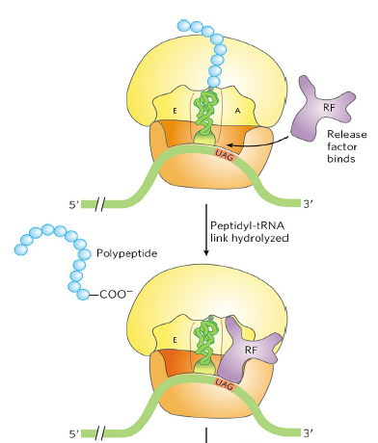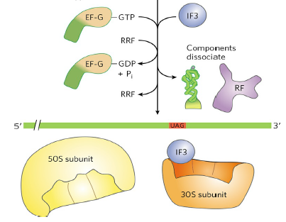
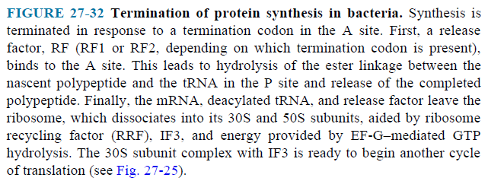

Stage 5: Folding and Posttranslational Processing
- The polypeptide chain is folded and processed into its biologically active form.

